Kingsbarns PS
School Travel Plan
2025



Headteacher: Patricia Shafren

School address: Main Street
Kingsbarns
KY16 8SZ

Telephone No: 01334 659422

Social Media/Website: Website

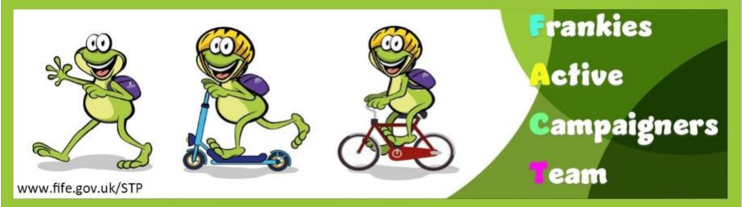

Contents Page

3: 1.0 WHY HAVE A SCHOOL TRAVEL PLAN

3.: 2.0 BENEFITS OF HAVING A SCHOOL TRAVEL PLAN

4: 3.0 Current Travel Habits

3.1 Family Questionnaire Data

7: 3.2 Staff Questionnaire Data

9 4.0 ROUTE AUDIT OF KEY ROUTES TO SCHOOL

4.1 Access Arrangements

10: 5.0 ACTION PLAN

11: 6.0 MONITORING AND EVALUATION

11: 7.0 DISTRIBUTION OF SCHOOL TRAVEL PLAN

- Why have a school travel plan

School-related traffic congestion and the risks congestion poses to the safety of the pupils, teachers, parents, residents, and motorists in and around school locations is a significant problem in communities around Fife.

The most obvious cause of traffic congestion around our schools is vehicles, and the biggest source of those vehicles is parents’ dropping off and picking up their children from school.

Statistics highlight that 1 in 4 cars during the hours of 8:30 to 9:15 and 2:30 to 3:15 is primary school traffic.

Our annual Hands Up Survey highlights that 23%, that’s 5562 primary school children are driven to the school gate each day with a further 17% opting to Park and Stride. That is an additional 4111 pupils being driven in and around the school streets.

Fife Council’s Road and Transportation Service are working with schools in Fife to develop School Travel Plans and support Junior Road Safety Officers to develop campaigns such as Walking Buses, Park n Stride sites, Parking Pledges, available routes to school maps, delivery of Bikeability as well as looking at any engineering works that may be required to make active travel to school your first choice of travel.

2.0 BENEFITS OF HAVING A SCHOOL TRAVEL PLAN?

The benefits of encouraging active travel are clear and a school travel plan can ensure that your school has a long–term vision with aid to support Junior Road Safety Officers with delivering campaigns to;-

- Improve health and well-being by reducing harmful emissions and increasing activity levels.
- Improve safety through engineering measures and increasing road safety education.
- Improve access and opportunity by developing pupils’ skills for safe and independent travel.
- Improve the environment by reducing pollution and CO2 emissions.
- Gain school accreditations such as Fresh Air Frankie STP Awards, Active School Award Eco School Award, Cycle Friendly School Award
- Have access to additional funding and support.

All work associated with School Travel Planning has been designed to fit into the Curriculum for Excellence.

3.0 CURRENT TRAVEL HABITS

Each year all Fife schools undertake the Hands Up Survey which gives a true reflection of how pupils are travelling to school and the latest results show that 39% of pupils are actively travelling to school with a further 56% being driven.
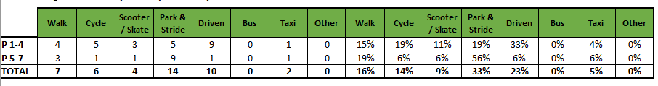

3.1 Family Questionnaire

14 families answered the school travel plan online questionnaire, and the results are detailed in the graphs and text below.

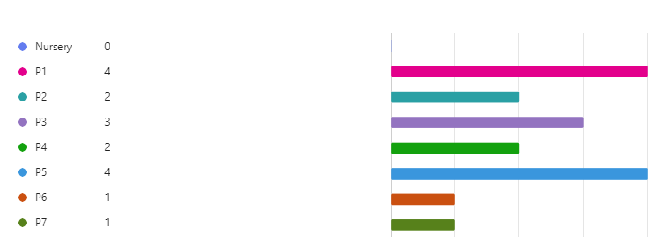
What school year is your child in?

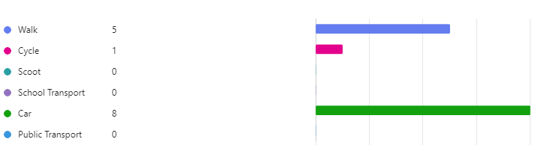
How do you normally travel to and from school?

Those parents who are already actively travelling to school were asked if they would like to volunteer to help the school set up a walking bus.
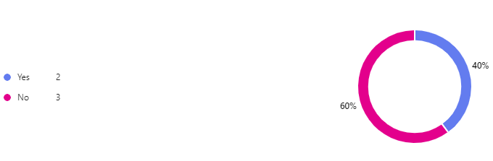
When asked what would improve your active journey to school?
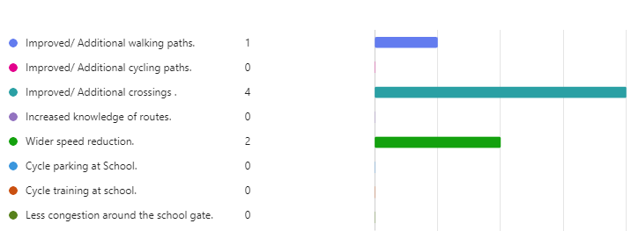
All parents who stated that they drive to school were asked if they would consider using a Park and Stride Site away from the school gate to help with congestion.



Those parents were then asked what could they do to help with safety concerns with regards to parking around the school gate?

- My children are active and get sufficient daily exercise. The only think that could ease congestion would possibly be to have alternative car parking in another location.
- I always park at the parking space opposite the school, and not find it too congested
- Lollipop person / traffic lights to improve road crossing safety. Clear and increased road markings for no parking on school days.
- My child exercises a lot throughout the week - between football training, golf, swimming and skiing, on top of bike rides I don’t have any requirements to increase his daily exercise.
- Daily mile
- As long as there are many children coming to the school from outside the village, and public transportation remains infrequent and unreliable, it is unfortunately inevitable that many children will need to travel by car. Perhaps there would be a way of encouraging car pools?
Further questions about active travel were asked and the results are as follows

- there is no safe crossing to school from the side of the road that the bus stop is on and where people park their cars in the village carpark. I drive my children to school as it's too far to walk or cycle & the buses are too infrequent. If we lived closer I would not let my children cycle to school as the there are not designated cycle paths, at best, just a line painted in the side of the road & that's not on all roads. I do not think it is safe for my children to cycle on the roads.
- Some cars travel exceedingly fast along the main road and it’s only a matter of time before a child gets hurt. The new reduced speed limit signs haven’t helped in the slightest, drivers are still going 30 or 40mph regularly, and even above this on odd occasions.
- to reduce driving we splitting daily drop offs and pick ups with other family
- When crossing from the square if someone has parked on the road opposite the school it can be tricky to see past the parked cars. It is quite common this happens.
- We cycle, but speed reduction through the village would be good
- It would be great to have a bit more space for bikes / improved bike parking. There isn't always enough room and the bike racks themselves are very narrow for some bike wheels, so bikes often topple over and cause an obstruction
- We are happy with either cycling or walking (with a parent). A walking bus would be lovely - I know some other parents have talked about the road crossing / having a volunteer lollipop person, which would be great too
If you have selected Improved/ Additional paths or crossings please indicate if there is a specific location where you feel either of these can be improved.

- Either around the center of the square or on the sidewalk right after the square.
- Desperately need a pelican or zebra crossing as close to school as possible. Or at the very least a lolly pop person.
- Crossing over the main road
- Crossing the main road is difficult as there's not good visibility in both directions, plus bus stops on both sides of the road and lots of cars entering and leaving the square

3.2 Staff Questionnaire

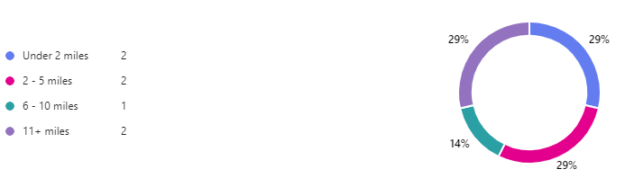
How far do you travel for work?
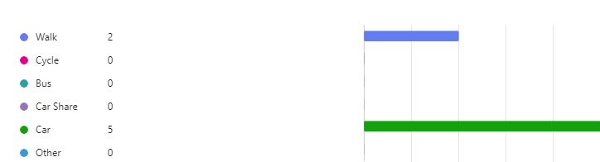
How do you travel to work?
Staff were also asked if they would like to consider car sharing?
No one responded to this question.

They were also asked if they would like to undertake Bikeability training to deliver cycling in school?
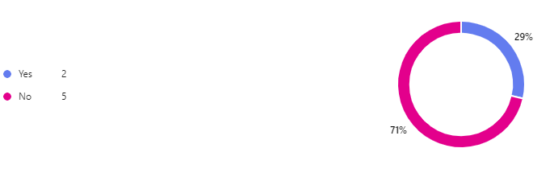
When asked what would encourage them to consider an alternative mode of transport to work, they replied.

- If there was a cycle track I would consider cycling, but the road is a bendy country road and cars travel fast so I'd be nervous cycling it-especially in the dark.
- The bus times do not coincide with my starting times at work.
- Have mobility issues so do not have alternative to car, unless I share
- I can't really go for alternative - HT of two schools and need so much flexibility. I do have a small car for this.
- bus
- Not practical

Finally, when asked are there any improvements or tell us anything else about your journey to school the following comments were made.

- The routes do not tend to be too congested on my journey and I can adjust where I park if that is too congested.
- Share lifts
- My journey is ok - currently lots of traffic improvements but can't be helped.
- Leaving before/after rush hour
- Disabled parking an option?
- The car park in the village is often full if something is on in the Church and I arrive later but that can't be helped. There are no designated bays so try to park as safely as possible.
- The journey adds on quite a bit to my working day which can be tiring at times.

4.0 MAPPING WORK AND ROUTE AUDIT

A mapping exercise was carried out with the school on Thursday 27th February to identify the routes pupils travelled. These were then analysed and categorised as active travel routes (green) with red routes highlighting those that drive and where they park.

A route audit of the streets surrounding the school was carried out by members of the FACT group with discussions centring around pupils’ thoughts about their journey to school. Those members of the group stated that although traffic speed seemed fast at times, they had no real issues actively travelling to school. However, from the information received from parents and those who live within the community speed and volume of traffic is an issue. At the time of undertaking the travel plan Fife Council’s Traffic Management team are working with the local Community Council to reduce the speed throughout the village and add in extra traffic calming measures and will monitor the routes and feed back to the travel plan team. The FACT group did pick up that the school keep clears outside the school gate where in need of a refresh.

It is advisable, at this stage, that the school continues to work with pupils on road safety and deliver campaigns set out in this travel plan to increase active travel to school.

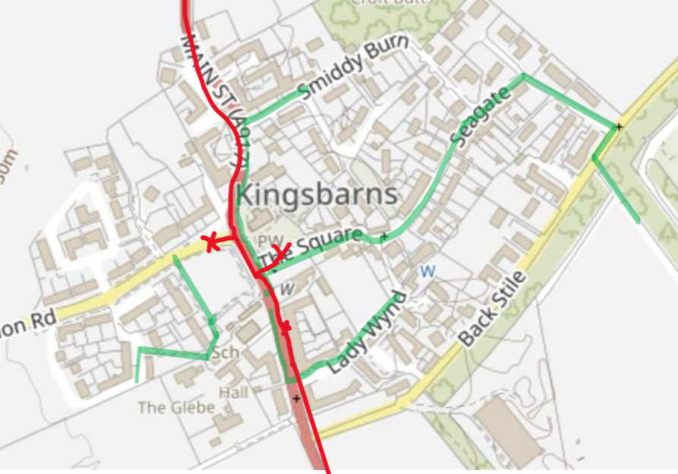

4.1 Access Arrangements

The school has two access routes into the school, one on Main Street and the other leads from the community park.
5.0 ACTION PLAN

Action | Solution | Action Owner
Promote School Travel Plan | - Upload plan to website and social media pages  - Create a FACT notice board or story board  - Create articles for school newsletters, social media, and assemblies,  - Keep the school travel plan team updated on all work carried out to include in the Fresh Air Frankie termly newsletter. | School
Travel Tracker | - Update the travel tracker when required | School
Local and National Campaigns | Term 1  - Hands up Survey Active Travel  - Cycling Competition  - Bike Week  - Interschool Active Travel Challenge  Term 2  - Launch #dontparkhere Campaign  - Parking Letter to Parents  - Road Safety Week  - Be Bright Be Seen Competition  Term 3  - Create an active travel leaflet for the new starts that can be included in the school induction pack.  Term 4  - Walk to School Week  - Scoot to School Week  - Active Travel Treasure Hunt  - Bike to School Week | School  School/Travel Plan Team
Reduce congestion | Consider developing the following:-  - Parking Pledge  - Park N Stride Site  - Walking Bus | School/Travel Plan Team
Bikeability | Deliver Bikeability | School/Bikeability Team
Awards | Work towards gaining the Fresh Air Frankie School Travel Plan and  Active Schools Award | School/Travel Plan Team
6.0 MONITORING & EVALUATION
The FACT will continue to meet periodically to monitor progress.
Specific progress will be monitored by participation in the “Hands Up Travel Tally” each year and a repeat of the full travel survey will take place in 2028. The school’s ongoing commitment to travel planning will be publicised in the school handbook, the school newsletters, the Parent’s notice board and through assemblies.

7.0 DISTRIBUTION OF SCHOOL TRAVEL PLAN
The following bodies will receive a copy of the School Travel Plan:
• Fife Council Roads and Transportation via the Travel Plan Team
• Fife Council Education Service
• Fife Council School Estates Team
• Parent Partnership
• Copies will also be made available to the parents from the School Office and via
the school information site.

