Kingsbarns Playground Charter

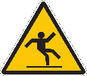
Because it can get wet and slippery, it is best to stay off the green foam area with wheeled toys and when running. You can still go on the area around it though.

Because the monkey bars can be dangerous when they are wet, we can dry them with a cloth and you can use them again.
This Photo by Unknown Author is licensed under CC BY-NC

Because there aren’t many places to sit, our class bubbles and the staff outdoors can all share the tables and benches to have a wee rest and a chat at.

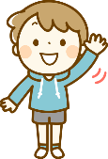
Because it could be distracting to passing drivers, we need to be sensible when waving at the passing traffic.

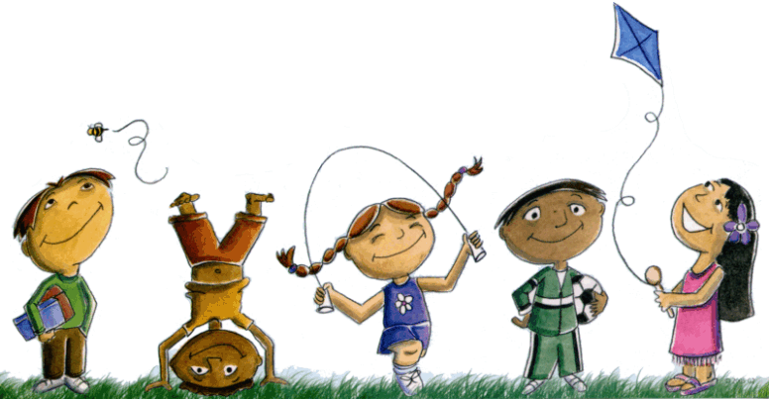
Because the back grass area has poor drainage, when it is soaking wet, we won’t be able to play on it. However, the village green has better drainage so unless the weather is terrible, staff will be able to decide if it is ok to play there.
This Photo by Unknown Author is licensed under CC BY-NC-ND

Because we need to keep to our classroom bubbles, we will try to create as big an area out on the green as possible so we can run around and burn off all our energy.
This Photo by Unknown Author is licensed under CC BY-NC-ND

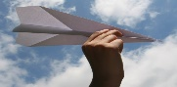
Because the adult supervising may need to get our attention, we still need to use our indoor voices at indoor playtime. We can do art and craft things, even make paper aeroplanes. We can’t fly them around the classroom though because there isn’t the space to run around. We can save them and our teachers will take us out to test them when the weather improves.
This Photo by Unknown Author is licensed under CC BY-NC-ND

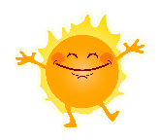
Because the weather in Scotland can change so quickly, we should wear our coats to go outside. If we get too warm, we can always take it off.

