DATE: | 17th February 2025 @ 7.30pm
ATTENDEES: | School: Alan Cumming; Scott Wilson; Kelly Syme; Katherine Turner;  Councillor: Cllr Julie McDougall; Cllr Kathleen Leslie;  Chair: Neil Bathgate;  P.C: Lesley Backhouse; Dee Chishti; Holly Walker; Laura McGowan; Lee-Anne Smith (secretary); Lisa Walters; Hazel MacKay; Erin Burke; Fran Simpson; Heather Lang; Jenny Bellfield; Rowan Young; Amy Gannon
APOLOGIES: | Janice O’Keefe, Roisin Connolly, Nichola Ritchie & Vicky Bathgage

PREVIOUS MEETING: 11th November 2024 @ 8pm
Agenda Items: 1. Welcome & Introductions
2. Update from the School
3. Previous Meetings Minutes
a. Calendar of Events: i. PC Fundraiser
ii. Volunteer Day
iii. Black Rock 5 Fun Run
iv. Sports Day
4. Treasurer Report
5. AOB

- Welcome and Introductions: Neil thanked Carol Wyse for all her hard work and PTC will arrange flowers to let her know that we are thinking of her. He introduced Alan Cummings who is working with the school during this period of change and introduced Scott Wilson who is the Interim Head Teacher (update: Now appointed as Head Teacher).
Alan thanked Scott for stepping in and Louise Gordon who has helped out since Carole left.
- Update from the School: Scott gave a brief background to his experience of 11 years working closely at closing the poverty gap. Scottish event still went ahead and went very well. Louise and Leanne Bain did extremely well and keeping continuity within the school.
The school will start to send out a weekly update to parents to let them know what is happening in the school the following week and what the highlights have been in the current week.
Ardroy Update: Dates have been given. September 2025 which may be a too soon, and March 2026 which will give parents longer to pay. School also has 2026/27 dates which are March 2027.
Linda asked about Transition to Balwearie for P7’s this year - Scott advised that there has been no information sent to any of cluster schools at that point in time.
- Previous Meetings Minutes: Calendar of Events – Parent council social event to replace the spring fare, all ideas welcome!
JUNE 3RD VOLUNTEER DAY – Dee has created the poster with the details. SW suggested that at previous schools the school has taken pictures of what needs to be done and that can form the basis of the volunteer day. Or people may be able to help out with that day also.
BLACK ROCK 5 FUN RUN – 9th May 7pm – A form is to be sent out to see who would like to take part. All participants are to meet in the community centre at 6.45pm. John and Margaret who run the race like them to stay there, and someone from the school to be present at the beginning and end of the race is nice for the children to see. Suggestions on how to celebrate welcome
SPORTS DAY – June 2025 - Tea, Coffee and Cake stand; with donations to PTC.
AULD HOUSE OPEN MIC – Funds will come to the nursery from the open mic night at the Auld House.
Hazel mentioned a fundraiser that the school used to do, so may worth reigniting – Teatowel self portrait.

Nativity fundraiser went well which raised £208.20 less deductions. Card machine made a difference in donations. Thanks to Nichola for organising.

Bikeability Training: Neil asked Scott W if there was anyone he knew that could assist who had been trained at another school. A list of volunteers is to be sent out.

Communication: It was felt that the new weekly update would greatly improve this.

Christmas Jumper day was a success well done Amy and Holly for organising.

Rights Respecting School – This has been moved to the new school year.

Funding Request for New nets has been purchased by PTC thanks to Jenny for organising this.

Movie Night: This will now need to be in the new school year, possibly November 2025.

ACTIONS FROM THE LAST MEETING:

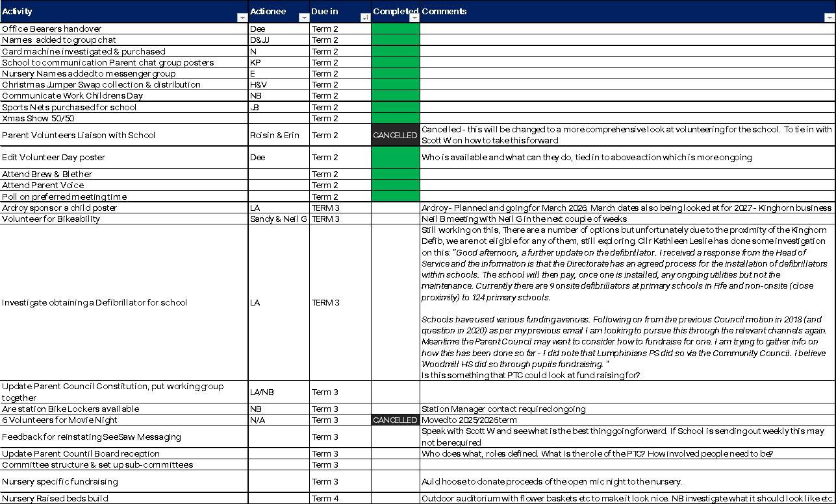

- Treasurer Report: Not Received.

- AOB:
Volunteering conversation was started on getting a list from the school (as suggested photos on what is required) and a list of people that could help. For instances where children are involved e.g., reading to a class, or helping out in school security clearance is required. If PTC could help with gathering a list of people who are cleared that could help with starting some clubs etc. Action to put together a form to send out to parents / grandparents etc to see what they can offer the school
Scott W to let PTC know what the school requires, PTC have monies available and it would be good to spend this. Scott advised that books of various text types are required, but would pull together a list.
Hazel suggested that parents would be interested in Scotts background in education and in his first weekly update that would be interesting to read. (UPDATE: This has been done)
Dee asked about the outcomes of the inspection and how improvements would implemented. Scott advised that an action plan would be created and that would inform the school improvement plan. There are some quick fixes, and some longer term issues. Laura asked if feedback would be provided as some of the feedback she found alarming. Alan C advised that feedback is provided through the normal quality reports as per legal requirements. However, if there are particular concerns that could be looked at.
Jenny asked if going forward key issues could be collated before the meeting so that they could be added to the agenda. Going forward this will be done.
Next Meeting: 28th April at 7.30pm at the school
If you are interested in raising a topic or joining a meeting, please contact Parent Council through this link:
https://docs.google.com/forms/d/e/1FAIpQLSdvhwrFAFk7Rr7VKhslZC12I4yr2pKVb96pOGoh1mrFkNBv_g/viewform

