Please use this space to note down any questions you may have, or information you would like to share with us.
The image used on this leaflet is
- Title: Neurodiversity Crowd
- Creator: MissLunaRose12
- Source: https://en.wikipedia.org/wiki/Neurodiversity#/media/File:Neurodiversity_Crowd_2.png
- License: CC BY-SA 4.0

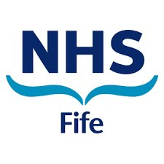
Fife Neurodevelopmental Pathway for Children and Young People

Information for parents and carers
This leaflet provides information about neurodevelopment and what to do if you think your child might be developing differently.
What is Neurodevelopment?
Neurodevelopment is about the way the brain develops and how it works in our everyday life. Everyone’s brain develops slightly differently – this is part of what makes us unique and gives each of us different strengths. Many children and young people, including those with neurodevelopmental differences, get the support they need from their family, school and community without the need for a specific diagnosis. In Fife, support is based on need, rather than diagnosis.

Children and young people may experience difficulties across different areas. These areas could include:
- Independence Skills
- Motor skills
- Social Communication Skills
- Play/Flexibility
- Sensory/Regulation
- Academic and Learning
- Attention, Memory, Organisation and Planning Skills
- Emotional Wellbeing / Mental Health
- Attachment and Relationships

Children often have differences in more than one area. These differences can be a normal part of development and growing up. However, if you feel that these differences are having a significant impact on your child, you may wish to seek further support.

What should I do if I have concerns about my child?
If you are concerned that your child is developing differently, in a way that is causing them significant difficulties, you may wish to discuss this with a professional and seek support:

- You can contact your child’s health visitor or school
- You can contact our Parent/Carer Neurodevelopmental Advice Line on 01592 226699 to discuss your concerns with experienced clinicians and explore what practical advice and support would make the biggest difference to you and you family. Our advice line is open on Tuesdays 10am-12noon and Wednesdays 2pm-4pm.
- Access relevant groups/courses and support materials (see below links):

How can we help you? - Access Therapies Fife NHS (scot.nhs.uk) | 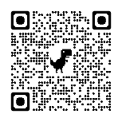
Neurodevelopment | GIRFEC (fife.scot) | 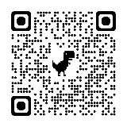
Mood Cafe | Welcome to Fife's Neurodevelopmental Hub | 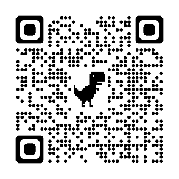

What happens next?
You and the team around your child may start gathering information about your child and think about supports and interventions which could help. This will take time, but will ensure that the right supports are in place for your child.
What happens after this?
The information gathered and the supports put in place may help you and your child. However, if the information gathered highlights that neurodevelopmental differences are having a significant impact, you and the team around your child may ask The Neurodevelopmental Team for more help. This is called a Request for Assistance (RfA). This will only be done with your consent and (if your child is over 12 years) with your child’s consent.
What is the Fife Neurodevelopmental Pathway?
The Fife Neurodevelopmental Pathway is a multi-agency pathway which can provide specialist assessment and support for children and young people who are developing differently.

Requests for Assistance (RfA) to the Pathway will be completed and submitted by professionals supporting your child. The RfA will contain information from a range of sources about your child’s strengths and difficulties at home and in school.

A team of professionals will look at the information contained within the RfA and agree appropriate next steps. This may include:
- Identified specialist support for child / family
- Identified specialist support for professionals
- Request for Assistance / involvement from other services
- Identification of a neurodevelopmental condition such as Autism, ADHD and/or a Learning Disability.
Once next steps have been identified, someone will be in touch to let you know.

You do not have to have a diagnosis to receive support. Support should be offered according to assessment of need. Previously your child or young person may have waited a long time on different waiting lists in order to access support. Our new pathway allows you access to the right support at the right time.

