Kinghorn Primary School
‘Sailing To Success’
September 2023
DATES DATES DATES!!  See our dates for this session on the reverse of this newsletter – keep in a safe place  Article 3 – Right to get support from all adults | School Uniform  Our Kinghorn School Uniform guidance is available for all. We have returned to wearing indoor shoes, let us know if we can support you in any way to achieve this.  Kinghorn Community Centre supported by our Parent Council holds a stock of ‘Pre-loved’ school uniform available to all – please pop in and ask for the key to the cupboard!  Please ensure that ALL clothes, bags, shoes (both!) and belongings are labelled with your child’s name – if we find an item with no name on and locate its owner we can label this for you. If you would rather we did not label this for you please let us know.  Please ensure your child comes to school prepared for whatever the day ahead can bring – a coat for inclement weather, suncream for our sunny days.  Kind, Include, Nurture, Generous, Honest, Open, Respect, Never give up
New School Website

Our new Kinghorn Primary School and Nursery website has been launched. Visit us at

https://blogs.glowscotland.org.uk/fi/kinghornprimaryschool/
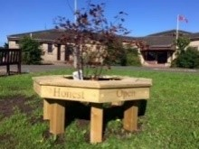
Article 13 – Right to find things out
Our classes use Seesaw as a way of sharing our learning – we are continuing to use Seesaw as our Learning Journals and for weekly Home Learning activities.
Teachers will send your child’s targets to you via Seesaw and ‘post’ photos of work, activities and class engagement on Seesaw for you to see and share at home throughout the terms.

The Seesaw messaging service has been removed to minimise messages not being seen or read – we welcome your feedback around this as we will review later in the session.
If your child is ill or will be absent please contact our school office.
Please also inform our school office if your contact details change.

Article 23 – Right to Education

School and Nursery Hours
School and Nursery start at 9am
Our Nursery have a flexi-start to each day from 9-9.30am
Nursery closes at 3pm – we open our Nursery door from 2.40pm to allow plenty of time for pick up and exit by 3pm. School finishes at 3.05pm
Health Promoting School/Nursery
Kinghorn Primary and Nursery is a health promoting school/nursery. We ask that you consider this when choosing playtime snacks with your child – one healthy snack/drink for morning break and perhaps another for lunchtime is more than adequate for our children – many pupil snacks are uneaten and binned by children as they have too much, we hope to reduce this waste.

Pupil Voice Groups 2023-2024  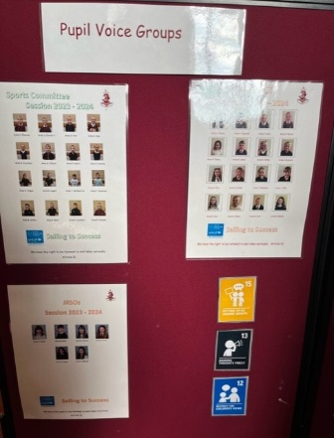  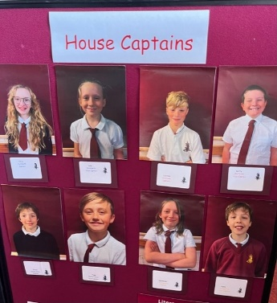  JRSO  Sport Committee  Respect | School Improvement  This session we continue to focus on improvement, our main priority is across Literacy.  Mrs Bauld is seeking volunteers to support reading in our classes this will be through playing phonic games, hearing reading, supporting word building etc. Mrs Bauld will provide full training – if you are interested please contact our school office.  If you are interested in joining a Parent Voice group around school improvements  please contact our school office.
Staffing 2023 – 2024
Nursery
Mrs Hamilton
Mrs Townsend
Ms Cathcart
Mrs Curran
Mrs Scott
Mrs Toddie-Moore
Mrs Henderson
Mrs Yuill
Miss McLeod
Mrs Walker (Nursery Teacher)
Support Staff
Mrs Balfour
Mrs Gray
Mrs Glachan
Mrs McCabe
Mrs Morris
Mrs Couser

P1T – Mrs Turner
P1/2S – Mrs McDonald and Mrs Gillespie
P2/3B – Miss Borthwick
P3/4S – Mrs Hay and Miss Gilmour
P4B – Miss Bell
P5M – Miss MacDonald
P6B – Mrs Brown
P7S – Miss Swanson
PE – Mrs Gilfillan
French/Spanish – Mrs Gillespie
Learning Support – Mrs Bauld
Admin – Mrs Connor
Clerical – Mrs Parry
Principal Teacher – Mrs Horne
Headteacher – Mrs Wyse
Please RESPECT our Kinghorn Community and do not smoke in or bring dogs into our school grounds.
Thank you .

Parent Council
Our Parent Council work tirelessly to support our school with fundraisers and being visible at school events such as our recent Race for Life which raised over £350!
Our next meeting is our AGM on Monday 20th November 2023 7pm and is a virtual TEAMS meeting – all welcome!

Our Parent Council are supporting us in seeking volunteers for our school – we are looking for help in a number of ways covering a range of skills.
Can you help with:-
- Running a healthy tuck shop
- Painting our school benches
- Delivering Bikeability
- Weeding around our school grounds
- Planting around our school grounds
- Numeracy activities with our pupils
- Reading/Literacy activities with our pupils
- Lunchtime Art/Craft activities in the playground

Contact Parent Council or school if you have some spare time and can offer your skills and help – thank you.
Dates for your diary – keep this safe!

Term 1 – 2023
19 September – Parents Evening 3.30-6pm
21 September – Parents Evening 5-7.30pm
4 October – Brew and Blether in playground from 8.40am
Shared Start – join us in class to learn through Play 9am-9.40am
6 October – Harvest Celebrations at Kinghorn Parish Church – 9.30am
P5 and P6 leading – donations for Food Bank sought
10 Oct – Pre-Loved Uniform event at Community Centre 9-12noon
Term 2 – 2023
9 November – Parent Council Movie Night in school hall (TBC)
10 November – INSET DAY – school closed to pupils
20 November – World Children’s Day (info to follow)
1 December – Busy End – join us in class for Xmas themed learning
7 December – Brew and Blether in playground from 8.40am
12 December – P1-P7 trip to Panto @ Adam Smith Theatre (£10 per child)
13 December – School Xmas Lunch
20 December – End of term celebrations at Kinghorn Parish Church 1.45pm
P3/4 and P4 leading
Term 3 – 2024
January – Scottish themed Month across school and Nursery
26 January – Scottish Ceilidh afternoon 1.30pm – all welcome (Tickets TBC)
29 January - Brew and Blether in playground from 8.40am
13 February – Busy End – join us in class for topic-based learning
14 February – INSET DAY – school closed to pupils
15 and 16 February – SCHOOL HOLIDAYS
13 March - Parents Evening 3.30-6pm
15 March - Brew and Blether in playground from 8.40am
17 March – Parent Council Spring Fayre (TBC)
21 March – Parents Evening 5-7.30pm
28 March - Spring Celebrations at Kinghorn Parish Church – 9.30am
P1, P1/2 and P2/3 leading
25 April – Brew and Blether in playground from 8.40am
Shared Start – join us in class to share our French themed morning
9am-9.40am
6 May – SCHOOL HOLIDAY
9 May – INSET DAY – school closed to pupils
22 May - Brew and Blether in playground from 8.40am
3 June – SCHOOL HOLIDAY
6 June – P1 to P7 Sports Afternoon – all welcome
12 and 13 June – P7 days at Balwearie
20 June – Reserve Sports afternoon
28 June – Leavers Celebrations at Kinghorn Parish Church – bring your tissues!

Recycling Centre
Do you have empty crisp bags, used pens and stamps?
Send them all to school with your child to add to our recycling centre, located near our Lost Property shelves.

Article 29 – Right to education that helps care for the world

Please see our separate Nursery Newsletter for all our Nursery news and the exciting learning happening with our 3 and 4 year-old pupils!
Copies available from our Nursery team too!

Many of our pupils bring their bikes or scooters to school – we encourage this but remind everyone that ALL bikes/scooters must be placed in our bike shed and locked for the day (please bring your lock).
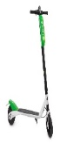
Please do not leave any bikes or scooters in school overnight, as we cannot guarantee their safety.
Pupils must walk with their bikes/scooters
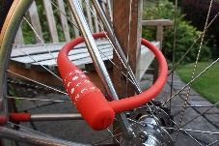
whilst in school grounds.

Breakfast Club
Breakfast Club is open 8.20-8.50am, 50p per person daily, no booking, simply come along.
All pupils from P1 – P7 welcome.
Breakfast Club will now exit/enter via the hall door round the back of the school.
Attendance at Breakfast Club is growing – which is super to see - we are seeking help – if you are a parent/grandparent/aunt/uncle etc and have time to support at our Breakfast Club – one day a week even more if you are able, please contact our school office – all offers are very much appreciated!

We continue to be a NUT FREE school due to pupil allergies.
We also are a CAR FREE playground!
Please repsect the safety of our pupils and do not bring your car into our playground at any time.
Our JRSOs remind us all that parking at the Community Centre and walking from there is best and safest for all!
Our JRSOs will be campaiging throughout this session to raise awareness of Road Safety and Safe Travel to School.
We will be reviewing our School Travel Plan – if you are willing to support us to achieve this please let us know through our school office.
Article 24 – Right to a clean and safe environment

