Kinghorn Primary School
Baliol Street
Kinghorn
Fife
KY3 9UD
Telephone: 001592 583429
Email: kinghorn.enquiries@fife.gov.uk

Headteacher: Carol Wyse
Principal Teacher: Kelly Syme

Kinghorn Primary School and Nursery
School Travel Plan

Issue 1 Jan 2022
Review Jan 2023

Article 19
Children have the Right ….to be and feel safe
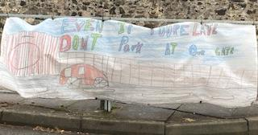
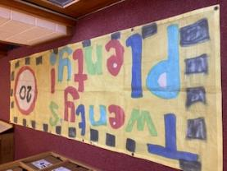

What is a School Travel Plan?

Definition:

“A Travel Plan is a document put together by a school, parents and pupils or group of schools which sets out a package of short, medium, and long-term measures to encourage more children, young people and staff to choose alternatives to the car when making the journey to school”.

It signifies an all-round commitment to develop safer routes to school, and as stated in the United Nations Convention for the Rights of the Child, Article 24 - Children have the right to the best health care possible and a clean and safe environment to live in.
All adults and children should have information about how to stay safe and healthy.

The need for travel plans has arisen due to growing concerns over:

- Increasing congestion associated with the ‘school run’.
- Pupil health concerns concerning inactive lifestyles.
- The need for pupil to gain “road sense” and independence.
- Road safety issues and concerns partly generated by school run related traffic.
- Air quality and climate change.

- Introduction

  - School Background

Welcome to the School Travel Plan for Kinghorn Primary School and Nursery. This plan sets out how our school aims to encourage staff, pupils and parents to travel more sustainably to and from school, in safety. The plan will give some background information on the school, consider the policies and objectives relevant to the School Travel Plan (STP), look at initiatives – both current and proposed – and use these to underpin a comprehensive action plan to deliver the objectives of the STP. The success of the STP will be monitored and evaluated fully to demonstrate progress, and, when required, allow future changes to the action plan and its targets.

Kinghorn Primary is housed in a modern building built in 1986. The Primary School is contained within one single storey building which accommodates P1-7 children within semi-open planned areas. There is a large hall, which doubles as a dining area. Currently the Nursery is housed in a hut within the school grounds for our 3- and 4-year-olds.

Within the school there are 38 members of staff including a Head Teacher, 1 Principal Teacher, 11 Class Teachers, 1 Support for Learning Teacher, 5 PSA’s, 8 EYO’s, 1 Office Administrator, 1 Clerical, Janitorial, Catering and Cleaning Staff. Each week the school welcomes a visiting violin teacher. Until recently the school also benefitted from parental/carer volunteers to support groups during their learning throughout the week we hope to be able to invite volunteers back into school once Scottish Government Guideline allows.

The school is situated within a built up, well established residential area of Kinghorn. Although the building is surrounded on one side by housing, it is fortunate to have a paved playground area, a wildlife garden and a large grassed area adjacent to Kinghorn Golf Club.

There are good footways and footpaths through the catchment area and the residential areas adjacent to the school are covered by a mandatory 20mph speed limit and have associated traffic calming features.

  - Access Arrangements

There are two gates offering access to the school, one to the front of our school and the other at the side of the school beside the staff car park entrance. The staff car park should not be used by pedestrians or parents and is strictly for staff with parking for disabled users by prior arrangement.

The gate offering access to the front of the school is located beside the School Crossing Patrol Officer maintaining safe crossing over the A921. This is used by parents, pupils and visitors to the school. The second gated entrance offers entry to parents, pupils and visitors from the East of the village.

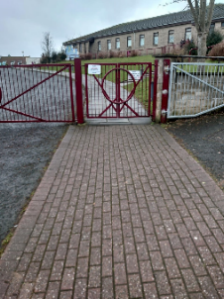
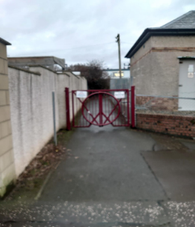

Front Entrance Side Entrance

Kinghorn Primary and Nursery also offer adequate cycle/scooter shelters situated within the playground.
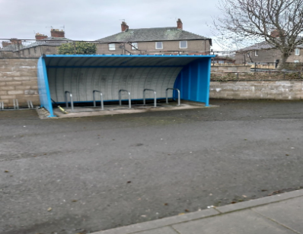
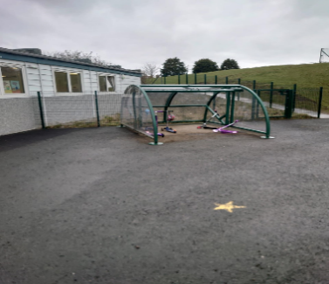

Nursery Shelter School Shelter
  - Policy and Objectives

We are producing a School Travel Plan to improve the health and safety of the children travelling to and from school. The reduction of pollution in the air surrounding the school is in line with Eco-School guidelines, and providing a safe environment which our children have the right to. (Article 24 UN Convention on the Rights of the Child)

  - Formation of the Travel Action Group (TAG)

The school set up a TAG to produce and maintain the School Travel Plan. The group includes staff, pupils and parent representatives. The group were involved in conducting a site audit and other activities including a whole school competition to make banners encouraging drivers to slow down and think carefully about where they are parking.

1.5 Aims and Objectives

At Kinghorn Primary School and Nursery our School Travel Plan aims to:

- Improve the safety of the pupils on their journey to and from school.
- Reduce the number of pupils travelling to school by car.
- Reduce congestion in Baliol Street and surrounding areas, especially at the beginning and end of the school day.
- To make staff, pupils and parents aware of the health advantages of actively travelling to school i.e. walking and cycling.
- Reduce pollution in the air surrounding the school.
- To ensure the STP continues to be successfully integrated into the ethos of Kinghorn Primary School and Nursery.

  - Data Analysis

The TAG issued questionnaires to parents, children and staff. Results were collated and are shown below in the form of a bar graph. It is evident from this that the most common methods of travelling to and from school each day are by car and walking.

Summary from Parents’ and Pupils’ Questionnaires
- Approximately 53% of pupils walked to school at least 3 days per week
- Most parents (86%) would be keen for their child(ren) to travel actively to school.
- Most parents and pupils (93%) would be happy to let their child take part in active travel initiatives e.g. Bikeability training.

From the 74 completed questionnaires 59 families lived within 1 mile of the school, 6 are within 2 miles and 2 children are more than 5 miles away from Kinghorn Primary School and Nursery. On average 10 of the children living 1 – 2 miles away from the school travel each day by car. A further 12 Children travel by car but they park away from the school grounds and walk the necessary distance.

Summary of Comments From Parents’ and Pupils’ Questionnaire

Below is a selection of comments from parents and pupils regarding issues that they feel have an impact on their journey to school.
- Inconsiderate and indiscriminate parking by parents near the school
- Too many cars speeding and too many roads to cross
- Restricted views due to overgrown shrubs
- No pavements on Barclay Road, however the road is shared by both pedestrians and drivers
- Traffic manoeuvring carelessly outside the school gates and high volumes of traffic during busy periods
- The need for SLOWER TRAFFIC – sometimes drivers do not stop for crossing patrol
- Lack of safe crossing points
- New housing requires designated safe crossing area to allow the pupils to cross the B923
- New housing also requires a safer route to school, with a paved area on which to walk

Possible Solutions
- Whole town car free
- Shrubs cut back regularly
- Better road/pavement markings to tell pedestrians/drivers that children are walking to school
- Designated crossing points
- More crossing patrols at busy roads/junctions
- Bright yellow no parking road markings around the school
- Community Police monitor parking and issue tickets for illegal parking
- Encourage drivers to adhere to speed limits
- Promote health benefits of walking to school
- Parents take ownership of beginning a walking bus to school
- Develop Bikeability training and promote benefits to all pupils
- Continue road safety education
- Parents should be encouraged through publicity etc. to park further away from the school entrance, alleviating congestion and encouraging children to walk to school.
- Park at the Community Centre

1.7 Data Analysis from Staff Questionnaires

Kinghorn Primary School and Nursery currently employ 38 full-time and part-time members of staff, from these 16 questionnaires were completed. The information given in the staff questionnaires was collated and is shown below in the form of a bar graph.

The bar graph highlights that the majority of staff travel by car daily. Looking at the distance travelled by staff, 12 live at least 6 miles or more away from Kinghorn and travelling by car is the most convenient way to travel. Those staff members who live 2 miles or less reported walking, cycling or car sharing as their way of travelling to and from school.

Mapping Work
The TAG team issued maps to the school to help children identify their routes to school, the group then decided on the most popular routes used. This was passed to Transportation Services to arrange our Route Audit.

Key Routes

- Macduff Crescent/Park Place/David 1st St/Canmore St
- Burntisland Road
- High Street
- Baliol Street/Strathmore Street
- Kilcruik Road/New Housing Estate

Findings & Recommendations

A site visit of the key routes was carried out on the afternoon of Thursday 3rd June 2021. The weather conditions were sunny and bright.

The following observations were made during the route audit: -

Macduff Crescent/Park Place/David 1st St/Canmore St
Issues
Road safety issues due to 3-way junction at point where pupils are advised to cross the road to gain access to the footpath on Macduff Cres before the start of the pedestrian barrier.

Proposed solution
Request Traffic Management to investigate the junction, looking at any engineering works that may improve the road safety of the site.

Comments
This is one of the major routes for pupils walking to school. There is also an issue with speed and lack of visibility of vehicles coming from Burntisland Road.

During a previous audit the mention of a traffic mirror was suggested as this may aid in visibility within this area.

Burntisland Road/High Street
Issues
Speed of traffic at both ends of the town. No crossing link to new multiuse path on Burntisland Road.

Proposed solution
Traffic Management to investigate the area for any possible engineering improvements.

Comments
The new multiuse path on Burntisland Road should be promoted as the main safer route to school, however, the lack of connectivity from the surrounding streets causes some road safety issues that need investigating by the technical team.

Baliol Street/Strathmore Street
Issues
Parked cars and lack of visibility.

Proposed solution.
Investigate the proposal of re-installing thermo plastics at appropriate points along the route.

Comments
Presently there are thermo plastic highlighting the safer route to school, unfortunately some of these are positioned in the wrong site.
New Housing Estate area and connecting paths to school.
Issues
Concerns with regards to speed of traffic on the B923 and road safety issues on Kilcruick Road.
No footpath on Barclay Road.

Proposed solution.
Request further investigation and site meeting with Traffic Management.

Key Issues and Barriers

Traffic Congestion and Barriers
- There is a recognised problem with the congestion caused by parents dropping off and picking up children from school site and manoeuvring dangerously out with the school gates.
- Parents parking illegally on the zigzag lines beside the School Crossing Patrol Officer.

Issues relating to walking to school were also identified:
- Speed of Traffic
- Lack of cycle training
- Lack of identified safe crossing beside new housing estate

Aim | Action | By Who | Target Date | Outcome
Increase Travel Awareness | Make Travel Plan available to all staff, pupils, parents and wider school community.  Develop a school travel noticeboard  Promote National Walk to School Week | School/TAG  School/TAG  School/TAG | Term  Term  Term | Less traffic outside school  Pupils and parents are more active in journey to school.

Safety on Journey | Highlight safer routes to school – Assemblies, STP noticeboard and TAG team representatives present at Parents’ evenings (when restrictions allow).  Road safety as part of the curriculum  Road safety reminders at assemblies  Ensure all new pupils receive travel information through the welcome pack.  Bright to be seen day TAG team assembly, competition to design a new piece of clothing. | School/TAG  All Staff  HT/PT/TAG/  Community Police  Office/HT/PT  School/TAG | Ongoing  Ongoing  Termly  Ongoing  Term 2 | Through sharing safer ways to school and pour travel plan we hope to help parents and pupils feel safer on the journey to school.  Children manage journey to school safely.  New pupils understand the safety issues.  TAG team highlight the importance of wearing bright reflective clothing during an assembly and hold bright to be seen day. Further to these children will be asked to design a new piece of clothing which would be suitable to wear in the darker nights

Road Safety Week |  | PT/School/JRSO | Term 2 | BRAKE - The theme of Road Safety Week 2021 is ROAD SAFETY HEROES, celebrating the heroic work of road safety professionals, and explaining how we can all play a part in making journeys safer for everyone.  Assembly and week-long activities organised by PT, staff and JRSO.
Traffic Congestion and Parking | Use child designed banners to encourage users to think about parking elsewhere.  No car zone day each week/month/term | School/TAG/Community Police  School/TAG/Community Police | Term 2 | Reduce school traffic entering Baliol Street.  A zero-tolerance car zone day in Baliol Street and the high street for drop off and pick up– publicise using school Facebook and encourage a park and walk approach to school.
Bikeability | Staff to undergo training | PT | Term 1 | Staff members have been fully trained on Bikeability 1 & 2

