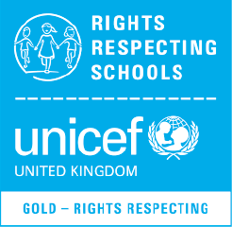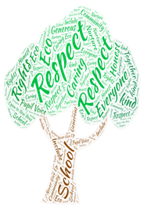

Newsletter June 2022

RESPECT

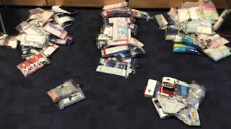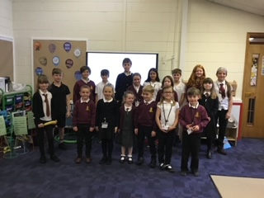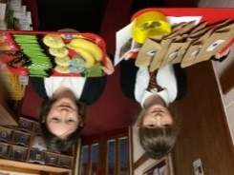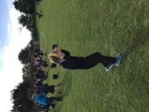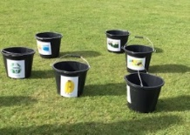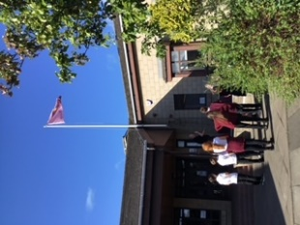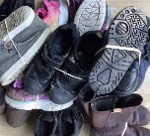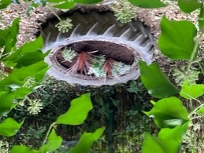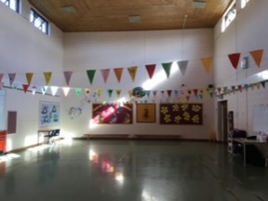  
  
  
  
  
  
  
  
  
  
  
  
  
  
  
  
  
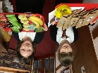  
  
  
  
  
  
  
  
  
  
  
  
  
  
  
  
  
  
  
  
  
  
  
  
  
  
  
  
  
  
  
  
  
  
  
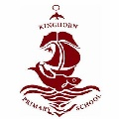  
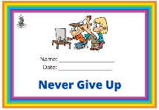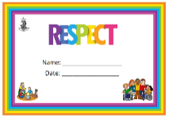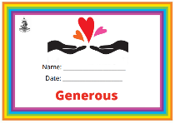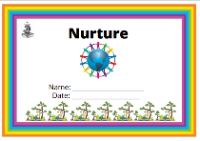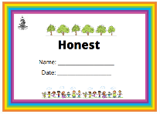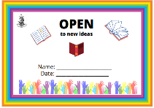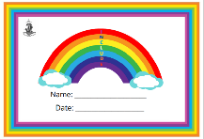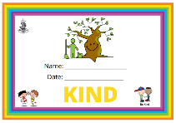

Building on our Global Citizenship we completed litter picks in term 4 in our school grounds. Analysing the rubbish, we found most of it could be recycled. We have made posters to promote our recycling centre and are providing monthly updates to monitor this further. We also feel another bin is needed for the field area and we’ll work on getting this for next session.



In September we focused on Sustainable Goal 1: No Poverty. We encouraged the whole school to donate underwear to the charity ‘Smalls for All’. This challenged us to think about dignity and children’s rights.

We collected over 600 pairs which were sent to children in need in Africa and the UK. This helped us understand our role as Global Citizens.

Smalls for All

*Sailing to Success*

Article 12 – Respect for Children’s Views

Our Group

Our group is made up of elected representatives from each class, giving respect for children’s views in all aspects of our school life (Article 12).

In August we focused on Sustainable Goal 4: Quality Education. The school and community donated used shoes and we collected 39 pairs. We donated these to UNICEF’s ShoeSHARE which helps children in the UK and around the world with education programmes to help ensure every child’s right to an education is realised (Article 28). It also diverts shoes away from landfill as we think about caring for our world.

ShoeSHARE

We celebrated achieving our Gold Rights Respecting School Award. RESPECT group pupils planned events. Everyone in school planted a bulb, got a special badge, took part in a sport event and we then raised our new school flag. Our flag reminds us of our values that impact everything we do.

Gold Award Celebration

We achieved our FairActive Award this year. We carried out an assembly, held a tuck shop and created a potted sport event based on Fairtrade. Pupils know that their views are taken seriously and accepted full responsibility for planning and achieving this award.

Fairtrade

Value Certificates

At Kinghorn Primary School we recognise children who are demonstrating their Kinghorn values. The RESPECT group shared ideas to update our Value Certificates and then we all took part in designing new certificates for the whole school to use.

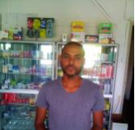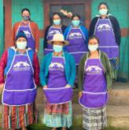

Poppies

Kiva

For Remembrance Day we decorated the playground with poppies made by the pupils from recycled bottles. This helped us think about Article 38 and children being protected in war.

We support individuals and groups around the world to access their rights and basic needs.

We have voted on who to loan money to and this year we have loaned money to:

* Jose in Mozambique for his pharmacy, supporting the right to healthcare (Article 24).
* Saba in Tanzania for refillable bottles, supporting the right to clean, safe drinking water (Article 24).
* A group in Guatemala for traditional clothing, supporting the right to their own culture and heritage (Article 30).

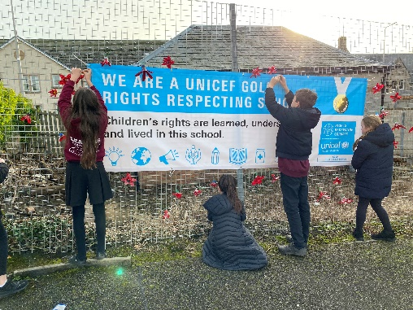

Sustainable Goal Home Learning

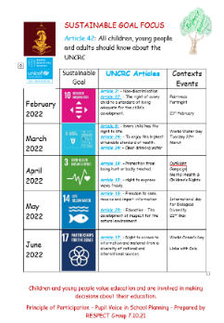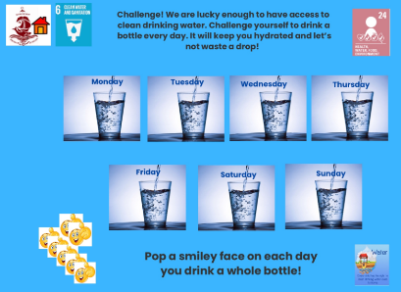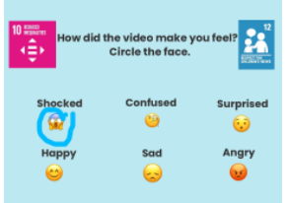

As a Gold Rights Respecting School pupils value education and are involved in making decisions about their education. We have planned the Sustainable Goal focus for the year. This gives us a vehicle to use for the work we do.

Sustainable Goal Planning

We created home learning for the whole school, based on Sustainable Goal 6 and Sustainable Goal 10. This allowed families at home to have conversations about the Sustainable Goals, linking them to our Rights. An impact of this was increased participation in home learning when designed by pupils.