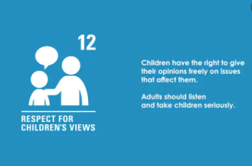
RESPECT Group

Meeting Minutes

Date: 12th May 2022

Present:

A1 – Jorga and Kyle
A3 – Olivia and Joseph
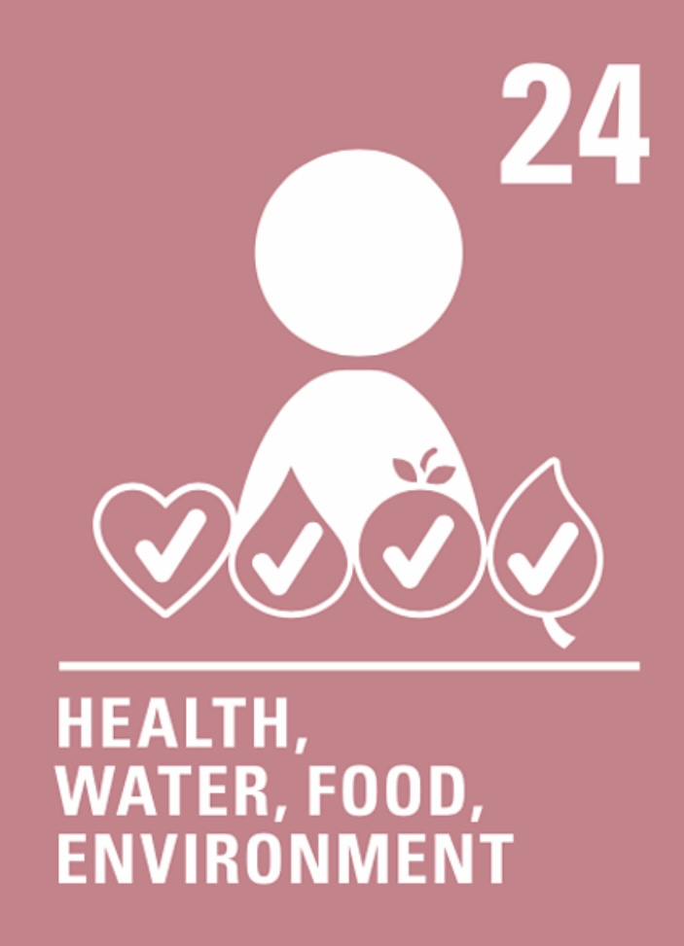
A4 – Kianna and Isabelle
A5 – Lachlan and Mirren
A6 – Lochlann and Jorgie
A7 – Rafe and Kirsten
A8 – Peter and Hannah
A9 - Ruby, Charlotte, Adam and Jack.
Mrs Turner and Miss Grundy

Our focus for this week was Article 24: Our Right to a Clean Environment.

We conducted our monthly audit of our recycling station.

This month we collected:
- 42 batteries to be recycled to prevent acids from getting into our soils and water.
- 148 pens which we took to Rymans in Kirkaclsdy to be recycled as part of the Terra Cycle scheme.
- 73 stamps to be sent to Purple Café to support children with Epilepsy.
- We continue to collect over 100 crisp packets each week which are recycled in partnership with the Co-op.

We would like to encourage everyone to use our recycling stations and have produced some posters to display around the school to encourage everyone to recycle more.

Pupils are requesting further development of our playground.

Top requests are for:
- Goals for the field.
- Sand for outdoor play.
- Grass sledging opportunities up the field near the large trees.
- More bins for the field.
Miss Grundy and Mrs Turner are going to seek funding to hopefully provide some of these play opportunities for next session.

It was noted:
Pupils are frustrated by the vandalism in the school grounds.
Picnic benches require cleaning as bird droppings make them unhygienic to use.
The play equipment up the field is requiring maintenance and some elements to replaced.

