**Kirkcaldy High School**

[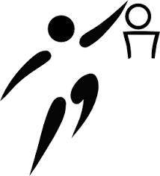](https://www.google.com/url?sa=i&source=images&cd=&cad=rja&uact=8&ved=2ahUKEwimqPzkn_jaAhXOZlAKHSFKCfkQjRx6BAgBEAU&url=https://u-cluj.ro/program-competitional-luna-martie-2/&psig=AOvVaw03ZX3dPb6dj_oZOim4ZTqw&ust=1525942117943724)[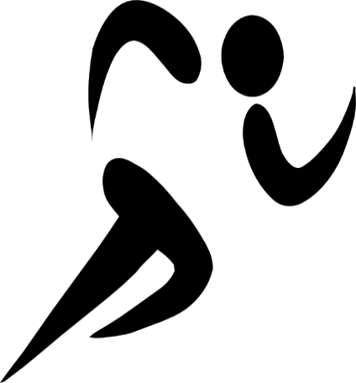](http://worldartsme.com/olympic-sports-clipart.html)

[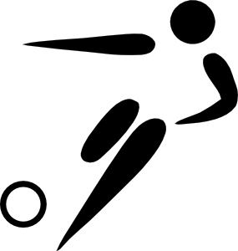](https://www.google.com/url?sa=i&source=images&cd=&cad=rja&uact=8&ved=2ahUKEwjw1LXcn_jaAhVNaFAKHRM-CAIQjRx6BAgBEAU&url=http://www.clker.com/clipart-29856.html&psig=AOvVaw03ZX3dPb6dj_oZOim4ZTqw&ust=1525942117943724)

**S3 Elective PE**

**Workbook**

**Name: ______________________  
  
Teacher: ____________________**

**S3 Elective PE Course**

You will cover 3 activities in S3;

* Hockey
* Gymnastics
* Badminton / Table Tennis

During these activities you will receive a mixture of both practical and theory lessons, where you will have the opportunity to develop both your practical skills and knowledge of the **FOUR FACTORS** which impact performance.

|  |  |  |  |
| --- | --- | --- | --- |
| **FACTORS IMPACTING PERFORMANCE** | | | |
| **PHYSICAL** | **MENTAL** | **EMOTIONAL** | **SOCIAL** |
| **SKILLS**  Skill Repertoire  Fluency  Accuracy  Timing  **FITNESS**  CRE  Power Flexibility  Speed  Strength  Agility  **TACTICS**  Game awareness | Concentration  Decision Making  Motivation | Fear & Anxiety  Anger/ Frustration | Communication  Team Dynamics  Roles & Responsibilities |

In each activity you will cover **at least two factors.**  
  
For example; in gymnastics you will focus on PHYSICAL FITNESS and the EMOTIONAL factor.

**Performance Profiling Wheel**

Performance profiling is a way for athletes to identify and understand areas which **require improvement** in **their performance.**  
This method allows athletes to first of all identify what **factors they feel are important within their sport,** rate how **effective a model performer** is within these factors and then rate their **current level of ability** in this area.

**Your performance in PE:**

CRE

Motivation

Decision Making

Team Dynamics

Skill Repertoire

Flexibility

Power

Game/tactical awareness

Fear & Anxiety

Concentration

Anger

Communication

**Model performer in PE:**

CRE

Motivation

Decision Making

Team Dynamics

Skill Repertoire

Flexibility

Power

Game/tactical awareness

Fear & Anxiety

Concentration

Anger

Communication

Motivation

**Hockey Badminton**

CRE

CRE

Fear &  
Anxiety

Decision   
Making

Power

Motivation

Skill   
Rep.

Concentration

Anger

Communication

Power

Team   
Dynamics

Fear &  
Anxiety

Skill   
Rep.

Flexibility

Game/  
tactical   
awareness

Decision   
Making

Motivation

Anger

Game/ tactical   
awareness

Concentration

**Gymnastics End of S3…**

CRE

Motivation

Decision   
Making

Team   
Dynamics

Skill   
Rep.

Flexibility

Power

Game/tactical

Awareness

Fear & Anxiety

Concentration

Anger

Communication

Motivation

Concentration

CRE

Skill Repertoire

Flexibility

Power

Anger

***HOCKEY***

**[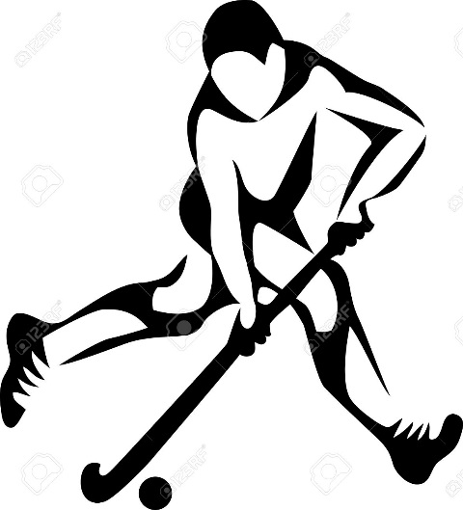](https://www.google.com/url?sa=i&source=images&cd=&cad=rja&uact=8&ved=2ahUKEwiD3_qnoPvaAhUCmbQKHa1CCuIQjRx6BAgBEAU&url=https://www.123rf.com/clipart-vector/field_hockey.html&psig=AOvVaw0jBGYUTNzAWvhKeixWwqrx&ust=1526045412906342)**

**Physical Tactics**

**&**

**Social Factor**

***Get to know your sport…***

* *There are 11 players on each team made up of a goalkeeper, defenders, midfielders and forwards.*
* *A match consists of 2x35 minutes halves.*
* *A centre pass is taken from the half way line at the start of the 1st and 2nd half or after a goal has been scored.*
* *Players can only score within the shooting circle.*
* *Players are not allowed to play the ball with the back of their stick (flat side only).*

**Factors Impacting on Performance**

**Physical Tactics**

**Sub Factor - Role Related Demands   
  
Definition:** Your role is the part you play in activity e.g. as a performer in hockey you might play a defender, midfielder or forward. You may also take on roles such as team captain. Demands are the qualities you require to fulfil that role effectively.   
  
**Positive Impact on performance:**   
In hockey a midfielder will be required to support both their defence and attack for the duration of the game. Therefore they must have a good level of CRE so they can effectively make runs into space or track back into defence quickly when the opposition mount an attack on goal.   
  
A team captain must also show good leadership qualities so they can effectively communicate, encourage and motivate their team mates.

**How can we collect data on Physical Tactics?**

**Video Analysis**An observer/coach/teacher records the whole hockey performance using a video camera, trying to capture all aspects of the game. The performer/team can then watch back the footage at a later date. During this time they can pause, rewind or watch the footage in slow motion to look at the effectiveness of their team’s tactics and formation. This may then allow the team to discuss/ plan for what they can work on in future.

[](https://www.google.com/url?sa=i&source=images&cd=&cad=rja&uact=8&ved=2ahUKEwjh8OH-qvvaAhXM_aQKHRsdCM8QjRx6BAgBEAU&url=http://www.freepngimg.com/png/30050-video-icon-clipart&psig=AOvVaw02_0Cq9-UKEBwJQEOiLvw9&ust=1526048213656235)

**Tactics Board – Team Formations & Penalty Corners**

**Team Formations**

[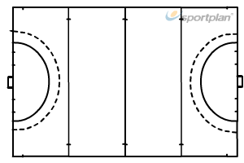](https://www.google.com/url?sa=i&source=images&cd=&cad=rja&uact=8&ved=2ahUKEwjg7s-8xf3aAhXOJVAKHRP2AmIQjRx6BAgBEAU&url=https://www.sportplan.net/drills/Hockey/Extras/Full-Hockey-Pitch-h802002.jsp&psig=AOvVaw0S--BrWoIz0HmDyP4uzjMe&ust=1526123931640013)**Formation: _________________________________  
Your position: _______________________________**

**What is your role within the game: _________________________________________________  
_________________________________________________  
_________________________________________________**

**Attacking Tactic:  
_________________________________________________  
_________________________________________________  
_________________________________________________**

[](https://www.google.com/url?sa=i&source=images&cd=&cad=rja&uact=8&ved=2ahUKEwjg7s-8xf3aAhXOJVAKHRP2AmIQjRx6BAgBEAU&url=https://www.sportplan.net/drills/Hockey/Extras/Full-Hockey-Pitch-h802002.jsp&psig=AOvVaw0S--BrWoIz0HmDyP4uzjMe&ust=1526123931640013)**Formation: _________________________________  
Your position: _______________________________**

**What is your role within the game: _________________________________________________  
_________________________________________________  
_________________________________________________**

**Attacking Tactic:  
_________________________________________________  
_________________________________________________  
_________________________________________________**

[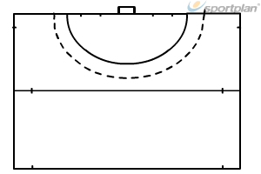](https://www.google.com/url?sa=i&source=images&cd=&cad=rja&uact=8&ved=2ahUKEwj_oabuxP3aAhVFU1AKHROxCDQQjRx6BAgBEAU&url=https://www.sportplan.net/drills/Hockey/Extras/Half-Hockey-Pitch-h802003.jsp&psig=AOvVaw0S--BrWoIz0HmDyP4uzjMe&ust=1526123931640013)**Penalty Corners**

Come up with your own tactics to use in the next game:



**Your role within the penalty corner:   
_________________________________________  
_________________________________________  
_________________________________________  
What qualities do you have to carry out this role  
 effectively: _______________________________  
_________________________________________  
_________________________________________**

**Factors Impacting on Performance**

**Social**

**Sub Factor – Team Dynamics/Relationships**

**Definition:** Team dynamics is the interaction of performers within a team or group. Team Dynamics is the effectiveness of the team and this can be highlighted in the relationships between players and how they support each other, regard and behave towards each other.

**Negative Impact on performance:** Poor team Dynamics and Relationships in a game will mean that players will not get on, will fall out and will not work for each other. If someone makes a mistake, others will be cruel and make horrible comments, instead of helping and supporting. This will lead to players feeling bad about themselves, feeling that they are not good enough and feeling nervous. This can then lead to further mistakes. When this happens this allows the opponents to dominate by gaining possession and scoring. In training the team won’t be motivated to work, this will mean that the practices will fall down as teammates will not give full effort. Which will hinder the progress and improvements of the team. This will cause players to get frustrated and arguments will occur. This will lead into games causing a divide and a lack of cohesion.  **Sub Factor – Communication**



**Definition:** Communication is the ability to convey information to team mates/coach through the use of speech, signals or actions.

**Positive impact on performance:** Good communication **before** the performance, allows players to discuss tactics/strategies and to finalise roles/positions and starting formations. This means that the team will be organised, alert and players are fully aware of what they are trying to do during the performance. If communication is good and positive, this will motivate the team and create a positive atmosphere, which will allow the team to feel that they can rely on and trust each other to give their best effort in the performance.

Good communication **during** the performance, allows the team to convey instructions, call set plays, and give advice to encourage and support each other. For example, a player starting an attack will then be aware of his/her passing options, which will help to guide team mates to correct positons on the pitch. In defence, players will be able to keep their formation/shape and guide team mates to mark/deny space. This allows the team to have a sustained positive team dynamic, enabling them to play as a strong cohesive unit for the entire performance.

**How can we collect data on Team Dynamics/Relationships?**

**Team dynamics Scale**

18 statements allowing a wide range of data to be collected on the team’s dynamics and relationships between players.

The following statements ask about your feelings toward your team and the dynamic within your team. **1st analysis:** Please circle a number 1 to 9 to show how much you agree with each statement. **2nd analysis** - circle the number with a different coloured pen.

Discuss the answers with your team- 1 = strongly disagree, 9 = strongly agree

|  |  |  |  |  |  |  |  |  |  |
| --- | --- | --- | --- | --- | --- | --- | --- | --- | --- |
| 1. We all share the same commitment to improve our team’s performance | | | | | | | | | |
| 1 | 2 | 3 | 4 | 5 | 6 | 7 | 8 | 9 |
| 2. We all agree on what our team need to work on to improve | | | | | | | | | |
| 1 | 2 | 3 | 4 | 5 | 6 | 7 | 8 | 9 |
| 3. I like the way we work together as a team | | | | | | | | | |
| 1 | 2 | 3 | 4 | 5 | 6 | 7 | 8 | 9 |
| 4. We watch the best players in our team and learn from them | | | | | | | | | |
| 1 | 2 | 3 | 4 | 5 | 6 | 7 | 8 | 9 |
| 5. We encourage each other before and during games to do our best | | | | | | | | | |
| 1 | 2 | 3 | 4 | 5 | 6 | 7 | 8 | 9 |
| 6. We are happy to accept feedback from each other to help us improve our team’s performance | | | | | | | | | |
| 1 | 2 | 3 | 4 | 5 | 6 | 7 | 8 | 9 |
| 7. We don’t blame each other when things go wrong in our game | | | | | | | | | |
| 1 | 2 | 3 | 4 | 5 | 6 | 7 | 8 | 9 |
| 8. We discuss as a team how we can improve | | | | | | | | | |
| 1 | 2 | 3 | 4 | 5 | 6 | 7 | 8 | 9 |
| 9. Our players will work even harder if we are losing and/or playing badly | | | | | | | | | |
| 1 | 2 | 3 | 4 | 5 | 6 | 7 | 8 | 9 |
| 10.I value all my team mates efforts | | | | | | | | | |
| 1 | 2 | 3 | 4 | 5 | 6 | 7 | 8 | 9 |
| 11. We avoid giving negative comments to each other on or off the court | | | | | | | | | |
| 1 | 2 | 3 | 4 | 5 | 6 | 7 | 8 | 9 |
| 12. I know my team-mates will work hard to support and cover for me during games. | | | | | | | | | |
| 1 | 2 | 3 | 4 | 5 | 6 | 7 | 8 | 9 |
| 13. I am listened to and I feel as though my opinion is valued during team discussions | | | | | | | | | |
| 1 | 2 | 3 | 4 | 5 | 6 | 7 | 8 | 9 |
| 14. My team mates work hard in practice to improve | | | | | | | | | |
| 1 | 2 | 3 | 4 | 5 | 6 | 7 | 8 | 9 |
| 15. I feel as though I am a valued team member | | | | | | | | | |
| 1 | 2 | 3 | 4 | 5 | 6 | 7 | 8 | 9 |
| 16. We have confidence in each other when playing | | | | | | | | | |
| 1 | 2 | 3 | 4 | 5 | 6 | 7 | 8 | 9 |
| 17. Our team are respectful to each other, our opponents and the officials. We avoid giving negative comments to each other. | | | | | | | | | |
| 1 | 2 | 3 | 4 | 5 | 6 | 7 | 8 | 9 |
| 18. Our team have a positive team dynamic | | | | | | | | | |
| 1 | 2 | 3 | 4 | 5 | 6 | 7 | 8 | 9 |

Add the total number of points for each question and divide the score by 18 to get an average point’s score

Team Dynamics Scale NORMS

|  |  |  |
| --- | --- | --- |
| 1-3 | Poor | An **average** score of 3 or below indicates that the team dynamic is dysfunctional and as a team to struggle to support one another in each of your roles. |
| 4-6 | Average | An **average** score of between 4 and 6 shows that the team dynamic functions relatively well however, it may breakdown under pressure and affect the group’s ability to works as a team. |
| 7-9 | Good | An a**verage** score of 7 or above shows that the team dynamic is strong and even under pressure the group can work as a team to make decisions and cope with pressure. |

Team Average score: _______________________________

**Approaches to Develop Team Dynamic & Relationships**

**TEAM BUILDING and TRUST GAMES**

Team building and trust games help to build a positive team dynamic and trust within a group or between individuals within a group. They rely on the whole team to be fully involved. Cooperation and support are required when participating in the activities.

These games are physical in nature and the movement and outcomes required will help to ease tension and enhance group development. They can also help to identify team leaders.

**Bench Line-ups**

Task: Team members stand randomly on end to end benches and they must rearrange themselves into a specific order E.g.: Height / Alphabetical (first and/or second) /Age.

Rules: You cannot step off the bench or a life is lost. Set a time limit.

Please draw an example and write a description of what you did.

|  |
| --- |
|  |

Name some other Trust activities and Team Building Exercises that you have completed in class.

________________ _________________ ________________ ________________

|  |
| --- |
|  |

Pick one from above. Draw an example and write a description of what you did. **Homework Tasks**

**Task 1:** Find out as many rules as you can about hockey.

1. What equipment is needed for hockey? ______________________________________________________________________________________________________________________________________________________________________________

2. Where does hockey take place? ___________________________________________________________

3. How many players are there in a hockey team? ______________________________________________

4. What are the different positions in hockey and what happens when a goal is scored?   
______________________________________________________________________________________________________________________________________________________________________________  
_______________________________________________________________________________________

5. Describe two different types of fouls.

______________________________________________________________________________________________________________________________________________________________________________  
_______________________________________________________________________________________

6. What happens if a foul is committed?

_________________________________________________________________________________________________________________________________________________________________________________________________________________________________

**Task 2:**

Watch the following YouTube clip on the QR code –

**Question**: How did cooperation impact positively on the hockey performance?   
_____________________________________________________________________________________________________________________________________________________________________________________________________________________________________________________________________________________________________________________________________________________________________________________________________________________________________________________________________________________________________________________________________________

______________________________________________________________________________________________________________________________________________________

**Task 3:**

Name a **method** you have used to collect data in **hockey:** __________________________

**Describe** how you used this method to collect data:  
___________________________________________________________________________________________________________________________________________________________________________________________________________________________________________________________________________________________________________________________________________________________________________________________________________________________________________________________________________________________________________________________________________________________________________________________________________________________________________________________________________________________________

**Analyse** the data you gathered and discuss your **strengths** and **areas for development**?

_____________________________________________________________________________________________________________________________________________________________________________________________________________________________________________________________________________________________________________________________________________________________________________________________________________________________________________________________________________________________________________________________________________

***GYMNASTICS***

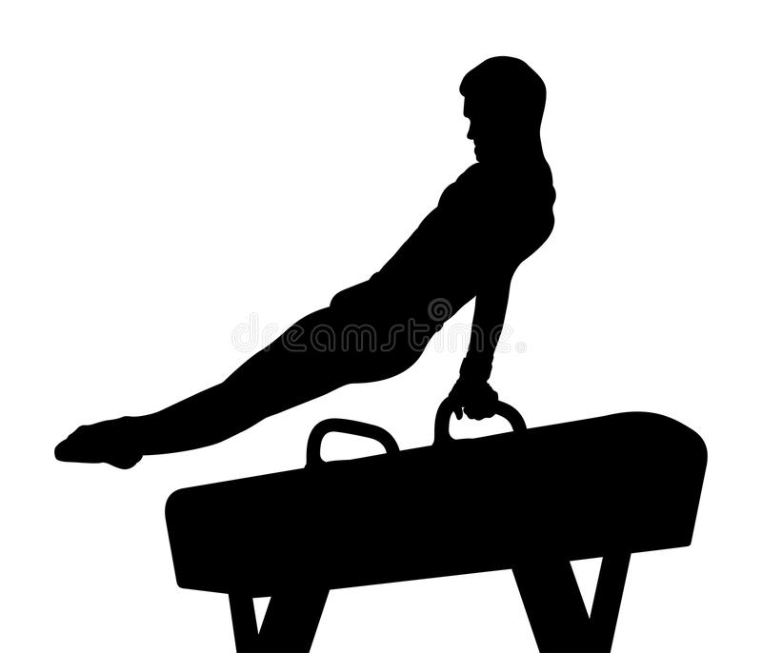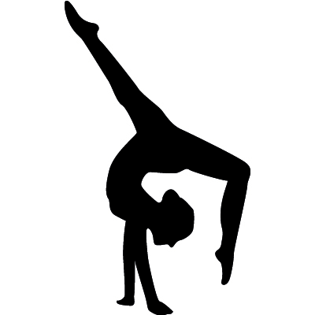 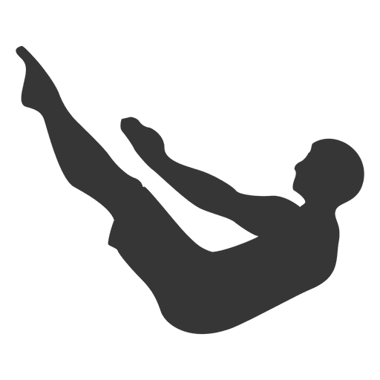

**Physical Fitness**

**&**

**Emotional Factor**

***Get to know your sport…***

* *There are 4 disciplines – Artistic, Trampoline, Tumbling & Acrobatic.*
* *Men’s Artistic consists of 6 events – Floor, Pommel Horse, Rings, Vault, Parallel Bars & High Bar.*
* *Women’s Artistic consists of 4 events – Vault, Floor, Bars and Beam.*
* *All gymnasts must - wear appropriate clothing, NO jewellery & watches, Long hair tied back, bare feet or gymnastics slippers, glasses can be worn but contact lenses or glasses with flexible frames are recommended, chewing gum is NOT allowed.*
* *Judges give a D-score & an E-score (difficulty & execution) the two scores then get combined.*
* *Judges score looking at – difficulty value, composition requirements & connection value (D-score) and execution & artistry of the routine (E-score). Both scores are added together to give the final mark.*
* *Vault is the only exception – each gymnast is assigned a specific points value for their D-score. Every gymnast performing the same vault receives the same number of points. The E-score is the most important on this apparatus. Judges on this panel work from a 10.0 base mark and deduct for form, technique, execution and landing. The D-score and E-score are added together for the gymnast's final mark.*

**Factors Impacting on Performance**

**Physical Fitness**

**Sub Factor - Power****Definition:** Power is the ability to exert a maximal force in as short a time as possible, as in accelerating, jumping or throwing. Power is a combination of speed and strength. Therefore, by increasing the speed of the action the greater the force exerted.   
  
**Positive Impact on performance:**   
In gymnastics power is crucial when performing skills such as handsprings, somersaults and vaults. For example, when performing a straddle vault over the box, a performer needs good power in their legs for both the run up and jump onto the trampet. This will allow them to jump higher and further which will give the performer more time in the air to get into the require position to perform the correct vault technique. This will also help to ensure the performer clears the box and lands safely with balance and control.

**Sub Factor - Flexibility**

**Definition:** Flexibility is the range of motion in a joint or group of joints or the ability to move joints effectively through a complete range of motion.

**Negative Impact on performance:**

Flexibility is important in gymnastics because without the right range of motion, gymnasts will be unable to learn how to do certain skills and will find it difficult to hold certain balances with control for a period of time. For example, when performing their floor sequence, a performer might lack flexibility in their shoulders and back which prevents them from performing a bridge correctly. This could result in the performer being awarded a lower score by the judge.

**What Approaches Can We Use to Develop Physical Fitness?**

**Sub-Factor – Power**

**Approach:** Plyometric Training

Plyometric training involves sport-specific training to enhance power and performance. Exercises focus on muscles exerting maximum force in short intervals of time, with the goal of increasing power (speed & strength). This training focuses on learning to move from a muscle extension to a contraction in an explosive manner, e.g. repeated jumping. Plyometrics includes explosive powerful training exercises that are trained to activate the quick response and elastic properties of the major muscles in the body. Sports using plyometrics include basketball, gymnastics, tennis, badminton, netball and volleyball.

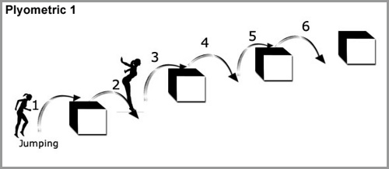

**Example Plyometric Training – Legs**

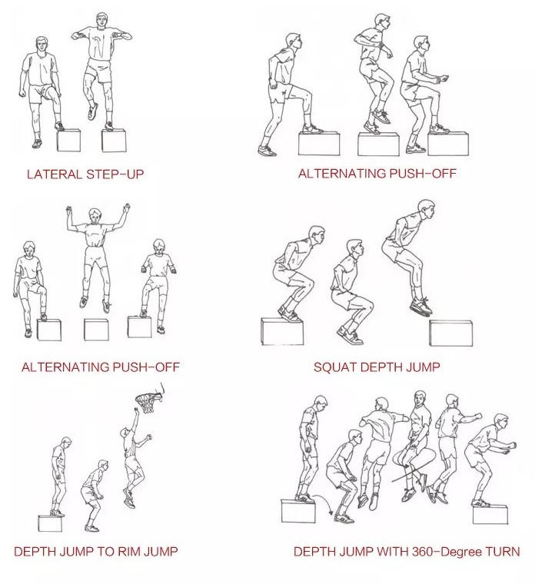

In the box below please draw an example of a Plyometric Circuit you have completed in class. Label each station and the muscle group it focuses on.

|  |
| --- |
|  |

**Sub-Factor – Flexibility**

**Approach:** Stretching (Static, Dynamic, AIS (Active Isolated Stretching) and PNF (Proprioceptive Neuromuscular Facilitation)

Flexibility training includes stretching exercises to lengthen the muscles and may include activities like yoga or Tai Chi. Improving your flexibility can help you move more comfortably throughout the day Sports using stretching to improve flexibility include gymnastics, dance, tennis, badminton, karate and kick-boxing.

Examples of Stretch Exercises

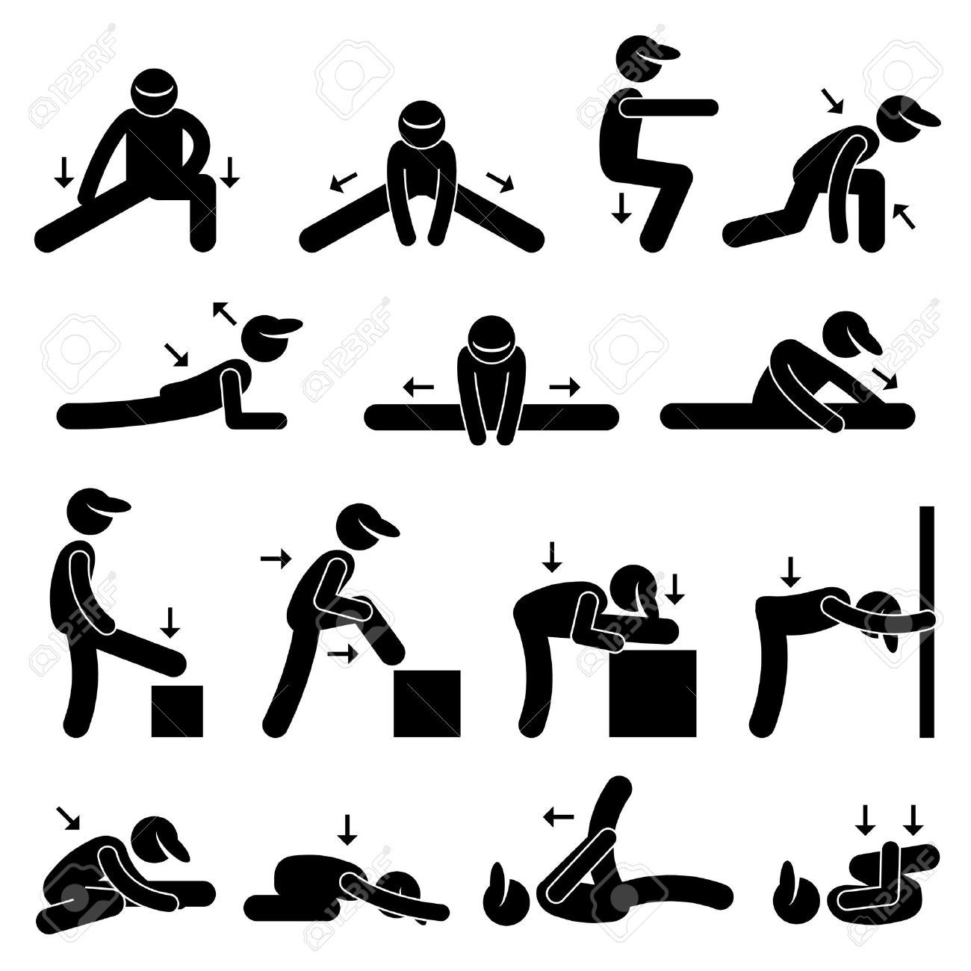

In the box below - Explain why it is important to stretch as part of your warm-up in Gymnastics. Draw and label an example of some stretches you have completed in class.

|  |
| --- |
|  |

**Factors Impacting on Performance**

**Emotional**

**Sub Factor – Anxiety & Fear**

**Definition:** Anxiety is an unpleasant state of inner turmoil, often accompanied by nervous behavior, restlessness, fatigue, concentration problems and muscular tension.

Fear is an emotion induced by a perceived threat, which causes you to quickly pull away or, in sporting terms, usually hide.

**  
Negative Impact on performance:**

In gymnastics you may become anxious and fearful about performing your gymnastics sequence in front of others or learning a more complicated skill.

For example, when learning a handspring over the box, you may fear that you are going to hurt yourself as you rotate over the box. This could cause your muscles to tighten up and as your approach the box you may not fully commit to the run up or take off, meaning you can’t get into the correct position to perform the skill. This fear may also cause you to stop mid run up and not attempt the skill at all.

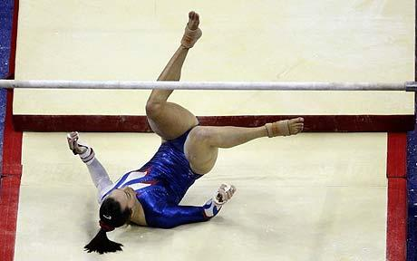

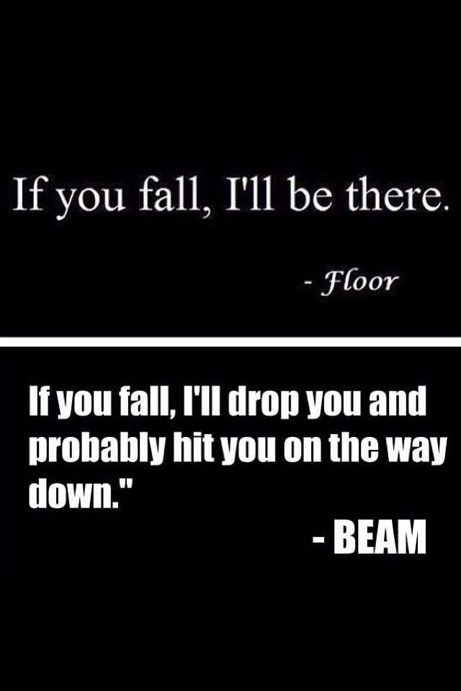

**How Can We Collect Data on Anxiety?**

Sport Competition Anxiety Test (SCAT)

Read each statement below, decide if you "Rarely", "Sometimes" or "Often" feel this way when competing in your sport, tick the appropriate box to indicate your response.

Rarely Sometimes Often

1. Competing against others is socially enjoyable

1. Before I compete, I feel uneasy

1. Before I compete, I worry about not performing well

1. I am a good sportsman when I compete

1. When I compete, I worry about making mistakes

1. Before I compete, I am calm

1. Setting a goal is important when competing

1. Before I compete, I get a queasy feeling in my stomach

1. Just before competing, I notice my heart beats faster than usual

1. I like to compete in games that demands a lot of physical energy

1. Before I compete, I feel relaxed

1. Before I compete, I am nervous

1. Team sports are more exciting than individual sports

1. I get nervous wanting to start the game

1. Before I compete I usually get uptight

|  |
| --- |
|  |

SCAT Test Score

A score of less than 17 means you have a LOW level of anxiety

A score between 17 to 24 means you have an AVERAGE level of anxiety

A score of more than 24 means you have a HIGH level of anxiety

**Approaches to Develop Anxiety & Fear**

**PRE-PERFORMANCE ROUTINE – Controlled Breathing**

Before your gymnastics performance you may visualise the routine in your head, picturing each stage of the routine, then signal (present) to show your ready to begin your performance, then take three deep breaths. Pre- performance routine is carried out for training sessions as well as performance. This allows your routine to become part of your performance and not just something you do sometimes.

Using Controlled Breathing will help to lower your heart rate and give you a moment to calm yourself down to get rid of any anxiety/fear.

One of the easiest ways to achieve a relaxed state of mind is to maintain a good flow of oxygen throughout your body to regulate your heartbeat. This can be achieved by working on your breathing technique.

**CONTROLLED BREATHING TECHNIQUE**

Many people tend to breathe faster than normal when they are anxious. Sometimes this can make you feel a little dizzy, which makes you more anxious. If you practice and learn the art of deep breathing when you are relaxed, you should be able to use this technique when you feel tense or anxious to help you to relax.

In the box below - Please write a description of what you do when using controlled breathing.

|  |
| --- |
|  |

**Homework Tasks**

**Task 1:** Find out as much information as you can about gymnastics.

1. What equipment is needed for gymnastics? ______________________________________________________________________________________________________________________________________________________________________________

2. Where does gymnastics take place? ______________________________________________________

3. How many performers are there in a gymnastics? ______________________________________________________________________________________

4. Name 5 different skills in gymnastics  
______________________________________________________________________________________________________________________________________________________________________________

4. What is the scoring system in gymnastics and what are the different artistic events for men and woman?  
______________________________________________________________________________________________________________________________________________________________________________  
_______________________________________________________________________________________

5. Describe 2 safety rules in gymnastics.

______________________________________________________________________________________________________________________________________________________________________________  
_______________________________________________________________________________________

**Task 2:**

Watch the following YouTube clip on the QR code –

**Question**: how did anxiety/fear impact negatively on the gymnastics performance?   
_____________________________________________________________________________________________________________________________________________________________________________________________________________________________________________________________________________________________________________________________________________________________________________________________________________________________________________________________________________________________________________________________________________

_____________________________________________________________________________________________________________________________________________________

**Task 3:**

Name a **method** you have used to collect data in **gymnastics:** _______________________

**Describe** how you used this method to collect data:  
___________________________________________________________________________________________________________________________________________________________________________________________________________________________________________________________________________________________________________________________________________________________________________________________________________________________________________________________________________________________________________________________________________________________________________________________________________________________________________________________________________________________________

**Analyse** the data you gathered and discuss your **strengths** and **areas for development**?

_____________________________________________________________________________________________________________________________________________________________________________________________________________________________________________________________________________________________________________________________________________________________________________________________________________________________________________________________________________________________________________________________________________

Badminton

[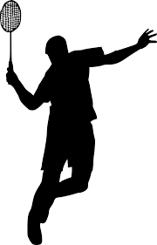](https://www.google.com/url?sa=i&source=images&cd=&cad=rja&uact=8&ved=2ahUKEwjtgbHU3KrbAhWLaxQKHeysDcAQjRx6BAgBEAQ&url=http://www.onlygfx.com/8-badminton-silhouette-png-transparent/&psig=AOvVaw1rMS1YYstli8nDDdcj-rKE&ust=1527676501878265)

**Physical Skills & Mental**

**Factor**

***Get to know your sport…***

* *A badminton match is played in a ‘best of 3’ games format, with each game being played up to 21 points. If the score is tied at 20-20, the game must be won by ‘2 clear points’. For example, you cannot win 21-20. If the game reaches 29-29, whoever wins the next point is the winner.*
* *If you win a point, you continue to serve until you lose a point.*
* *When the server’s score is an even number, they serve from the right service court. When their score is an odd number, they serve from the left service court. For this reason, the right service court is also known as the* even *service court, and the left service court is known as the* odd *service court.*
* *The receiver’s position is determined not by his own score, but by the server’s score. The receiver always stands in the service box diagonally opposite from the server.*
* *The outermost lines form the doubles court. So in a doubles rally, the shuttle is allowed to land anywhere on the court.*
* *The singles court is slightly narrower than the doubles court. The singles side lines are not the outermost lines, but the next ones in. Taken together with the outermost (doubles) side lines, these make narrow alley shapes along the sides of the court. These alleys are often called the* tramlines*.*

**Factors Impacting on Performance**

**Mental**

**Sub-Factor – Motivation**

**Definition:** Motivation, simply defined, is the ability to initiate and persist at a task.

**Positive Impact on Performance:** A goalkeeper in football may make a mistake and cost their team a goal. This players good level of motivation allowed them to continue on to the best of their ability, try make up for their mistake and to make crucial saves which resulted in their team winning.

**Sub-Factor** – **Concentration**

**Definition**: Concentration is the ability to stay fully focused on a task for the full period of time that task is happening. This may be following a tactic, marking a player or carrying out a skill repeatedly.

**Negative Impact on Performance:** A tennis player with low levels of concentration will start to react and move with much less efficiency to shots. This will reduce the chances of a successful return. This will in turn cause frustration, further mistakes and missed points.

**Sub-Factor** – **Decision Making**

**Definition:** Decision-making is when the performer makes a voluntary choice from a set of alternatives. This decision will usually lead to a movement, action, tactical change or selected skill.

**Positive Impact on Performance:** A 1500m runner nearing the final lap is assessing the form of the other athletes, judging how well their own body is coping with the race and the fitness strengths of the competitors in previous races.

The runner decides to push the pace to high intensity from the bell and ensure the stronger sprinters cannot use that strength in this race. This gives the runner a better chance of winning.

**The Sport Motivation Scale**

Using the scale below, please indicate to what extent each of the following items corresponds to one of the reasons for which you are presently practicing your sport.

|  |  |  |  |  |
| --- | --- | --- | --- | --- |
| **Does not correspond at all** | **Corresponds a little** | **Corresponds moderately** | **Corresponds a lot** | **Corresponds exactly** |
| 1 2 3 4 5 6 7 | | | | |

*WHY DO YOU PRACTICE YOUR SPORT?*

|  |  |  |  |  |  |  |  |
| --- | --- | --- | --- | --- | --- | --- | --- |
| 1. For the pleasure I feel in living exciting experiences. | 1 | 2 | 3 | 4 | 5 | 6 | 7 |
| 2. For the pleasure it gives me to know more about the sport that I practice. | 1 | 2 | 3 | 4 | 5 | 6 | 7 |
| 3. I used to have good reasons for doing sport, but now I am asking myself if I should continue doing it. | 1 | 2 | 3 | 4 | 5 | 6 | 7 |
| 4. For the pleasure of discovering new training techniques. | 1 | 2 | 3 | 4 | 5 | 6 | 7 |
| 5. I don't know anymore; I have the impression of being incapable of succeeding in this sport. | 1 | 2 | 3 | 4 | 5 | 6 | 7 |
| 6. Because it allows me to be well regarded by people that I know. | 1 | 2 | 3 | 4 | 5 | 6 | 7 |
| 7. Because, in my opinion, it is one of the best ways to meet people. | 1 | 2 | 3 | 4 | 5 | 6 | 7 |
| 8. Because I feel a lot of personal satisfaction while mastering certain difficult training techniques. | 1 | 2 | 3 | 4 | 5 | 6 | 7 |
| 9. Because it is absolutely necessary to do sports if one wants to be in shape. | 1 | 2 | 3 | 4 | 5 | 6 | 7 |
| 10. For the prestige of being an athlete. | 1 | 2 | 3 | 4 | 5 | 6 | 7 |
| 11. Because it is one of the best ways I have chosen to develop other aspects of myself. | 1 | 2 | 3 | 4 | 5 | 6 | 7 |
| 12. For the pleasure I feel while improving some of my weak points. | 1 | 2 | 3 | 4 | 5 | 6 | 7 |
| 13. For the excitement I feel when I am really involved in the activity. | 1 | 2 | 3 | 4 | 5 | 6 | 7 |
| 14. Because I must do sports to feel good myself. | 1 | 2 | 3 | 4 | 5 | 6 | 7 |
| 15. For the satisfaction I experience while I am perfecting my abilities. | 1 | 2 | 3 | 4 | 5 | 6 | 7 |
| 16. Because people around me think it is important to be in shape. | 1 | 2 | 3 | 4 | 5 | 6 | 7 |
| 17. Because it is a good way to learn lots of things which could be useful to me in other areas of my life. | 1 | 2 | 3 | 4 | 5 | 6 | 7 |
| 18. For the intense emotions I feel doing a sport that I like. | 1 | 2 | 3 | 4 | 5 | 6 | 7 |
| 19. It is not clear to me anymore; I don't really think my place is in sport. | 1 | 2 | 3 | 4 | 5 | 6 | 7 |
| 20. For the pleasure that I feel while executing certain difficult movements. | 1 | 2 | 3 | 4 | 5 | 6 | 7 |
| 21. Because I would feel bad if I was not taking time to do it. | 1 | 2 | 3 | 4 | 5 | 6 | 7 |
| 22. To show others how good I am good at my sport. | 1 | 2 | 3 | 4 | 5 | 6 | 7 |
| 23. For the pleasure that I feel while learning training techniques that I have never tried before. | 1 | 2 | 3 | 4 | 5 | 6 | 7 |
| 24. Because it is one of the best ways to maintain good relationships with my friends. | 1 | 2 | 3 | 4 | 5 | 6 | 7 |
| 25. Because I like the feeling of being totally immersed in the activity. | 1 | 2 | 3 | 4 | 5 | 6 | 7 |
| 26. Because I must do sports regularly. | 1 | 2 | 3 | 4 | 5 | 6 | 7 |
| 27. For the pleasure of discovering new performance strategies. | 1 | 2 | 3 | 4 | 5 | 6 | 7 |
| 28. I often ask myself; I can't seem to achieve the goals that I set for myself. | 1 | 2 | 3 | 4 | 5 | 6 | 7 |

*© Luc G. Pelletier, Michelle Fortier, Robert J. Vallerand, Nathalie M. Brière, Kim M. Tuson and Marc R. Blais, 1995*

**KEY FOR SPORTS MOTIVATION SCALE**

**Intrinsic motivation**

|  |
| --- |
| Intrinsic Motivation – to know more about the activity, – to accomplish – to get better, be as good as they can be, – to accomplish – to get better, be as good as they can be |

Add your scores for questions 1, 2, 4, 8, 12, 13, 15, 18, 20, 23, 25 and 27.

Intrinsic Motivation score: ________________________Retest score _______________

**Extrinsic motivation**

|  |
| --- |
| Extrinsic Motivation –Motivated because it is important to you to pass your Higher PE. Motivated out of a sense of guilt or obligation or a need to prove that you can pass Higher PE. external recognition Motivated to gain reward – or not getting into trouble for failing |

Add your scores for questions 6, 7, 9, 10, 11, 14, 16, 17, 21, 22, 24 and 26

Extrinsic Motivation score: ______________________Retest score _________________

**Amotivation**

|  |
| --- |
| Amotivation – not motivated because you do not think you are good at the activity or it is not important to you to be good at the activity |

Add your score for questions 3, 5, 19, 28

Amotivation score: ___________________Retest score _______________________

**Methods of Collecting Data – Physical Skills**

**General Observation Schedule (GOS)**

A general observation is a table that is used to gather initial data on performance. It can be used to gather information on a range of skills/techniques in order to find out your strengths and weaknesses within that activity.

To complete a GOS you could either video yourself performing and then watch the recording back and complete the GOS yourself or you could have somebody (coach/teammate) complete the GOS as you perform.

**Instructions:** Place a tally mark in the relevant column next to the shot played. EVERY shot must be marked.

To calculate the %, use the formula: 100 ÷ total shots played x successful

|  |  |  |  |
| --- | --- | --- | --- |
| Stroke | Successful | Unsuccessful | % Successful |
| High Serve |  |  |  |
| Low Serve |  |  |  |
| Overhead Clear |  |  |  |
| Smash |  |  |  |
| Drop Shot |  |  |  |
| Net Shot |  |  |  |
| Backhand |  |  |  |
| Underarm Clear/Lift |  |  |  |

**Physical Factor – Skills - Focused Movement Analysis Observation Schedule (FMAOS)**

After doing a skill repertoire G.O.S you can focus on the technique of your weakest skills. This can be done using a Focused Movement Analysis Observation Schedule.

This breaks down a skill into its component parts (sub routines)

**🗸 If performed well**

**X if improvement needed**

Weakest Skill/Technique selected: **High Serve**

Performer: Observer: Date:

Watch you partner performing 10 high serves and complete the FMAOS sheet based on each of the criteria.

|  |  |  |  |  |  |  |  |  |  |  |  |
| --- | --- | --- | --- | --- | --- | --- | --- | --- | --- | --- | --- |
| **Preparation phase** | **1** | **2** | **3** | **4** | **5** | **6** | **7** | **8** | **9** | **10** | **Effectiveness**  **✓ X ?** |
| Stance is side-on to net |  |  |  |  |  |  |  |  |  |  |  |
| Feet are shoulder width apart |  |  |  |  |  |  |  |  |  |  |  |
| Weight is on back foot |  |  |  |  |  |  |  |  |  |  |  |
| Racquet is up and back |  |  |  |  |  |  |  |  |  |  |  |
| Hand is cocked back at wrist |  |  |  |  |  |  |  |  |  |  |  |
| Shuttle is held out in front of body |  |  |  |  |  |  |  |  |  |  |  |
| **Action phase** |  |  |  |  |  |  |  |  |  |  |  |
| Shuttle is dropped and racquet arm swings forward at speed to generate power |  |  |  |  |  |  |  |  |  |  |  |
| Shuttle is struck below waist height and the WHOLE of the racquet head is below the hand at the moment of impact (rule) |  |  |  |  |  |  |  |  |  |  |  |
| Weight is transferred forward from back foot to front foot |  |  |  |  |  |  |  |  |  |  |  |
| **Recovery phase** |  |  |  |  |  |  |  |  |  |  |  |
| Racquet swing finishes up with arm crossing in front of body to finish close to opposite shoulder |  |  |  |  |  |  |  |  |  |  |  |
| ‘Ready’ position and ‘Base’ position are recovered |  |  |  |  |  |  |  |  |  |  |  |

**Physical Factor – Skills - Focused Movement Analysis Observation Schedule (FMAOS)**

After doing a skill repertoire G.O.S you can focus on the technique of your weakest skills. This can be done using a Focused Movement Analysis Observation Schedule.

This breaks down a skill into its component parts (sub routines)

**🗸 If performed well**

**X if improvement needed**

Weakest Skill/Technique selected: **Low Serve**

Performer: Observer: Date:

Watch you partner performing 10 low serves and complete the FMAOS sheet based on each of the criteria.

|  |  |  |  |  |  |  |  |  |  |  |  |
| --- | --- | --- | --- | --- | --- | --- | --- | --- | --- | --- | --- |
| **Preparation phase** | **1** | **2** | **3** | **4** | **5** | **6** | **7** | **8** | **9** | **10** | **Effectiveness**  **✓ X ?** |
| Stance is side-on to net |  |  |  |  |  |  |  |  |  |  |  |
| Feet are shoulder width apart |  |  |  |  |  |  |  |  |  |  |  |
| Weight is on back foot |  |  |  |  |  |  |  |  |  |  |  |
| Hold shuttle at waist level |  |  |  |  |  |  |  |  |  |  |  |
| Racket at side of body with wrist cocked |  |  |  |  |  |  |  |  |  |  |  |
| **Action phase** |  |  |  |  |  |  |  |  |  |  |  |
| Drop shuttle as racquet swings forward |  |  |  |  |  |  |  |  |  |  |  |
| Push action and racket head keeps behind hand keeping wrist cocked |  |  |  |  |  |  |  |  |  |  |  |
| Transfer weight onto front foot |  |  |  |  |  |  |  |  |  |  |  |
| Racquet face should be flat |  |  |  |  |  |  |  |  |  |  |  |
| Hit shuttle in front of leading leg |  |  |  |  |  |  |  |  |  |  |  |
| **Recovery phase** |  |  |  |  |  |  |  |  |  |  |  |
| Follow through with racket along the line of flight of shuttle |  |  |  |  |  |  |  |  |  |  |  |
| ‘Ready’ position and ‘Base’ position are recovered |  |  |  |  |  |  |  |  |  |  |  |

**Tasks**

**Name as many different shots you have learned to play in a game of badminton?**

[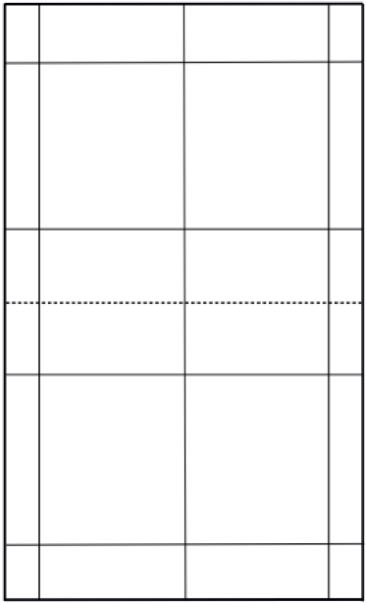](https://www.artengo.fr/conseils/apprendre-la-technique-du-service-court-a_35008)

**On the court to the side, mark where the server and receiver would stand if the score was 12-11 in a game of FULL COURT SINGLES?**

Name a **method** you have used to collect data in **badminton:** _______________________

**Describe** how you used this method to collect data:  
___________________________________________________________________________________________________________________________________________________________________________________________________________________________________________________________________________________________________________________________________________________________________________________________________________________________________________________________________________________________________________________________________________________________________________________________________________________________________________________________________________________________________

**Analyse** the data you gathered and discuss your **strengths** and **areas for development**?

_____________________________________________________________________________________________________________________________________________________________________________________________________________________________________________________________________________________________________________________________________________________________________________________________________________________________________________________________________________________________________________________________________________