Trig Graphs Course Notes
- Basic trig graphs with varying amplitude and period
- Basic trig graphs with shift in y and x-axis

2: Trig graphs (You can watch the video below or click on the link to take you to the webpage)
- FULL LESSON – Examples are at 3:08 – 18:30
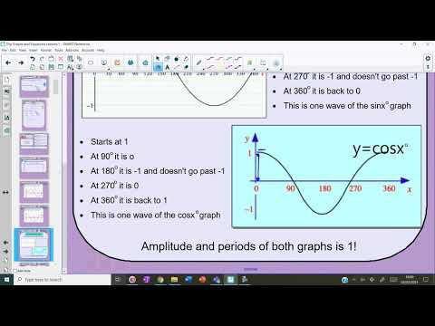
3: Further trig graphs (You can watch the video below or click on the link to take you to the webpage)
- FULL LESSON – Examples are at 2:11 – 16:05
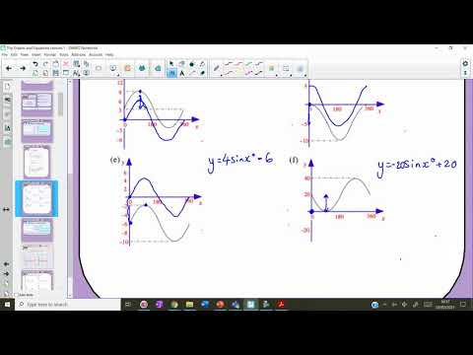
Trig Equations Course Notes
- Solving trig equations for one solution
- Solving trig equations for all solutions
- Exam style trig equations (EXTRA EXAMPLES)

1: Trig equations (You can watch the video below or click on the link to take you to the webpage)
- FULL LESSON – Examples are at 3:22 – 15:54
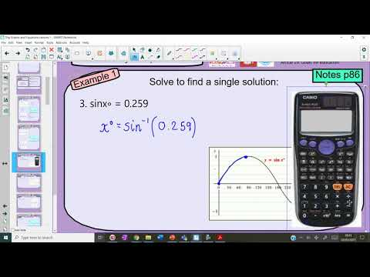
2: Further trig equations (You can watch the video below or click on the link to take you to the webpage)
- FULL LESSON – Examples are at 3:18 – 13:40
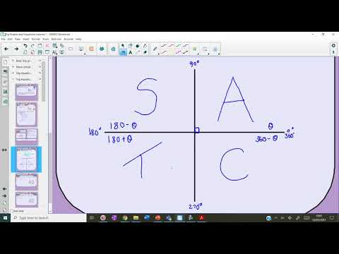
3: Exam style trig equations (You can watch the video below or click on the link to take you to the webpage)
- FULL LESSON – Examples are at 3:43 – 8:07
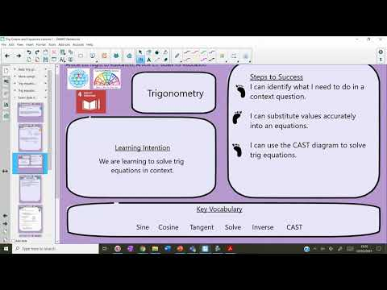
Trig Formulae Course Notes
- Area of a triangle
- Reverse area
- Sine rule for sides
- Sine rule for angles
- Cosine rule for sides
- Cosine rule for angles
- Applying sine/cosine rule to bearings and exam-style questions (EXTRA EXAMPLES)

1: Area of a Triangle (You can watch the video below or click on the link to take you to the webpage)
- FULL LESSON – Examples are at 6:00 – 16:44
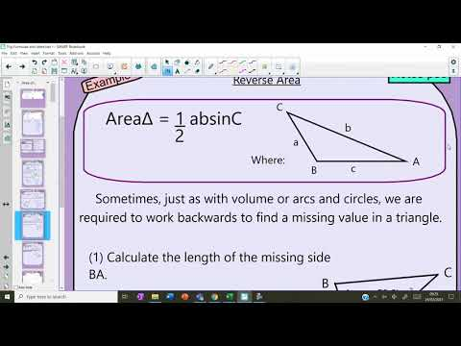
2: Sine rule for sides (You can watch the video below or click on the link to take you to the webpage)
- FULL LESSON – Examples are at 4:40 – 10:00
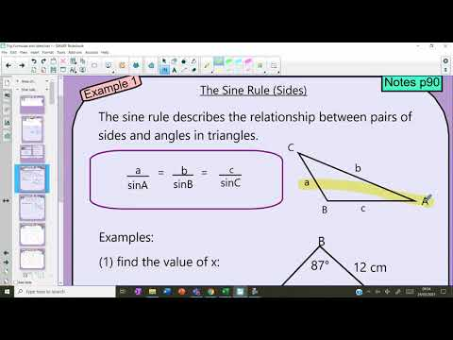
3: Sine rule for angles (You can watch the video below or click on the link to take you to the webpage)
- FULL LESSON – Examples are at 5:11 – 9:05
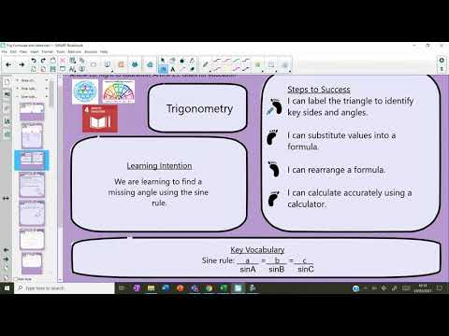
1: Cosine rule for sides (You can watch the video below or click on the link to take you to the webpage)
- FULL LESSON – Examples are at 7:56 – 11:03
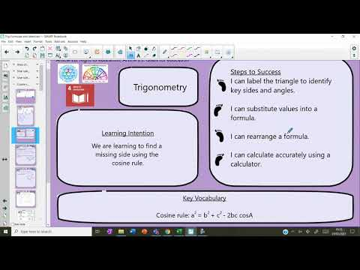
2: Cosine rule for angles (You can watch the video below or click on the link to take you to the webpage)
- FULL LESSON – Examples are at 3:54 – 8:22
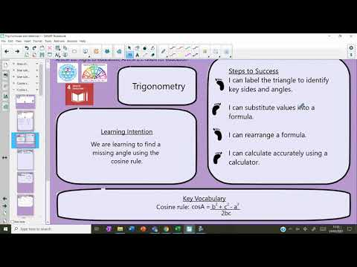
3: Sine and Cosine rules (You can watch the video below or click on the link to take you to the webpage)
- FULL LESSON – Examples are at 3:48 – 16:55
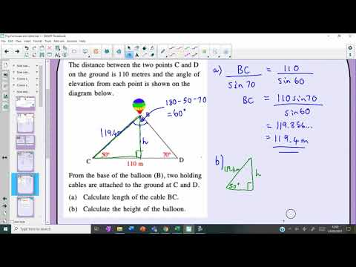
Trig Identities Course Notes
- Using trig identities to simplify expressions (EXTRA EXAMPLES)

4: Trig identities (You can watch the video below or click on the link to take you to the webpage)
- FULL LESSON – Examples are at 2:26 – 8:44
