Quadratics Course Notes
- Solving quadratic equations using factorising (find the roots)
- Solving quadratic equations using the quadratic formula
- The discriminant to determine the nature of the roots
- Quadratic graphs at the origin and shifted up/down
- Quadratic graphs in completing square form
- Quadratic graphs and roots
- Sketching quadratic graphs

1: Quadratics Recap This summarises the key examples from the different lessons with the full lessons below with more examples.
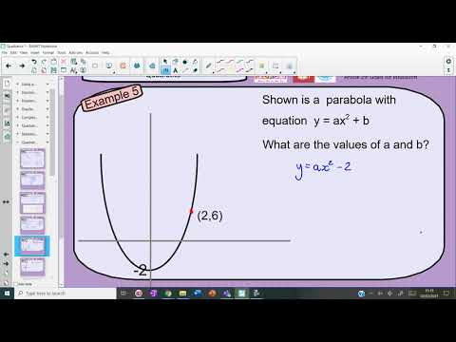
1: Solving quadratics using factorising (You can watch the video below or click on the link to take you to the webpage)
- FULL LESSON – Examples are at 4:50 – 15:05
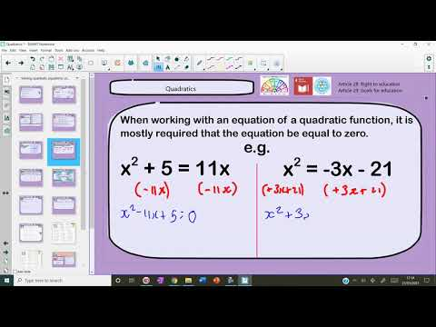
2: Quadratic formula (You can watch the video below or click on the link to take you to the webpage)
- FULL LESSON – Examples are at 2:38 – 9:00
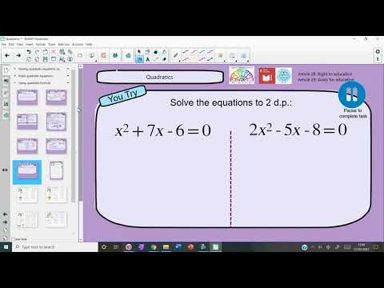
3: Discriminant (You can watch the video below or click on the link to take you to the webpage)
- FULL LESSON – Examples are at 5:03 – 10:37
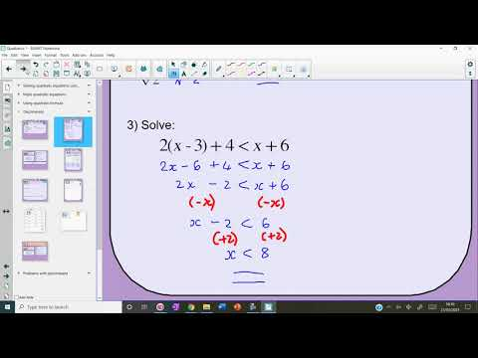
1: Quadratic graphs and equations (You can watch the video below or click on the link to take you to the webpage)
- FULL LESSON – Examples are at 8:32 – 20:41
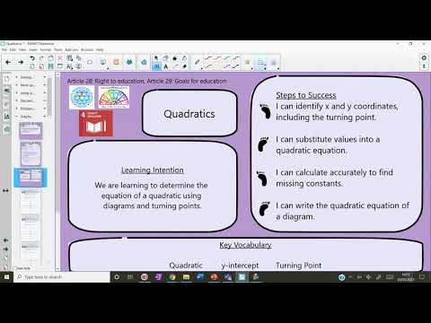
2: Completed square form (You can watch the video below or click on the link to take you to the webpage)
- FULL LESSON – Examples are at 3:33 – 17:29
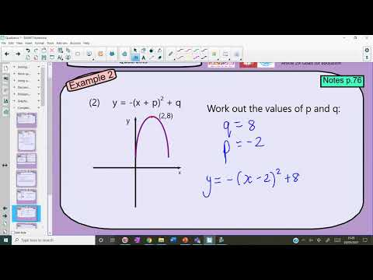
3: Sketching quadratics with roots and axis of symmetry (You can watch the video below or click on the link to take you to the webpage)
- FULL LESSON – Examples are at 4:03 – 23:30
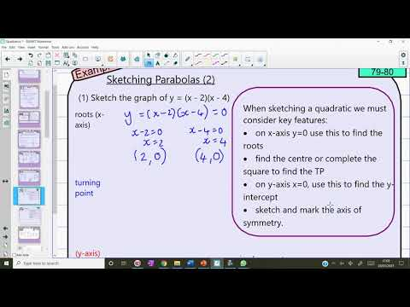
4: Sketching quadratics (You can watch the video below or click on the link to take you to the webpage)
- FULL LESSON – Examples are at 6:02 – 16:17
