Surds Course Notes
- Simplifying surds
- Adding and subtracting with surds
- Multiplying and dividing with surds
- Expanding brackets with surds
- Problems with surds, e.g. Pythagoras in 3D
- Rationalising the denominator

1: Simplifying Surds (You can watch the video below or click on the link to take you to the webpage)
- FULL LESSON – Examples are at 4:07 – 11:44
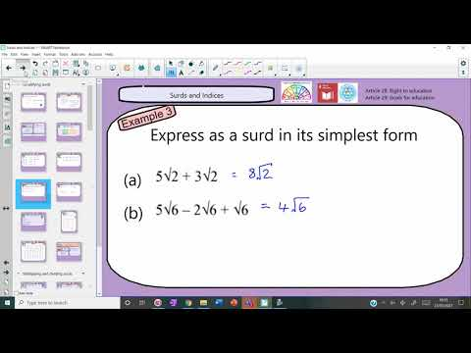
2: Multiplying and Dividing Surds (You can watch the video below or click on the link to take you to the webpage)
- FULL LESSON – Examples are at 3:18 – 11:20
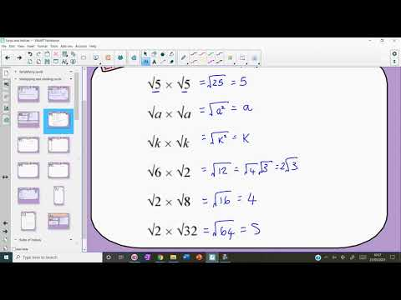
Indices Course Notes
- Evaluating powers
- Power of zero
- Negative powers
- Multiplying and dividing terms with indices
- Raising powers
- Fractional powers
- Expanding brackets with indices
- Scientific notation

3: Rules of Indices (You can watch the video below or click on the link to take you to the webpage)
- FULL LESSON – Examples are at 3:13 – 16:04
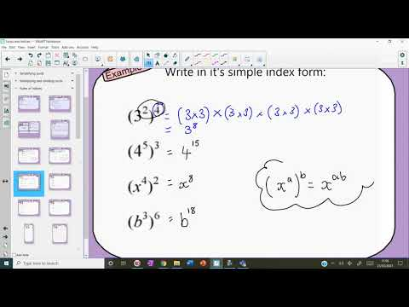
4: Negative Powers (You can watch the video below or click on the link to take you to the webpage)
- FULL LESSON – Examples are at 4:06 – 8:55
