Fractions Course Notes
- Adding and subtracting fractions (with mixed numbers)
- Multiplying fractions (with mixed numbers)
- Dividing fractions (with mixed numbers)

12 Fractions (You can watch the video below or click on the link to take you to the webpage)
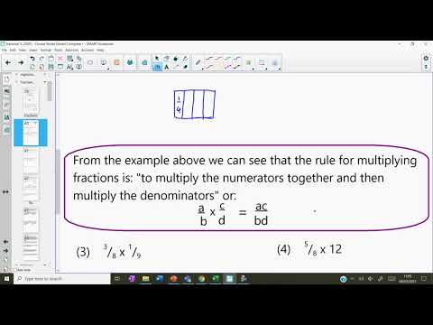
Percentages Course Notes
- Percentage change using a decimal multiplier
- Percentage change over time (repeated calculation and using powers)
- Reverse percentages (non-calculator and calculator)

13 Percentages (You can watch the video below or click on the link to take you to the webpage)
