Straight Line Course Notes
- Gradient
- Drawing Straight Lines
- Rearranging Straight Line Equations to y = mx +c
- Equation of a Straight Line y – b = m(x – a)
- Scatter Graphs (lines of best fit)

7 Straight Line (You can watch the video below or click on the link to take you to the webpage)
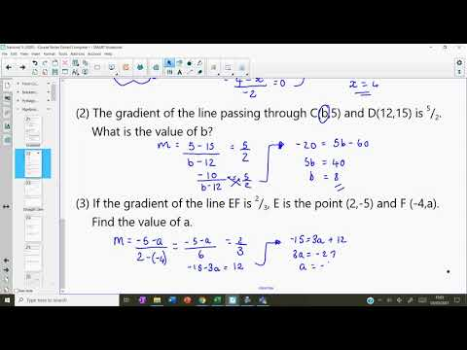
Functions Course Notes
- Calculating with functions, e.g. f(x) = 2x + 1
- Reverse functions

8 Functions (You can watch the video below or click on the link to take you to the webpage)
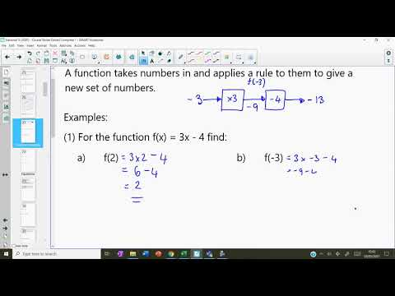
Equations and Inequations Course Notes
- Solving equations with brackets
- Constructing equations
- Solving equations with fractions
- Solving inequations

9 Equations and Inequations (You can watch the video below or click on the link to take you to the webpage)
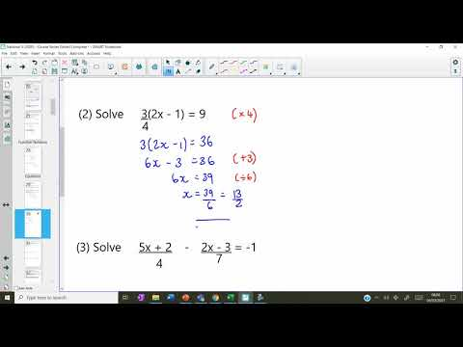
Simultaneous Equations Course Notes

- Graphical solution
- Algebraic solution without scaling
- Algebraic solution with scaling

10 Simultaneous Equations (You can watch the video below or click on the link to take you to the webpage)
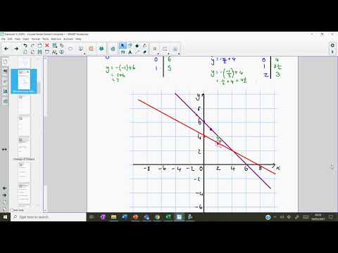
Changing the Subject Course Notes

- Basic change the subject
- Change the subject with fractions
- Change the subject to a denominator
- Change the subject with powers and brackets

11 Changing the Subject (You can watch the video below or click on the link to take you to the webpage)
