Pythagoras Course Notes
- Basic Pythagoras
- More complex 2D Pythagoras with more than one triangle
- Converse of Pythagoras
- Pythagoras in 3D

4 Pythagoras (You can watch the video below or click on the link to take you to the webpage)
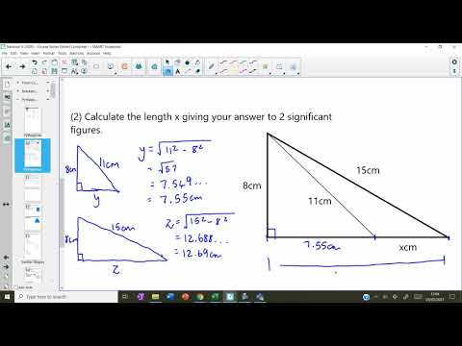
Similarity Course Notes
- Linear scale factor and similarity
- Area scale factor and similarity
- Volume scale factor and similarity
- Reverse scale factor

5 Similar Shapes (You can watch the video below or click on the link to take you to the webpage)
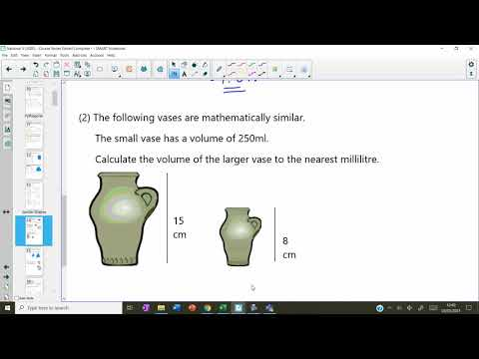
Circle Course Notes
- Isosceles triangles in circles using two radii
- Perpendicular bisectors and using Pythagoras in circles.
- Right-angled triangles in semi-circles
- Tangents to circles
- Tangent kits with a circle

6 Circle Properties (You can watch the video below or click on the link to take you to the webpage)
