Expanding Brackets Course Notes
- Expanding single brackets and simplifying
- Expanding double brackets and simplifying
- Expanding triple brackets, brackets with trinomials and simplifying
1 Expanding Brackets (You can watch the video below or click on the link to take you to the webpage)
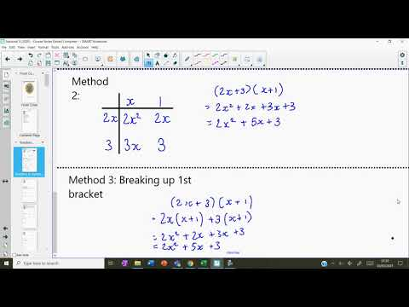
Factorising Course Notes
- Highest common factor
- Difference of 2 squares
- Simple trinomials
- More complex trinomials
- Completing the square (EXTRA EXAMPLES and SEPARATE VIDEO)
2 Factorising (You can watch the video below or click on the link to take you to the webpage)
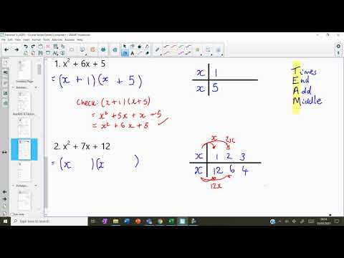
3 Completing the Square (You can watch the video below or click on the link to take you to the webpage)
