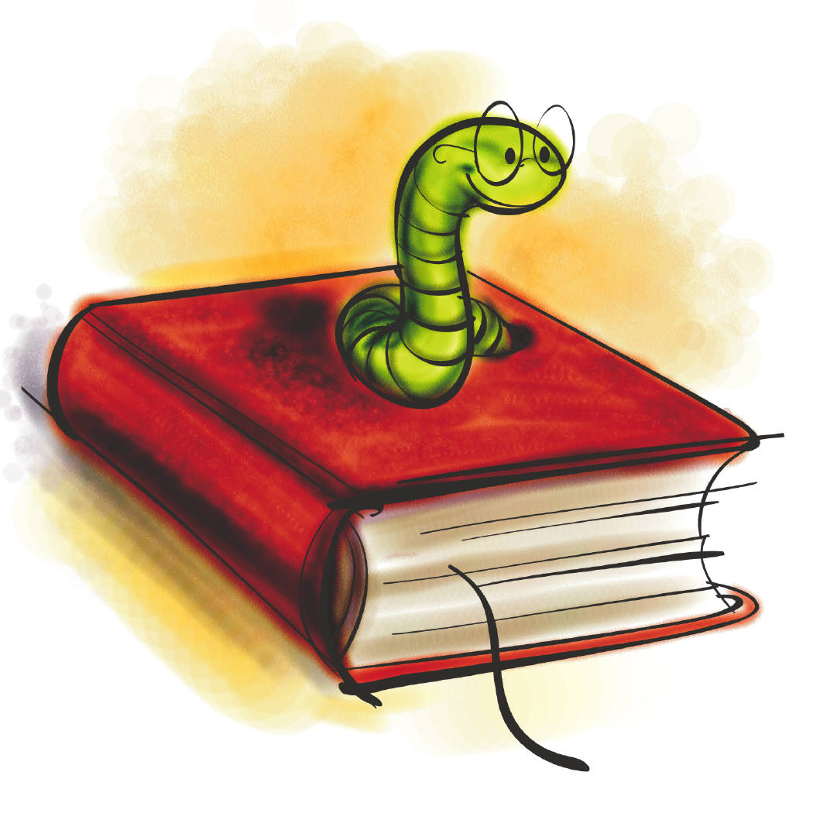
Critical Terminology - General

Get to know the terms listed below in preparation for textual analysis, close reading and critical essays.

Adjective – a describing word

Adverb – a word which tells s more about a verb

Alliteration – the use of the same consonant sound, usually at the beginning of words, e.g. ‘She sells sea shells on the sea shore.’

Ambiguity – the idea that a word or phrase might mean more than one thing

Cliché – an overused expression, e.g. ‘There’s plenty more fish in the sea’

Conjunction – a word that links together phrases or clauses e.g. ‘and’

Connotation – the ideas suggested by a particular word

Context – the words, phrases, sentences around a specified word or expression

Enjambment – a sentence or expression over more than one line without a pause

Hyperbole – deliberate exaggeration, e.g. ‘It was a million times worse than I had imagined’

Image – a picture created by words

Irony – language that says the opposite of what is meant, sometimes for humorous effect.

Literal – where a word means exactly what it says, e.g. ‘raining cats and dogs’ taken literally would mean that cats and dogs were falling from the sky. The opposite of literally is figuratively.

Metaphor – a comparison where one thing is said to be another, e.g. ‘Juliet is the sun’

Noun – a word which names things. Proper nouns are used for the names of actual people and places; common nouns are used for objects; collective nouns refer to groups of things and abstract nouns refer to thoughts, feelings and qualities.

Onomatopoeia – where a word makes the sound it is describing, e.g. snap, pop, bang, whoosh

Oxymoron – two words placed side by side which are contradictory, e.g. ‘sweet sorrow’ or ‘bitter sweet’

Paradox – two contradictory ideas placed together

Parenthesis – non-essential information which is separated from the rest of the sentence by double commas, dashes or brackets, e.g.:
The cat, which was black and gorgeous, sat on the mat. The section in bold could be removed from the sentence and it would still make sense.

Personification – inanimate objects are described as having human qualities, e.g. ‘the wind whistled’

Pronoun – a word which replaces a noun, e.g. he, she, it, they, I …

Rhyme – words that have the same sound

Rhythm – the beat within a line of poetry

Simile – two things are directly compared using ‘like’ or ‘as’

Stanza – groups of lines in poetry

Symbol – an idea or an object that represents more than just its literal self. The seasons are often used to symbolise life

Theme – the main idea in a text

Tone – the feeling or attitude that is suggested by words, e.g. sarcastic, frightened…

Punctuation Reminder:
Apostrophe (‘) Used to show when a letter has been missed out in a contraction, e.g. do not = don’t. Apostrophes are also used to show possession, e.g. the girl’s books – the books belonging to the girl
Comma (,) Used to create a pause in a sentence and to separate items in a list
Semi-colon (;) Can introduce an expansion of an idea in the second part of a sentence or can break up a list of phrases
Colon (:) Used to introduce a list or explanation
Inverted Commas (“ “) For direct speech and titles, or to show when a word should not be taken literally
Dash (-) Used as a sign of interruption.
Hyphen (-) Joins together two separate words to make an expression
Brackets ( ) Used to separate a word or phrase from the rest of the sentence

