

School Travel Plan

Headteacher: Mrs Wilson

School address: 6 Rumdewan, Kingskettle, KY15 7QR

Telephone No: 01334 659421

Social Media/Website: Website

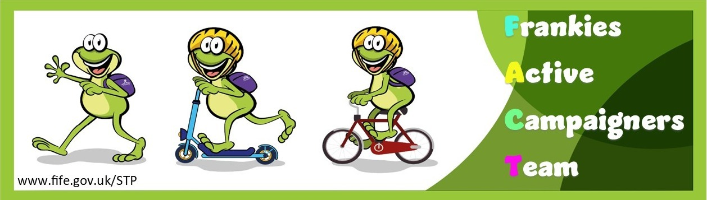

Contents Page

3: 1.0 WHY HAVE A SCHOOL TRAVEL PLAN

3.: 2.0 BENEFITS OF HAVING A SCHOOL TRAVEL PLAN

4: 3.0 Current Travel Habits

3.1 Family Questionnaire Data

10: 4.0 MAPPING WORK AND ROUTE AUDIT

4.1 Access Arrangements

13: 5.0 ACTION PLAN

14: 6.0 MONITORING AND EVALUATION

14: 7.0 DISTRIBUTION OF SCHOOL TRAVEL PLAN

1.0 Why have a school travel plan

School-related traffic congestion and the risks congestion poses to the safety of the pupils, teachers, parents, residents, and motorists in and around school locations is a significant problem in communities around Fife.

The most obvious cause of traffic congestion around our schools is vehicles, and the biggest source of those vehicles is parents’ dropping off and picking up their children from school.

Statistics highlight that 1 in 4 cars during the hours of 8:30 to 9:15 and 2:30 to 3:15 is primary school traffic.

Our annual Hands Up Survey highlights that 20%, that’s 4968 primary school children are driven to the school gate each day with a further 14% opting to Park and Stride. That is an additional 3616 pupils being driven in and around the school streets.

Fife Council’s Road and Transportation Service are working with schools in Fife to develop School Travel Plans and support our Frankies Active Campaigners Team (FACT)to develop campaigns such as Walking Buses, Park n Stride sites, Parking Pledges, available routes to school maps, delivery of Bikeability as well as looking at any engineering works that may be required to make active travel to school your first choice of travel.

2.0 BENEFITS OF HAVING A SCHOOL TRAVEL PLAN?

The benefits of encouraging active travel are clear and a school travel plan can ensure that your school has a long–term vision with aid to support Frankies Active Campaigners Team with delivering campaigns to;-
- Improve health and well-being by reducing harmful emissions and increasing activity levels.
- Improve safety through engineering measures and increasing road safety education.
- Improve access and opportunity by developing pupils’ skills for safe and independent travel.
- Improve the environment by reducing pollution and CO2 emissions.
- Gain school accreditations such as Fresh Air Frankie STP Awards, Active School Award and Eco Schools.
All work associated with School Travel Planning has been designed to fit into the Curriculum for Excellence.

3.0 CURRENT TRAVEL HABITS

Each year all Fife schools undertake the hands up survey which gives a true reflection of how pupils are travelling to school, and the latest results show that 55% of pupils are actively travelling to school. However, with over 36% still being driven to school the school must continue to keep up the good work and reduce the number of cars parked around the school gate.

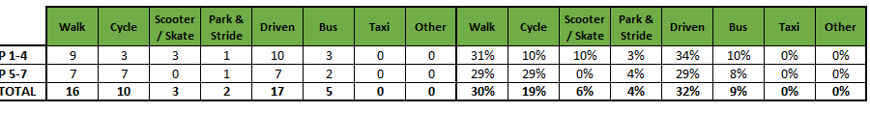

3.1 Family Questionnaire

22 families answered the online questionnaire, and the results are as follows.

What school year is your child/children in?
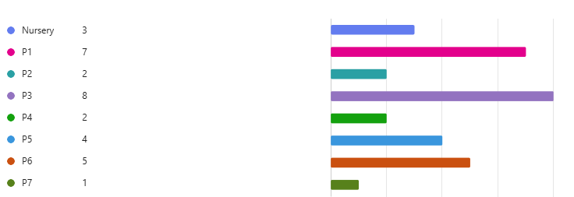

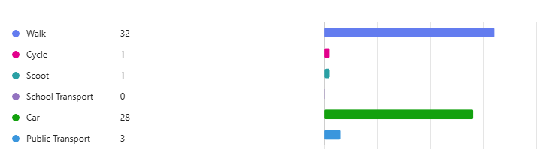
How does your child/children normally travel to school?

Those that travel by car were asked the following questions.

Can you tell us why you drive your child/children to school

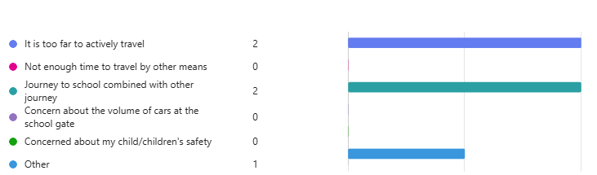

Would consider using a Park N Stride site
Only 2 parents responded and said that they would think about it.

Congestion around the school gates is a real problem, do you know you are contributing towards this issue.
Again only one parent answered this question and said that they were aware that choosing to park outside the school gate was adding to the problems.

.

What else do they think they could do to ease congestion around the school gate.

- Park somewhere else and walk to the school
- No sure
- I would love to walk them to school but it is impossible for us
- When I drop off my child there is no congestion as it is early around 8.10/8.20am
- Walk to school

Those that actively travel to school were asked the following questions:

If your school was to set up a walking bus, would you volunteer to support this?
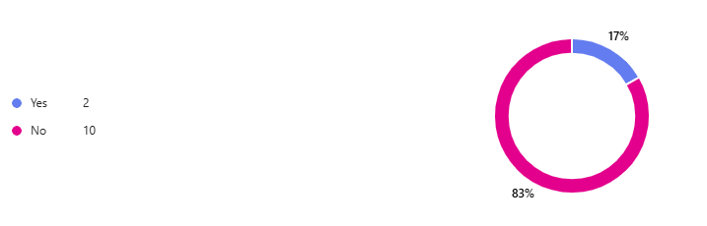

What would improve your active journey to school?

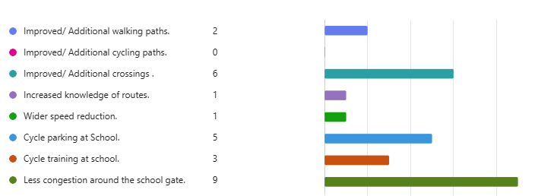
If you have selected Improved/ Additional paths or crossings please indicate if there is a specific location where you feel either of these can be improved.

- From rumdewan across to Haughfield terrace
- No improvement need
- Bottom of north street onto rumdewan
- Rumdewan/ North street.
- No change needed
- To cross between Shorehead onto Rumdewan.
- Half way up the road beside north street crossing

Is there anything you would like to tell us about your journey to school

- Drive 50% of time due to work will walk when able or whe their other parent is home from work
- A zebra crossing or lollipop man would be so appreciated as when the sun sits low it’s hard to see what’s coming
- We drive to kettle as we stay outside the village but sometimes park at a friends house and walk to the school.
- Gillian the bus driver has been great in making sure kids get on and off the school bus safely, and away from the traffic. Kids will need to be seated and using seat belt.
- We have to drive as we live in another village, we would love to walk or cycle but it isn’t possible.
- Parents gathering at the gate can be difficult to manoeuvre in/out
- No change needed. Nice safe walk to school
- Cycle during Spring/Summer/Autumn. Drive in Winter months.
- From Rumdewan to north street is always busy with cars a crossing would help the safety of the children
- We mostly walk or cycle already anyway

3.2 Staff Questionnaire

All staff members were asked how far they travelled to work and what type of transport do they use.
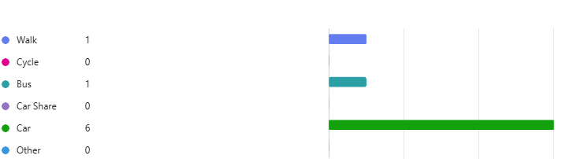
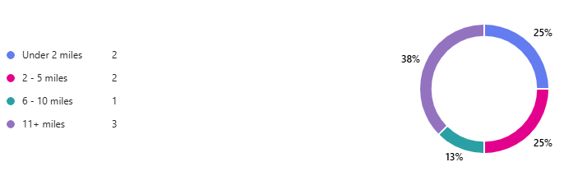
For those that drive they were asked the following

Where do you park?

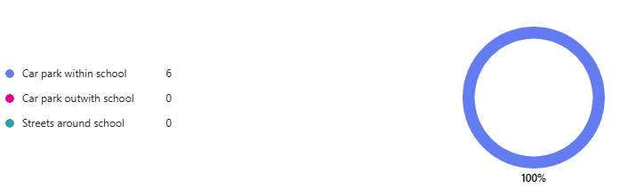

What would encourage you to consider an alternative mode of transport to work?

- Better public transport between home and work
- Nothing – public transport is more expensive and less reliable
4.0
MAPPING WORK AND ROUTE AUDIT

A mapping exercise was carried out on 22nd April by the FACT group to highlight the active travel routes to school and the findings are marked on the map below.

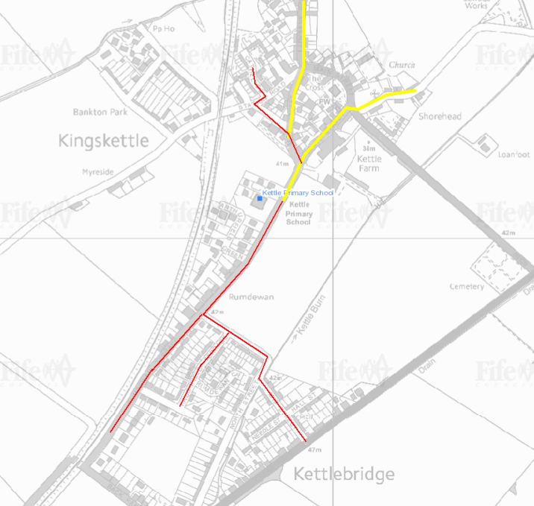

4.1 Access Arrangements

The school has one pupil entrance and is accessible from Rumdewan Terrace and there is a car park at the front of the school.

This car park is for staff and visitors and must not be used by parents unless there has been prior agreement made with the Head Teacher.

Pupils must not walk across the car park.

5.0 ACTION PLAN

Action | Solution | Action Owner
Promote School Travel Plan | - Upload plan to website and social media pages.  - Create a FACT notice board.  - Create articles for school newsletters, social media, and assemblies.  - Keep the school travel plan team updated on all work carried out by completing your FACT floor book. | School
Fresh Air Frankie Awards Campaigns | Term 1  Hands up Survey Active Travel  Bike Week – capture data on travel tracker  Interschool Active Travel Challenge  International Walk to School Month  Create a video for #dontparkhere campaign next term  Term 2  Launch #dontparkhere Campaign  Send out social media post about congestion at the school gate  International Walk to School Week – capture data on tracker  Optional Campaigns - Road Safety Week  Term 3  Continue #dontparkhere social media campaign  Big Walk and Wheel  Create a travel plan induction sheet for P1 intake  Term 4  Walk to School Week – capture data in tracker  Bike to School Week  Clean Air Day  End of term newsletter to parents about the work carried out | School – full details held within your FACT folder
Reduce congestion | Consider developing the following:- Parking Pledge  Walking Bus  Campaigns to increase active travel to school. | School – full details held within your FACT folder
Bikeability | Deliver Level 2 Bikeability and apply for Cycle Friendly School Award | School/Bikeability
Annual Active Travel Award | Top 3 schools that can showcase the largest increase in Active Travel to School will be crowned champions. Data will be collated from the HUSS and our own travel tracker. | School/Travel Plan Team

6.0 MONITORING & EVALUATION
The FACT will continue to meet periodically to monitor progress and amend strategies to comply with the actions set out in this plan. Specific progress will be monitored by participation in the “Hands Up Travel Tally” each year and a repeat of the full travel survey will take place in 2028/29.

The school’s ongoing commitment to travel planning will be publicised in the school handbook, the school newsletters, the Parent’s notice board and through assemblies.

7.0 DISTRIBUTION OF SCHOOL TRAVEL PLAN
The following bodies will receive a copy of the School Travel Plan:
• Fife Council Sustainable Transport and Travel via the Travel Plan Team
• Fife Council Education Service
• Parent Partnership
• Copies will also be made available to the parents from the School Office and via
the school information sites.

ROUTE AUDIT

1.0 INTRODUCTION
An Audit was carried out on Tuesday 22nd April, 2025 of routes taken by pupils attending Kettle Primary School. The audit team consisted of: School Travel Plan Team and the FACT group. The school has two pedestrian entrances on Rumdewan. A bus brings some pupils and stops near to the south pedestrian gate. The roads adjacent to the school are covered by a full time mandatory 20mph speed limit with some traffic calming features, roundels and repeaters.

The routes audited were:
- Rumdewan
- South Street
- Main Street
- Haughfield Terrace.

2.0 Routes Audited
Rumdewan at the school gates
Issues
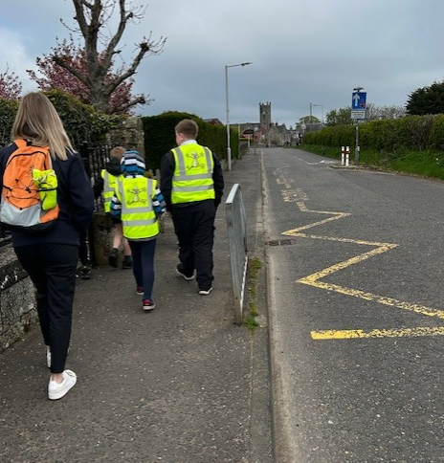
Some pupils must be driven to school due to the remoteness of their homes. Cars are being parked directly outside the school gates. The School Keep Clear Markings are very faded and extend from the north pedestrian gate northwards. The school bus sits at the south pedestrian gate to drop off and pick up pupils, however there are no designated bus box markings
Recommendations
It would make the area safer for pedestrians if the cars were parked further away from the school gates.
Actions
The FACT group should work with the School Travel plan Team to promote the existing Park N Stride site on Haughton Street. This area is within a short distance of the school gates and is a safe drop off and pick up point. Utilising this area would also improve active travel to school.

The School Travel Plan Team to investigate the introduction of a bus box and refresh the School Keep Clear Markings.

Junction of South Street and Main Street
Issues
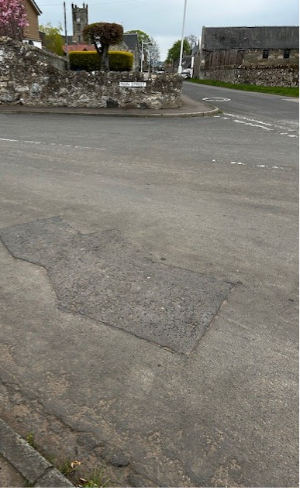
The Junction of South Street and Main Street is wide and visibility is reduced by stone walls either side. It is used most days by pupils actively travelling to and from school and to the church for events.. The footway on South Street is narrow at the junction.
Recommendations
Building out the footway either side of the junction would improve visibility and safety for pedestrians crossing the road. It would provide a larger area for pedestrian to gather while waiting to cross. It would also help to reduce speeds
in the village.
Action
Travel Plan Team to investigate the possibility of building out the footway.

SUMMARY
There are good opportunities for active travel within the village to and from the school. The roads around the school generally seemed to be safe and are covered by a 20 mph zone. However during the route audit it was noted that pupils lack of understanding of road safety was concerning at times. This may be due to the lack of awareness of their surroundings as during the audit we only encountered 2 vehicles on the road. Further road safety education would benefit pupils at Kettle and remind them of their own responsibilities when navigating crossing the road.

The area immediately around the school gate is the main area where improvements can be made.

To pursue the recommendations included in this report they should be incorporated into the School Travel Plan. Interventions should include Education, Engineering and Enforcement to improve safety around the school and to support a successful School Travel Plan.

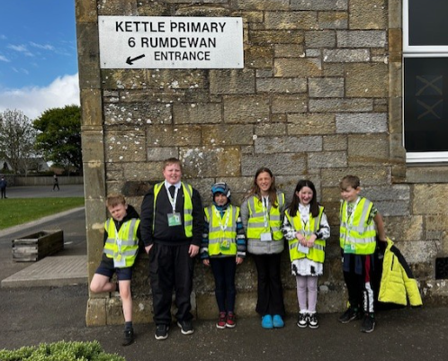
Where engineering measures have been identified, these will only be implemented when the School Travel Plan has been approved and signed off.

