

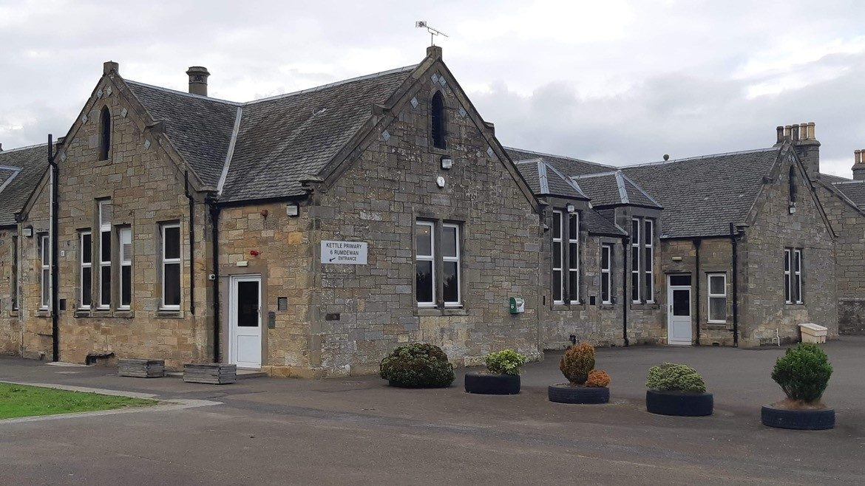

Kettle Primary School

Provision of Time for Reflection (Religious Observance)

May 2025

Provision of Time for Reflection (Religious Observance)
What is Time for Reflection (otherwise known as Religious Observance)?

Religious Observance (RO) is defined for schools in Scotland as: “Community acts which aim to promote the spiritual development of all members of the school community and express and celebrate the shared values of the school community.” (Religious Observance Review Group Report 2004)
In line with current policy and legislation all Fife Schools are expected to fulfil this statutory requirement through undertaking acts of Religious Observance (RO) as described below. In this guidance, RO is referred to as Time for Reflection (TfR), although other names may be used to describe it.

Time for Reflection in Kettle Primary School

Kettle Primary school places high importance on ensuring that Time for Reflection(TfR) is inclusive of a diverse range of faith and belief traditions and reflects both faith and non-faith perspectives. We are proactive in ensuring high-quality, pupil, staff, and partner-led opportunities and events that enable a shared community understanding and celebration of the diversity within TfR.
Children experience a range of opportunities across the school year to engage with TfR during our weekly assemblies where appropriate.

We work closely with our school chaplaincy team and other visiting speakers who support us in planning, delivering and reviewing our TfR programme. We welcome the opportunity to work with a range of partners who represent faith and non-faith groups which reflect and are relatable to the diverse beliefs and values of our school community.

TfR links to our school vision and values, We are Caring, we are respectful, we take responsibility and we show teamwork. At Kettle we are learning to respect a diverse range of faiths and beliefs and reflecting on our own sense of faith through times for reflection.

Opportunities for TfR are provided for our young people in the following ways:

E.g.:
- Assemblies focused on our school, our values and how we reflect these values in our interactions with our wider community, will be held six times per year please refer to our Assembly planner which is developed each year. Information about assemblies are shared on our monthly sway.
- Involvement in community projects to support for example developing the value of charity.
- Focused year group, small group or whole school opportunities to develop the young person’s four capacities to be: a successful learner, confident individual, responsible citizen and effective contributor.
- Whole school events that celebrate and promote the diverse achievements, cultural heritage, and talents of young people e.g. Award ceremonies or other family engagements.
- Extracurricular groups and prayer space following the faith needs of the school community.

What part does worship play in the school TfR programme?

Our school approach to TfR aligns with the recommendations of the Religious Observance Review Group Report 2004:
“Where … there is a diversity of beliefs and practices, … the appropriate context for an organised act of worship is within the informal curriculum as part of the range of activities offered for example by religions, groups, chaplains and other religious leaders.” (Religious Observance Review Group Report 2004). This may include, for example, lunchtime or after-school activities or events.

We have partners in our community who help us to engage in time for reflection and religious observance. They also help those within our community who do not attend church, to learn about Christianity and its beliefs.

Liz Slattery, Session Clerk – Fife Eden Tay Parish - edentaysessionclerk1@gmail.com – Church of Scotland

Can I withdraw my young person from Time for Reflection/ Religious Observance(RO)?

Under the terms of the Education (Scotland) Act 1980, parents/ carers/ families do have the right to withdraw their child from Time for Reflection/ Religious Observance. Where a request is made, we will work in partnership with families to manage this with sensitivity and understanding.

If you wish to make a request please email: kettlelps.enquiries@fife.gov.uk Following receipt of this communication, a member of the school Senior Leadership Team will arrange a meeting with you to explain in more detail our inclusive approach to RO and TfR, discuss any implications for withdrawal and to agree suitable arrangements as an alternative where required. Where a young person wishes to undertake religious practice or worship as part of their school day, we will seek to provide facilities which support this.

