Primary 6/7

Literacy

Some of us spent time this week editing and redrafting our Instructions text using Microsoft Word. We had to focus on our layout, and correcting any mistakes from the first draft and reading and responding to the feedback given by our peers.

We watched the trailer for the film ‘Zarafa’ which we are going to see at the Discovery Film Festival in Dundee on the first Monday back. The teacher asked us some questions about the trailer and we all made predictions about what the film will be about and what happens. We watched the trailer again and while watching we took notes about the clothes the characters were wearing, the weapons in the trailer, the buildings and the transport. After we go to watch the film, we will be learning how to write a Film Review.

Numeracy

This week we were learning or some of us were revising Roman Numerals up to 30, 50 or 100. There is a homework sheet for further extension and revision of this over the holidays.

We also learned how to show tenths and hundredths as a fraction and to represent tenths and hundredths by shading in parts of a ten square and a hundred square. This has helped our understanding of whole numbers and decimals and we then applied this to carrying out textbook questions.

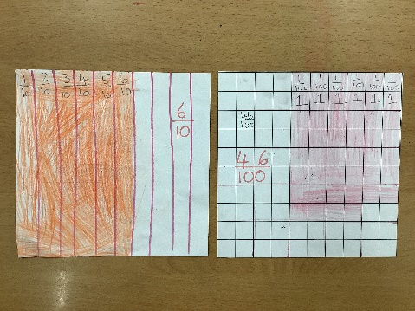

Rights Respecting Schools

To work towards our Bronze Rights Respecting School Award, we have been learning more about our Rights and which ones are important to us. We each made and decorated a small picture to represent ourselves and we attached a card with our names and the right we think is most important at school. We have made a wall display in the gym hall to showcase this.

Other areas

Primary 7s have made a door monitor timetable to make sure that younger pupils don’t come in and out of classrooms during break and lunch, and also to let pupils in and out to use the toilet

Home Learning

* Roman Numerals worksheet