***Primary 4,5,6 and 7***

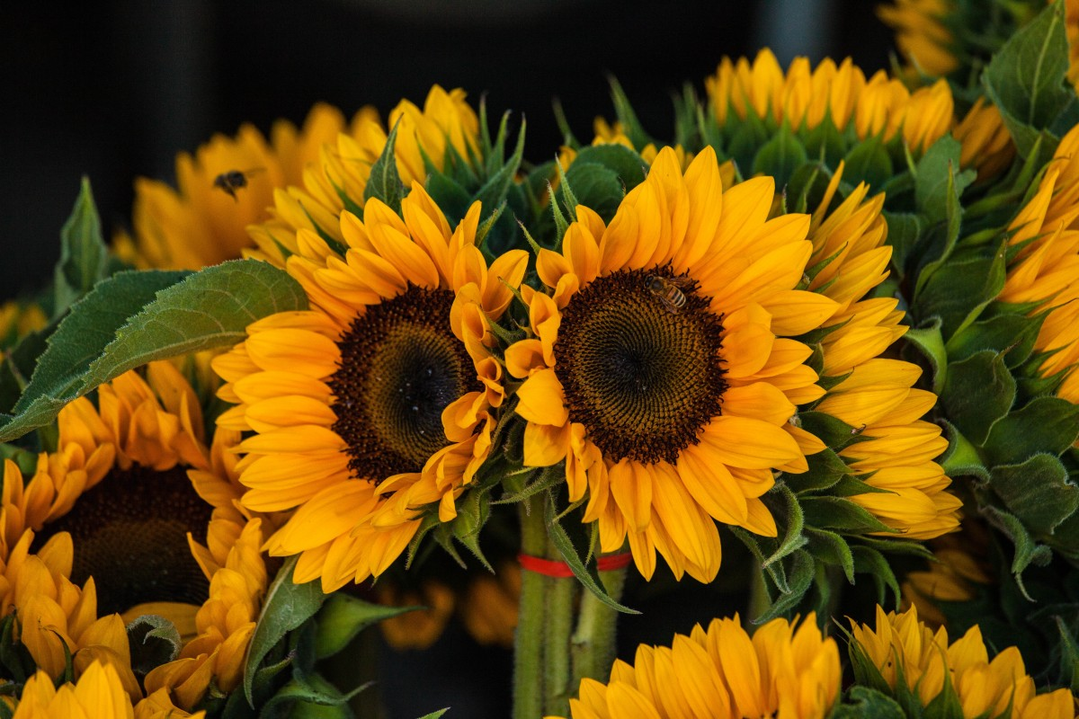

**Art**

We were making drawings of sunflowers. We drew the pot and then the flowers using pencil. Then we went over the outline using black fine pens. We will complete the work by painting using water colour pencils.

We also used a range of colours to create a geometric shape design.

**Writing**

We are busy writing newspaper reports for our own newspapers. The story we are reporting on was about Ken going missing in the water of the coast of Majorca.

**Maths**

We did a fun active maths lesson called Escape Room. We had a key pad and clues. We had to work out the answers to the clues using our maths skills. This gave us the code for the keypad. We also had to break a code by working out answers to different problems.

**Science**

Some of us were experimenting with paper aeroplane design. We made a range of folded aeroplanes and had a competition to se who had the plane that could travel the farthest.

**P.E**

We have been working on developing our skills of ball control during tennis. We also, took part in social games and developing skills using a variety of small gym equipment.

**Park Visit**

Kids from P6 and P7 were away to Ardroy this week. All the kids in the upper two classes got together on Monday and have spent the week together. On Monday we all went to the park together to help us mix and have fun together.

**Baking**

Some of us were following recipes. We made lemon drizzle cake. We were using our measuring skills. The cake was a big hit with the school staff.