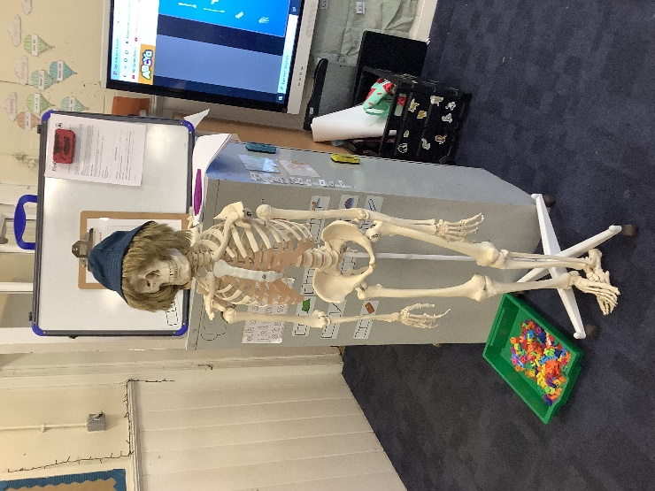 Weekly Update P1/2 – WB 28.8.23

Hi my name is George. I am a new member of P1/2 here to help them learn about their bodies. They learned the names of some of their bones this week.

The primary 2s have also been learning to double their numbers and add 1. They played smartboard games and 4 in a row to help them practice their adding.

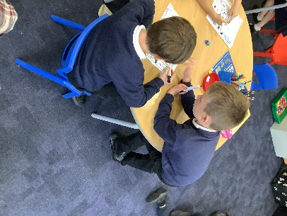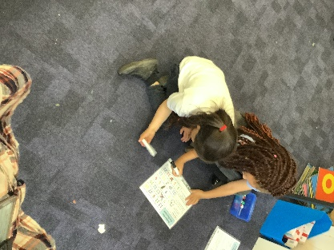

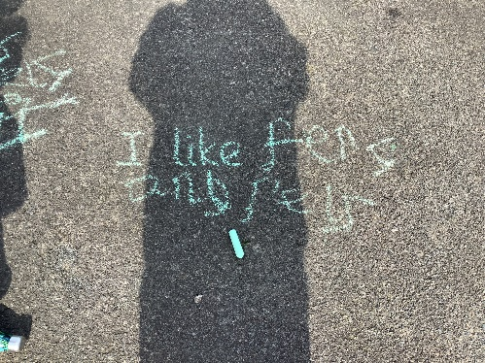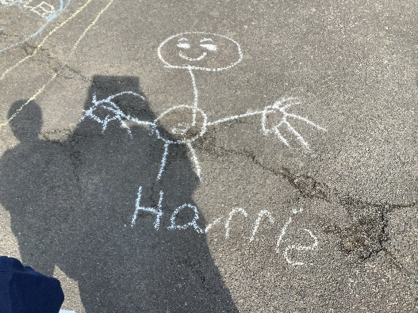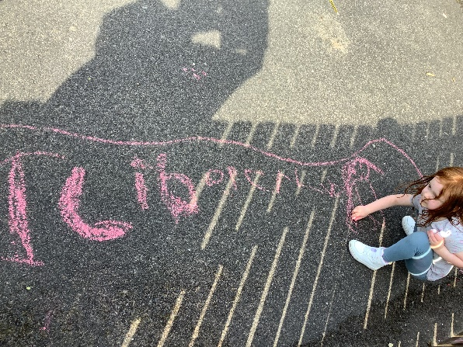 Primary 1 have been continuing to work on writing their numbers to 20 and have been learning to work out before/after and missing numbers in a number line.

Today we took our writing lesson outside and used chalk on the playground. We also enjoyed listening to information about bones in the school garden.

Did you know?

* There are 27 bones in the human hand