P6/7

24.08.2023

This week we have been exploring our new classroom and woodwork area and we welcomed our new class pet, an African land snail who was kindly donated to the school and we decided to name him Gary. We have been doing some research about giant snails and we will be finding out more about hermaphrodite creatures this term in science.

P7s who wanted to apply for House and Vice House Captain roles have been very busy preparing posters to distribute and display around the school before a whole school pupil vote. P6s who want to apply for Junior Road Safety Officer or Peer Mediator roles have been given information and can prepare for interview with Mc McNaughton in coming weeks.

For Health and Wellbeing, we are learning about reactions and our different reaction styles. You could have a chat and compare reaction styles with family members at home. We are also working to become a Rights Respecting School this year so pupil voice sessions have begun for that. Many of us are very excited for Ardroy!

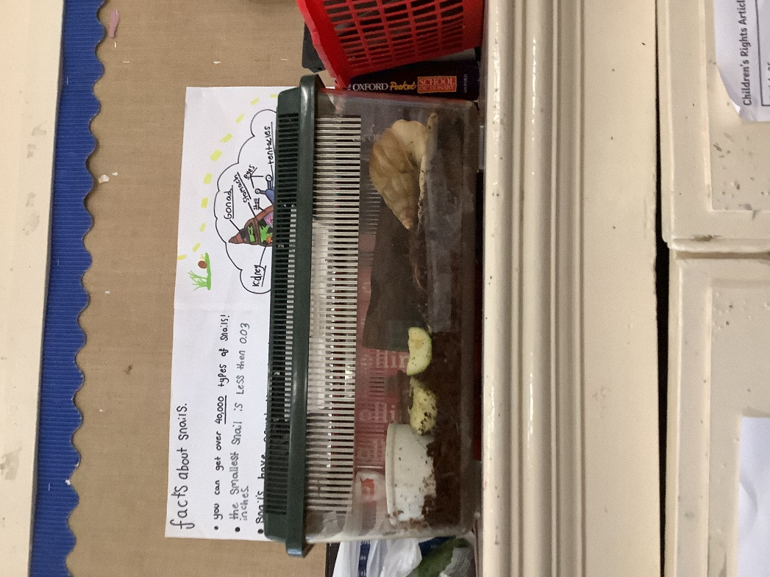

Home Learning

Personal reading books from school can be read at home, but reading group books will stay in school, class teacher will read with groups and carry out comprehension tasks in class.

P6/7s could start to think about an idea for their wood work project for this year.

Pack for Ardroy!