Last week we welcomed our new P1s into our school. The children spent time exploring their learning through play and made new friends. This week we have been working on where we want to go with our learning and have been thinking about our goals for this year. We read "all the places you will go" By Dr Seuss. The children used patterns and practised their cutting skills to make these wonderful hot air balloons.

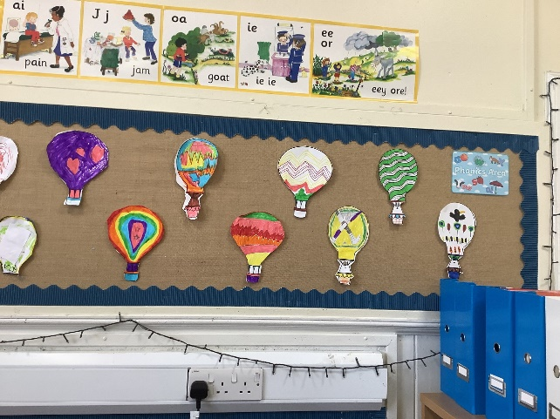

We have also been learning hockey and teamwork skills in PE and the Primary 1s have started to learn their sounds. Primary 2 children have been revisiting their number bonds to 10 through ICT games and have been writing wonderful sentences about their goals for this year.

**Some important information:**

**Gym days** are **Monday** and **Thursday.** Children should come wearing appropriate clothes and shoes for physical activity.

**Reading books** for those children who have them will go **home on a Wednesday** along with their key words and need to be **returned to school the following Tuesday.**

Thank you

Mrs Robertson and P1/2