

Fresh Air Frankie’s
School Travel Plan 25/26

School: Kelty Primary School

Headteacher: Colin Lyle

School address: 137 Main Street, Kelty, KY4 0AQ

Telephone No: 01383 602418

Contents Page

3: 1.0 WHY HAVE A SCHOOL TRAVEL PLAN

3.: 2.0 BENEFITS OF HAVING A SCHOOL TRAVEL PLAN

4: 3.0 SUMMARY OF TRAVEL HABITS, TRENDS & DATA LIMITATIONS

7: 4.0 RESIDENTIAL AREA ONLINE ROUTE AUDIT

9: 5.0 ACTION PLAN

10: 6.0 MONITORING AND EVALUATION

10: 7.0 DISTRIBUTION OF SCHOOL TRAVEL PLAN

1.0 Why have a school travel plan

School-related traffic congestion and the risks congestion poses to the safety of the pupils, teachers, parents, residents, and motorists in and around school locations is a significant problem in communities around Fife.

The most obvious cause of traffic congestion around our schools is vehicles, and the biggest source of those vehicles is parents’ dropping off and picking up their children from school.

Statistics highlight that 1 in 4 cars during the hours of 8:30 to 9:15 and 2:30 to 3:15 is primary school traffic.

Encouraging active travel—such as walking, cycling, or scooting to school—offers children a healthier, more energising start to their day. It helps improve physical fitness, boosts mood and concentration, and reduces traffic congestion and pollution around school gates, making the environment safer for everyone.

Fife Council’s Road and Transportation Service are working with schools in Fife to develop School Travel Plans; a practical framework to promote sustainable travel and address barriers families may face by supporting Frankies Active Campaigners Team (FACT) to lead activities, raise awareness, and celebrate progress. These initiatives empower children to take pride in their choices and inspire others to get moving – making active travel a positive part of everyday school life.

2.0 BENEFITS OF HAVING A SCHOOL TRAVEL PLAN?

The benefits of encouraging active travel are clear and a school travel plan can ensure that your school has a long–term vision with aid to support your FACT group with delivering campaigns that will;-
- Improve health and well-being by reducing harmful emissions and increasing activity levels.
- Improve safety through engineering measures and increasing road safety education.
- Improve access and opportunity by developing pupils’ skills for safe and independent travel.
- Improve the environment by reducing pollution and CO2 emissions.
- Gain school accreditations such as Fresh Air Frankie STP Awards, Active School Award and Eco Schools.
All work associated with School Travel Planning has been designed to fit into the Curriculum for Excellence.

3.0 SUMMARY OF TRAVEL HABITS, TRENDS & DATA LIMITATIONS

The 2025/26 Hands Up Scotland Survey (HUSS) shows a strong shift toward active and sustainable travel modes across the school.

Whole school – mode share 2025/26
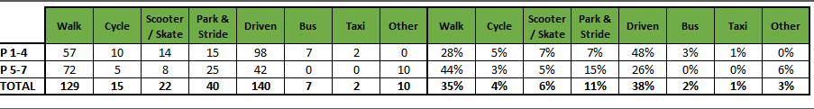

Headline messages

Active travel accounts for over half of all journeys (52%).
Direct car drop‑off has fallen sharply (38% → 27%).
Walking has rebounded significantly, especially in p5–7.

HUSS year‑on‑year comparison (whole school)
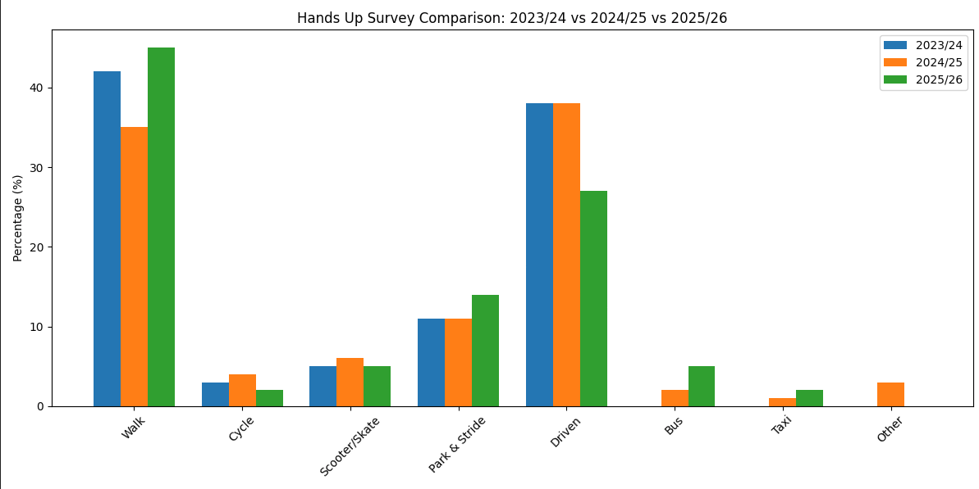

KEY TRENDS

- Large rise in walking (+10 pp).
- Substantial fall in direct car drop‑off (–11 pp).
- Park & stride becoming more embedded (+3 pp).
- Public transport use increasing, especially among older pupils.
- Data categorisation improved: “other” reduced to 0%.

Interpretation of the data

- Active travel has reached 52%, an all‑time high for the three years analysed. Walking is particularly strong among p5–7 (50%), suggesting confidence and independence increase with age.
- Significant reduction in direct car use

Direct car travel is down from 38% to 27%, pointing to:

- Successful park & stride adoption
- Improved congestion management
- Possible safety or visibility improvements
- Families substituting walking or bus journeys

Park & Stride increasingly popular - rose from 11% → 14%, especially strong in p5–7 (18%), indicating:

- Willingness among families to reduce gate congestion
- Positive school engagement with p&s messaging
- Suitable parking locations being used appropriately

Bus use increased from 0% → 5%, suggesting:

- Improved perception of bus safety or reliability
- More pupils in the catchment eligible or willing to travel independently
- Possible influence from after‑school clubs or timings

Behavioural differences by stage:-

- P1–4: still more likely to be driven (36%) but improving
- P5–7: majority walking, and more confident with park & stride and bus travel

Data Limitations

While huss provides clear and consistent mode‑share data, the current evidence base has important constraints.

No data on actual routes taken, the surveys do not capture:

- Which streets/paths pupils use
- Where pupils experience risks or discomfort
- Informal crossing points or desire lines
- Pinch points caused by traffic, parking, or narrow pavements

This prevents:

- Route‑specific risk assessments
- Prioritisation of engineering solutions
- Targeted behaviour‑change interventions in known hotspots

Limited insight from families - no qualitative data was gathered regarding family decision‑making. Missing information includes:

- Reasons behind mode choice
- Parental safety concerns
- Barriers to walking and cycling
- Car availability and parking behaviours
- Willingness to change modes

Without this, assumptions about motivators or barriers remain untested.

Reliance on single‑day snapshot surveys - because HUSS is conducted on one day:

- Data is influenced by weather, attendance, roadworks, or events
- Seasonal patterns cannot be identified
- Smaller shifts may be caused by conditions rather than true change
- Year‑on‑year tracking is less robust without secondary data sources

Sample size variability - each year the number of respondents differs, meaning:

- Small percentage changes may reflect variations in class sizes
- Minority modes (taxi, bus, cycle) may be sensitive to minor fluctuations

Lack of additional monitoring by the school - The school has not provided:

- Gate‑side observations
- Parking behaviour audits
- Staff travel data
- Longitudinal monitoring from campaigns
- Pupil or parent mapping exercises

Therefore, all findings must be interpreted within the limits of HUSS data alone.

RESIDENTIAL AREA ONLINE ROUTE AUDIT

The area benefits from wide pavements, adequate dropped kerbs, and traffic calming measures including 20 mph speed zones. There is a good network of off-road paths through the residential areas with most pupils travelling from these areas.

Key Findings:

- Pavement Quality and Width:
- Pavements throughout the area are consistently wide, allowing for safe passage of children, parents, and mobility aid users.

- Surfaces are generally smooth and well-maintained, with minimal trip hazards or obstructions.

- Dropped Kerbs and Crossing Points:
- Dropped kerbs are present at major junctions and crossing points, supporting accessibility for wheelchairs, pushchairs, and visually impaired pedestrians.

- Tactile paving is in place at most crossings, enhancing safety for visually impaired users.

- Traffic Calming and Speed Limits:
- The 20 mph speed limit is clearly signposted and contributes to a safer environment for school children. The strategic map highlights that most pupils who actively travel to school travel through these 20 mph zones.

- Residential streets show evidence of traffic calming features such as speed humps and narrowed carriageways.

- Visibility and Lighting:
- Street lighting is adequate along main routes, ensuring visibility during early morning and late afternoon travel times.

- Sightlines at junctions and crossings are generally clear, reducing the risk of vehicle-pedestrian conflict.

5. Signage and Wayfinding:
Clear 20mph speed limit signs are prominently displayed along Aberdour Road, particularly near school pick-up and drop-off points, ensuring drivers are aware of the reduced speed requirement. Within the surrounding residential areas, signage varies, providing additional reminders to maintain safe driving practices.

SUMMARY

Across three years of data, the school has seen positive improvements, notably increased active travel and reduced car use. However, progress is limited by gaps in communication and missing qualitative data.

By strengthening partnership working, participating in active travel campaigns, and forming a Frankie’s Active Campaigners Team, the school can significantly enhance travel outcomes, safety, and community engagement—while unlocking opportunities for recognition and rewards.

5.0 ACTION PLAN

Action | Solution | Action Owner
Promote School Travel Plan | - Upload plan to website and social media pages.  - Create a FACT notice board.  - Upload generic social media posts throughout each term.  - Keep the school travel plan team updated on all work carried out by completing your FACT floor book. | School
Fresh Air Frankie Awards Campaigns | Term 1  Hands up Survey Active Travel  FACT Assembly about Active Travel Month  Send out generic Social Media Posts  Active Travel Month (distribute and collect Fresh Air Frankie  Travel Passports)  Term 2  Launch #dontparkhere Campaign  FACT Assembly  Send out generic Social Media Posts  Road Safety Week  Term 3  Frankie’s Step into Spring Campaign  FACT Assembly  Big Walk and Wheel  Term 4  FACT Assembly about Active Travel Month  Send out generic Social Media Posts  Active Travel Month (distribute and collect Fresh Air Frankie  Travel Passports) | School – full details held within your FACT folder
Reduce congestion | Consider developing the following:- Parking Pledge  Walking Bus  Campaigns to increase active travel to school. | School – full details held within your FACT folder
Bikeability | Deliver Level 2 Bikeability and apply for Cycle Friendly School Award | School/Bikeability
Annual Active Travel Award | Top 3 schools that can showcase the largest increase in Active Travel to School will be crowned champions. Data will be collated from the HUSS and our own travel tracker. | School/Travel Plan Team

6.0 MONITORING & EVALUATION
The FACT will continue to meet periodically to monitor progress and amend strategies to comply with the actions set out in this plan. Specific progress will be monitored by participation in the “Hands Up Survey” each year and a review of the travel survey will take place in 2029/30.

7.0 DISTRIBUTION OF SCHOOL TRAVEL PLAN
The following bodies will receive a copy of the School Travel Plan:
• Fife Council Sustainable Transport and Travel via the Travel Plan Team
• Fife Council Education Service
• Parent Partnership
• Copies will also be made available to the parents from the School Office and via
the school information sites.

