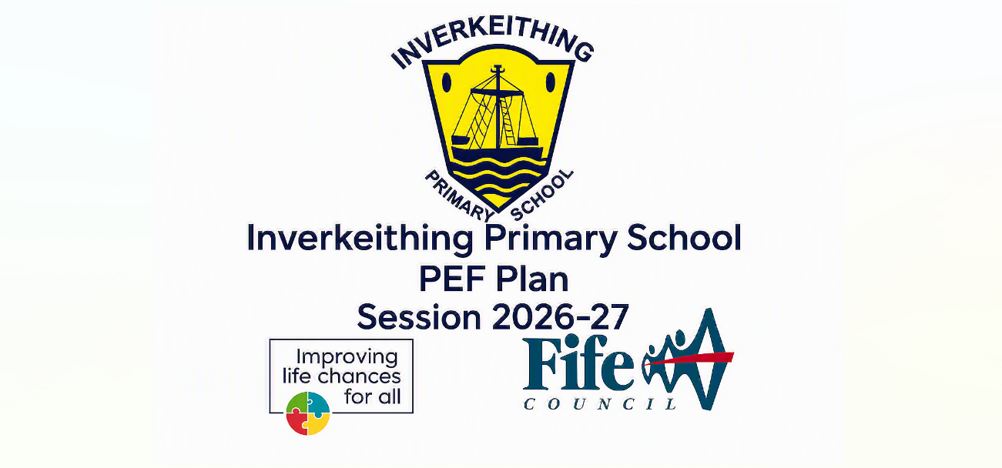
Pupil Equity Fund allocation for session 2026/27 | £ 105,350
School Context (copied from SIP)
Inverkeithing Primary School has 13 classes. 350 children attend Inverkeithing Primary School.
- 27.2% of children have Free Meal Entitlement (FME)
- 0.28% of children are Young Carers.
- 36.47% of children have an additional support need recorded.
- 1.14% of children are Care Experienced.
- 6.84% have English as an additional language.
- Our school’s average SIMD profile = 4.8
- Our school’s average attendance is 89.41%.
- Authorised absences account for 5.94%
- Unauthorised absences account for 4.64%
- We have 0.01% exclusions.

Cost of the School Day (In what key ways do you plan to mitigate against Costs within the School Day)
At Inverkeithing Primary School, we recognise the diversity in socio-economic climates within our community and the hidden costs associated with a child’s schooling. It is our mission to ensure every child has equal opportunities and experiences with a focus on inclusion. We do this by knowing our individual pupils well and understanding our duty to remove any barriers to accessing education including being able to attend school and being equipped to access learning, social and fun experiences.
We will:
- Offer free uniform
- Offer free breakfast and snack provision on a pupil self-referral basis.
- Work with partners to offer ‘cost of living’ essential basics support packs with food and household items to support families before holiday periods and presents at Christmas time.
- Publicise available benefits and free community opportunities to IPS families.
- Offer free books to children through our partnership with Better World Books and ‘The Big Hoose’
- Offer free school resources such as ties at key transition points (moving into P1, P7, S1) and bookbags for home/ school resources.
- Ensure we offer free active opportunities and clubs to children across the school.
- Have a free stock of seasonal clothing to support individuals to be included in activities (e.g. Halloween, Christmas).
- Ensure access to free period products for all users of our school facilities.
- Limit fundraising activities and give good notice of these to support family budgeting.
- Offer subsidies for as many school trips as possible and ensure staff (a) give good notice to support family budgeting and (b) keep trip costs as low as possible. We will be proactive at securing grants and subsidies to support this as well as aim to take up free or subsidised opportunities that would link and benefit children’s learning and achievements.
- Use allocated school funding (PEF, LAC funds) to support targeted interventions for specific pupils to reduce barriers to learning and achievement, engagement and enjoyment.

Stakeholder engagement  (in what ways have you engaged with your stakeholders – children/parents/community etc.) | Participatory Budgeting  (Are you using any of your PEF allocations to support participatory budgeting. If yes, what is the focus?)
Parent, staff and pupil consultations undertaken.  Learners have been surveyed on the provision they would like to see at school in our ‘What’s Going Well / Even Better If’ survey.  Responses from our Parentwise, Pupilwise and Staffwise surveys also impact on decision making of PEF expenditure.  A pupil voice group focused on targeted learners gave feedback on how targeted interventions are impacting on children at school. | Pupil Voice: including children in decision making to reduce barriers to learning at school.  Parent Voice: through questionnaires, feedback from initiatives, Parent Council will use this information to inform us about our budget expenditure.  Staff Voice: through staff meetings, questionnaires, and observations in school. We will use this information to inform our budget expenditure.

Rationale | Total PEF Allocation: £105,350
While our school has successfully narrowed the SIMD 1 vs SIMD 5 attendance and attainment gap, 30% of the school population resides in SIMD 1–4, requiring sustained focus on removing financial and learning barriers.

This plan focuses on NIF Priority 2 (Closing the attainment gap) and Priority 5 (Excellence through raising achievement).

Our school will use its £105,350 PEF allocation to ensure equitable access to resources, such as free uniforms and "cost of living" support packs, alongside high-quality professional learning for staff to implement targeted interventions towards targeted learners at risk of lower attendance, engagement and attainment because of the poverty related attainment gap. Specifically, we will:
- Use creative approaches to engage children in resilience and anti-bullying approaches to support pupil: pupil relationships and individual resilience.
- Poverty proof our children’s school experience by supporting families by contributing financially to school trips, residentials and school uniform.
- Invest in staff training for targeted learners interventions for identified learners.
- Invest in staffing to support targeted learners with individualised programmes of learning through play, numeracy, literacy and social, emotional and physical wellbeing.

PEF Priority 1: Focus on CfE Early Level Learners |  | Amount of Fund allocated (if appropriate) £ 25, 233
Expected Impact  (What is the expected impact on outcomes for children and young people) | Planned Interventions  (What is the intervention? How will it be delivered? Who is responsible?) |  | Measure of Success  (Triangulation of Evidence/QI Methodology) | Impact on children  Ongoing evaluation ongoing throughout school session/ final evaluation in June
- By June 2027, maintain or increase the percentage of P1 learners achieving Early Level in Literacy and Numeracy from a baseline by 6%  - By June 2027, ensure that 100% of P1 learners identified as requiring additional support have their needs met through the consistent application of Summary of Support documents and CIRCLE framework tools.  - Learners will demonstrate increased confidence in communication, Literacy and Numeracy skills, with BASE data showing a measurable group gain between the Start of Year and End of Year assessments. | Play-Based Engagement Improvement Idea: Upscale play pedagogy across P1-P3.  Meeting Learner Needs: Use the Fife Play Pedagogy Toolkit to move beyond "downtime" to using play for problem-solving and creativity. Continue using the CIRCLE framework and "Up, Up and Away" planning to ensure universal support is consistent.  Improving Learning, Teaching & Assessment: Deploy P6 Literacy Ambassadors to lead peer-led play tasks focusing on initial sounds and common words, which has already shown progress in BASE data regarding letter recognition and decoding.  Curricular Pathways: Strengthen transitions by embedding play-based communication tools such as story sacks and "Talking Tins". |  | Evidence from observations, tracking assessments and planning/ tracking meetings.  Reading data, high frequency words and phonic / spelling results analysed and tracked across the whole school.  Feedback from learners through surveys.  Class observations.  Learning Partnership report  Moderation between colleagues.  Baseline test of change/QI methodology  Monitoring of attainment termly.  Curriculum Development sessions throughout the year to be identified on the collegiate calendar for PL, exit passes noting next steps and impact of session)

Rationale |  |  | Amount of Fund allocated £80, 117 (shared with Priority 3)
PEF PRIORITY 2: Supporting P3-P7 Engagement, attainment and attendance
Expected Impact | Interventions Planned | Measure of Success |  | Impact on children  Ongoing evaluation ongoing throughout school session and final evaluation in June
To increase year group attainment to 90% for P3–P6 learners within the SIMD 1–4 cohorts (representing 30% of the school population), the following priorities have been identified through the interrogation of SNSA aggregate data, BASE assessments, and the Education Dashboard.  Link to SIP  - Priority 1: Improving Learning, Teaching & Assessment  - Priority 3: Strengthening Curricular Pathways | P3–P5 Priority: Targeted Literacy Intervention  - Reading Gap: 11 learners will be targeted to move toward First Level achievement; the priority is the continuation of independent High Frequency Word (HFW) groups and P3/P7 HFW buddy pairings.  - Writing Gap: 7 learners will be targeted to be supported through the application of Quality Improvement (QI) writing methodologies and Stephen Graham text types.  - Adaptive Support: Consistent use of digital supports will be prioritized for targeted learners in reading,  2. P3–P4 Priority: Numeracy Automation and Fluency  - Core Skills: Priority will be given to targeted learners to support the automation of number sequences, bonds, and times tables.  - Peer-Led Support: P6 Numeracy Champions will be deployed to provide daily input to P4 pupils, a strategy designed to increase the rigour, pace, and challenge required for attainment gains.  3. P5–P6 Priority: Scaling QI Methodologies and Leadership  - P5 Writing Focus: The PEF staff will oversee a specific P5 writing focus linked to the Fife writing assessment pack. This aims to transition more targeted learners into higher achievement bands before entering P6.  - P6 Consolidation through Leadership: Learners in P6 will be prioritised for leadership roles as Literacy Ambassadors and Wellbeing Warriors. This "leadership of learning" reinforces their own curricular knowledge while supporting lower stages. | Evidence from observations, tracking reading assessments and planning/ tracking meetings.  Reading data, high frequency words and phonic / spelling results analysed and tracked across the whole school.  BASE and NSA data, school-based reading age, spelling and numeracy assessments.  Feedback from learners through pupil surveys.  Class observations.  Learning Partnership report Moderation between stage partners and cluster colleagues.  Baseline test of change/QI methodology Monitoring of attainment termly.  Curriculum Development sessions throughout the year to be identified on the collegiate calendar for PL, exit passes noting next steps and impact of session)

 |  | Amount of Fund allocated £80, 117 (shared with Priority 2)
PEF PRIORITY 3: Supporting Engagement, Health and Wellbeing
Expected Impact | Interventions Planned |  | Measure of Success | Impact on children  Ongoing evaluation ongoing throughout school session and final evaluation in June
Support Engagement for targeted pupils in P7, P3 and P4 that leads to improved outcomes for 20% of learners | Cross-Stage Priority: Removal of Barriers  - Health and Wellbeing: Use Glasgow Motivation and Wellbeing Profiling for 10% learners in P7, P3 and P4 to measure the impact of supported timetabling for identified learners, ensuring they are emotionally ready to engage in literacy and numeracy tasks.  - Health and Wellbeing: Support 10% of P7, P3 and P4 targeted learners through a life skills curriculum to support engagement.  - Engagement: Maintain an exclusion rate of 0% through nurture-based approaches, ensuring that targeted learners remain "active participants" in "settled episodes of teaching and learning".  - Attendance: Targeted monitoring of families at risk of falling below 85% attendance, as attendance is recognized as a "key impactor of attainment". A specific focus will be on cohorts with less than 90% attendance (P4, P6 and P7). |  | Evidence from Glasgow Motivation and Wellbeing Profiling  Feedback from learners through pupil surveys.  Class observations.  Learning Partnership report  Moderation between stage partners and cluster colleagues.  Baseline test of change/QI methodology Monitoring of attainment termly.  Attendance and exclusion monitoring data

