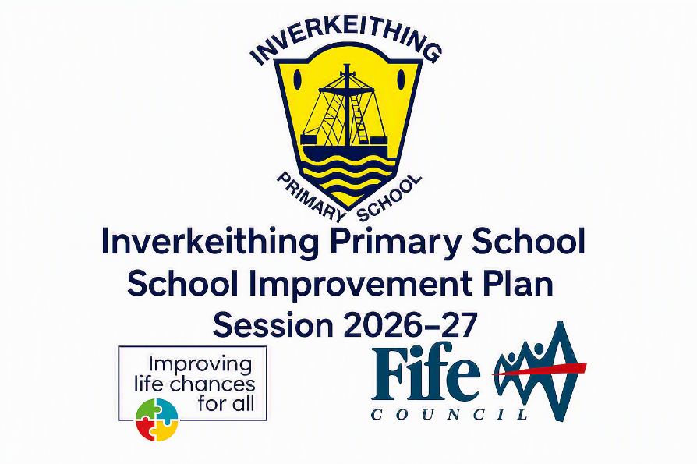

Inverkeithing Primary School Session 2026-2027 Improvement Plan
Education Directorate Improvement Plan: Improving Learning, Teaching & Assessment
Focused Priority 1: Improving Learning, Teaching and Assessment
HGIOS4 Quality Indicators |  | 1.3 Leadership of Change, 2.3 Learning, Teaching and Assessment, 3.3 Increasing Creativity and Employability
Expected Impact |  | Strategic Actions Planned | Responsibilities | Measure of Success  (Triangulation of Evidence/QI Methodology) | Timescales
Almost all teaching staff (95%) will self-evaluate an increase in confidence using digital pedagogy, transitioning tasks effectively across the SAMR model to enhance learner engagement | 1.Embedding Digital Pedagogy: Continue the rollout of the Transforming Learning Programme. Staff will engage in WTA-specified professional learning using Apple Education Community resources to impact positively on teaching and learning experiences. Collegiate Peer collaboration opportunities. |  | Transforming Learning Leads (SW, DH), and All Staff | 95% of staff will report increased confidence in digital pedagogy;  Evidence of SAMR model in forward planning,  PRD meetings  Termly CLPL, staff meeting and INSET evaluations | By May 2027
Learners will have an accurate understanding of their progress through high-quality, actionable feedback. Use of Showbie will bridge the gap between assessment and learning | 2. Developing Feedback: Implement a consistent whole-school approach to teacher, peer, and self-assessment. Feedback will be explicitly linked to success criteria and delivered through a variety of formats (written, oral, and digital via Showbie). Collegiate Peer collaboration opportunities planned. |  | All Teaching Staff and SLT | Pupil views show increased confidence in identifying next steps;  consistency in feedback quality across jotters and digital platforms | Termly focus:  Teacher: By Oct 26  Peer: By Dec 26  Self-assessment: By Mar 27
Learning environments (digital and physical) will be optimised to support universal and targeted needs, ensuring settled and well-organised teaching and learning opportunities. | 3. Learning Environments: Enhance physical environments with Learning Walls and concrete materials to celebrate and support learning.  Manage digital devices to ensure they are accessible and linked to literacy/Numeracy priorities. Collegiate peer learning walks planned during collegiate time (WTA). |  | SLT, SfL (CH) and Class Teachers | Learners independently select and use physical and digital resources to meet individual needs  Classroom monitoring feedback in Term 1 and Term 3  Planning and tracking meetings termly | By Oct 26  Classroom monitoring feedback in Term 1 and Term 3  Planning and tracking meetings termly
Ongoing Evaluation
Progress will be reviewed against the "continuing journey from good to very good" as validated by external Learning Partnership visits and internal QI methodologies

Education Directorate Improvement Plan: Meeting Learner’s Needs
Focused Priority 2: Meeting Learner’s Needs
HGIOS4 Quality Indicators | 1.2 Leadership of Learning, 2.4 Personalised Support, 3.1 Ensuring Wellbeing, Equality and Inclusion, 3.2 Raising Attainment and Achievement
Expected Impact | Strategic Actions Planned | Responsibilities | Measure of Success  (Triangulation of Evidence/QI Methodology) | Timescales
Almost all learners will feel that their rights are at the heart of school life, evidenced by increased positive responses in pupil surveys re: safety and feeling valued | 1. Embedding a Rights-Based Ethos: Progress the school's journey towards the Rights Respecting Schools Award. Create diversity and equity calendar. Implementation of Digital Profiles to support tracking of pupil experiences, attainment and achievement. | SLT, RRSA Lead (CH), All Staff. | Achieving Bronze/ Silver RRSA status;  Pupil survey data shows >90% of pupils feel safe and welcome, Learning Partnership observations
Learners will take meaningful responsibility for school improvement by leading evidence-gathering, increasing their "sense of belonging" and independence | 2. Strengthening Pupil Leadership and Self-Evaluation: Embed "How good is OUR school? “(Part 2) framework. Pupils lead "Learning Walks" to evaluate learning environments and use data (e.g., attendance and attainment) to propose improvement priorities. "Look Outward" visits or collaborative projects with other settings | DHT, Class Teachers, Pupil Leadership Groups (Wellbeing Warriors, Numeracy Champions). | Pupil-led impact reports shared with staff and parents; evidence of pupil influence in the 2027/28 SIP, Learning Partnership feedback
Targeted cohorts of inactive children will show increased engagement in physical activity | 3.Enhancing Physical Wellbeing: Target children identified as "inactive" for bespoke opportunities supported by Active Schools, ensuring equity of access to after-school provision. Create whole school playground charter and review playground resources. | Active Schools Coordinator (NH), SLT. | Increased participation rates for targeted cohorts (SIMD 1-3); improved well-being profiles, Active Schools data
Children across all stages will experience "challenging and enjoyable" learning through play, leading to measurable gains in Literacy and Numeracy | 4. Upscaling Play-Based Learning Approaches: Replicate Early Level success across the school using the Fife Play Pedagogy Toolkit. Focus on creativity and problem-solving through play, supported by P6 Literacy Ambassadors/ Numeracy Champions in peer-led play. "Look Outward" visits or collaborative projects with other settings | Early Level Lead (RG), Stage Partners, All Teaching Staff. | Learning Partnership validation of play pedagogy consistency across stages,  Classroom monitoring.
Ongoing Evaluation
This should be updated as part of on-going cycle of self-evaluation

Education Directorate Improvement Plan: Strengthening Curricular Pathways
Focused Priority 3: Strengthening Curricular Pathways
HGIOS4 Quality Indicators | 1.2 Leadership of Learning, 2.2 Curriculum, 2.3 Learning, Teaching and Assessment, 3.2 Raising Attainment and Achievement
Expected Impact | Strategic Actions Planned | Responsibilities | Measure of Success  (Triangulation of Evidence/QI Methodology) | Timescales
By June 2027, raise attainment in writing across all stages by 8%. Staff will demonstrate increased professional confidence in writing pedagogy across all text types | 1. Raising Attainment in Writing: Embed a consistent whole-school approach using Stephen Graham text types and cluster approaches. All staff will participate in termly Cluster ‘Writing Sprints’ and moderation cycles to ensure high-quality teaching and assessment. Termly moderation opportunities in cluster and school pairs. | HT/SLT, Literacy Lead (DS), and All Teaching Staff. | 3% increase in writing attainment (P1, P4, P7) from baseline data, jotter monitoring, Learning Partnership observations,  Termly Evidence Showcase where staff and pupil leadership groups present data/impact from their "test of change" cycle | 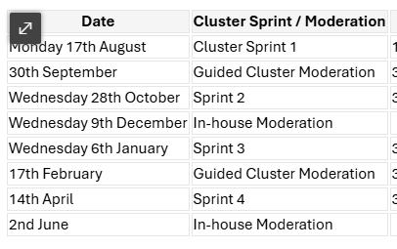
Learners across all levels will communicate with greater confidence and reasoning. Staff will have a shared understanding of Listening and Talking progression from Early to 2nd level. | 2. Developing Progressive Listening and Talking: Audit current opportunities and create a clear Listening and Talking progression pathway based on CfE Benchmarks. Provide professional learning on dialogic teaching and accountable talk to improve the quality of teacher professional judgements | SLT, Literacy Lead (DS), and All Teaching Staff. | Almost all staff report increased confidence in assessing Listening and Talking; learners justify opinions using evidence in Second Level leadership roles | Term 3/ Term 4
Almost all staff will report increased confidence in PE delivery, leading to physical activity sessions that support learner wellbeing | 3. Enhancing PE through Targeted CLPL: Engage in termly CLPL sessions in partnership with Active Schools. Focus on upskilling staff in specific PE approaches to ensure high-quality, inclusive delivery across all stages | SLT, Active Schools Coordinator (NH), and All Teaching Staff. | Staff self-evaluation shows increased confidence in PE pedagogy; pupil feedback indicates higher engagement in PE sessions | By June 2027
Increased understanding amongst staff related to Education Scotland’s Curricular Improvement Cycle | 4. Termly updates organised through WTA. Education Scotland and Fife materials will be used to update staff and support engagement with draft materials. | SLT and All Teaching Staff. | Staff self-evaluation shows increased confidence, curricular improvement cycle information and draft documents. | By June 2027
Ongoing Evaluation
Progress will be evaluated through the rigorous interrogation of attainment data and external validation from Learning Partnership visits, ensuring pathways provide "continuity and progression in learning"

