###### Hill of Beath Primary School

###### Promoting Positive Behaviour Policy

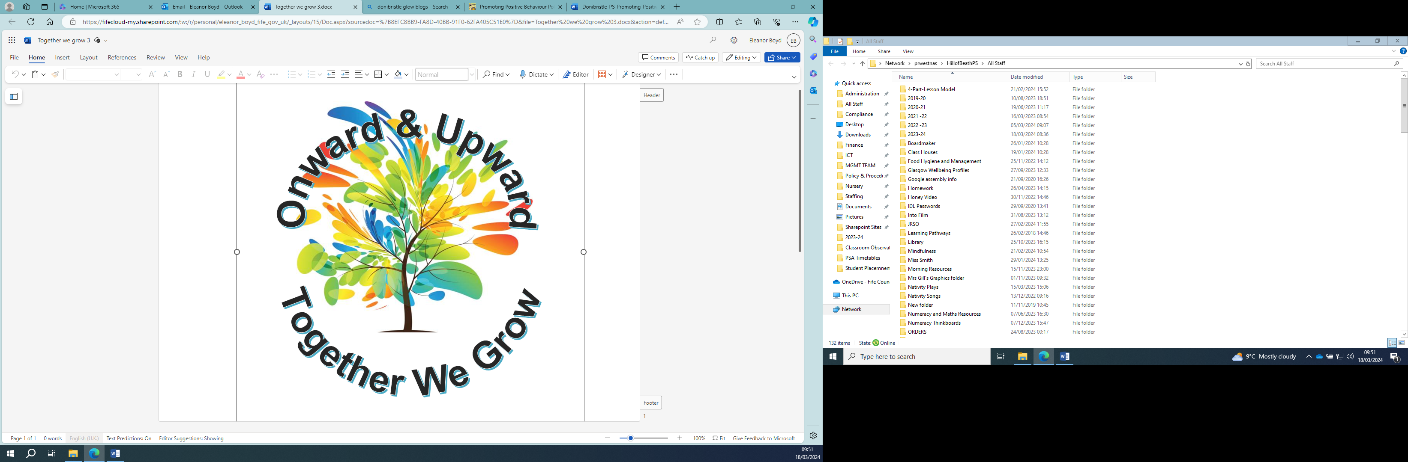

**Rationale**

The United Nations Convention on the Rights of the Child (UNCRC) underpins our Positive Behaviour Policy:

Article 28 – Discipline in schools must respect children’s dignity.

Article 29 - Children’s education should help them fully develop their personalities, talents and abilities. It should teach them to understand their own rights, and to respect other people’s rights, cultures and differences. It should help them to live peacefully and protect the environment.

“All stakeholders promote a climate where children and young people feel safe and secure.”

“The learning environment is built on positive, nurturing and appropriately challenging relationships which lead to high-quality learning outcomes.”

[How Good is Our School (HGIOS 4) (2015](https://education.gov.scot/nih/Documents/Frameworks_SelfEvaluation/FRWK2_NIHeditHGIOS/FRWK2_HGIOS4.pdf))

At Hill of Beath Primary School we believe that positive behaviour is essential for effective learning and teaching. Our behaviour policy is based on our school values of Teamwork, Respect, Unique, Nurture and Keen. We are committed to helping children to reach their full potential in a safe and nurturing environment.

**Vision, Values and Aims**

**Vision**

Onwards and upwards, together we grow.

**Values**

* Teamwork
* Respectful
* Unique
* Nurturing
* Keen

**Aims**

* To work together to promote a safe, nurturing and happy environment.
* To treat each other with kindness and respect.
* To recognise individuality and support each other to recognise and develop our skills and talents.
* To try our best, be resilient and be the best we can be

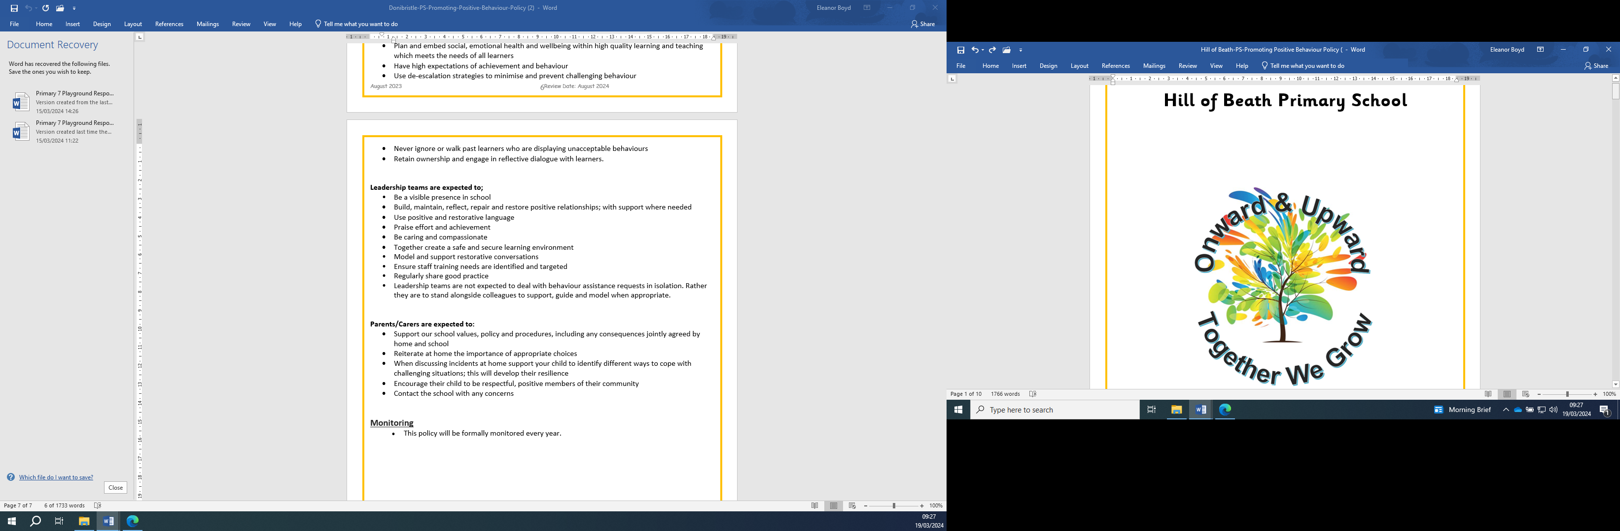

**Promoting Positive Behaviour**

**De-escalation**

De-escalation refers to the process of diffusing difficult situations or conflicts as they begin to prevent them from getting worse. De-escalation can minimise and prevent challenging behaviour and support learners to make positive choices.

*Key principles of de-escalation:*

* Triggers are identified
* Staff use strategies such as remaining calm, listening actively, offering positive choices, asking questions, and remaining solution focused.
* Early intervention strategies are used to support pupils and prevent or limit escalation
* An action plan is created to support pupils in managing their responses
* Situations that occur are reviewed when the pupil is able to do so

**Restorative Approaches**

Restorative approaches help to support pupils, school staff and parents to understand the impact of behaviour on others.

*Key principles of Restorative Approaches:*

* Individuals taking responsibility for their actions
* Respecting other people’s views and feelings
* Empathising with others
* Being fair
* Repair and move forward from situations

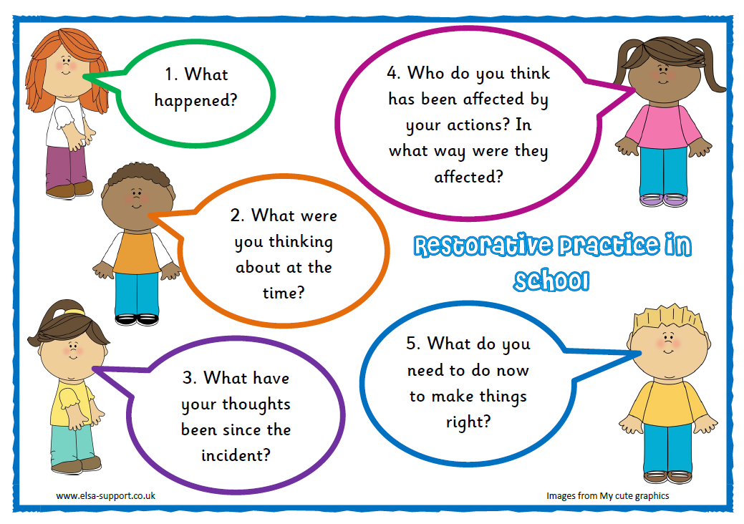

**Roles and Responsibilities -** Promoting positive behaviour is the responsibility of all. It is important that pupils, staff and parents / carers

**Pupils are expected to:**

(Our Rights Respecting Schools Committee were involved in creating Playground and School Charters.)



[This Photo](https://www.thebluediamondgallery.com/wooden-tile/c/charter.html) by Unknown Author is licensed under [CC BY-SA](https://creativecommons.org/licenses/by-sa/3.0/)

**Playground Promise**

**I will:**

* respect all staff, children and equipment while in the playground
* keep my hands and feet and unkind words to myself
* play appropriate games.
* take care of others
* take care of the environment
* keep safe in the playground by following the rules
* work as part of a team to make playtimes happy

**School Charter**

**I will:**

* respect myself, others and property
* keep my hands and feet and unkind words to myself
* take responsibility for my learning
* take responsibility for the choices I make
* respect the rights of others
* walk SMARTLY.
* show SMART listening
* follow instructions
* try my best at all times
* have a ‘can do’ attitude

**Roles and Responsibilities continued**

**Staff are expected to:**

* Create a safe and secure learning environment
* Be caring and compassionate
* Have high expectations of achievement and behaviour
* Promote and model positive behaviours and relationships
* Use positive and restorative language
* Use de-escalation strategies to minimise and prevent challenging behaviour
* Praise effort and achievement

**Leadership is expected to:**

* Be a visible presence in the school
* Build, maintain, reflect, repair and restore positive relationships; with support where needed
* Model and support restorative conversations
* Praise effort and achievement
* Ensure staff training needs are identified and targeted
* Regularly share good practice

**Parents are expected to:**

* Encourage their child to be respectful, positive members of their community
* Reiterate at home the importance of appropriate choices
* Support our school values, policy and procedures, including any consequences jointly agreed by home and school
* Support their child to identify different ways to cope with challenging situations to develop their resilience
* Contact the school with any concerns

**Positive Behaviour Strategies**

We use a range of positive behaviour management strategies including:

|  |  |  |
| --- | --- | --- |
| **Universal** | **Additional** | **Targeted** |
| * **Star of the Week** * **Class of the Week** * **Wider Achievements** * **Good Citizenship Award** * **House Points** * **Recognition Boards** * **Verbal praise of effort and achievement** * **Non-verbal praise (smile / positive body language)** * **Doubling up Praise (Mr / Mrs … was telling me, or showing learning to another adult in school)** | * **Small group support by PSAs** * **Small group support by SFL Teacher**   **Pupil Leadership Activities**   * **Pupil Council** * **Eco Committee** * **Junior Road Safety Officers** * **Librarians** * **Playground leaders** * **Peer Mediators** * **P7 Buddies** | * **Scripts** * **Passports** * **Proactive Management Plans** * **One-to-one support by PSA** * **Referral for specialist advice / support** |

**We have a whole school approach to deal with behaviour that is in line with our school charter.**

Step 1 – Reminder about expected behaviour as agreed on the school charter.

Step 2- Verbal warning and a reminder about the expected behaviour as agreed on the school charter.

Step 3 – Final verbal warning and a reminder about the expected behaviour as agreed on the school charter.

Step 4 – Radio for assistance. HT / PT will visit the pupil in class and discuss their behaviour / choices.

Step 5 – The CT / HT / PT will have a restorative chat in a quiet area to discuss choices. Pupil will have time to reflect during break.

Step 6 – Carers / parents will be contacted to inform them of inappropriate behaviour / choices of their child. Parents / carers will be asked to work cooperatively with the school to reiterate the values and expected behaviour agreed in the school charter.

If behaviour is significantly disrupting learning in the classroom, staff should radio for assistance immediately.

Pupils displaying violent behaviour should be immediately referred to the management team.