Guardbridge Primary
School Travel Plan



Headteacher: Mrs Kate Balsillie

School address: Innerbridge Street
Guardbridge
KY16 0UZ

Telephone No: 01334 659419
Social Media/Website: Website



Contents Page

3: 1.0 WHY HAVE A SCHOOL TRAVEL PLAN

3.: 2.0 BENEFITS OF HAVING A SCHOOL TRAVEL PLAN

4: 3.0 Current Travel Habits

3.1 Family Questionnaire Data

9: 3.2 Staff Questionnaire Data

11: 4.0 ROUTE AUDIT OF KEY ROUTES TO SCHOOL

4.1 Access Arrangements

12: 5.0 ACTION PLAN

14: 6.0 MONITORING AND EVALUATION

15: 7.0 DISTRIBUTION OF SCHOOL TRAVEL PLAN

16: APPENDIX 1 – ROUTE AUDIT REPORT
1.0 Why have a school travel plan

School-related traffic congestion and the risks congestion poses to the safety of the pupils, teachers, parents, residents, and motorists in and around school locations is a significant problem in communities around Fife.

The most obvious cause of traffic congestion around our schools is vehicles, and the biggest source of those vehicles is parents’ dropping off and picking up their children from school.

Statistics highlight that 1 in 4 cars during the hours of 8:30 to 9:15 and 2:30 to 3:15 is primary school traffic.

Our annual Hands Up Survey highlights that 23%, that’s 5562 primary school children are driven to the school gate each day with a further 17% opting to Park and Stride. That is an additional 4111 pupils being driven in and around the school streets.

Fife Council’s Road and Transportation Service are working with schools in Fife to develop School Travel Plans and support Junior Road Safety Officers to develop campaigns such as Walking Buses, Park n Stride sites, Parking Pledges, available routes to school maps, delivery of Bikeability as well as looking at any engineering works that may be required to make active travel to school your first choice of travel.

2.0 BENEFITS OF HAVING A SCHOOL TRAVEL PLAN?

The benefits of encouraging active travel are clear and a school travel plan can ensure that your school has a long–term vision with aid to support Junior Road Safety Officers with delivering campaigns to;-

- Improve health and well-being by reducing harmful emissions and increasing activity levels.
- Improve safety through engineering measures and increasing road safety education.
- Improve access and opportunity by developing pupils’ skills for safe and independent travel.
- Improve the environment by reducing pollution and CO2 emissions.
- Gain school accreditations such as Fresh Air Frankie STP Awards, Active School Award Eco School Award, Cycle Friendly School Award
- Have access to additional funding and support.

All work associated with School Travel Planning has been designed to fit into the Curriculum for Excellence.

3.0 CURRENT TRAVEL HABITS

Each year all Fife schools undertake the Hands Up Survey which gives a true reflection of how pupils are travelling to school and the latest results show that 64% of pupils are actively travelling to school with a further 35% being driven and the rest via school transport.

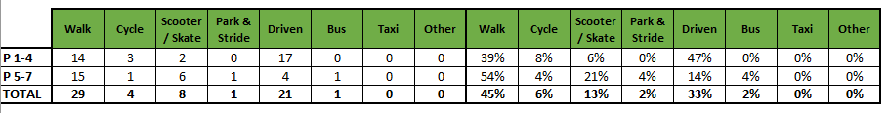

3.1 Family Questionnaire

22 families answered the school travel plan online questionnaire, and the results are detailed in the graphs and text below.

How do you normally travel to and from school?

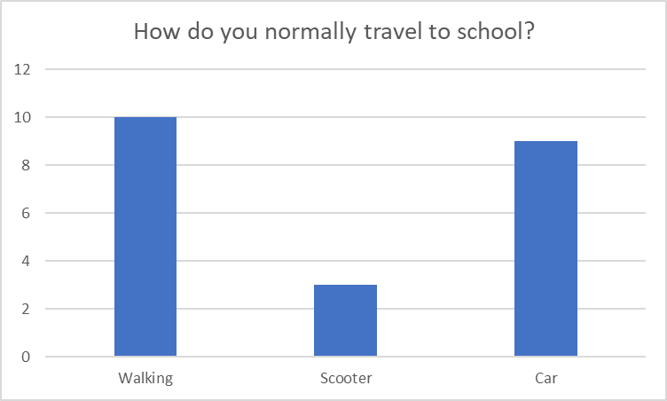

Those parents who are already actively travelling to school were asked if they would like to volunteer to help the school set up a walking bus, 3 parents said that they would.

Analysis of those who lived within 1 mile of the school highlighted that there were a few families who opted to drive this short distance.

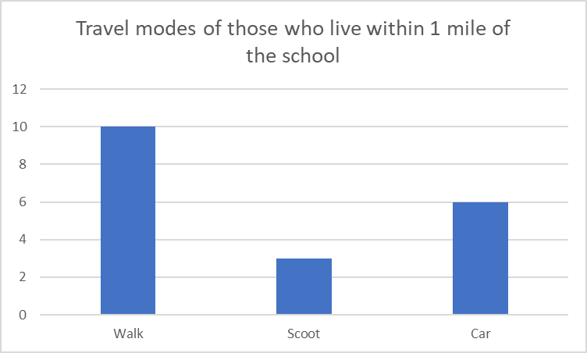

All parents who stated that they drive to school were asked if they would consider using a Park and Stride Site away from the school gate to help with congestion all stated yes and that they would prefer a site that was within a 5-minute walk to the school.

Those parents were then asked what could they do to help with safety concerns with regards to parking around the school gate?

- Bigger car park facilities
- Park further away. We drive due to work commitments, and it is not safe enough for them to walk independently.
- I have 1 child at Leuchars so have to drop both of by car since there is no nursery in Guardbridge.
- People need to stop parking in the yellow lines around the gate area. Parents also need to come into the playground instead of congregating around the gate and blocking the path.
- We do try to park away from the school gate although it's difficult when trying to turn in the street.
- I never park near or on the yellow lines, but a lot of cars do and just speed off once their child is in. People don’t seem to understand the yellow lines are there for a reason and I find it very selfish! I only use car when I’ve to go to work or coming back from work.
- Have a walking school train with possibly parents who walk their children as helper/volunteers
Parents were then asked if they wanted to add anything else about their journey to school.

- Having somewhere to safely drop her off to be able to continue onto nursery in Leuchars
- Get parents to stop blocking the gate.
- We wouldn't mind cycling however it's weather dependable. Also the main road to cross into Guardbridge is extremely busy.
- I only come to school by car when I’ve to rush off from work or on way back from work and getting parked is a complete nightmare sometimes people just seem to park where if they like because they can’t be bothered to walk 5 minutes up the hill. People have no care for the zig zags and I think you might need to start enforcing something and fining these people think it’s the only way to stop this.
- Walking to and from school is always my preference however weather doesn’t always allow this. Part of the issue at Guardbridge is the amount of parents who stand outside the gate rather than entering the playground to collect their child. This completely blocks the pavement forcing those exiting to walk on the road.
- Currently it's tricky with ongoing roadworks on the main road, traffic lights etc and also construction vehicles from the new housing estate. Pathways that should be in place aren't and this is one of the reasons I don't let my child walk to school on their own.
- We need car to go straight to work from school so walking isn’t practical. When they are picked up by grandparents they walk home.

3.2 Staff Questionnaire

How far do you travel for work?
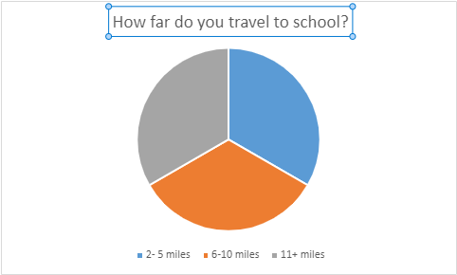

As most staff stated that they drove to school they were also asked if they would like to consider car sharing.

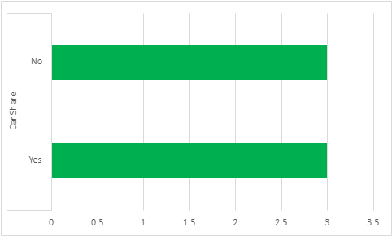

They were also asked if they would like to undertake Bikeability training to deliver cycling in school and all teachers answered no.

When asked what would encourage them to consider an alternative mode of transport to work, they replied.
nothing
- Cheap/Free and RELIABLE buses (Fife's are not)
- If I lived closer to work
- too far no time
- car

Finally, when asked are there any improvements you could make to your journey to ensure the routes to school are less congested, again, all stated no.

4.0 MAPPING WORK AND ROUTE AUDIT

A mapping exercise was carried out within the school to identify the routes pupils travelled. These were then analysed and then categorised as active travel routes (green) and vehicular routes (orange).

4.1 Access Arrangements

There is one main entrance to the playground for pedestrians/cyclists and another for car users. Vehicular access to the playground is restricted to staff and delivery/works vehicles.

The school is situated at the end of a narrow street which has no through access. Vehicles must turn in the street to exit which in itself is a hazard to other road users and pedestrians.

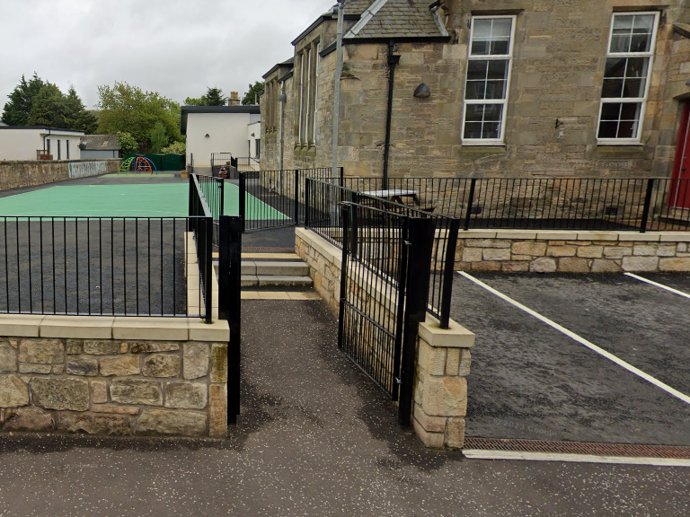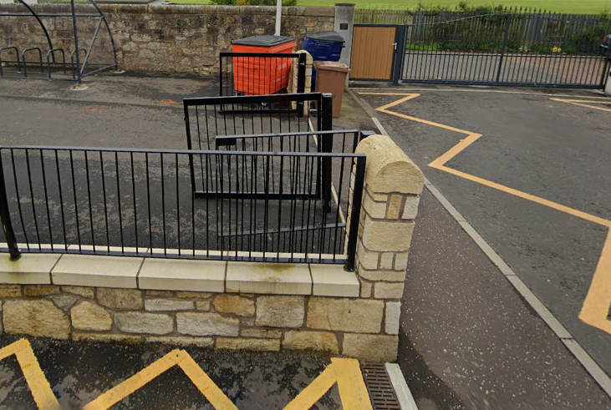

5.0 ACTION PLAN

Action | Solution | Action Owner
Promote School Travel Plan | - Upload plan to website and social media pages  - Create a JRSO notice board or story board  - Create articles for school newsletters, social media, and assemblies,  - Keep the school travel plan team updated on all work carried out to include in the Fresh Air Frankie termly newsletter. | School
Travel Tracker | - Update the travel tracker every day | School
Local and National Campaigns | Term 1  Week 1 Hands up Survey Active Travel  Week 2 Cycling Competition  Week 3 Bike Week  Week 4 Interschool Active Travel Challenge  Term 2  Week Launch #dontparkhere Campaign  Week 2 Parking Letter to Parents  Week 3 Road Safety Week  Week 4 Be Bright Be Seen Competition  Term 3  Create an active travel leaflet for the new starts that can be included in the school induction pack.  Big Walk and Wheel  Term 4  Week 1 Walk to School Week  Week 2 Scoot to School Week  Week 3 Active Travel Treasure Hunt  Week 4 Bike to School Week | School  School/Travel Plan Team
Reduce congestion | Consider developing the following:- Parking Pledge  Park N Stride Site  Walking Bus | School/Travel Plan Team
Bikeability | Deliver Bikeability | School/Bikeability Team
Awards | Work towards gaining the Fresh Air Frankie School Travel Plan and  Active Schools Award | School/Travel Plan Team

6.0 MONITORING & EVALUATION
The JRSO will continue to meet periodically to monitor progress.
Specific progress will be monitored by participation in the “Hands Up Travel Tally” each year and a repeat of the full travel survey will take place in 2027. The school’s ongoing commitment to travel planning will be publicised in the school handbook, the school newsletters, the Parent’s notice board and through assemblies.

7.0 DISTRIBUTION OF SCHOOL TRAVEL PLAN
The following bodies will receive a copy of the School Travel Plan:
• Fife Council Roads and Transportation via the Travel Plan Team
• Fife Council Education Service
• Fife Council School Estates Team
• Parent Partnership
• Active Schools
• Copies will also be made available to the parents from the School Office and via
the school information site.
Route Audit

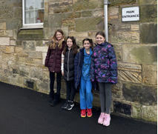

1. INTRODUCTION

1.1 This report results from a Safety Audit, undertaken on 25 January 2024, of key routes taken by children attending Guardbridge Primary School at the request of the school.

1.2 The audit team consists of:

- Trudy Brown – Travel Plan Coordinator (Sustainable Transport & Parking)
- Kate Balsillie – Headteacher at Guardbridge Primary
- 4 pupils from Guardbridge Primary

1.3 The school is situated on Innerbridge Street. Innerbridge Street forms part of a 20mph zone and is part of the adopted public road network.

1.4 The routes audited were Innerbridge Street, Motray Park, Main Street, Eden Grove and Seggie Drive.

2. Routes Audited

2.1 Innerbridge Street and Motray Park

Issue
Innerbridge Street is a residential street where the school is situated. The is only one way in and out of the street, which means that cars have to turn at the school gates making this unsafe for pupils. The school wall has been damaged on a few occasions from parents reversing into it.

Motray Park is a street that runs off the bottom of Innerbridge Street Leading to the Bowling Club. There is an area/car park at the end which could be used as a turning point.

Recommendation

Look at promoting Motray Park as a possible drop of and pick up location. There is good access to a turning point at the bowling club for cars to safely turn and children can be dropped off and walk up Innerbridge Street.

Action

JRSO’s can create campaigns or a school leaflet to show where the suggested drop off point is and to highlight the need to reduce congestion at the school gates.

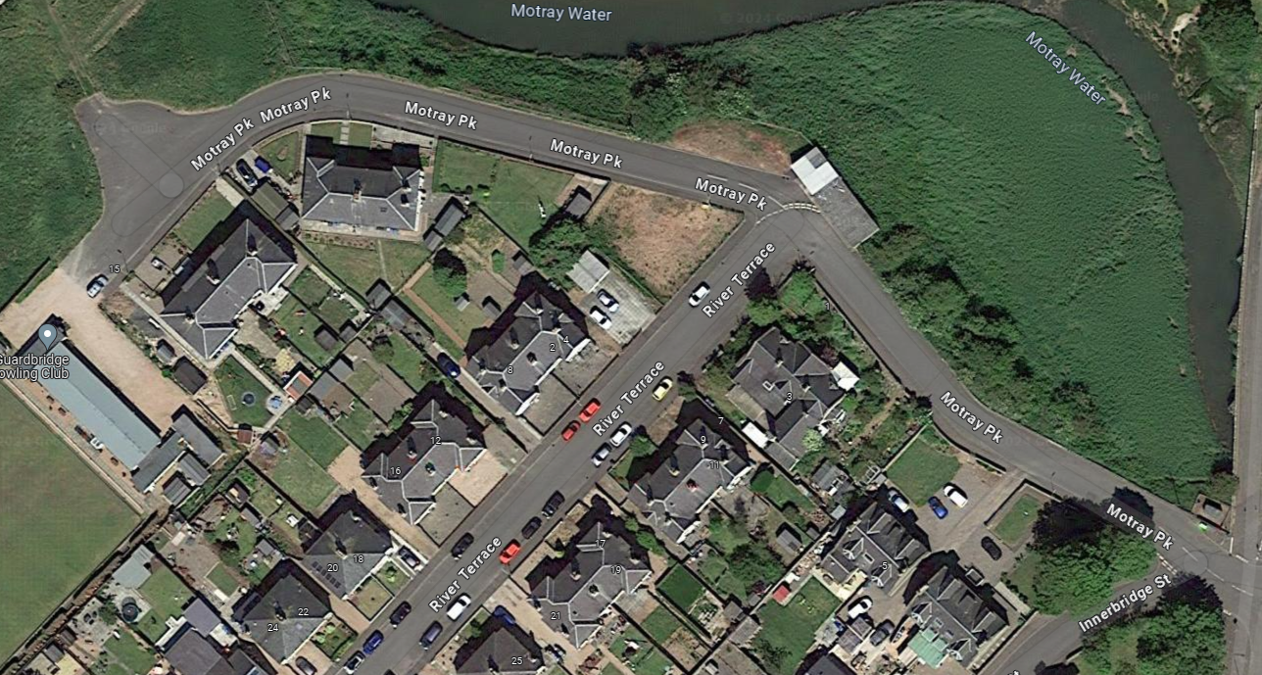

2.2 Main Street

Issue
Main Street is a very busy main access road in to Guardbridge from Leuchars and Dundee leading to St Andrews. The road is also used to access St Andrew’s University Buildings and Eden Mills Brewery. However to access the new housing estate there is a segregated pathway a short distance along Main Street which takes pupils/pedestrians away from the main road. This provides a safer route. Residents of the new housing estate have created a pathway from Eden Grove to Main Street down a grassy verge.
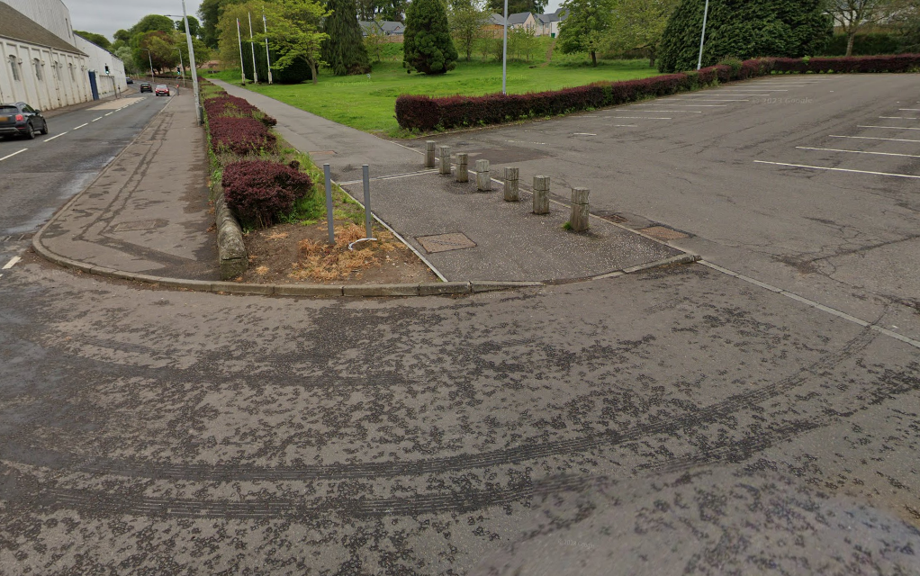

Recommendation

There are no noticeable issues with infrastructure along Main Street and the links to the new housing estate are good. We recommend that pupils are advised to stick to the main pathways as opposed to taking short cuts over the muddy grass hill to Eden Grove.

Action
General Road Safety lesson on being aware on busy roads and to stick to designated paths for safety.

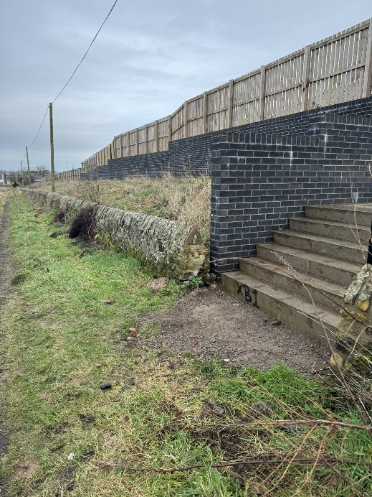
2.3 Eden Grove and Seggie Drive

Issue
Eden Grove and Seggie Drive are part of the new housing estate in Guardbridge. The streets although residential do seem to be quite busy with delivery drivers, residents and site workers as the scheme is still being developed. Children were aware of driveways and to be vigilant when crossing them.
There was plans to connect Seggie Drive and Eden Grove to a Pathway via the Farmers field however this did not happen due to 2 houses being built at the end of Innerbridge Street.

Recommendation
There are no noticeable issues with infrastructure.

Action
The school travel plan team will try to investigate to see if there are any plans for the access stairwell to the farmers field to be connected to the alley way at the bottom of the field to main street.

3.0 Summary

The condition of routes around Guardbridge Primary School are good. Identifying safe routes and promoting these as part of the Travel Plan is essential to improve safety and encourage sustainable travel, which will also help educate pupils in road safety.

