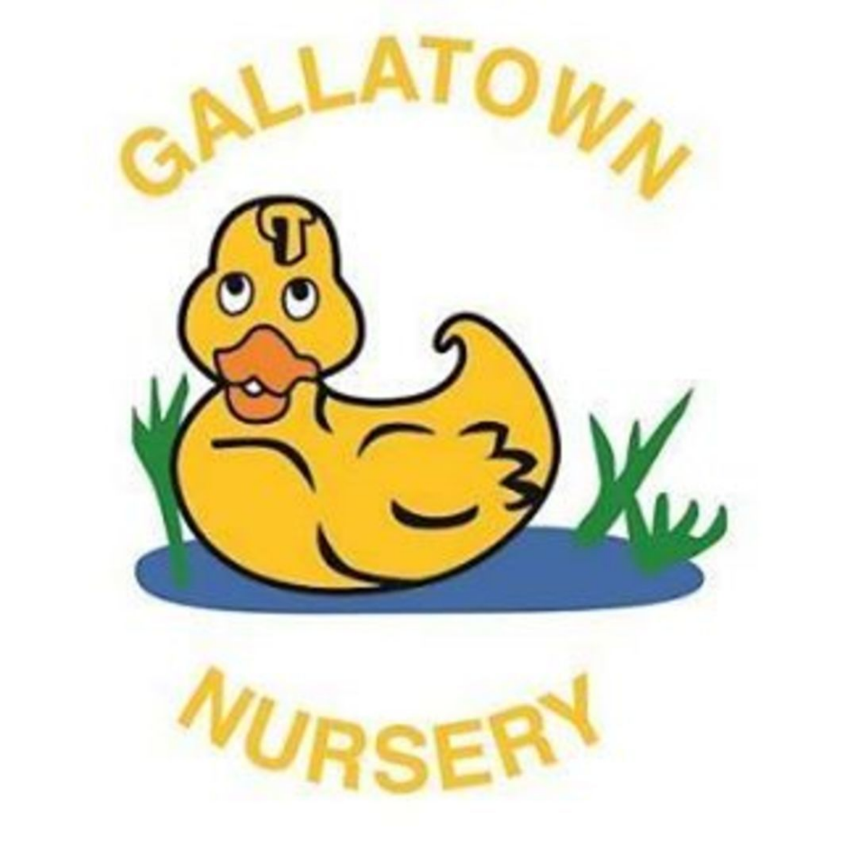
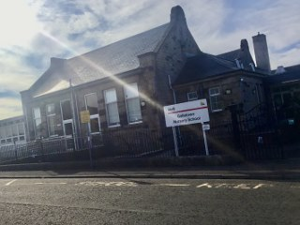
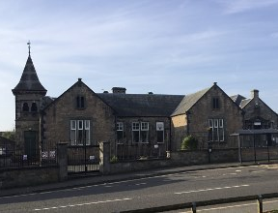
Standards and Quality Report
2024-2025

Gallatown Nursery
Context of the School
Demographic | At Gallatown Nursery there are 150 pupils, comprised of:  N3 – 30 N4 – 51 N5 – 69
  SIMD: | Cohorts of pupils include:
    Band 1 | 42%
    Band 2 | 24.7%
    Band 3 | 8.7%
    EAL | 11%
    ASN | 10%
    LAAC | 1%
    Deferral Year | 11%
Vision, values and aims | Our Vision  To provide a welcoming, safe, secure and inclusive learning environment. Children develop life skills that will enable them to become respected and valued members of the community.  Our Mission Statement  Nurture & C.A.R.E together  Our Values  - Child centred  - Achievement  - Relationships  - Equity  Our Aims  Children – Our children will experience a nurturing, child-centred, rich environment where they have fun, explore, play, learn and are supported by highly skilled practitioners.  Parents – A welcoming, nurturing environment where families feel their children can flourish and reach their potential.  Practitioners – Working together to create a positive learning ethos where all practitioners are included and valued. Providing high quality support and learning opportunities for children and families.  Professional Partners – Children and their families are getting the right support from the right people at the right time.  Safety – We are committed to creating and maintaining a safe and enjoyable environment for our children and colleagues.
Attendance | Attendance is non-compulsory at nursery however we do monitor attendance and support children and families where appropriate, our termly and overall attendance is:
  Term 1 | Term 2 | Term 3 | Term 4 | Overall
  89% | 86% | 86% | 85% | 87%
Summary of consultation with stakeholders | Families are consulted in a variety of ways throughout the session including weekly cuppa chats, termly Parent Forum, question of the month/term, regular informal discussions and questionnaires. The questionnaires reflect on the current work of the setting and consider engagement from families in setting future development priorities. We also engage with families through our family learning programmes and tailor this to meet their current needs. Staff and children’s views are also sought throughout the session. Staff have regular opportunities to engage through staff updates, collegiate sessions and questionnaires. Children’s views have been sought through responsive planning, KWL planning and pupil focus groups. Our partners are also consulted on an ongoing basis through a short survey which helps to evaluate the setting.
Cost of the School Day statement | At Gallatown Nursery we recognise the need to minimise costs to our families. As a setting we ensure nursery is free at the point of entry, provide all outings free of charge, provide additional snack on a daily basis, termly support through our Market day where families can link with agencies and also secure household essentials/toys/clothes and provide Fareshare on a weekly basis. We also provide support to families through our family learning programme which helps families to develop new skills and support such as budgeting and outdoor learning activities that they can engage in with their child for free. Through our Family Learning Programme we also offer Breakfast with Bookbug which is an opportunity for families to share a special breakfast together. Annually we hold a sponsored event to raise funds to provide additional items to enhance learning, all children participate to ensure equity and equality. During the summer we also provide sunhats and suntan lotion to help minimise costs to families.

Summary of Progress and Impact from last session’s Improvement Plan and Next Steps

School Improvement Priority 1:
Learners will improve their problem solving, creativity, communication and thinking skills through the increase in rich learning opportunities in digital literacy.
HGIOS 4/HGIOELC Quality Indicators:
3.2 – Securing Children’s progress
2.2 – Curriculum
1.2 – Leadership of Learning
1.5 – Management of resources
2.5 – Family Learning
3.3 – Developing creativity and skills for life and learning
Has this priority been:  (please highlight) | Fully achieved |  | Partially achieved |  | Continued into next session | x
Progress

- A baseline audit of PLJ’s was undertaken and follow up audit detailing observations/tacking in digital literacy.
- An audit of current digital technology resources was undertaken across the nursery, gaps in resources were identified and new resources were purchased.
- An initial questionnaire to identify current practice and knowledge & understanding of practitioners and identification for areas for increasing professional capacity was carried out, through this all staff undertook CPD in using technology including cyber resilience and internet safety. A follow up survey was also completed.
- Technology has been incorporated into planning cycle
- Creation of a Digital Literacy document with useful websites/resources and links to skills children will develop when using certain resources.
- Development of learning cards using a WfL approach with a focus on using digital technologies safely and securely.
- Family Learning opportunities for families around internet safety and a ‘top tips’ sheet created
- PEEP session with children and families focussing device use, how to keep safe on these and use of story to support why we don’t share personal information.
- Introduction of Seesaw
- Focus week on capturing wider achievement, learning at home sheets shared during progress chats and through Seesaw.
Impact:

- Practitioners have a developed knowledge, understanding and practice of effective learning, teaching and assessment of digital literacy which has enhance experiences offered to children. Most staff now report feeling confident or very confident in delivering these experiences.
- Practitioners have a clearer understanding of the technology curriculum to ensure children experience rich learning experiences within technology both indoors and outdoors. Almost all staff report that they deliver technology experiences indoors on a weekly basis and almost all parents agreeing their child has regular opportunities to use technology and most parents strongly agreeing/agreeing that information has been shared on how to stay safe online.
- As a result of the digital resource audit and purchase of new resources digital technology is now more readily available for all children on a weekly basis. Planning reflects a focus on technology in all 3-5 playrooms.
- Through PLJ monitoring it is evident that children are being tracked more closely within digital literacy. There has been an increase in observations recorded in the use of digital technology, most N5s have recorded observations. Data from one cohort of children has increased from most children having no observations in an area (TCH 0-02a) to the majority of children having observations in the same area. Data from the same age range of children as last year (N4s) has increased.
- Children have increased opportunities both indoors and outdoors to explore and play through digital literacy such as using ipads, QR codes, talking buttons/clipboards, binoculars, metal detectors, Beebots and the use of the SMARTboard.
- Through observations, trackers and report cards it is evident that children have had greater experiences using technology
- Children have greater awareness of how to stay safe online and engaged with stories using a WfL approach around cyber safety.
- Families have greater understanding of how to use technology safely with their children this has been demonstrated through feedback from families.
- Staff are using Seesaw with confidence, to enhance the link between home and nursery learning. This was particularly demonstrated through the SIMOA task where children were engaged in a variety of ways to keep safe including online safety.
Next Steps (if appropriate) to be detailed:
- Continue to embed, develop and extend the use of technology consistently both indoors and with a particular focus outdoors.
- Create opportunities for children to develop mouse and keyboard skills.
- Through PLJ monitoring continue to track learning experiences using technology
- Lead Officer to focus on technology as part of their role to support universal strategies

School Improvement Priority 2:
Increase literacy and numeracy opportunities through RME and Social Subjects
Use benchmarks for literacy, numeracy, social subjects and RME to measure children’s progress and achievement of a level using a range of assessment evidence to inform professional judgement
HGIOS 4/HGIOELC Quality Indicators:
2.2 - Curriculum
2.3 – Learning, teaching and assessment
2.4 – Personalised Support
2.5 – Family Learning

Has this priority been:  (please highlight) | Fully achieved | x | Partially achieved |  | Continued into next session
Progress

- Baseline and end of year audit of observations for N5 pupils in Social Subjects and RME
- Professional learning around global goals and learning for sustainability
- Creation of Intentional Promotion Calendar incorporating diverse experiences and opportunities through social subjects and RME.
- Resource boxes created to support social subject themes developed through global goals, intentional promotion, and child-led interest.
- Learning cards template adapted and created to continue to embed WfL and numeracy across the curriculum approaches.
- Professional learning using Educational Scotland RME and Numeracy Document.
- 3 working parties established focusing on eco schools, road safety and communication.
- Pre-termly meeting/regular engagement with families to discuss needs of family engagement.
- Family Learning Opportunities to support literacy and numeracy through RME and Social Subjects.
- Varied family learning sessions to suit all families and a variety of abilities and needs. Introduction of community groups.
- Bookbug focus using a wide and diverse range of literacy materials.
- Resourcing of wide range of inclusive books.
- Learning consultations with a focus on targets for literacy, numeracy, social subjects and RME.
- Learning Consultations and professional learning input to promote professional dialogue and develop understanding of Progress Framework and benchmarks.
- Intentional Promotion and responsive planning to reflect cross curricular links in these areas.
- All practitioners using reporting aspect of framework to complete end of session reports for all N5 children transitioning to school.
Impact:

- Enhanced practitioner knowledge of Social Subjects and RME has led to enhanced and more varied experiences for children with only a few practitioners feeling not so confident in any of the areas.
- Children have had opportunities to explore and appreciate the wonder of nature within different environments and have played a part in caring for the environment and through this we achieved our Eco Schools Green Flag award.
- Children have had opportunities to experiment with imaginative ways such as modelling and drawing, to represent the world around them, the journeys they make and the different ways they can travel. We have a Nursery Travel Plan and a focus on road safety which led to greater understanding by children.
- The curriculum we offer and our approaches to learning and child development promote diversity and equality.
- Family Learning to reflect the needs of the community and for all to feel valued, respected and included. This has included bedtime stories which celebrate diversity, Polish Bookbug and a wide range of diverse books used during Bookbug. Families feel involved through stay and play sessions and value PEEP, learning together sessions.
- Community groups allowing families from our local community an opportunity to come in to the nursery environment and feel included.
- Children have experienced planned progressive learning experiences across literacy, numeracy, social subjects and RME. This is demonstrated through an increase in observations recorded, richer learning experiences and opportunities available for all children.
- Parents/carers gaining skills and confidence.

Next Steps:
- Continue to work towards our second Green Flag through Eco working party
- Embed approaches to social subjects and RME through responsive and intentional promotion planning and Year Calendar of events.

School Improvement Priority 3:
Increase staff confidence, knowledge and understanding of the Early Entrant Curriculum
HGIOS 4/HGIOELC Quality Indicators:

Has this priority been:  (please highlight) | Fully achieved |  | Partially achieved |  | Continued into next session | x
Progress

- Practitioners undertook professional learning around schematic play
- Planning and PLJ’s reflect schematic play
- Bank of resources created to support each schema
- Clear transition timeline for starting nursery including home visits has been developed
- Schematic play family learning opportunities including workshops and ‘top tips’ sheets
- Practitioners engaged in professional learning using Circle Framework (Up Up and Away)
- Completed Voice of the Infant audit and created an action plan
- Staff training and development using ‘Let’s Connect’
Impact:
- Practitioners have a deeper understanding of what schematic play is and how to support children displaying schema which has led to children experiencing activities and play to support and develop their learning with all practitioners reporting that they feel very confident/confident in their knowledge of schematic play, providing schematic play experiences and sharing knowledge of schematic play experiences with families.
- Practitioners are confident when nurturing and supporting children within under 3’s provision and all have developed their knowledge of using Up Up and Away to identify support strategies. All families completing the end of year survey strongly agree or agree that their child is safe, happy, healthy, motivated and engaged in nursery.
- Practitioners are able to identify children who need literacy support as early as possible in order to prevent difficulties arising.
- Developed practitioner understanding to profile a child’s stages of development, in relation to their environment, routines, motivation and skills.
- Children and families feel supported upon transition into early entrants provision and moving into 3-5 nursery placement.
- Practitioners are beginning to engage with parents and share ideas for building the foundations to early play and development.
Next Steps:
- Continue to develop approaches using Up Up and Away
- Engage with families through ‘Let’s Connect’
- Introduction of e-Lips for 2 year olds to identify gaps in early language development and plan interventions

Improving Outcomes

Achievements
There has been a wide variety of wider achievement opportunities across Gallatown Nursery this session. Opportunities have developed a range of skills linked to the 4 capacities and across the 4 contexts for learning.

Significant Events and Achievements include:
 | Successful Learners | Confident Individuals | Responsible Citizens | Effective Contributors
Curriculum Areas and Subjects | Maths Week | World Nursery Rhyme Week | Safer Internet Day | World Religion Day
Interdisciplinary Learning | Social Subject learning themes | Gallatown Galivants | Road Safety Week | One Planet Picnic
Ethos and Life of the Nursery | ‘Wee Officers’ | Key to Kindness | Environmental Week | Christmas Singalong
Opportunities for personal achievement | SIMOA Safety Superstars | Soup Bags | Walk to school Week | Road Safety Environmental Hunt

Through these experiences’ children have also had the opportunity to develop their meta-skills:
Children have developed their initiative through the social subjects learning themes by leading learning and being creative, this has included a trip to a local car wash, comparing and contrasting old/new toys and setting up a doctors surgery.
The ‘Wee Officers, Road Safety Officers and Eco Warrior’ roles have allowed children to develop their ability to take on leadership roles within the nursery such as reminding their peers how to stay safe when out in the environment, competing daily risk assessments and recycling.
Through participating in World Religion Day each playroom tailored the learning to meet the needs and diversity of the learners, children were curious to learn about different religions. During world religion week the children in one playroom explored many celebrations, choosing Diwali to develop their knowledge further. In another playroom children were curious and creative when making mandala patterns.

Evaluations (ELC)
 | 2022-23 | 2023-24 | 2024-25 | Inspection Evaluations
1.3 Leadership of Change | 5 | 5 | 4
2.3 Learning, teaching and assessment | 5 | 5 | 4
3.1 Ensuring wellbeing, equity and inclusion | 5 | 5 | 4
3.2 Securing children’s progress | 5 | 5 | 4
Care Inspectorate Evaluations (ELC)
 | 2022-23 | 2023-24 | 2024-25
How good is our care, play and learning? |  |  | 4
How good is our setting? |  |  | 5
How good is our leadership? |  |  | 4
How good is our staff team? |  |  | 3
Statement about feedback from Education Scotland/Care Inspectorate if inspected this session. | Key Messages  - Children benefitted from the warm, caring approaches of staff that met their needs, rights and choices.  - The outdoor area had been developed to offer children spacious areas to play. They benefitted from physical play, exploration and using their imagination which supported their overall wellbeing.  - The deployment of staff, including senior leaders, should be improved to provide a fair and equitable approach that helps staff to meet children's needs, rights and choices consistently.  - Quality assurance systems could be developed so staff have opportunities to discuss feedback and agree action plans.  - Established relationships with parents supported partnership working.

