Foulford Primary School, Cowdenbeath
08
Fall


Foulford Primary School
Anti-Bullying Policy

Reviewed January 2026

Foulford Primary School
Anti-Bullying Policy

This policy compliments Foulford’s Positive Relationships policy.

Policy Statement:

Foulford Primary School is committed to providing a safe and nurturing environment for our whole school communities, including staff, parents and pupils and therefore this p[policy extends to all parents, pupils and staff who learn and work here.it has therefore been developed through consulting with staff, pupils and parents through improvement activities carried out in session 2024/2025 and agreed with the Parent Council in June 2025.

“The starting point for learning is a positive ethos and climate of respect and trust based upon shared values across the school community, including parents, whether for young people in school or those not in school.”

Curriculum for Excellence: Building the Curriculum 3 (2006)

Definition of Bullying:
At Foulford we use the nationally agreed definition of bullying as follows:

“Bullying is face-to-face and/or online behaviour which impacts on a person’s sense of physical and emotional safety, their capacity to feel in control of their life and their ability to respond effectively to the situation they are in.” “The behaviour does not need to be repeated, or intended to cause harm, for it to have an impact. Bullying behaviour can be physical, emotional or verbal and can cause people to feel hurt, threatened, frightened and left out.”

What does bullying look/feel like?

Whilst bullying behaviour would often be categorised as persistent or frequent occurrences, it is vital to recognise that each incident should be considered individually as the impact on each person varies. The fear and anticipation of further bullying can affect a person’s ability to be themselves and interact with others in a healthy fashion.

Bullying behaviour can include:

- Being called names, teased, put down or threatened
- Being hit, tripped, pushed or kicked
- Having belongings stolen or damaged
- Being ignored, left out or having rumours spread about you
- Receiving abusive text messages or emails
- Being targeted because of who you are or who you are perceived to be

Important Note:

People will tease, fall in and out with each other, have arguments, stop talking to each other and disagree on matters of personal taste and opinions. For children in particular this is a normal part of growing up and should be distinguished from bullying. However, in an environment where this behaviour is left unchecked it can lead to bullying making those that are being bullied feel afraid, uncomfortable and unsafe in their environment.
In Foulford we will always consider the behaviours causing concern and respond to them rather than relying on a rigid definition of bullying

It is important to tell the difference between bullying and other types of conflict or fallouts. Not every disagreement between children is bullying and calling all relationship problems “bullying” can take away from the seriousness of real bullying and the harm it causes.

What We Aim to Do

Prevention of Bullying:

In Foulford we are committed to taking a proactive approach to the prevention of bullying through the promotion of a positive ethos of mutual respect and trust. A consistent approach across the school is achieved through adherence to national guidelines, United Nations Convention on the Rights of Child and Fife Council’s Anti-bullying Policy. For further information and for how to offer further support please see: http://www.respectme.org.uk

Our whole school communities have a responsibility to provide positive role models for our pupils. We will do this through:
- Ongoing professional learning opportunities for professional learning and development as well as Biannual “Respect Me” training.
- Provision of high-quality learning experiences within the Health and Wellbeing curriculum and through focussed events such as whole school themed weeks
- Ensuring appropriate risk assessment is in place to ensure the health and safety of all
- Encouragement of parents to ensure appropriate monitoring of their child’s online activities (i.e. age appropriate activities and networks)
- Engagement with pupils, parents and external partners
- We will encourage pupils to always speak to a trusted adult about worries and/or fears

How to Report Bullying:

- Anyone can report bullying-a child, a parent, a friend or a member of staff
- Children can speak to any adult in school or ask someone they trust to speak on their behalf. Reports can be made by phone or in writing/email.
- We will always take reports seriously and ensure that the right person follows it up.

What we will do when a concern is raised/reported:

- Listen carefully to the concern
- When an incident involving bullying behaviour involves a child, the class teacher should be informed, and a member of the Senior Leadership Team (SLT)/Named Person will ensure appropriate communication with parents as soon as is practicably possible
- Ensure that the person is taken seriously
- Remain calm
- Empower the person to take control through restorative approaches e.g. scripting to support person’s emotional vocabulary. Staff will allow them to address the emotional impact of the bullying behaviour in a way that allows them to recover. For example, through Kitbag, Emotion Works etc.
- Following an incident involving bullying behaviour, Senior Leadership Team/Named Person will record the incident on SEEMIS and ensure monitoring of the situation by appropriate follow up action, within two weeks.

Support for all involved:
(This is not an exhaustive list but a suggested toolkit of strategies to be employed as appropriate)

- Time out/quiet space
- Discussion with the individual about what they may need to recover
- Employment of outside agencies
- Facilitation of restorative conversations/approaches
- Continued communication with all involved

Celebrating Diversity and Promoting Inclusion:
We know that bullying is often linked to how people treat those who are perceived to be different. That’s why we actively celebrate diversity and teach children to value and respect each other.
We take extra steps to support children who may be more vulnerable to bullying. This might include:
- Extra supervision at break times
- Peer support groups
- Lessons that help children to understand and appreciate differences
- Targeted support or interventions if needed

Prejudice- Based Bullying:

This may be targeted towards:

- Asylum seekers and refugees
- Those with body image issues
- Those with disabilities / Additional Support Needs
- Looked After Children
- Young Carers
- Religion and Belief
- Culture
- Socio-economic status

Or take the form of:
- Homophobia
- Racism
- Sectarianism
- Sexism and genderism
- Ageism

Cyber Bullying

Online bullying, also called cyberbullying can make a person feel embarrassed, left out and hurt. It takes place through mobile phones, emails, instant messaging, online gaming, social networks and much more. It is important to remember that online bullying is still bullying behaviour, it is not new behaviour it’s where it takes place that is new.
It can include:
- Hurtful texts
- Name calling on social network pages
- Threats online
- Being targeted online because of who you are or because someone thinks you are different
- Sharing information, content or images of an individual intended to hurt, shame or embarrass.

Why do People Bully?

Labelling young people as “bullies” or “victims” can be disempowering and unhelpful to changing their behaviour or supporting their recovery from the impact of bullying. Clearly labelling an action as bullying behaviour is a more effective way of motivating a child or adult to change that behaviour. The words “bully” and “victim” can stigmatise and stereotype. As an alternative, we can use being “involved” in, “displaying” or “experiencing” bullying behaviour.

Monitoring Effectiveness of our Policy

Effectiveness of this policy will be evaluated on an ongoing basis with the whole school community to ensure all voices are heard e.g. through Pupil Voice activities, Parent Forums, questionnaires etc.

 | Is This Bullying?
What’s the Scenario? |  |  | 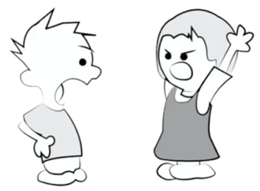 | 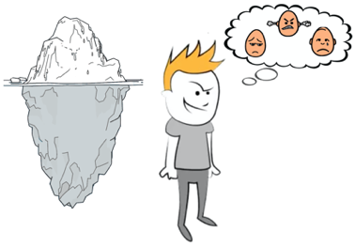 | 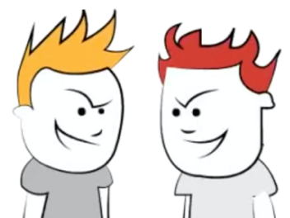
 |  | No problems | Accidents, Fallouts & Misunderstandings | Bullying Behaviours | Bullying
How are you feeling? |  | - I am happy and the people around me make me feel good.  - I feel safe. | - I am upset.  - I have fallen out with a friend.  - They are upset too and have been unkind to me. | - For no reason, someone has been unkind to me or has hurt me.  - I feel sad, worried or angry. | - The same person or people keep on doing and saying unkind things to me.  - They seem to enjoy finding me to make me feel sad, angry and upset.  - I feel like there is nothing I can do and it will never stop.
Why has this happened? |  | - No one is being unkind to me. | - Fallouts happen and when they do, we can become angry at each other.  - When we are angry, we can say or do things that are hurtful – we don’t usually mean it though.  - This is annoying and upsetting but perfectly normal – you will probably be friends again in no time! | - Some people say or do unkind things for apparently no reason. This is unacceptable and needs to stop.  - There is probably a reason why someone is being mean to you and it probably has nothing to do with you.  - It is likely that the person being unkind to you is feeling really sad, angry or overwhelmed by something you don’t know about or can’t see – they may need help too. | - This is bullying.  - This behaviour is unacceptable and needs to stop.
What can I do about it? |  | - Enjoy it! | - Have you read the situation properly?  - Let the person upsetting you know they are upsetting you so they can stop.  - If that doesn’t work, you may need space away from the person you have fallen out with.  - When you feel calmer you could try making friends again.  - If you feel you cannot solve this problem yourself or someone hurts you physically, you must speak to an adult. | - These situations can be upsetting because you can feel like there is nothing you can do but that’s not true. Try to get some space away from this person so they can’t keep upsetting you.  - You must find and adult to tell them what has happened – they can make sure you’re safe and help fix what has happened.  - It’s important that you tell an adult so you can feel safe but the person who is being mean to you may also need help. | - These situations can be really upsetting because you can feel like there is nothing you can do about it but that’s not true. If you ever feel like this, you must speak to an adult who will make sure this stops.  - Hopefully the bullying will stop immediately but, in some cases, this can take some time.  - You must keep on speaking to adults in school and at home and if you keep doing this, it will eventually stop.

