Junior Reading Group Set Ordering Guide

Use this link to take you to our online catalogue Home | OnFife Libraries (spydus.co.uk) You should see the screen below once you have clicked on Login at the top right of your screen. The login you use must be the one created for the group, as the collections are only for group use. Enter your Junior Reading Group card number and pin.
Using the login details provided, this is your Book group membership number that was emailed to your school and PIN (originally set to 1234) login to your account
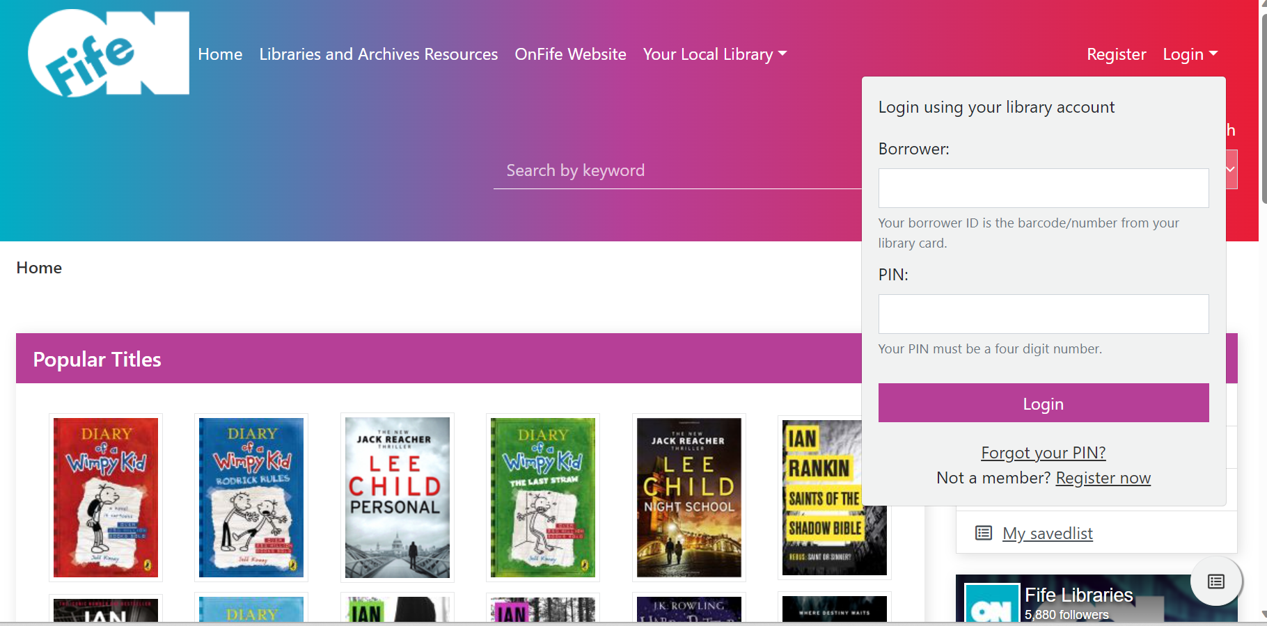
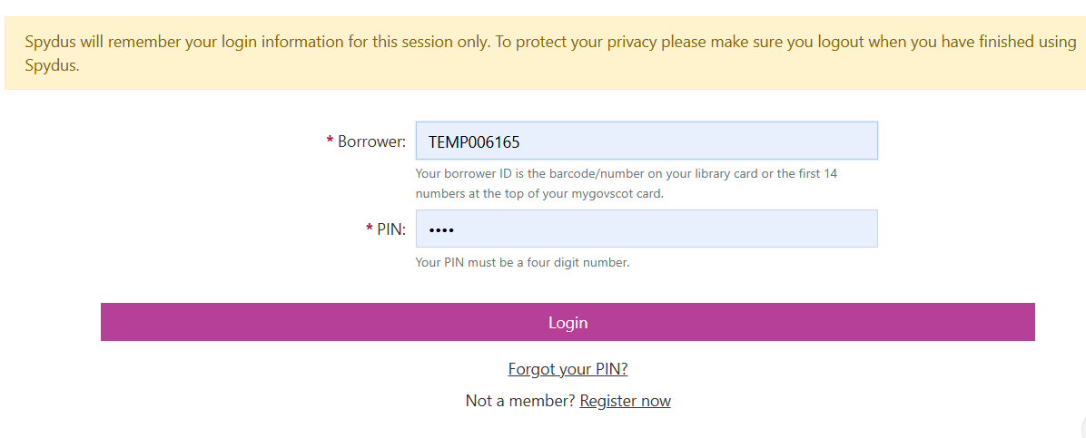

This will take you straight to the dashboard, once you’re ready to decide what to request? Click on Book Group Kits
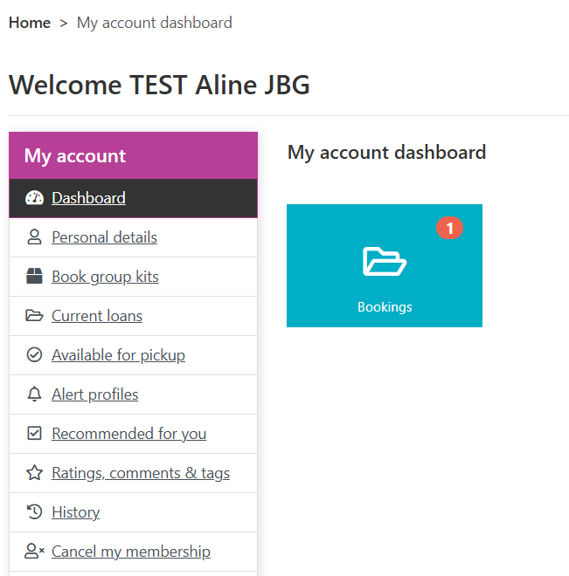

You should now be able to see the screen below. If you don’t see the option Book Group Kits, please check that you are logged in using the group membership and not an individual's personal or class library membership. If you are logged in correctly but unable to see the Book Group Kit option, please email OnFifeLearning@onfife.com

If you know the title of the set you’d like to borrow you can use the Anywhere or Kit description search to put in part or all of the title. If you would like to browse the whole collection you can click on Junior Book Groups at the bottom and just hit search and it will bring up the Junior Reading Groups sets we have. 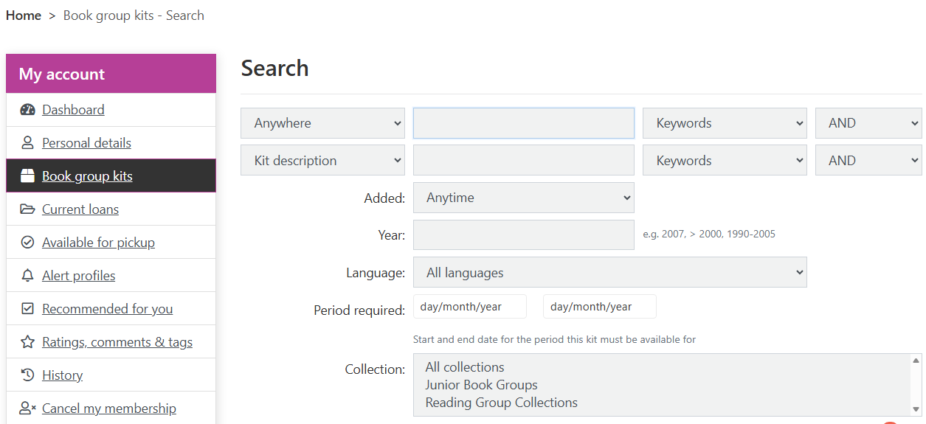

A list of collections will appear – like you see below.
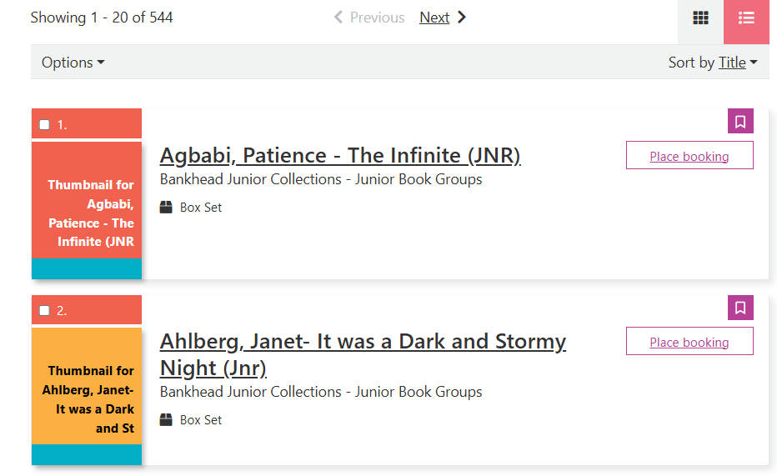

Once you find the box set you’d like to borrow click on the title and then click on Date/time booking rather than place booking – it is much easier to use. If you click on Place booking instead there is an option just under the title to go to Date/time booking instead.

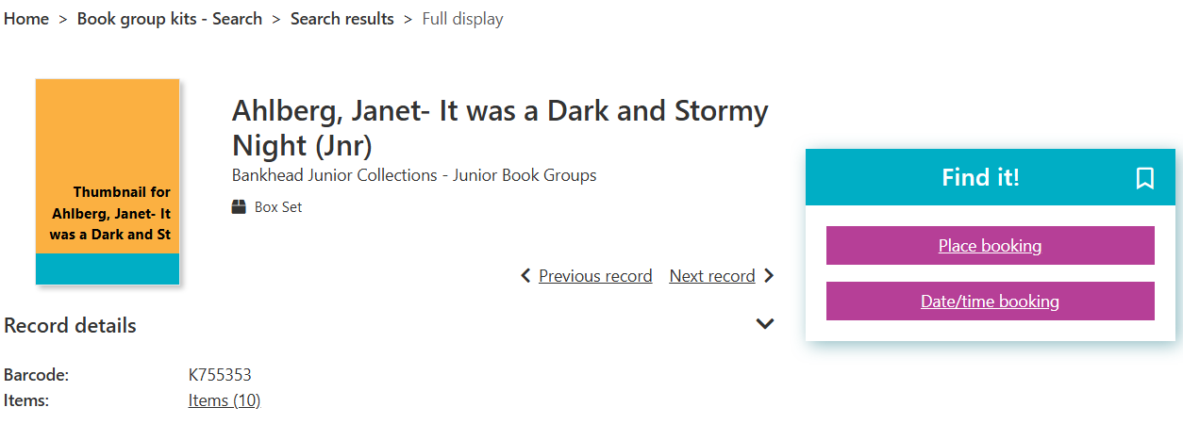

Once you click Date/time booking you’ll see this page where you can enter the dates for your box set. If the dates are greyed out that means the set has already been ordered by another school so you’ll need to choose a different box or title.
The dates for this order period are the 21st of September to the 1st of December
Once you have selected your dates click on Continue.
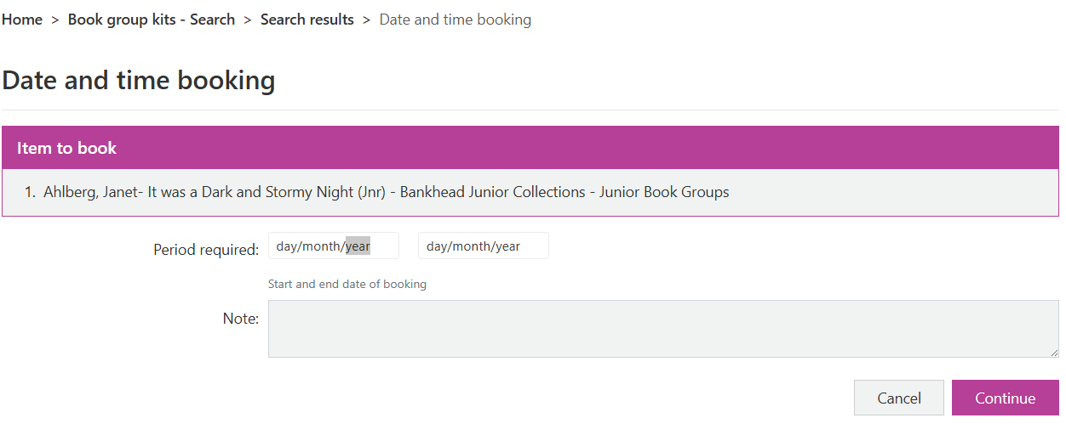If you select Place booking instead it gives you a calendar to select the start and end dates of the booking. If the dates are redded out that means the set has already been ordered by another school so you’ll need to choose a different box or title.
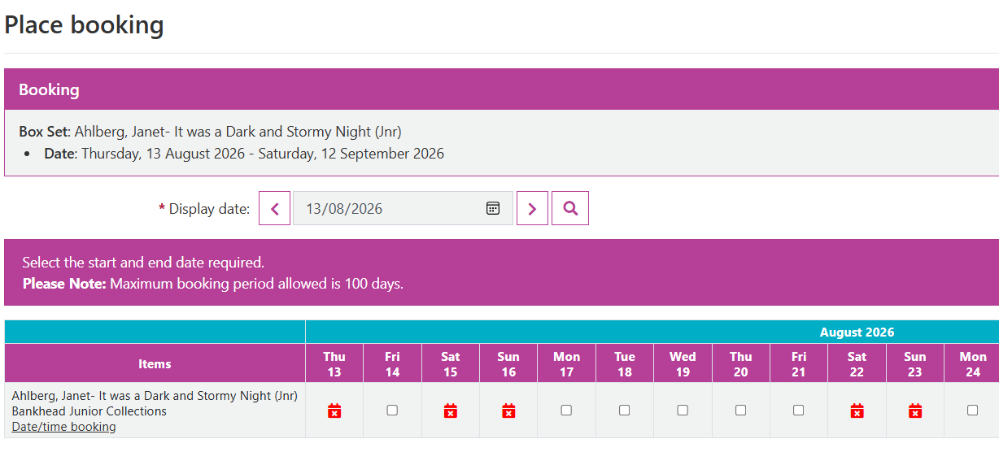

One last step – you should now see a summary of your request as shown below. If you are happy with all the details shown, please click on Continue.
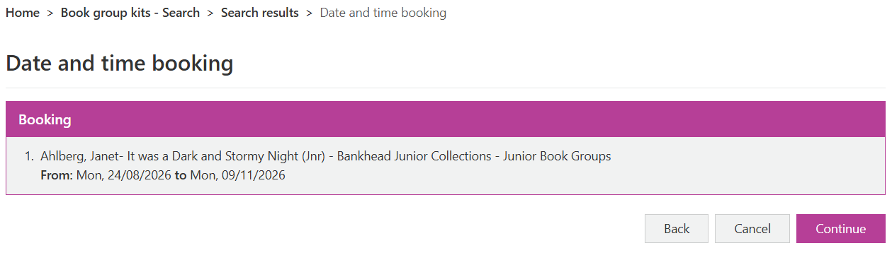
You will now be back at your reading group account page and should see the details of your request. At this point it will show as pending until the request has been approved. If you decide you would like to cancel this booking, you can click on the 3 vertical dots on the right and click on Cancel Booking.
