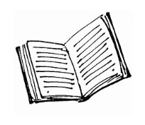
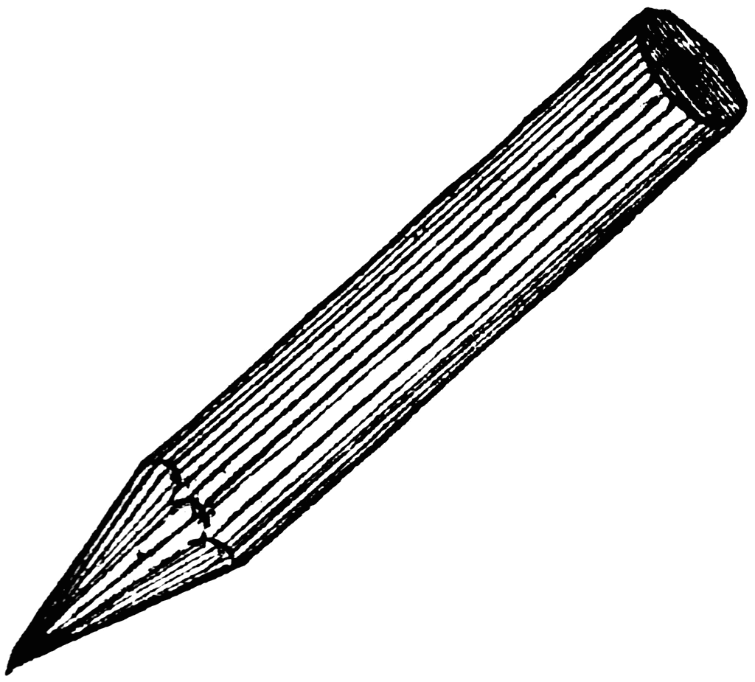

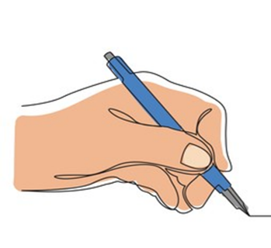
CREATING WRITTEN TEXTS

References, Resources and Recommended Reading
5 Steps to Better Peer Marking in the Primary Classroom
https://www.teachwire.net/news/shirley-clarkes-five-steps-to-better-peer-marking-in-the-primary-classroom

‘Box Planning’ https://jamesdurran.blog/

Boscolo, P & Gelati, C (2008) Motivating Reluctant Students to Write: Suggestions and Caveats

Cabell, S. et al (2013) How Do I Write…? Scaffolding Preschoolers' Early Writing Skills The Reading Teacher, 66(8), pp. 650-659. http://www.readingrockets.org/article/how-do-i-write-scaffolding-preschoolers-early-writing-skills

Chambers, A. (2011) Tell Me: Children, Reading & Talk, The Reading Environment, How Adults Help Children Enjoy Books

Clements, J. (2018) Teaching English by the Book: Putting Literature at the Heart of the Primary Curriculum

Core Literacy Documentation Literacy Core Approach Resources | Fife Literacy

Drysdale, J. (2009) Overcoming the Barriers to Literacy: An Integrated Contextual Workshop Approach, The Routledge Companion to Dyslexia

Elliot, V et al (2016) A Marked Improvement? A Review of the Evidence on Written Marking
https://educationendowmentfoundation.org.uk/public/files/Publications/EEF_Marking_Review_April_2016.pdf

Education Scotland The Writing Process: An Equitable Approach to Writing, Differentiation, Text Types, Overview of the Writing Process, Getting Ready to Write, Time for Writing, Feedback, Tools for Writing, Improvement and Celebrating Success
https://www.youtube.com/playlist?list=PLcD2TdZ4bXSkS4xbSJ6DMvs1BpfYJHNtJ

First Steps in Literacy (2013) suggest a range of teaching and learning experiences for each phase of writing development. http://det.wa.edu.au/stepsresources/detcms/navigation/first-steps-literacy/

Fisher, D & Frey, N (2009) Feed up, Back, Forward in Educational Leadership
http://www.ascd.org/publications/educational-leadership/nov09/vol67/num03/Feed-Up,-Back,-Forward.aspx

Graham, S. (2021) Explicitly Teaching Writing https://www.youtube.com/watch?v=0WCt-Z_-00w

Graham, S. (2021) Creating a Balanced Reader and Writer https://www.youtube.com/watch?v=W8jrzW_qOOw

Graham, S. (2023) Creating a Balanced Reader and Writer Stephen Graham Literacy Inputs (Fife, 2023)

Grossmith, J. (2021) Writer’s Journals – a Place to Store the Tools Children Need for Writing
https://www.talk4writing.com/wp-content/uploads/2021/01/Using-a-Writers-Journal.pdf

Hattie, J & Clarke, S (2018) Visible Learning Feedback

Models of Text Type https://www.literacywagoll.com/

Myhill, D. and Fisher, R. (2010) Writing Development: Cognitive, Sociocultural, Linguistic Perspectives, Journal of Research in Reading, Volume 33, Issue 1, p1-3

Quigley, A. (2022) https://www.theconfidentteacher.com/2022/06/write-like-the-romans/

Reading and Studying Writing
https://www.masterclass.com/classes/joyce-carol-oates-teaches-the-art-of-the-short-story/chapters/reading-and-studying-writing#

Resources for Writing (film, animation, photographs, images, music)
https://screeningshorts.org.uk/
https://www.literacyshed.com/
http://www.pobble365.com/
https://www.onceuponapicture.co.uk/
https://www.pixar.com/sparkshorts

Scottish Book Trust https://www.scottishbooktrust.com/

Story, Plot and Idea Generators https://www.plot-generator.org.uk/

‘Talk for Writing’ https://www.talk4writing.co.uk/

The Vocabulary-Rich Classroom: Modelling Sophisticated Word Use to Promote Word Consciousness and Vocabulary Growth
https://www.readingrockets.org/article/vocabulary-rich-classroom-modeling-sophisticated-word-use-promote-word-consciousness-and

Wagner, R et al (2011) Modelling the Development of Written Language
http://www.ncbi.nlm.nih.gov/pmc/articles/PMC3249727/

Writing Assessment Resource Pack Writing Assessment Resource Pack | Fife Literacy

Writing Prompts and Independent Practice Exercises http://writingexercises.co.uk/index.php

Word Choice https://www.telescopictext.org/

Young and Ferguson (2021) What the Research Says: The Most Effective Ways to Improve Children’s Writing https://writing4pleasure.com/2020/10/21/what-the-research-says-the-most-effective-ways-to-improve-childrens-writing/

These links and professional readings are a recommendation rather than an exhaustive list. If you have further sources you feel it would be beneficial to highlight, please contact the Fife PL Team (professional.learning@fife.gov.uk)

