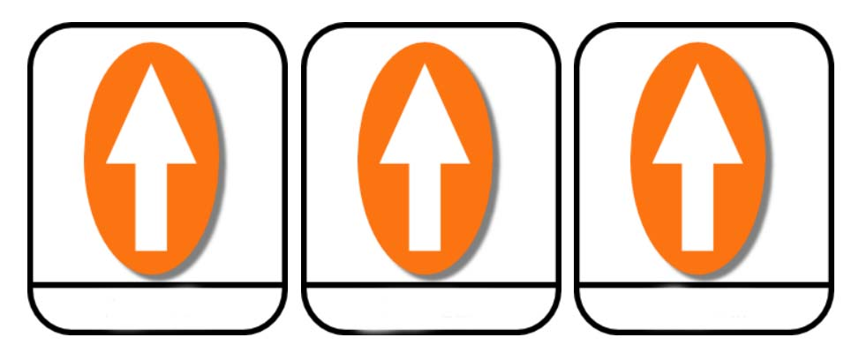

forward

forward

forward



forward

forward

forward



forward

forward

forward



forward

forward

forward

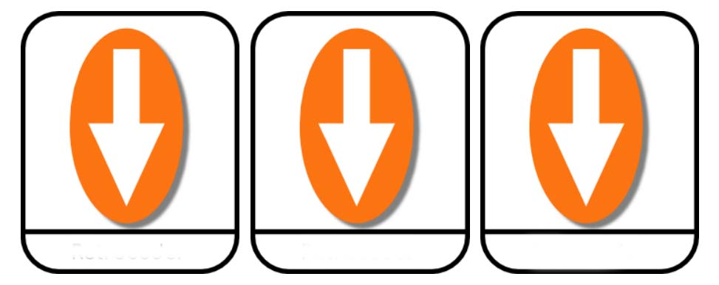

back

back

back



back

back

back



back

back

back



back

back

back



turn left

turn left

turn left



turn left

turn left

turn left



turn left

turn left

turn left



turn left

turn left

turn left



turn right

turn right

turn right



turn right

turn right

turn right



turn right

turn right

turn right



turn right

turn right

turn right

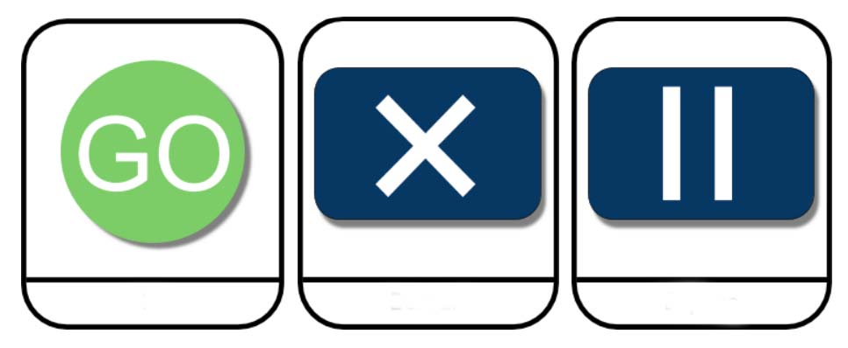

go

clear

pause



go

clear

pause



go

clear

pause



go

clear

pause