DRAFT update
March 26

Supporting Attendance: An assessment and intervention toolkit

Contents
1. Background 3
2. Effective whole school practice 3
2.1 School-Based Anxiety and Early Intervention 5
2.2 Pupil Voice and Participation 7
3 Assessment 7
3.1 Importance of Early Intervention 7
3.2 Assess, Plan, Do, Review Process 8
3.3 Understanding Attendance Assessment Tool 10
4 Analysis and Planning 15
4.1 Understanding Attendance: Reflection and Planning Tool 16
4.2 Interventions 19
5 Do and Review 23
5.1 Partner Agencies 23
6 References 25
7 Appendices 27
Appendix 1: Flowchart – How to use the Toolkit 28
Appendix 2: Pupil Voice and Participation tools 29
Appendix 3: Parent / Carer Information Gathering for Secondary Learners 30
Appendix 4: Pull and Push Factors for Home and School 32
Appendix 5: Understanding Attendance Assessment Tool Worked Example 33
Appendix 6: Additional Assessment Tools 36
Appendix 7: Additional Considerations for Autistic Learners 37

Background

Many factors can affect school attendance. This toolkit aims to support school staff working with learners with a profile of non-attendance, including emotionally based non-attendance, and provides a framework to support assessment and intervention.

The language we use is important. Throughout this toolkit, we are using the phrase ‘non-attendance’ to encapsulate the broad range of underlying factors influencing attendance and engagement. Historically, this has been referred to as ‘school refusal’ or ‘school avoidance’. Instead, we now understand that non-attendance is usually related to a learner’s emotional wellbeing which is largely influenced by a range of environmental factors (NAIT, 2020; Zapata et al., 2018). The image below illustrates the range of possible underlying contributing factors which need to be considered when gathering assessment information and planning supports. With this in mind, this toolkit should be used in conjunction with Fife Council’s attendance guidance. A flowchart of how to use the toolkit can be found in Appendix 1.

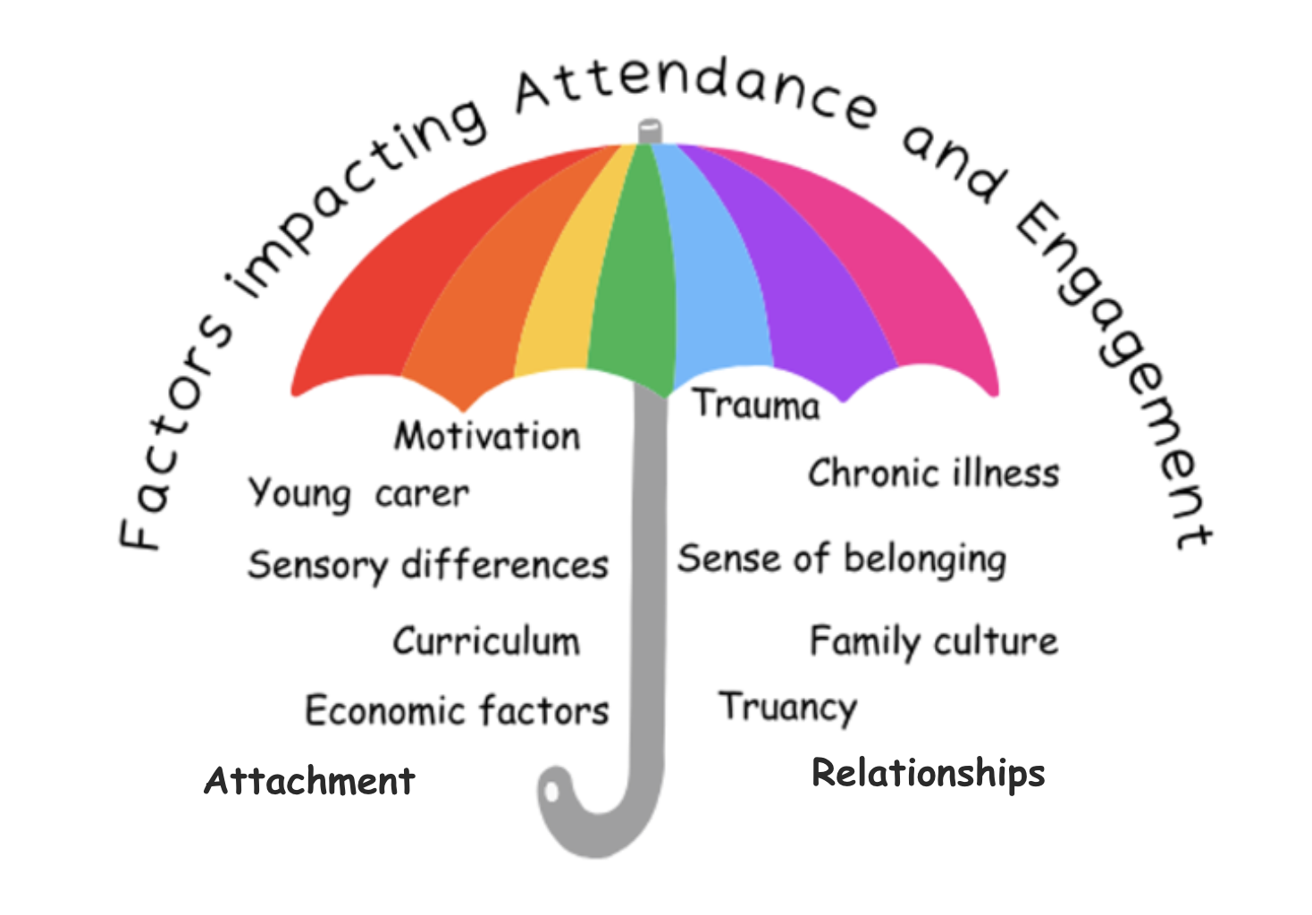

Effective whole school practice

The diagram below outlines six key themes identified in research investigating practice that most effectively supports learners whose emotional wellbeing is creating a barrier to school attendance (Corcoran et al., 2022; Daily et al., 2020; Durham & Connolly, 2017; Finning et al., 2018; Kearney & Graczyk, 2014; Sommer et al, 2017; Zapata et al., 2018).

In summary, the literature suggests that early identification and intervention are key. Central to this is having a robust and consistent process for recording and monitoring attendance and the inclusion of learners in this process. The research calls for a staged approach to assessment and intervention where relationships are at the centre. Schools that are nurturing and reflective are more open to working collaboratively with learners, their families and other supporting professionals. Collaborative working and pupil voice and participation are recurring themes in the research. They are also highlighted as good practice within Getting it Right for Every Child and Fife’s Child Wellbeing Pathway.
Despite decades of research into non-attendance at school, it has been difficult to identify universal effective intervention strategies due to the complexity and individual nature of non-attendance. Core areas of effective intervention, however, can be broadly themed in the areas of school culture, school systems and school practice. Education Scotland (2023) offer a model for intervention based on these three areas.
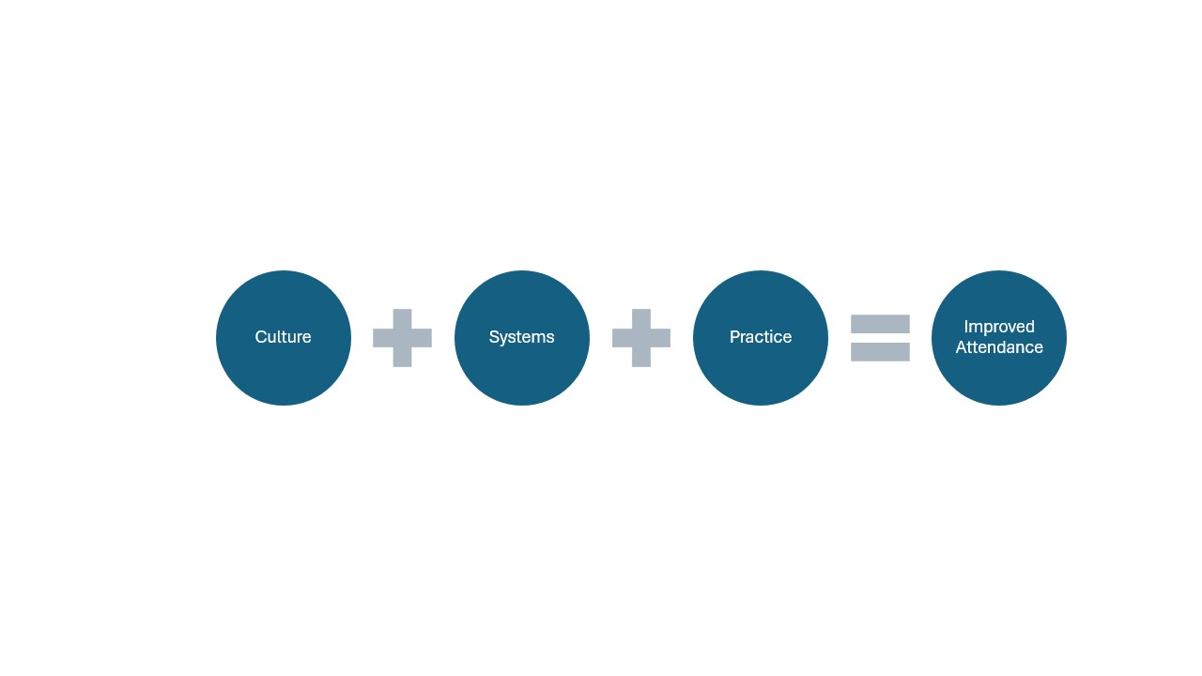
It is recommended that schools consider the following aspects in the table below when seeking change in the three core areas above.
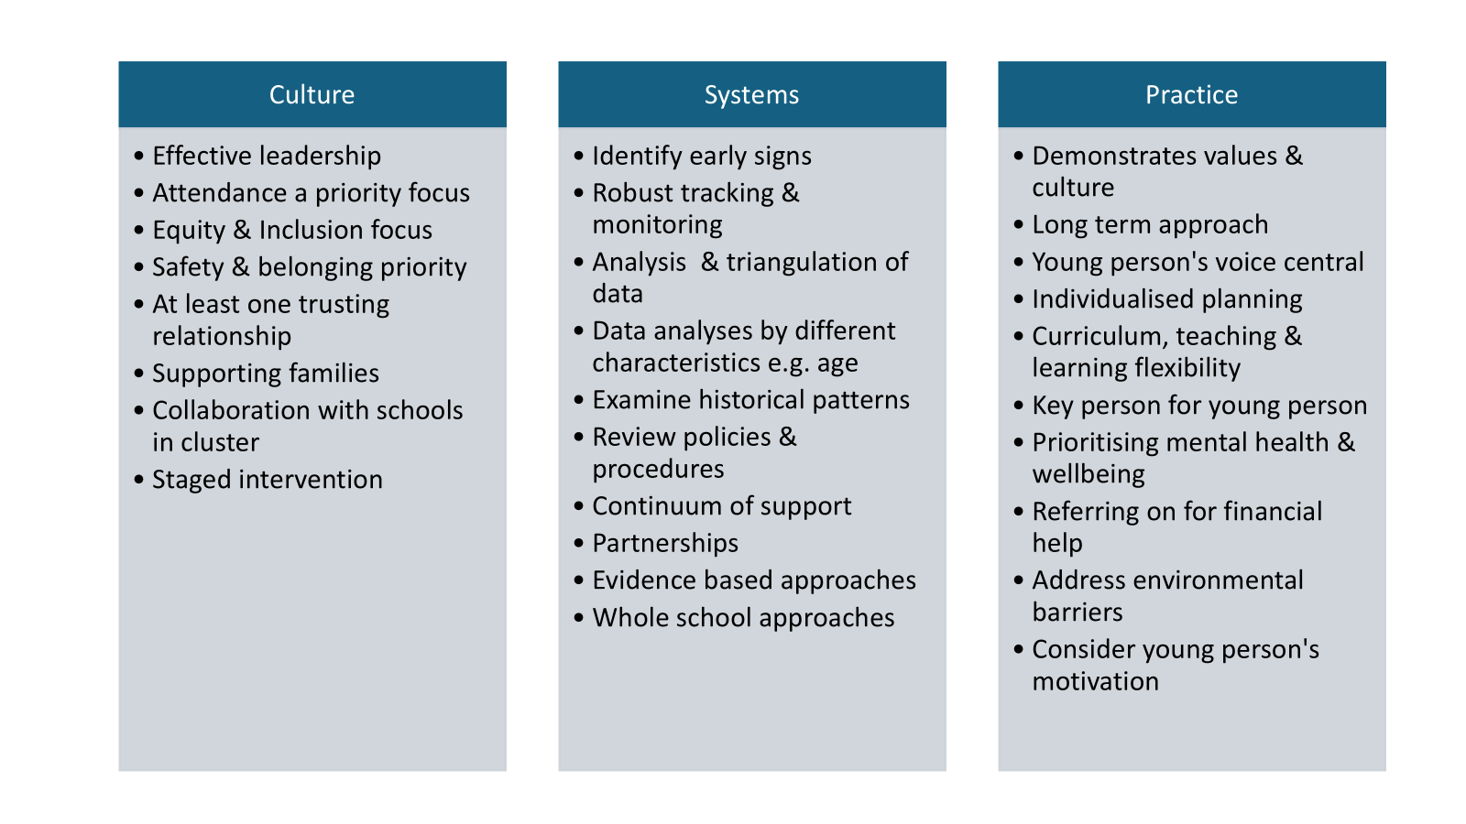

2.1 School-Based Anxiety and Early Intervention
Anxiety is a normal response to stress, and when linked to school avoidance, it manifests as fearful thoughts and unpleasant physical sensations about attending school. This can lead to withdrawal, refusal, and ongoing non-attendance.
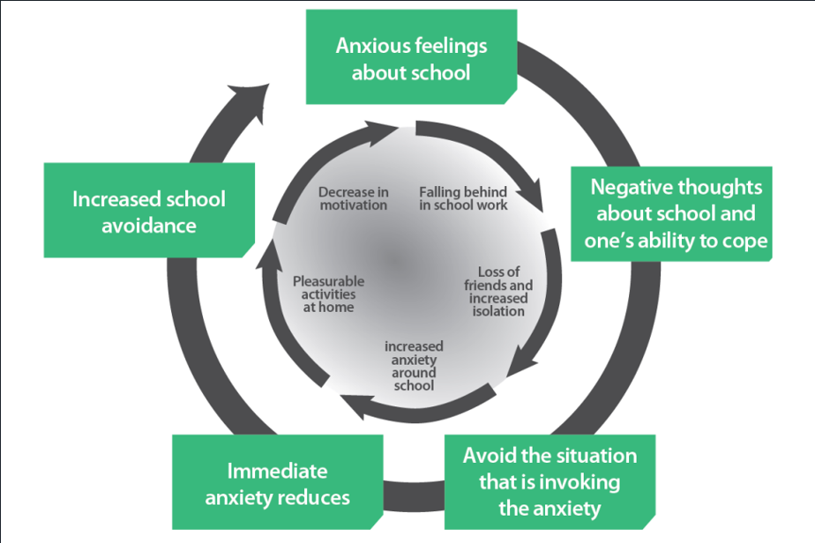
From: West Sussex Educational Psychology Service (2022). Emotionally Based School Avoidance | West Sussex Services for Schools
To avoid these overwhelming emotions and the fear associated with school attendance, the learner may withdraw from the situation by refusing to get ready for school, leave the house or enter the school. These behaviours, and the avoidance of school, can contribute further to the non-attendance over time. Heyne and Rollings (2002) suggest that the learner’s own perception of their ability to cope is important to consider. If a learner is worried about their ability to manage their emotional regulation, their learning or their social abilities, those worries can feed into their anxiety cycle. The response of the adults around the learner can be key in supporting the learner to cope with this feeling.
The illustration above supports the adults to consider the unintended psychological consequences of jumping too quickly to remove perceived demands. Priority should be given to first consider supports that can help the young person cope with those demands, this includes adults communicating a belief in the young person that they can do it. Once a full assessment has been carried out, strategies such as reducing demand temporarily can be considered as discussed in the intervention section below.

2.2 Pupil Voice and Participation
Pupil voice is crucial when supporting non-attendance (Corcoran et al., 2022; NAIT, 2020). Listening to the perceptions of learners themselves is thought to be the best way of ensuring that the assessment process is as individualised as possible. Children and Young People’s right to be included in all educational matters affecting them has been incorporated into Scottish Law (UNCRC Scotland Act, 2024). To ensure that learners are meaningfully included in decision making, Lundy (2013) developed a ‘Model of Participation’ in which the conditions required to support this right are outlined. There are a range of tools available to support these conversations. Staff are encouraged to use their relationship with the learner to make a professional judgement when considering the best method or tool to use. For additional pupil voice and participation tools, please see Appendix 2.
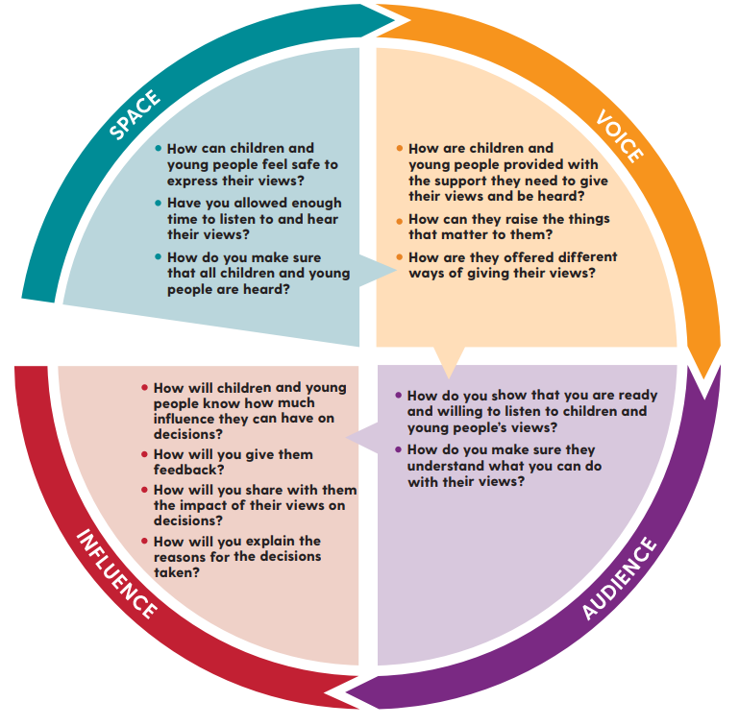
The Lundy Model (2013) of Child Participation (Assessment and Planning Guidance)

Assessment

3.1 Importance of Early Intervention

It is particularly helpful if all staff are aware of the early indicators of school non-attendance as shown by examples in the first column of the table below. When early indicators are identified, information and concerns about attendance should be actively shared, explored, and care
fully tracked and monitored. The second column of the table below shows indicators of non-attendance that are at risk of becoming an established pattern of behaviour. These are just some examples of what you might see. It is important to involve the learner at each stage and remain curious about barriers to attendance.

Taken from: Solihull EPS: Emotionally-Based School Non-attendance: Guide for Professionals, West Sussex EPS Guidance, Wakefield EPS guidance and The Children’s Commissioner for England Guide (2022).

3.2 Assess, Plan, Do, Review Process
Where concerns about a learner’s attendance are identified, further information needs to be gathered from them, their families and any involved professionals. Understanding the learner's unique circumstances and individual reasons behind the non-attendance will allow staff to identify supports and strategies that will work for them. Early intervention is key to avoiding school non-attendance becoming an entrenched pattern.

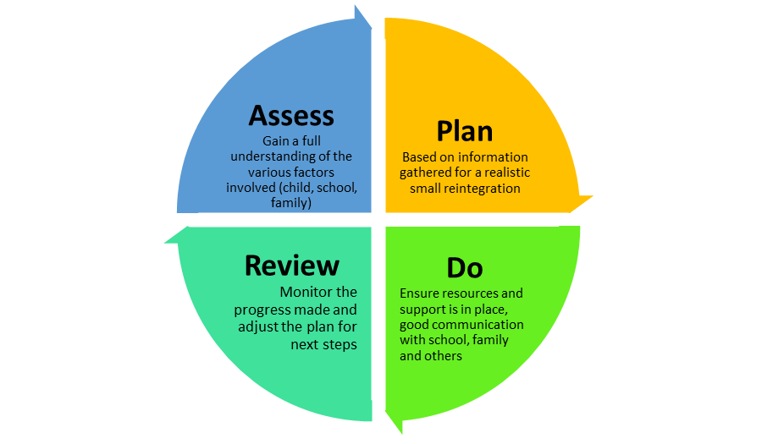
The Assess, Plan, Do, Review cycle is a helpful way of conceptualising the process of supporting a learner to gradually reintegrate back into school.

The model below outlines key assessment principles underpinning all assessment processes.
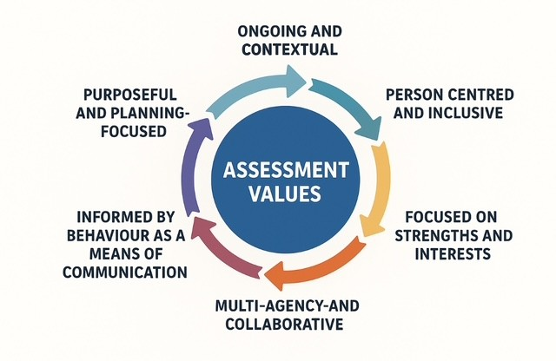

3.3 Understanding Attendance Assessment Tool

The Understanding Attendance Assessment Tool will help to build a holistic assessment picture of supports and the barriers to a learner’s school attendance. Information should be gathered through collaboration with the learner, key staff members and parents. Appendix 3 could be used in advance of a meeting to gather parental views on what is helping their child to attend school and what are the barriers.
The tool can be used to collate information on an ongoing basis. Populating the tool may involve initial information gathering from the learner and parent before meeting together to agree the relevant information to include. It is not necessary to complete each box, nor to repeat information if it applies in the same way in different boxes; however, consideration should be given to where there are gaps in assessment information.

Within each box, decide together if the factor:

- Pulls the learner towards school (Pull S +)
- Pushes the learner positively away from home, and into school (Push H +)
- Pushes the learner away from school (Push S -)
- Pulls the learner towards being at home, rather than in school (Pull H -)
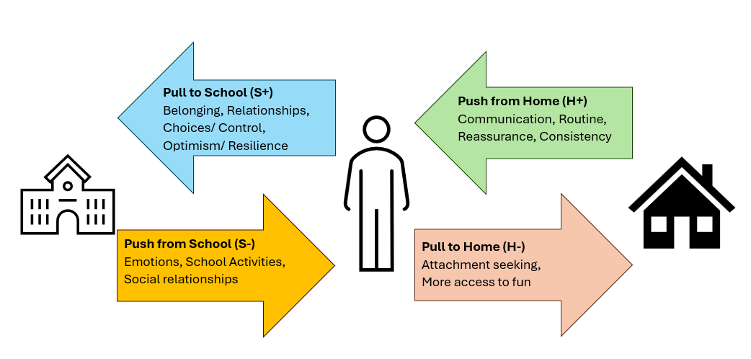
Highlight the relevant aspects and add any additional information. The TAC may decide that the factor involves elements of both ‘push’ and ‘pull’.

More information on ‘push’ and ‘pull’ factors can be found in Appendix 4.
See Appendix 5 for a worked example of the Understanding Attendance Assessment Tool.
Understanding attendance assessment tool
Name: Stage: School: Completed with: Date:
Review date:
Individual factors |  |  |  | Family/home factors |  |  |  | School factors
Emotional wellbeing / mental health |  |  |  | Care circumstances (e.g. at home, foster care) |  |  |  | Relationships with peers
Pull S + | Push H + | Push S - | Pull H - | Pull S + | Push H + | Push S - | Pull H - | Pull S + | Push H + | Push S - | Pull H -
Past experiences (e.g., positive experience of school, traumatic events, move school, etc.) |  |  |  | Family experiences / change (e.g. separation, loss & bereavement) |  |  |  | Relationships with staff
Pull S + | Push H + | Push S - | Pull H - | Pull S + | Push H + | Push S - | Pull H - | Pull S + | Push H + | Push S - | Pull H -
ASN (e.g., Neurodivergent) |  |  |  | Relationships in the home |  |  |  | Specific subjects / lessons
Pull S + | Push H + | Push S - | Pull H - | Pull S + | Push H + | Push S - | Pull H - | Pull S + | Push H + | Push S - | Pull H -
Making and sustaining friendships |  |  |  | Separation / being apart from parents or carers |  |  |  | Response to academic demands / pressure incl. exams assessments
Pull S + | Push H + | Push S - | Pull H - | Pull S + | Push H + | Push S - | Pull H - | Pull S + | Push H + | Push S - | Pull H -
Self-image |  |  |  | Current family circumstances (e.g. level of stress, physical and mental health) |  |  |  | Primary / secondary transition
Pull S + | Push H + | Push S - | Pull H - | Pull S + | Push H + | Push S - | Pull H - | Pull S + | Push H + | Push S - | Pull H -
Learning / appropriate curriculum |  |  |  | Parent/ carer work circumstances (e.g. work demands, shift work, working from home, have had to give up work, not in work) |  |  |  | Behaviours in class (own or others)
Pull S + | Push H + | Push S - | Pull H - | Pull S + | Push H + | Push S - | Pull H - | Pull S + | Push H + | Push S - | Pull H -
Motivation and mindset |  |  |  | Family resources to support attendance and/or engagement in school learning |  |  |  | School ethos (e.g., relationships, sense of belonging, connectedness/community)
Pull S + | Push H + | Push S - | Pull H - | Pull S + | Push H + | Push S - | Pull H - | Pull S + | Push H + | Push S - | Pull H -
Physical health |  |  |  | Family support for learner’s resilience to attend (e.g., parents’ own experiences and beliefs) |  |  |  | Transition to school in morning
Pull S + | Push H + | Push S - | Pull H - | Pull S + | Push H + | Push S - | Pull H - | Pull S + | Push H + | Push S - | Pull H -

On completion of the Understanding Attendance Assessment Tool, you may decide more in-depth assessment is needed in a particular area. Some supportive tools are outlined in Appendix 6. These are organised into themes of emotional needs, learning needs, and neurodivergence.

For autistic learners there may be additional aspects to take account of in assessment and intervention. Appendix 7 outlines some key areas for consideration.

Analysis and Planning
The Understanding Attendance Assessment Tool provides insight into “what” is happening for the learner in relation to attendance and its influencing factors. Once this has been completed, the information can be analysed to answer, “So what” are the learner’s unmet support needs? This will guide the next step; targeted decisions for “Now what” interventions and supports to put in place.
Keeping in mind the key assessment values (highlighted above in Section 3.2) will ensure meaningful, relevant, individualised answers to the “So what?” question.
Prioritise a small number of areas to begin, either by asking the learner what impacts them most or by seeking quick wins, such as removing easily addressed barriers or implementing immediate strategies, for example, supporting a smoother physical transition into school. Not every issue needs to be tackled at once; the goal is to increase factors that encourage attendance while improving the learner’s overall school experience.
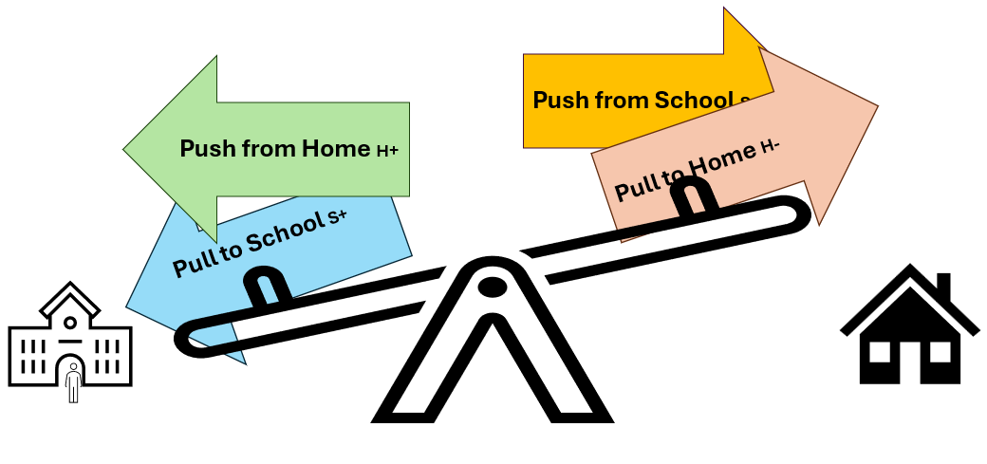
The table below enables analysis of the assessment information gathered and reflection on factors that both push and pull. Supports should be considered at the individual, home, and school levels, and focus on what is within the circle of influence. For example, a home factor like family illness cannot be changed, however individual strategies, (e.g. breathing techniques) or school-based interventions (e.g. office facilitated check-ins with home) can help minimise its impact. Through the analysis process, it is likely that themes such as relationships, motivation, regulation, safety and sense of belonging will occur across all push and pull factors.

4.1 Understanding Attendance: Reflection and Planning Tool
This tool can be used to support the analysis of the ‘Understanding attendance assessment tool’ and identify next steps and interventions.
 | Pull to school  (Increase factors which pulls the learner towards school)  Pull S + | Push from Home  (Increase factors which push the learner positively away from home, and into school)  Push H + | Push from School  (Reduce factors which pushes the learner away from school) Push S - | Pull to Home  (Reduce factors which pull the learner towards being at home, rather than in school)  Pull H -
Individual | How can we build on the learner’s identified strengths/interests/hopes for the future to make attendance feel purposeful and rewarding?  How can we strengthen the learner’s connections with trusted adults and peers to foster a sense of belonging that encourages regular attendance?  Does the learner feel understood, celebrated and valued? | What support is needed to help the learner feel emotionally safe and understood? How are we supporting the learner to develop their resilience and coping strategies? How is this communicated to the adults supporting the learner?  How can we ensure the learner feels heard and sees their views reflected in their education planning, building their sense of inclusion and ownership? | How is the learner supported to understand and manage difficult emotions that affect their attendance?  When school feels challenging, what supports help the learner build confidence, feel a sense of control, and access regular opportunities to pause and regulate?  How is the learner supported to explore their social and communication preferences in ways that reduce stress and affirm identity? | How is the learner’s connection to home acknowledged and supported throughout the school day?  If the learner has caring responsibilities, what supports are in place to help them engage meaningfully in learning while balancing their role as a young carer?
Family | Is there a need for additional agencies and support for the family to manage the transition into school? For example, school buddies, Includem, Barnardo's, wider friends and family. | What home-based routines and strategies can we support or suggest to help the learner feel emotionally and physically ready to transition into the school day - such as consistent sleep habits, co-regulation practices, or positive end-of-day plans?  How can the learner's connection to home be supported during their day at school? | How can we encourage a positive narrative around school attendance that feels meaningful to learners and their families? Would any of our families benefit from additional information and support e.g., Access Fife Therapy courses, Flourish, etc.? | How can we build the learner’s confidence to take part in activities away from home in a way that feels manageable?  If the learner finds separation from their caregiver difficult, how can the caregiver be supported to ease this transition?  Is there scope to shift enjoyable or connecting activities with caregivers to times outside the school day?  Can home-based learning be used during the school day as a bridge to re-engagement, rather than a replacement for school?
School | How do learners with decreased attendance know that the school has a culture where all learners are understood, celebrated and valued?  How can we foster strong, trusting relationships with key adults for this learner?  How can we maintain meaningful connection with learners when they are not physically present in school?  How can we increase positive aspects of school? For example, extracurricular and social experiences. | In what ways does the school environment offer the learner meaningful opportunities to experience success — academically, socially, or personally?  Are there regular chances for the learner to engage in activities that feel relevant, motivating, and aligned with their interests or strengths?  How does the learner know that they are kept in mind by key school adults throughout the day? | What aspects of the school environment may need reviewing to reduce barriers to attendance, and how can tools like CIRCLE guide this process?  What school community-based supports (e.g. buddies, home liaison) are in place to strengthen the learner’s sense of belonging and connection?  What does a safe space look like for this learner, and how are they supported to access it when needed?  How is the learner’s return to class or school thoughtfully planned after missed lessons — with care, flexibility, and connection?  How are social opportunities throughout the day used to build peer relationships in ways that feel safe and affirming for the learner?  Does the learner’s timetable offer the learner regular experiences of success, and is there flexibility to adapt it when needed?  How do key adults in school stay attuned to the learner’s needs and actively build trust and connection?  How are we making learning feel relevant, motivating, and achievable for the learner? | How do learners with decreased attendance know that the school has a culture where all learners are understood, celebrated and valued?  How can we foster strong, trusting relationships with key adults for this learner?  How can we maintain meaningful connection with learners when they are not physically present in school?  What signals or routines help the learner feel that they matter - even during transitions, unstructured times, or when things aren’t going well?  How can we increase positive aspects of school? For example, extracurricular and social experiences.

4.2 Interventions
The table below outlines common interventions to consider when creating a plan to increase the learner’s attendance at school. Collaborative problem solving is key when considering which interventions will best meet the learner’s underlying needs and address barriers to attendance at individual, home and school levels.

Theme | Intervention | Additional information
Learner voice and relationships with staff | Person Centred Planning | Tools such as a Giftedness Poster, PATH and MAP can be useful. For pupils who struggle to verbalise the barriers to attendance, a ‘Talking Mat’ or ‘School wellbeing cards’ may be useful.  See Appendix 1 / link with Educational Psychologist (EP) for more information.
 | Identify at least one key adult in school for a secure, trusting relationship
 | Emotion check-ins at regular points through the week/day
 | Regular staff check-ins / links with learner when out with school (e.g. home visit, Teams call, email)
Using learner’s strengths | Consideration of using interests / motivators in school
 | Responsibility jobs, specific roles in school
 | Links with community opportunities to build motivation for future roles
Social supports | Buddies / peer supporters
 | Encourage into structured social situations e.g. clubs and activities
 | Small group intervention on targeted social skills
 | Use of Cool in School online resource | Cool in School – A site about keeping your cool in school
 | Maintain a sense of belonging via peer links (e.g. Seesaw, Teams, online, peer activities out with school)
Structure of school day | Soft start / breakfast club
 | Alternative start and finish times from school
 | Alternative break and lunch plans
 | Timeout card
 | Identified safe spaces
 | Early pass from class
 | Preventative sensory breaks or regulating opportunities built into day
 | Option to access learning out with main school building
 | Agreed Reduced Attendance / Flexi Arrangements | See guidance on intranet Promoting engagement and attendance.  ARA agreements can be considered as a short-term intervention, in combination with addressing wider underlying needs and barriers.
Teaching and learning | Timetable review to rate subjects and match to teacher approach where appropriate
 | Differentiate curriculum (learning approaches in class)
 | Adapted timetable (wider achievement, planned time out of class)
 | Online learning offer | E.g. access to work on Teams page  Or online learning offer from E-Sgoil Home Page | e-Sgoil
Learner Emotional Wellbeing strategies | Mindfulness exercises | Info available on Moodcafe Mood Cafe | For young people
 | Support learner to understand anxiety cycle and / or link between thoughts, feelings and behaviour | See link EP for ‘Anxiety is Normal Resource Pack’  Courses available on Access Therapies Fife website  Home - Access Therapies Fife NHS
 | Individualised or small group targeted intervention for emotional wellbeing/ emotional literacy | E.g. Kitbag group, Energy Accounting
 | De-sensitisation approach to reduce fears, where aspects of school causing anxiety are identified and gradually managed in a structured plan. | E.g. Visits after school, link with one member of staff initially, etc. (Link further with Educational Psychologist for more information on de-sensitisation)
Home | Agreed routine for separation from parent | May be supported by a social story depending on age and stage of learner
 | ‘Keeping in mind’ object from parent e.g. a note, something which reminds learner of them
 | Support family to understand learner's needs, including any anxiety | Courses available on Access Therapies Fife website  Home - Access Therapies Fife NHS

Do and Review

Staged intervention is based on the principle that a learner’s needs are best and most effectively met at the universal level with an intervention designed to offer solutions in the least intrusive manner. The stages of intervention offer a framework for facilitating problem-solving to ensure that appropriate and proportionate supports are offered to learners and families who need them most, based on assessment information. Staged intervention does not imply that each stage must be tried and tested to move on. Rather, the stages are assessed and considered in relation to each individual’s circumstances.

Following your analysis of the assessment information, the next step involves identifying and agreeing on appropriate outcomes and actions. The process of assessing and planning is a continuum, from Universal to Additional or Intensive levels. Given the nature of the challenges around attendance, it is key to regularly review the plan to ensure it is effective and is progressing towards set outcomes. Guidance on effective assessment and planning can be accessed on the intranet.

5.1 Partner Agencies

Universal supports / consultation
- Educational Psychology Service offers ‘no name’ consultations
- Supporting Learners Service (SLS), including the Neuroinclusive Support Team. All teams offer no name consultation
- Primary Mental Health helpline
- Neurodevelopmental Pathway helpline
- Occupational Therapy helpline
- Speech and Language Therapy helpline

Referrals and Requests for Assistance for additional / intensive supports
- Educational Psychology Service
- SLS, including Neuroinclusive Support Team
- Pupil Support Service (PSS) offer initial consultation with receipt of a ‘Request for Assistance’ form.
- Early Help and Support Team (Social Work early intervention)
- Primary Mental Health / Child and Adolescent Mental Health Service (CAMHS)
- Occupational Therapy
- Speech and Language Therapy

Signposting
Choosing the right support website is continuously updated to reflect any changes to agencies and services, including third sector partners involved in supporting families, children and young people. Further information can also be found on the Our Minds Matter - Mental Health Information for Young People in Fife - Wakelet

References

Corcoran, S., Bond, C., & Knox, L. (2022). Emotionally based school non-attendance: Two successful returns to school following lockdown. Educational Psychology in Practice, 1-14. https://doi.org/10.1080/02667363.2022.2033958

Daily, S. M., Smith, M., Lilly, C. L., & Davidov, D. M. (2020). Using school climate to improve attendance and grades: Understanding the importance of school satisfaction among middle and high school students. Journal of School Health, 90(2), 683-693. https://www.researchgate.net/publication/343134327_Using_School_Climate_to_Improve_Attendance_and_Grades_Understanding_the_Importance_of_School_Satisfaction_Among_Middle_and_High_School_Students/link/609ac93fa6fdccaebd2512b0/download

Durham, R. & Connolly, F. (2017). Strategies for student attendance and school climate in Baltimore's community schools. https://files.eric.ed.gov/fulltext/ED578884.pdf

Education Scotland (2023). Improving Attendance- Understanding the Issues. Education Scotland releases deep dive report into school attendance in Scotland | News | Education Scotland

Finning, K., Harvey, K., Moore, D., Ford, T., Davies, B., & Waite, P., (2018). Secondary school educational practitioners’ experiences of school attendance problems and interventions to address them: A qualitative study. https://ore.exeter.ac.uk/repository/bitstream/handle/10871/31810/School%20attendance%20problems%20Final%20Accepted%2001_12_2017.pdf?sequence=1

Heyne, D. and Rollings, S. (2002). School Refusal. Oxford: Blackwell Scientific Publications.

Hook, P. McPhail, I. &Vass, A. (2006). The Coaching and Reflecting Pocketbook. Teachers’ Pocketbooks.

Kearney, C. A., & Graczyk, P. (2014). A response to intervention model to promote school attendance and decrease school absenteeism. Child Youth Care Forum, 43, 1-25. https://www.researchgate.net/publication/257545646_A_Response_to_Intervention_Model_to_Promote_School_Attendance_and_Decrease_School_Absenteeism

Lundy, L. (2013).’ Voice’ is not enough: conceptualising Article 12 of the United Nations Convention on the Rights of the Child. British Educational Research Journal https://doi.org/10.1080/01411920701657033

NAIT (2020). Anxiety-related absence: A guide for practice. http://www.autismtoolbox.co.uk/sites/default/files/resources/NAIT%20Anxiety%20Related%20Absence%20Guidance%202020.pdf

Solihull Educational Psychology Service (2020). Emotionally-Based School Non-attendance: Guide for Professionals. https://socialsolihull.org.uk

Sommer, T. E., Sabol, T. J., Chase-Lansdale, L., Small, M., Wilde, H., Brown, S., & Huang, Z. Y. (2017). Promoting parents' social capital to increase children's attendance in head start: Evidence from an experimental intervention. Journal of research on educational effectiveness, 10(4), 732-766. https://doi.org/10.1080/19345747.2016.1258099

West Sussex Educational Psychology Service (2022). Emotionally Based School Avoidance: Good practice guidance for schools and support agencies. Emotionally Based School Avoidance | West Sussex Services for Schools

Zapata, E. D. M., Lara, L., Navaro, J-J., & Saracostti, M. (2018). Modelling the effect of school engagement on attendance to classes and school performance. Revista de Psicodidáctica (English ed), 23(2), 102-109. https://www.researchgate.net/publication/324204096_Modeling_the_Effect_of_School_Engagement_on_Attendance_to_Classes_and_School_Performance/link/5c0e4c54a6fdcc494fe90ac9/download

Appendices

Appendix 1: Flowchart – How to use the Toolkit 28
Appendix 2: Pupil Voice and Participation tools 29
Appendix 3: Parent / Carer Information Gathering for Secondary Learners 30
Appendix 4: Pull and Push Factors for Home and School 32
Appendix 5: Understanding Attendance Assessment Tool Worked Example 33
Appendix 6: Additional Assessment Tools 36
Appendix 7: Additional Considerations for Autistic Learners 37

Appendix 1: Flowchart – How to use the Toolkit
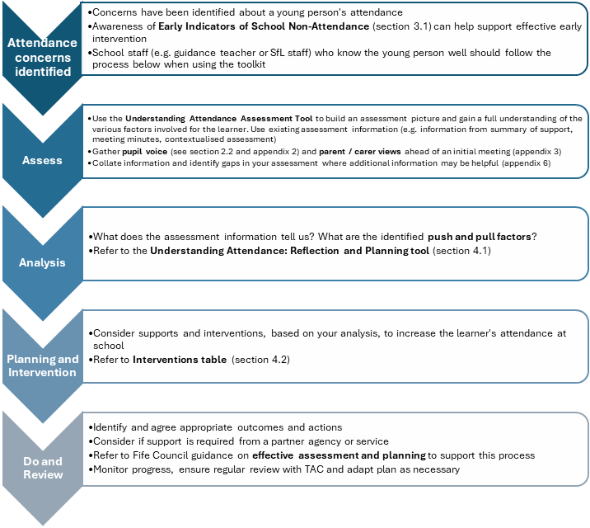

Appendix 2: Pupil Voice and Participation tools
Person-centred assessment allows a shift in focus from the surface behaviour to the function of those behaviours, helping the team around the learner understand which underlying needs are not being met. Subsequently, individualised interventions and planning can then be identified to target support for these underlying needs.

Learner tool | Location
Generic Tools
Tools for Gathering the Views of Learners | Highland Educational Psychology Service  Tools for gathering the views of children and young people – Highland Council Psychological Service
Person-Centred Planning (PCP) tools | SEND Person Centred Planning tool  Person-Centered Thinking Tools - Helen Sanderson Associates
Solution-focussed framework | NSPCC Solution-focused practice toolkit
Pupil Voice Framework (based on Lundy model)  Learner Feedback form (based on Lundy model) | OneNote Assessment and Planning > Good meeting practice > Additional Resources  Assessment and Planning Guidance for Additional Support and Wellbeing Needs Feb 2023  This section also contains examples of solution focussed questions
Attendance Specific
West Sussex Educational Psychology Service: Emotionally Based Avoidance | Emotionally Based School Avoidance | West Sussex Services for Schools
Neurodivergence and Attendance
Barriers to Education – Young Person Voice Tools | Young Person Voice Tools - Barriers to Education

Appendix 3: Parent / Carer Information Gathering for Secondary Learners

Parent/ Carer Information Gathering for Secondary Learners
We understand that children and young people may miss school for various reasons. Sometimes this is related to their physical health, their mental well-being, or a range of other school / family related factors.
We would like to meet to talk about what is supporting your child to attend school and to gain a better understanding of the reasons why they haven’t been able to attend. Parents and carers play a crucial role in this. We invite you to share your thoughts below which will help us know what to focus on when we meet. You might find it helpful to talk these through with your child.

Individual factors
These might be things like emotional wellbeing, additional support needs, friendships, self-image, physical health or their past experiences of school or learning.

What is helping your child to go to school?

What is making it difficult for your child to attend school?

Family / home factors
This might include any family changes, how they feel about being apart from you, your current relationship with your child, and how easy or difficult it is for you to support your child to attend school.

What is helping your child to go to school?

What is making it difficult for your child to attend school?

School factors
This might include relationships with staff or other pupils, how they feel about specific subjects, how they respond to tests, the move to secondary school, how much they feel part of school life, or how easy or difficult it is to come to school in the morning.
What is helping your child to go to school?

What is making it difficult for your child to attend school?

Please let us know if there is anything else you would like to talk about when we meet.

Appendix 4: Pull and Push Factors for Home and School
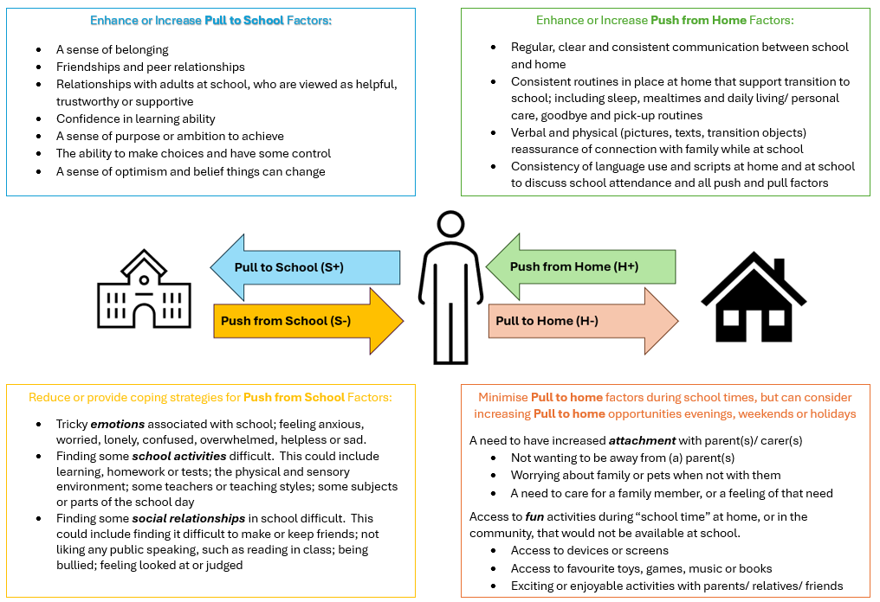

Appendix 5: Understanding Attendance Assessment Tool Worked Example
Name: Carol McKay Stage: S2 School: High school Completed with: Alex Smith, Guidance Date: 25/05/25
Review date:

Individual factors |  |  |  | Family/home factors |  |  |  | School factors
Emotional wellbeing / mental health |  |  |  | Care circumstances (e.g. at home, foster care) |  |  |  | Relationships with peers
Pull S + | Push H + | Push S - | Pull H - | Pull S + | Push H + | Push S - | Pull H - | Pull S + | Push H + | Push S - | Pull H -
Can have anxiety about new experiences and feels more comfortable at home |  |  |  | Recent return to mum’s care and may feel anxious about being removed again |  |  |  | No difficulties
Past experiences (e.g., positive experience of school, traumatic events, move school, etc.) |  |  |  | Family experiences / change (e.g. separation, loss & bereavement) |  |  |  | Relationships with staff
Pull S + | Push H + | Push S - | Pull H - | Pull S + | Push H + | Push S - | Pull H - | Pull S + | Push H + | Push S - | Pull H -
Has had a change of high school. Moved here in November |  |  |  |  |  |  |  | Good relationships with some teachers, PSO and guidance
ASN (e.g., Neurodiversity) |  |  |  | Relationship in the home |  |  |  | Specific subjects / lessons
Pull S + | Push H + | Push S - | Pull H - | Pull S + | Push H + | Push S - | Pull H - | Pull S + | Push H + | Push S - | Pull H -
Diagnosis of autism, finds home less demanding for social and sensory reasons |  |  |  | Good, nurturing relationship. Mum supportive of school attendance |  |  |  | Keen to access drama and music. Knows needs
Making and sustaining friendships |  |  |  | Separation / being apart from parents / carer |  |  |  | Response to academic demands / pressure incl. exams assessments
Pull S + | Push H + | Push S - | Pull H - | Pull S + | Push H + | Push S - | Pull H - | Pull S + | Push H + | Push S - | Pull H -
Two friends but finds it hard to make new links |  |  |  | Wants to be close to mum |  |  |  | Feels anxious due to missed learning
Self-image |  |  |  | Current family circumstances (e.g. level of stress, physical and mental health) |  |  |  | Primary / secondary transition
Pull S + | Push H + | Push S - | Pull H - | Pull S + | Push H + | Push S - | Pull H - | Pull S + | Push H + | Push S - | Pull H -
 |  |  |  | No current stressors. Supportive of school
Learning / appropriate curriculum |  |  |  | Parent/ carer work circumstances (e.g. work demands, shift work, working from home, have had to give up work, not in work) |  |  |  | Behaviours in class (own or others)
Pull S + | Push H + | Push S - | Pull H - | Pull S + | Push H + | Push S - | Pull H - | Pull S + | Push H + | Push S - | Pull H -
Finds multiple instructions difficult to follow. Variable across classes |  |  |  | Flexibility in day to support Carol for morning routine and getting to school
Motivation and mindset |  |  |  | Family resources to support attendance and/or engagement in school learning |  |  |  | School ethos (e.g., relationships, sense of belonging, connectedness/community)
Pull S + | Push H + | Push S - | Pull H - | Pull S + | Push H + | Push S - | Pull H - | Pull S + | Push H + | Push S - | Pull H -
Currently not motivated to attend school and feels interventions won't help |  |  |  | Mum helping Carol with learning at home so can keep up with curriculum |  |  |  | Doesn't feel part of or connected to X high school
Physical health |  |  |  | Family support for learner’s resilience to attend (e.g., parents’ own experiences and beliefs) |  |  |  | Transition to school in morning
Pull S + | Push H + | Push S - | Pull H - | Pull S + | Push H + | Push S - | Pull H - | Pull S + | Push H + | Push S - | Pull H -
 |  |  |  | Mum trying to engage Carol in wider community activities to build confidence |  |  |  | Finds bus busy and noisy
Analysis and Planning

Guidance arranged a meeting with mum and Carol to consider the assessment and plan next steps. The actions would be included in the Child’s Plan. The actions they agreed on were:

Individual factors:  - For the Guidance teacher to ask EP for information on anxiety to send through to mum and Carol  - For Carol to consider an online anxiety course through Access Therapies Fife  - For Guidance to ensure the Summary of Support is up to date with information and resend to staff to support Carol’s processing of instructions and awareness that she needs to use headphones to help with her sensory sensitivities | Who?  AS -GT  CM -Learner / MM -Parent  AS -GT | By when?  10/6/25  6/6/25  17/6/25
Home factors:  - For Mum to link with SW to let them know Carol's anxieties about being removed to foster care again  - Mum to write a note to Carol each morning that she can keep in her bag to help with Carol’s feelings of anxiety about being apart  - Mum to continue to encourage Carol to try new activities and clubs outside school | MM- Parent  MM - Parent  MM - Parent | 10/6/25  6/6/25  6/6/25
School factors:  - Guidance to ensure all class learning is uploaded on Teams so Carol can access it. Carol can meet with English and Maths teachers after school to go over recent learning before coming back into class  - Guidance to take Carol along to the drama club to help build her connectedness to school and give her a wider peer group  - Review meeting to be held in 4 weeks (29/6/25, at 2pm) | AS - GT  AS – GT | 17/6/25  10/6/25

Appendix 6: Additional Assessment Tools

On completion of the Understanding Attendance Assessment Tool, you may decide more in-depth assessment is needed in a particular area. Some supportive tools are outlined below. Please speak to your Educational Psychologist (EP) for further information.

Emotional needs | Anxiety is Normal - learn how to control it. School Resource Pack (Primary or Secondary)  Please speak to your link EP. | To assess the factors which may be causing a learner anxiety
 | School Based Resilience Assessment Tool (Primary or Secondary)  Please speak to your link EP. | To identify ways to build a learner’s resilience
Learning needs | CIRCLE Resource (Primary or Secondary) CIRCLE | ThirdSpace. | To identify universal strategies to support learning and access to the learning environment
 | Cognitive Skills Assessment Tool  Please speak to your link EP. | To unpick specific cognitive skills and the impact on learning
Neurodivergence | See below- Appendix 5: Additional consideration for autistic learners | Areas to consider for assessment and intervention for learners with autism
 | NAIT Anxiety Related Absence. A guidance for Practice (p.21)  NAIT-Anxiety-Related-Absence-Guidance-2020.pdf | Questions to reflect on the daily experience of a learner with autism
 | Barriers to Education Website  Welcome to Barriers to Education | This includes tools to gather the young person's voice to better understand their school experience and the barriers to education
 | The Dimensions of Health and Wellbeing Tool Dimensions - Public Landing | To assess home and school factors affecting wellbeing, including possible neurodivergence

Appendix 7: Additional Considerations for Autistic Learners

Autistic learners, or those where autism is being considered, experience many of the same anxieties as all learners who struggle with attending school. However, some aspects can be particularly challenging including:
- Potential misunderstanding or misinterpretations of language and social communication
- Managing multiple relationships with peers and adults, with heightened social anxiety
- Transitions to and from school, and transitions between subjects or activities
- Sensory processing needs or sensory sensitives to specific aspects of the physical environment
- An uneven learning profile with specific areas of strengths and needs
- May focus attention well in learning tasks only if they appear meaningful or interesting
- High anxiety or dysregulation around change and unpredictably
- Specific phobias or anxieties e.g. fear of germs, fear of hats
- May be unaware of, or find it hard to communicate, the barriers to attendance and therefore predicting what may help
These challenges may mean the learner is in a near constant state of high anxiety.
Additional considerations which may be helpful for learners with autism include:
- Developing a detailed understanding of the profile of underlying needs
- Ensuring the learner’s day is as predictable as is achievable by using supports such as timetables, visuals, checklists
- Preparing the learner for any potential changes as well as predictable, but unanticipated, events, e.g. a cover teacher as a result of illness, an unplanned fire alarm
- Carrying out a sensory questionnaire to understand any barriers to the physical environment e.g. NHS Greater Glasgow and Clyde, Sensory Processing Sensory Processing | RHCG
- Considering each transition the learner experiences in a day and what helps these to go as well as possible
- Mapping the social environment including all adults and young people the learner has interaction with, and looking at how those interactions feel for the learner
- Having an awareness of perceived peer rejection. Scaffolding peer relationships, potentially through shared interests
- Making teachers aware of motivators or areas of interest which may help to hook the learner into learning and class activities
- Using concrete questions, examples or options to gather the learner’s view
- Use person centred and strengths-based tools to support the learner’s flexibility of thought and openness to interventions / new plans
Fuller information can be found by accessing ‘Anxiety Related Absence: A guide for practice’. National Autism Implementation Team. 2020. Lorna Johnston and Dr Marion Rutherford. NAIT-Anxiety-Related-Absence-Guidance-2020.pdf

