Falkland Primary School and Nursery - Child Protection, Safeguarding and Wellbeing Policy

This policy applies to all staff and volunteers.

Within our school and nursery, we aim to create an environment in which all pupils are safe and feel safe. There is a strong, robust and proactive response from adults that reduces the risk of harm to children. Adults working with them know and understand the indicators that may suggest that a child/young person is suffering or is at risk of suffering harm. (Ref: How good is our school 4th Edition)

We are committed to practice in a way that protects all children and young people and fully adhere to the processes and procedures contained within Fife’s Inter-Agency Child Protection Guidance 2025. Child Protection in Fife Schools - August 2025

This document states that:

- All education staff have important roles in protecting children from abuse and neglect and in identifying children who may be at risk of abuse.
- The protection and wellbeing of the child must remain at the heart of all considerations and decisions

The purpose of this policy is;

- to protect children and young people attending Falkland Primary School and Nursery.
- to provide staff and volunteers with the overarching principles that guide our approach to safeguarding and child protection;

Staff at Falkland Primary School and Nursery believe that a child or young person should never experience abuse of any kind. We have a responsibility to promote the welfare and wellbeing of all children and young people and to keep them safe.
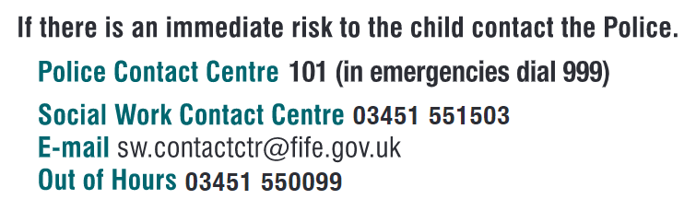
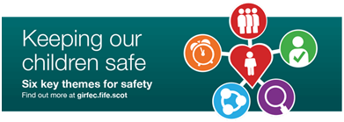

Fife Key Child Protection Principles

Fife Child Protection Committee’s ‘Six for Safety’ promotes best practice when working with children and families. Developed from analysis and learning from Significant Case Reviews, these are day-to-day ways of working to support and protect children and young people and support improved decision making.
- Child at the Centre – The needs of children and young people are at the centre of all practice.

- Relationships – Ensuring that all relationships with children, parents/carers are effective, constructive and are central to improving wellbeing and minimising risk of harm.

- Quality Assessment and Planning – All assessments and plans are accurate and effective by achieving outcomes in meeting needs and minimising risk of harm. All available resources and tools are used to best effect.

- Information Exchange and Communication – Relevant information is shared appropriately, clear lines of responsibility for action are understood across partners and communication is effective in minimising potential risks.

- Early Intervention – Early and effective intervention is achieved where possible, minimising risk of harm to children and young people.

- Professional Support and Oversight – A culture of effective management support and/or supervision is embedded which embodies the values and principles of Fife Child Protection Committee.

We recognise that:
- The welfare of the child is paramount, as enshrined in The Children (Scotland) Act 1995
- All children, regardless of age, disability, gender, racial heritage, religious belief, sexual orientation or identity, have a right to equal protection from all types of harm and abuse.
- Some children are additionally vulnerable because of the impact of previous experiences, their level of dependency, communication needs or other issues.
- Working in partnership with children, young people, their parents, carers and other agencies is essential in promoting young people’s welfare and wellbeing.
We will seek to keep children and young people safe by:
- Valuing them, listening to and respecting them.
- Appointing a Child Protection Co-ordinator for Child Protection for the school and also a Depute Child Protection Coordinator.
- Adopting the processes and procedures contained within Fife’s Inter-Agency Child Protection Guidance.
- Developing and implementing an effective e-safety policy and related procedures.
- Providing effective management for staff and volunteers through training, support and quality assurance measures.
- Recruiting staff and volunteers safely, ensuring all necessary checks are made.
- Recording and storing information professionally and securely.
- Using our procedures to share concerns and relevant information with agency’s who need to know, and involving children, young people, parents, families and carers appropriately.
- Using our procedures to manage any allegations against staff and volunteers appropriately.
- Creating and maintaining an anti-bullying environment and ensuring that we have a policy and procedure to help us deal effectively with any bullying that does arise.
- Ensuring that we have effective complaints and whistle blowing measures in place
- Ensuring that we provide a safe physical environment for our children, young people, staff and volunteers, by applying health and safety measures in accordance with the law and regulatory guidance.
- Sharing information about safeguarding and good practice with children, their families, staff and volunteers via leaflets, posters, one to one discussion.

Safeguarding Procedures Poster
A learner comes to talk to you/messages you.
You suspect there is something wrong at home/school.
You see physical symptoms/signs.
You have concerns about behaviour changes.
Make it as easy as possible to talk/message.
Fill in a Care and Welfare Form as fully as possible ensuring you note all facts clearly.
Give/send Care and Welfare form to Child Protection Coordinator.
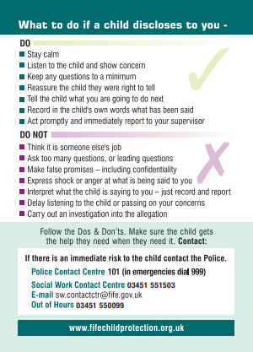
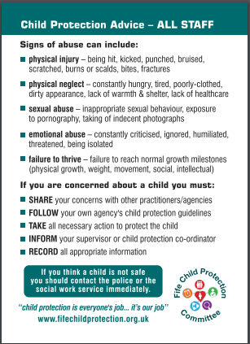
DCPC - Claire Adair
CPC - Holly Kirkhope
Child Protection Coordinators names:
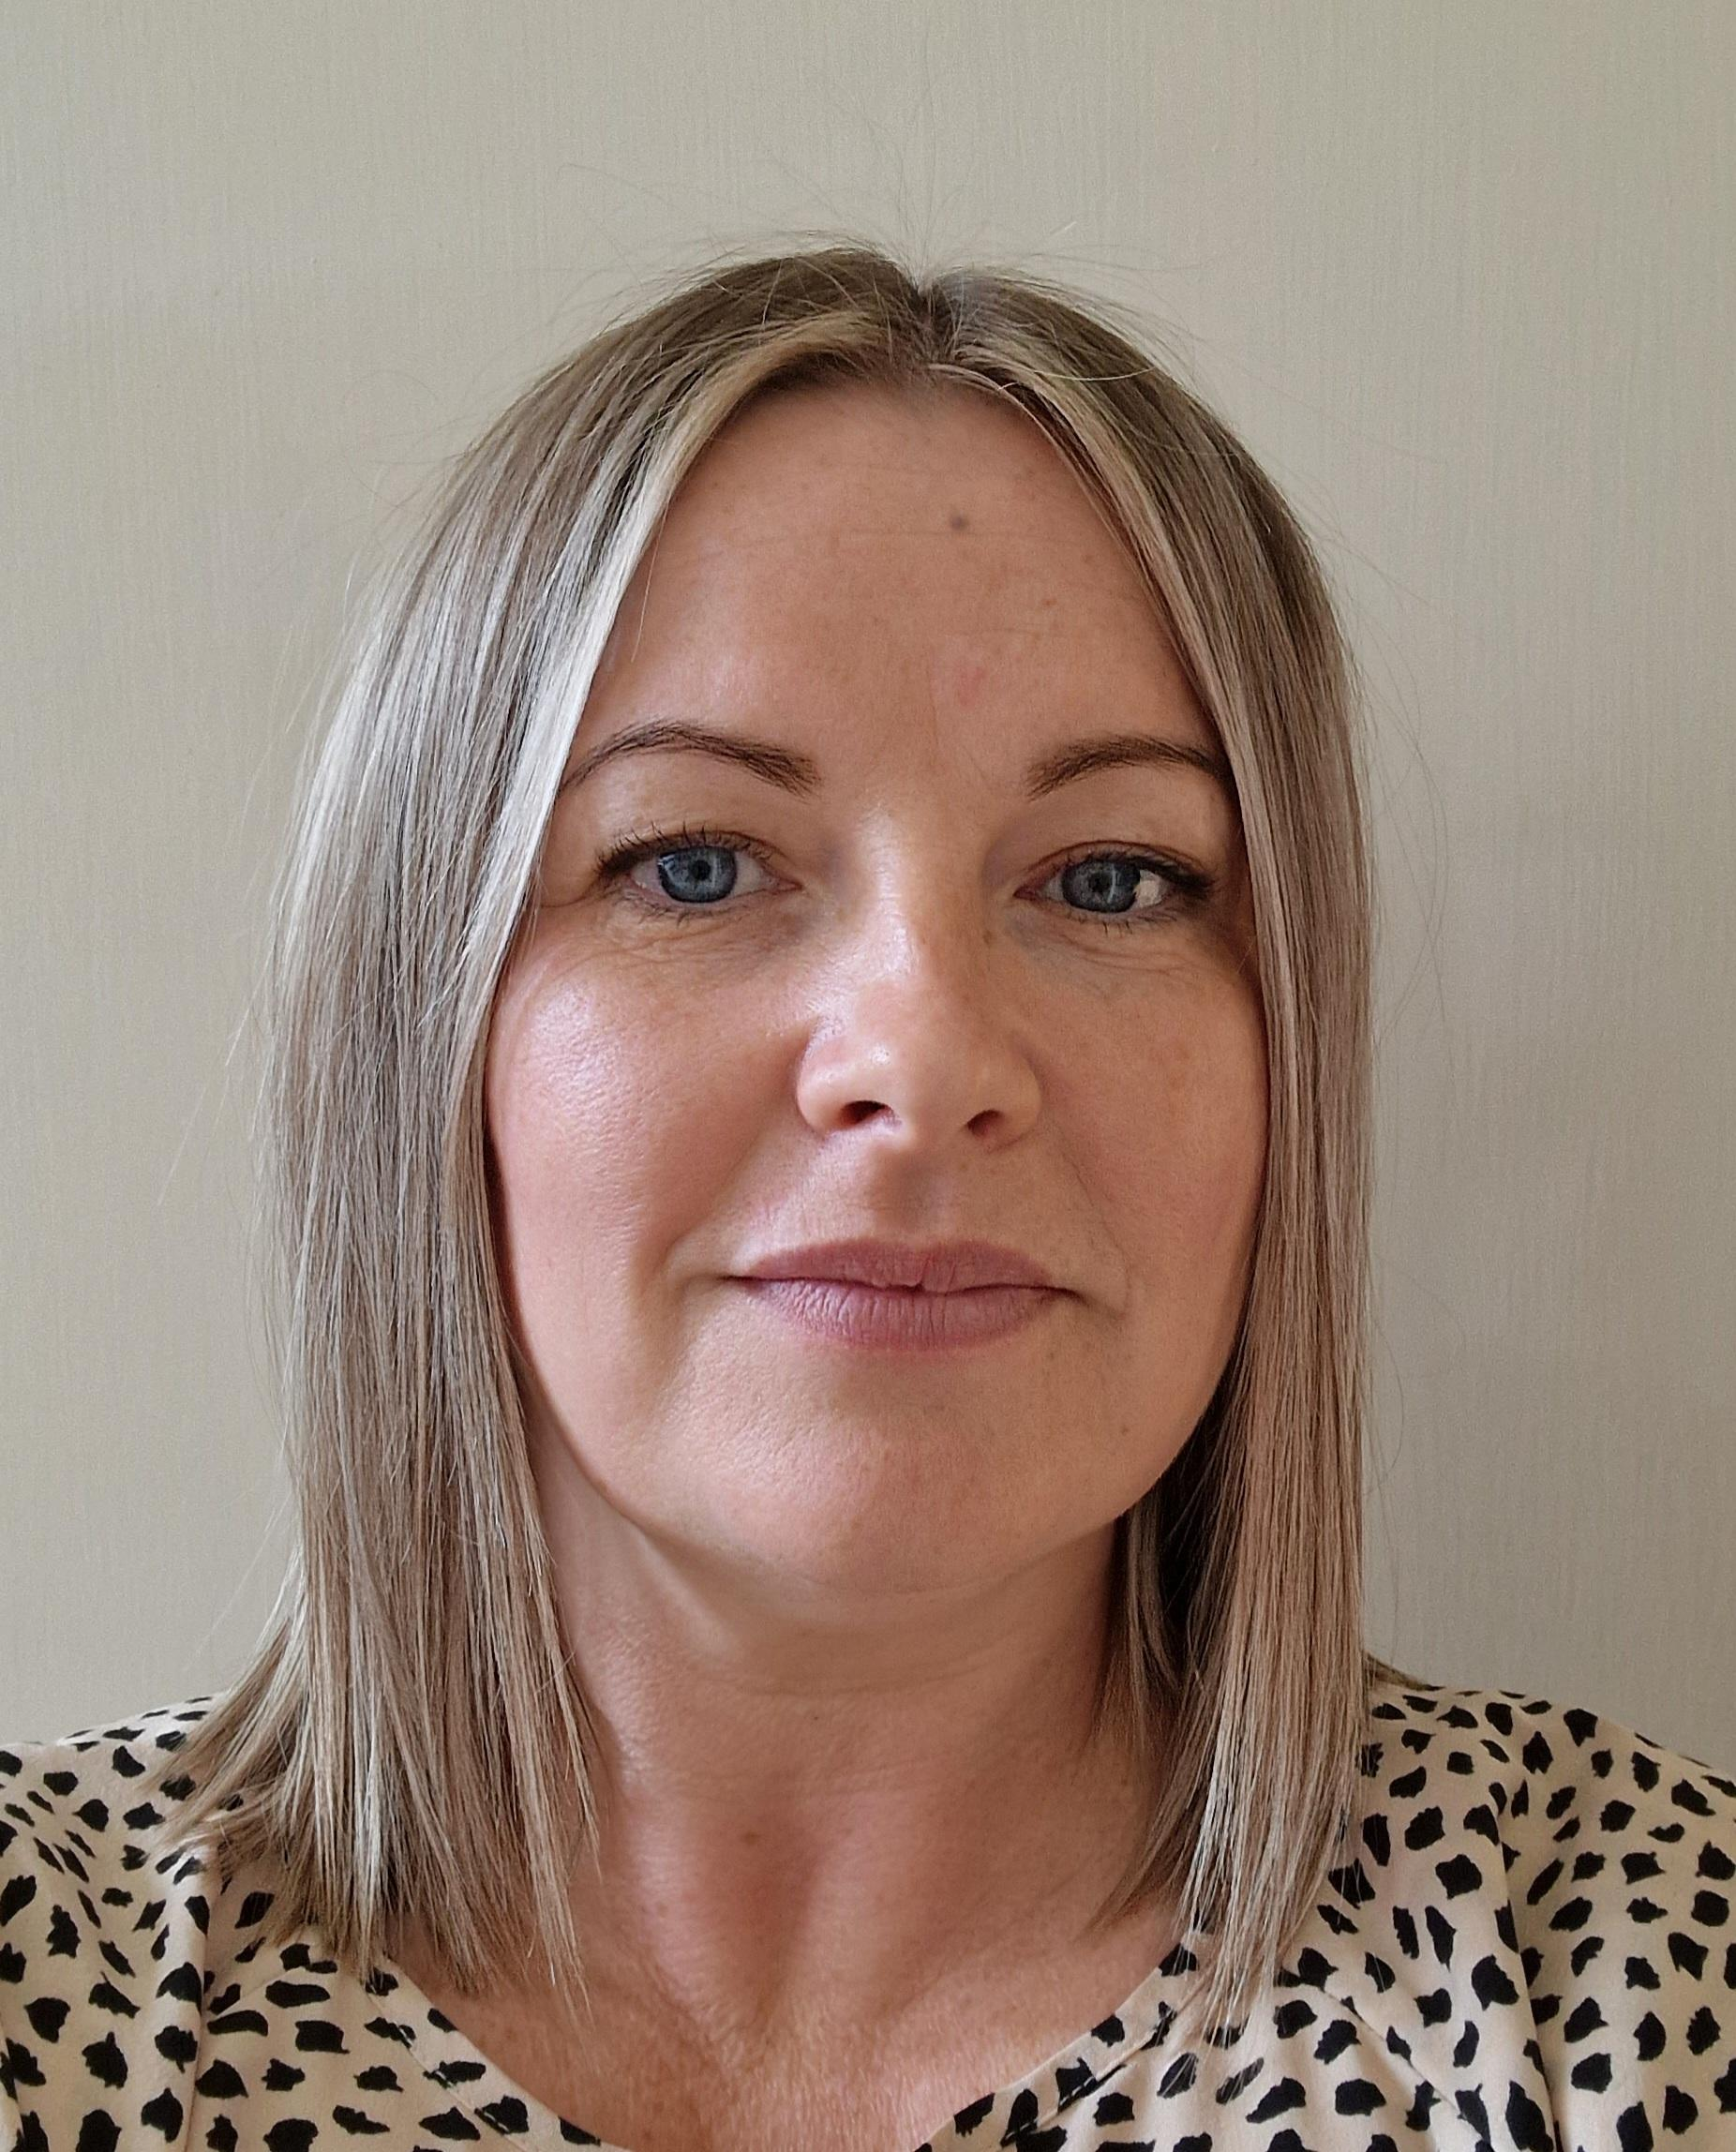

Expect and ask for feedback.

Fill in a Care and Welfare form as soon as practically possible and give/send to Child Protection Coordinator.
Record facts as fully as possible and use learner’s own words where possible.

Be honest about what you are required to do to ensure the learner gets the help they need.
Be explicit about being required to pass on information to the right people.
Do not attempt to gather evidence/proof.
If comfortable ask “wh” questions but do not ask leading questions. (Who, What, Where)
Take time/space to listen.
Discuss with Child Protection Coordinator.
Take the learner seriously and reassure them. Remain neutral and try not to express shock or anger at what is being disclosed to you – just record and report.

Contact details

Child Protection Coordinator
Name | Holly Kirkhope
VOIP | 441454/ 01334 659415
Email | Holly.kirkhope-bx@fife.gov.uk

Depute Child Protection Coordinator
Name | Claire Adair
VOIP | 441454/ 01334 659415
Email | Claire.adair@fife.gov.uk

We are committed to reviewing our policy and good practice annually.

This policy was last reviewed by Holly Kirkhope on 15.2.26

Position: Headteacher
Signed: 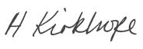

Legal Framework
This policy has been drawn up based on overarching legislation and guidance that seeks to protect children, namely but not exclusively:
- National Guidance for Child Protection in Scotland, Scottish Government, 2021
Child Protection Guidance 2021 (theapsgroup.scot)
- Inter-agency Child Protection Procedures – Fife (2016)
https://www.fife.gov.uk/__data/assets/pdf_file/0030/194970/CPC-Inter-Agency-Guidance-Final-Master-27.09.16.pdf
- Getting it Right for Every Child Policy
https://www.gov.scot/policies/girfec/latest/
- General Data Protection Regulation/Data Protection Act 2018
https://ico.org.uk/for-organisations/guide-to-data-protection/guide-to-the-general-data-protection-regulation-gdpr/
- Children’s Hearing (Scotland) Act 2011
https://www.legislation.gov.uk/asp/2011/1/contents
- Children and Young People (Scotland) Act 2014
http://www.legislation.gov.uk/asp/2014/8/contents/enacted
- Children (Scotland) Act 1995
https://www.gov.scot/publications/scotlands-children-children-scotland-act-1995-regulations-guidance-volume-1-support-protection-children-families/documents/
- Children Scotland Act (2020)
https://www.legislation.gov.uk/asp/2020/16/body/enacted
- Education (Additional Support for Learning) (Scotland) Act 2004
https://education.gov.scot/improvement/research/education-additional-support-for-learning-scotland-act-2004/
- National Framework for Child Protection Learning and Development in Scotland (2012)
http://www.gov.scot/Topics/People/Young-People/protecting/child-protection/national-framework-cp-learning-2012
- The Protection of Vulnerable Groups (Scotland) Act 2007
http://www.gov.scot/Publications/2011/08/04111811/1
- United Nations Convention on the Rights of the Child
http://www.unicef.org.uk/UNICEFs-Work/Our-mission/UN-Convention/

