Falkland PS
School Travel Plan



Headteacher: Mrs Laura Munro

School address: Pleasance, Falkland, KY15 7AW

Telephone No: 01334 659415

Social Media/Website: https://blogs.glowscotland.org.uk/fi/falklandprimaryschool/
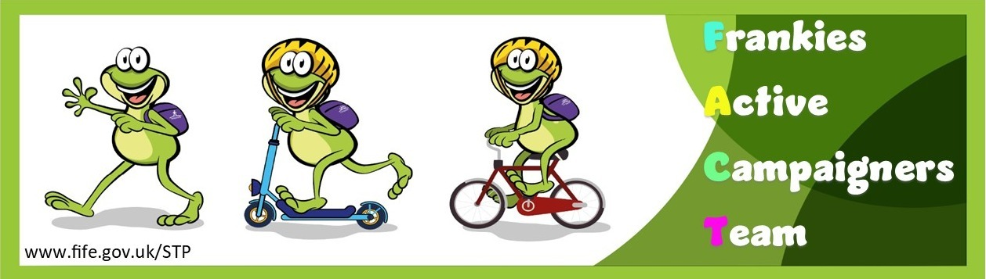

Contents Page

3: 1.0 WHY HAVE A SCHOOL TRAVEL PLAN

3.: 2.0 BENEFITS OF HAVING A SCHOOL TRAVEL PLAN

4: 3.0 Current Travel Habits

3.1 Family Questionnaire Data

6: 4.0 ROUTE AUDIT OF KEY ROUTES TO SCHOOL

4.1 Access Arrangements

7: 5.0 ACTION PLAN

8: 6.0 MONITORING AND EVALUATION

8: 7.0 DISTRIBUTION OF SCHOOL TRAVEL PLAN

1.0 Why have a school travel plan

School-related traffic congestion and the risks congestion poses to the safety of the pupils, teachers, parents, residents, and motorists in and around school locations is a significant problem in communities around Fife.

The most obvious cause of traffic congestion around our schools is vehicles, and the biggest source of those vehicles is parents’ dropping off and picking up their children from school.

Statistics highlight that 1 in 4 cars during the hours of 8:30 to 9:15 and 2:30 to 3:15 is primary school traffic.

Our annual Hands Up Survey highlights that 20%, that’s 4968 primary school children are driven to the school gate each day with a further 14% opting to Park and Stride. That is an additional 3616 pupils being driven in and around the school streets.

Fife Council’s Road and Transportation Service are working with schools in Fife to develop School Travel Plans and support our Frankies Active Campaigners Team (FACT)to develop campaigns such as Walking Buses, Park n Stride sites, Parking Pledges, available routes to school maps, delivery of Bikeability as well as looking at any engineering works that may be required to make active travel to school your first choice of travel.

2.0 BENEFITS OF HAVING A SCHOOL TRAVEL PLAN?

The benefits of encouraging active travel are clear and a school travel plan can ensure that your school has a long–term vision with aid to support Junior Road Safety Officers with delivering campaigns to;-
- Improve health and well-being by reducing harmful emissions and increasing activity levels.
- Improve safety through engineering measures and increasing road safety education.
- Improve access and opportunity by developing pupils’ skills for safe and independent travel.
- Improve the environment by reducing pollution and CO2 emissions.
- Gain school accreditations such as Fresh Air Frankie STP Awards, Active School Award and Eco Schools.
All work associated with School Travel Planning has been designed to fit into the Curriculum for Excellence.

3.0 CURRENT TRAVEL HABITS

Each year all Fife schools undertake the hands up survey which gives a true reflection of how pupils are travelling to school and the latest results show that 68% of pupils are actively travelling to school. However, with over 30% still being driven to school the school must continue to keep up the good work and reduce the number of cars parked around the school gate.
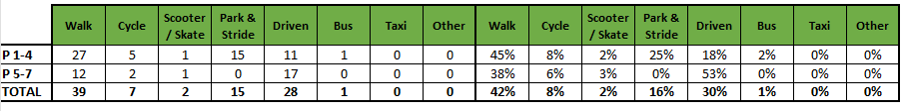

3.1 Family Questionnaire

50 families answered the online questionnaire, and the results are as follows.

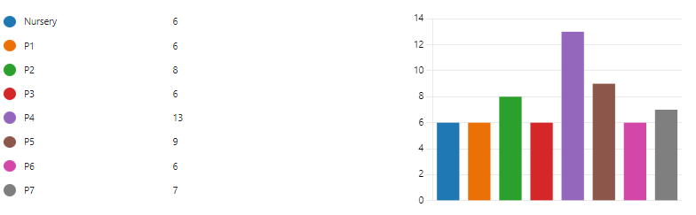
What school year is your child/children in?

How does your child/children normally travel to school?

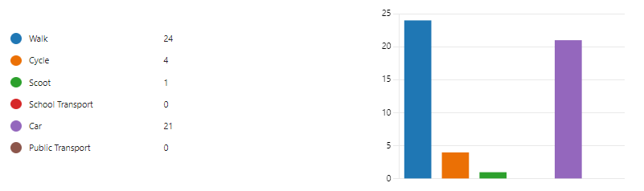

Those that travel by car were asked the following questions.

Can you tell us why you drive your child/children to school

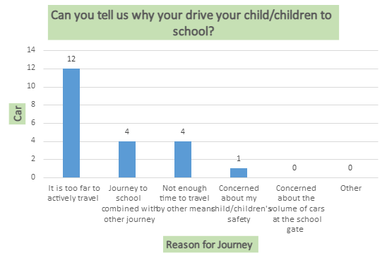
As per the graph the reason that there is concern about child’s safety is:

- The speed cars travel along the road between Newton and Falkland and there being no barrier between the pavement and road, other route is fine in nicer weather but takes longer so isn't always an option in the mornings.

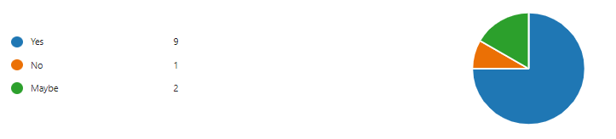
Would consider using a Park N Stride site

What else do they think they could do to ease congestion around the school gate.

- More information on a park and stride site could raise awareness of the availability of this and encourage parents to make use of it.
- We do sometimes walk (from Newton of Falkland) instead of taking the car - we could maybe do that more often, time allowing.
- Park further away, we park at the graveyard currently so as to not be driving down right outside the school.
- He may start walking to school. I wouldn’t let him scoot or cycle to school himself though. The general old road network in Falkland really doesn’t lend itself to this. There’s a lack of footpaths along part of south street and horse market. I wouldn’t mind him walking but I’d not be happy with him cycling or scooting. Also I think the roundabout junction and crossing at the school is really dangerous. So many cars come through the lights. He’s in p5 but I am a bit reluctant to let him walk home alone because of that crossing.
- Try to walk/ cycle to school when we have time
- I’m a breakfast club user so it’s quieter at this time
- I already park some distance away so my children can walk part of the way.
- Not sure regarding school gate. The distance we come means it is only feasible that we drive. My child gets more than enough daily exercise and of course if lived closer we would walk.
- I would happily drop them further from the school gates if there was a safe way for them to walk themselves into school. At present it is very congested, and I don’t feel comfortable with them crossing roads alone.
- I agree with allowing cars to park somewhere safe that is easily accessible for children to then walk to school. The main car park isn’t really an option as there are no pavements and there is that awful crossing.
- I drop my child off for out of school club so there is little/no congestion at that time of the morning.
- Drop children off in a different location for outdoor learning perhaps
- Prevent parking too close to the gates (use cones)
- My child gets plenty of exercise with sports clubs and daily walks with the dog. We drive to school as too far to walk and no public transport option/time. We park a little bit away from the school and walk.

Those that actively travel to school were asked the following questions:

If your school was to set up a walking bus, would you volunteer to support this?

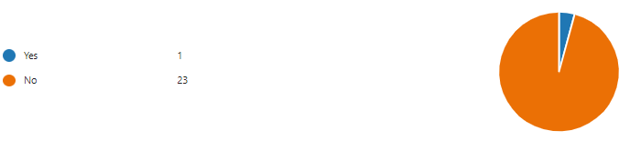

What would improve your active journey to school?

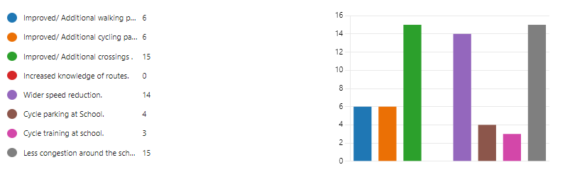

Is there anything you would like to tell us about your journey to school?

- My partner takes my child to school and then heads off to work straight after.
- The school has a lovely approach to the road safety, encouraging safe travel in class learning/outdoor learning as well as community spirit in terms of the crossing and parents looking out for all the kids.
- Apart from the brae and the school being located on main pad the route is relatively ok for us. The biggest issue is the cars flying through the roundabout at the school.
- Have noticed a lot of parents parking in the bus parking spot outside the nursery, this would be better suited to be used by disabled parents who have more difficulty walking further and would actually benefit from parking closer.
- Even with the new road layout outside the care home the traffic is still coming into the village at speed. The traffic leaving the village also tend to speed up from pharmacy out of village which has almost cause accidents with the cars coming into the village.
- Many parked cars on the route to school. Particularly on the road between the junction for Lomond crescent and the school gate on the pleasance. Many people continue to park on double yellow lines. Congestion of people at the school gate on the pavement at the entrance to the school, as this is where the crossing is. Concerns around drivers not seeing the crossing at the mini roundabout. Concerns remain around the speed of vehicles, including hgv's, despite a reduction in the speed limit to 20mph.
- We tend to walk to school most mornings except when my partner need to be in Edinburgh by a certain time. Time just doesn’t allow him to drop him off and make his way back to the house. This is normally just one day a week though. My child does tend to get picked up particularly Monday to Wednesday as my mum has to drive to the village to look after him those days so she has no option but to bring the car and Thursday Fridays my partner gets him from school but often they drive due to my partners work commitments. This may change a bit though as my child might want to start making his own way to school.
- We would be more likely to walk to school if this could be combined with walking or family dogs. Unfortunately, this is not currently possible for to dogs not being permitted in the school playground
- That main road is a massive safety concern. The road is too fast despite speed restrictions and the roundabout with traffic lights are not a good combination. Red lights are being missed putting children at risk.
- It is imperative that the priority is given to the pedestrians around Falkland and that traffic is reduced/better managed. Traffic calming points around the school should not be an option but a rule to control too many fast drivers.
- Cars don’t always stop at crossing
- Heavy flow of traffic, not enough parking for parents who need to drive.
- The speed limit into town gradually decreases but people do not seem to obey the speed limit. Even with the traffic calming. It’s scary walking along the road with my 3-year-old with cars rushing by. I appreciate the measures in place to slow cars but i wonder how it can be enforced.
- Cars parked up right hand side of pleasance make the journey safer, but few adhere to speed restriction around Laich Road and High Street
- Cars drive too fast. Too many near misses with children and cats getting killed! It’s supposed to be a 20, I’ve seen many cars do about 40. It’s scary and dangerous for everybody
- Unlocking the school field gate so children can avoid walking round the path at the roundabout where it gets crowded
- We only drive because we can’t physically otherwise, we would walk and reduce the traffic around the school.
- We don’t have loads of time in the morning as we have a busy morning before school so we could only do the above if it was a reasonable distance from the school and not too far out of the way.
- The crossing at the traffic lights is a concern
- Parking is an issue
- Short walk to school and glad cars park on pleasance as this helps to slow traffic.
- I drop my child off on the way to work as there is no school transport available from our home to the school at those times.
- Not especially. We loved walking to school but it’s not possible now as it would be a 3 hour walk.
- What is in place between the riggs and the care home as a traffic calming measure must be repeated across the village, particularly ok the pleasance and newton road as it is still unsafe.
- My daughter would like to walk to school on her own and a crossing guard would help her do that. We had one at our last school.
- "I would like vehicles to slow down"
- We enjoy getting fresh air on our walk to school each day
- Dog excrement is an ongoing issue on pavements
- It could be a lot less stressful
- I do support a walking bus but can’t help as we stay just opposite the school

3.2 Staff Questionnaire

All staff members were asked how far they travelled to work and what type of transport do they use.

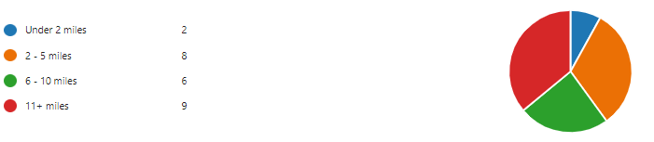
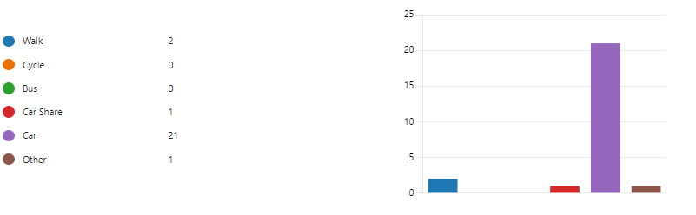

For those that drive they were asked the following

Where do you park?

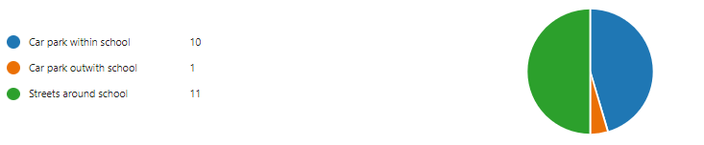
If you park in the street which street?

- Newton road
- Lomond crescent
- Small carpark up newton road

Would you consider parking away from the school gate?

No responses

Would you consider car sharing?

No responses

Are there any improvements you could make to your journey to ensure the routes to school are less congested?

- I choose back roads
- No due to living far away from the school and being dependant on one singular bus route
- I avoid travelling around drop off and pick up times

Is there anything else you would like to tell us about your journey?

- I leave early so that I am in the car park ahead of children and parents arriving. I use back roads for part of the journey, which are quiet and not congested.

All staff where also asked if they would consider undertaking Bikeability training so that they can deliver cycle training at school?

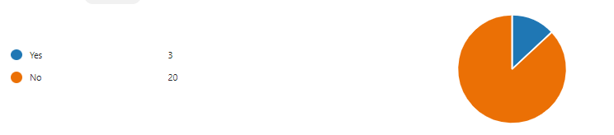

4.0 MAPPING WORK AND ROUTE AUDIT

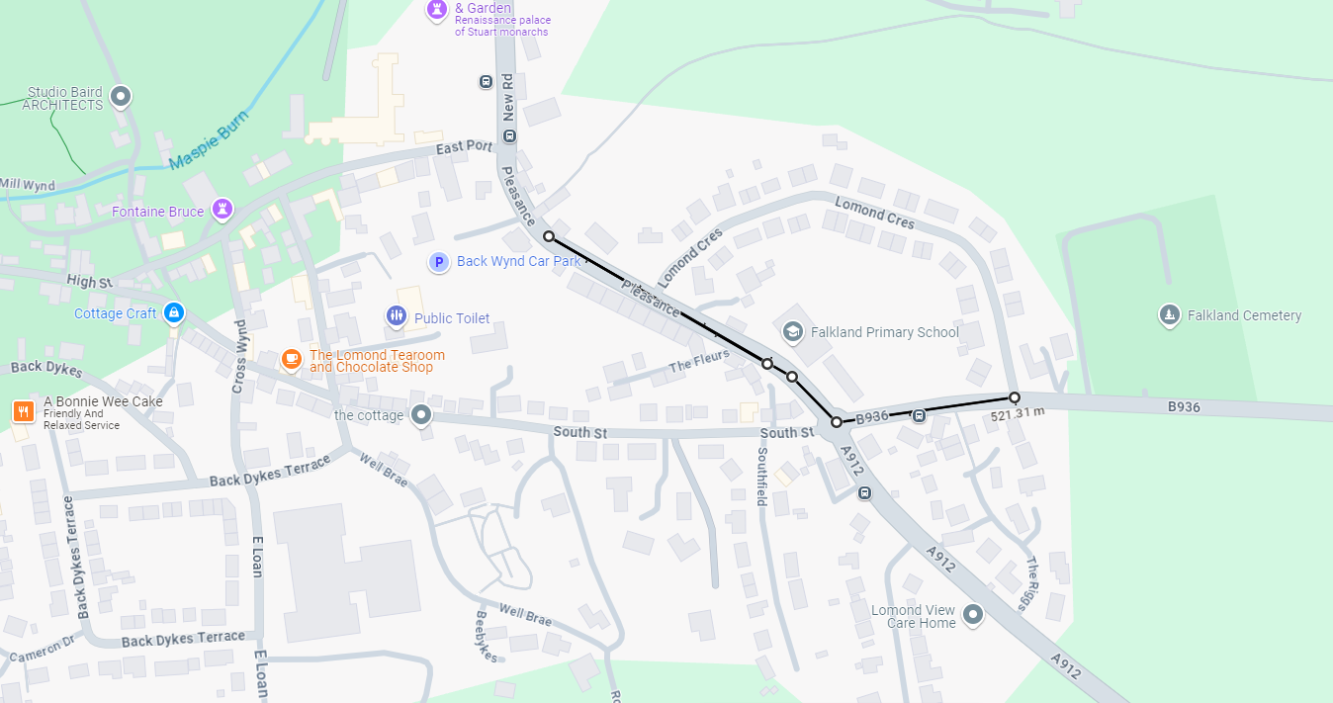
A route audit was carried out by Trudy Brown (School Travel Plan Co-ordinator, Marta Ramage School Travel Plan Co-ordinator and Cameron Lafferty Graduate Engineer) on Friday 22nd November 2024. The routes highlighted below were those that were deemed as the busiest routes.

4.1 Access Arrangements

There are good footways and footpaths through the catchment area and the residential areas adjacent to the school are covered by a mandatory 30mph speed limit and have associated traffic calming features. Speed limits are reduced to 20mps during school start and end, which is indicated by the flashing beacon school signs at either end on Pleasance. There are 2 entrances to the school site for pedestrians sited on Pleasance, one for access to the building and the other to the playground. There are visible school keep clears along the entire school site with additional traffic calming measures in place. The school has a dedicated car park for staff and those who need access to disabled parking.

Route Audit

Pleasance
Current Situation
The school and Parents have concerns about the speed and congestion of cars on Pleasance. The traffic calming measure that was put in place seems to be causing more issues than good. The traffic lights are too close to the roundabout that cars are not seeing a red light and are driving straight through. There has been several near misses and serious incidents.
Action
The School Travel Plan Team along with the relevant departments in Roads and Transportation are going to investigate what measures can be put in place to help slow traffic down and make it safer for pedestrians.
There is lack of signage to indicate that there is a school in the area, so this is going to be investigated too.

Newton Road
Current Situation
Newton Road can become congested at drop off and pick up times. This road is a through road to Newton of Falkland and often has HGV’s and Farm Traffic as well as buses. There is a School Bus bay which is no longer in use for buses but School Taxi’s use this.
Action
Fife Council will look at possibly reinstating the bus bay but renaming it to school taxi. The double yellow lines are also in need of a refresh.
Fife Council to look at the potential of installing a footpath in the school playing fields to create an entrance for pupils to use and closing off one of the entrances at the front of the school.

Summary

Since the last time the School Travel Plan was completed, additional traffic management speed reduction measures have been carried out. Nibs have been introduced close to the carehome to reduce the speed of traffic coming into the village.

5.0 ACTION PLAN

Action | Solution | Action Owner
Promote School Travel Plan | - Upload plan to website and social media pages.  - Create a FACT notice board.  - Create articles for school newsletters, social media, and assemblies.  - Keep the school travel plan team updated on all work carried out by completing your FACT floor book. | School
Fresh Air Frankie Awards Campaigns | Term 1  Hands up Survey Active Travel  Bike Week – capture data on travel tracker  Interschool Active Travel Challenge  International Walk to School Month  Create a video for #dontparkhere campaign next term  Term 2  Launch #dontparkhere Campaign  Send out social media post about congestion at the school gate  International Walk to School Week – capture data on tracker  Optional Campaigns - Road Safety Week  Term 3  Continue #dontparkhere social media campaign  Big Walk and Wheel  Create a travel plan induction sheet for P1 intake  Term 4  Walk to School Week – capture data in tracker  Bike to School Week  Clean Air Day  End of term newsletter to parents about the work carried out | School – full details held within your FACT folder
Reduce congestion | Consider developing the following:- Parking Pledge  Walking Bus  Campaigns to increase active travel to school. | School – full details held within your FACT folder
Bikeability | Deliver Level 2 Bikeability and apply for Cycle Friendly School Award | School/Bikeability
Annual Active Travel Award | Top 3 schools that can showcase the largest increase in Active Travel to School will be crowned champions. Data will be collated from the HUSS and our own travel tracker. | School/Travel Plan Team

6.0 MONITORING & EVALUATION
The FACT will continue to meet periodically to monitor progress and amend strategies to comply with the actions set out in this plan. Specific progress will be monitored by participation in the “Hands Up Travel Tally” each year and a repeat of the full travel survey will take place in 2028/29.

The school’s ongoing commitment to travel planning will be publicised in the school handbook, the school newsletters, the Parent’s notice board and through assemblies.

7.0 DISTRIBUTION OF SCHOOL TRAVEL PLAN
The following bodies will receive a copy of the School Travel Plan:
• Fife Council Sustainable Transport and Travel via the Travel Plan Team
• Fife Council Education Service
• Parent Partnership
• Copies will also be made available to the parents from the School Office and via
the school information sites.

