
"Opportunities For All"- Developing Leaders One by One

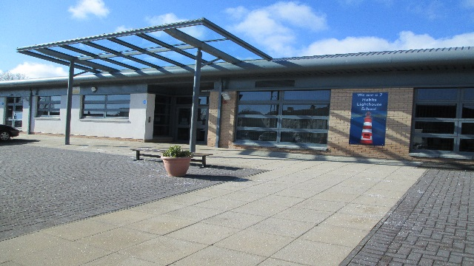

Fair Isle Primary School

Parent/Carer Summary
Standards & Quality Report
Session 2025 – 2026
and
School Improvement & PEF Plan
Session 2026 -2027



We are a Leader in Me Lighthouse School

Impact and Outcomes: Session 2025-2026

School Improvement Priority 1: Transforming learning

Progress and Impact:
- Transforming Learning training has been completed by all teaching staff as part of the cluster-wide programme, strengthening consistency in digital pedagogy.
- P6 and P7 iPad deployment ensured every learner in these stages received a personal device to support learning.
- Digital learning apps such as Showbie, Get Epic, Lexia, Freeform, Chatterpix, Canva, Adobe Express, Micro:Bit, Stop Motion Animation and Charanga have been introduced to enhance creativity, communication and problem-solving.
- Personalised learning opportunities have expanded, enabling children to work at an appropriate pace and level, supporting a wide range of needs and learning profiles. Almost all children are confident in accessing supports digitally.
- Children using the accessibility features of the 1-1 devices are using these very well to engage in learning and are demonstrating increased independence and making progress from prior levels of attainment.
- Future-ready skills are being developed, ensuring all children are better prepared for a world where digital competence is essential.
- There was very good use of the iPads to support and enhance learning and teaching in the upper school with almost all children using these very well to engage in learning that was transformative. The teaching staff team work together to identify the use of a wide range of digital tools to engage almost all children in learning as well as using accessibility tools for all those who require this.



School Improvement Priority 2: Follow up from HMIe

Progress and Impact:
- All classroom observations show explanations and instructions were clear, consistent use of learning intentions and success criteria and strong links to meta-skills and developing the young workforce. This is ensuring that all children continue to experience consistency in learning and teaching which is delivered in a timely manner.
- From all classroom observations all children are engaged in learning through motivating and purposeful learning experiences and all children are supported by the well organised and meaningful classroom learning environments.
- Our learning partnership demonstrated that almost all class teachers were very skilled in differentiating learning in all classroom observations and in some cases, this was very subtly done so as not to make this obvious to children. This ensured that children felt ownership of their learning and motivated to do well.
- Our Learning partnership also highlighted success criteria were co-constructed or differentiated to meet the needs of the children in all classes. As a result, almost all children knew how to be successful and showed understanding of this throughout the learning episode.
- Staff have further increased confidence in planning for differentiation because of engagement in professional learning. As a result, children continue to experience learning and teaching which is skilfully differentiated to meet their individual learning needs.
- Almost all children who are ahead of track and requiring challenge are experiencing this through learning and teaching. All children on track are experiencing challenge in learning and most children off track are experiencing sufficient support in learning enabling them to make progress from prior levels of attainment.
- Most learners are experiencing greater consistency in maths strategies due to staff moderation of maths and professional dialogue
- A majority of children are showing increased confidence in explaining their mathematical thinking, supported by the Maths No Problem approach.
- Most children with language needs are receiving more targeted support as staff have strengthened their understanding of Developmental Language Disorder




This Photo by Unknown Author is licensed under CC BY

Key Priorities for 2026-2027

Transforming Learning
- Staff will engage in professional learning on the use of iPads and associated apps to enhance the quality of learning, teaching and assessment.
- Staff will start using showbie for assessment information effectively to plan appropriate pace and challenge for all children.
- Accessibility features will be available to ensure learning is more inclusive for children with ASN whilst promoting independence.
- Teachers will use a range of creative pedagogical approaches and digital tools to create and share explanations and to model learning processes.
- Teachers within P6 and P7 will use book creator for IDL.
- Teachers within P1-P5 will plan appropriately for use of shared iPads once received.
- Staff will continue the development of Digital Portfolios to showcase learning over time using Showbie and leadership notebooks P1-P5 class leadership notebook. P6 and P7 individual leadership notebooks.


This Photo by Unknown Author is licensed under CC BY
Raising attainment
- Clear structure to be in place for the development of Early Level writing. Term 1- Talking and scribing, Term 2- Describing bubbles to expand oral/written sentence construction. Term 3 and 4 formal writing opportunities.
- Literacy learning at the beginning of first level (P2) to focus on the skills required for independent sentence building.
- At early and first level, teaching staff will now use Fife High Frequency words in conjunction with key ORT vocabulary to be taught in advance of each reading level.
- Dandelion launchers reading books to be introduced in the early stages of P1 to support de-coding skills
- Word Wall booklets to be sent home weekly
- Each stage to cover mental math’s benchmarks for their level, using the newly created mental math’s pathway
- Each stage to work on recall of mental math’s – 10/20 minutes per day (depending on stage).
- ICT time will include, using timetables rockstars (multiplication/division), which will be rewarded at assemblies
- NCCT teacher to teach supplementary mental math’s skills

Our School Wide Goals (WIGS) for session 2026-2027

- We aim to increase pupils in P1-P3 engagement with high frequency words from once per week to three times per week by May 2027
- We aim to increase pupils in P4-P7 engaging with dedicated mental maths sessions from weekly to more than once per week by May 2027.


This Photo by Unknown Author is licensed under CC BY-NC

WIGS for last session 2025-2026



- We aim to increase pupils in P1-P5 engagement in digital technologies daily from 61% to 79% by May 2026. ACHIEVED

- We aim to increase pupils from using an iPad to engage in learning from 46% to 90% by May 2026. ACHIEVED

Evidence of wider achievement for session 2025-2026

Opportunities for Personal Achievement;  P1 – P3  - Ace awards  - Achievement Awards  - Individual class points  - Sports Day  - Stampers  - Classroom roles  - Sparkle Award  - Creative Dance Festival  - Class Leadership Roles  P4-P7  - Ace Awards  - Achievement Awards  - Star Writer  - Lexia Awards  - Class rewards  - Stickers  - Share work with SLT  - Sharing examples of quality work on Twitter/X  - Sports Day  - Leadership Roles  - Best of You | Interdisciplinary Learning;  P1 – P3  - Workshop for Literacy  - School Trip  - Learning Walls  - Outdoor Learning  - Topics  - Fair Trade Coffee Afternoon  - Wellbeing Week  - Building Recycled Homes  - Opportunities to learn through play  P4-P7  - Transforming Learning/ICT  - Artist study –  - Scottish Inventors  - Topics  - Class Assembly  - STEM  - Class trips/workshops  - Fundraisers/Enterprise  - HWB – Health Week  - P7 Residential  - Enterprise and Me  - Air Cadets
Ethos and life of the school as a community;  P1-P3  - Holi Party (colour festival)  - After school clubs  - Open morning  - Children in Need and Red Nose Day  - World Book Day  - Halloween and Christmas parties  - Paired Reading – World Book Day  - Enterprise – Dress to Express  - Seven Habits learning  P4 – P7  - 7 Habits  - Class Charter  - Junior Lighthouse Team  - Sports Day  - Christmas Fayre donations  - Leadership roles  - Weekly Upper School Assemblies  - Class assembly with parents  - Easter card competition with KART  - Trainer competition for Commonwealth Games  - Junior Road Safety Officers  - Junior Lighthouse Team  - Care Home Visits  - Lead Charity Events  - P2 Paired Tutoring  - Football & Netball Teams  - Barnardos Drugs Sessions | Curriculum areas and subjects;  P1-P3  - Floating experiments  - States of matter experiment  - Scottish Country Dancing  - Reading buddies  - Health and Wellbeing Week  - Scotland Whole School Topic  - Online Author Visit (World Book Day)  P4 – P7  - Music – Beat Box/YMI music festival  - Class Assemblies –  - Ukulele – Big Strum at Rothes Halls  - Fife Athletics Festival – Michael Woods Centre  - Dirt Crit 2026 – Lochore Meadows  - Tennis Festival – Kirkcaldy Lawn Tennis Club  - YMI singing at Torbain  - Golf with Fife College  - Open morning to share learning with parents  - Walk Through Bible Sessions  - Maths Week Scotland

Fair Isle School Values

To help us achieve success everyday across – and beyond - the school community, we believe it is important to live by our values. The 7 habits are developed through departmental assemblies, across the curriculum and wider life of the school:

- Habit 1: Be proactive
- Habit 2: Begin with the end in mind
- Habit 3: Put first things first
- Habit 4: Think win win
- Habit 5: Seek first to understand then to be understood
- Habit 6: Synergize
- Habit 7: Sharpen the saw

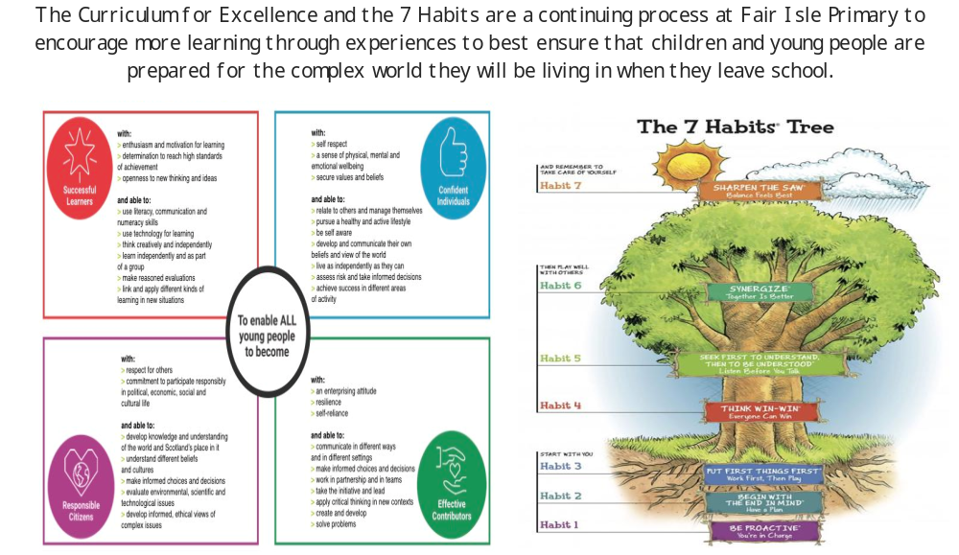

PEF

For our current session 2026/27 we received £215,600 through PEF (Pupil Equity Funding). The amount varies from school to school depending on the number of pupils receiving free school meals, giving additional targeted funding for each child in P1-S3 who is eligible, however, the Headteacher has the discretion to make decisions about which children would benefit most from any particular intervention.

We have initiatives to raise attainment in literacy, numeracy and health and well-being, in addition, to working to ensure better outcomes for everyone.

We also continue to work towards making sure as many of our initiatives are sustainable should PEF not be available in the future. Current initiatives:

Nurture/Support Base

Our Nurture Base continues to raise attainment for individual children who have difficulties coping full time in class and to raise attainment for other children in the class by decreasing interrupted teaching time.

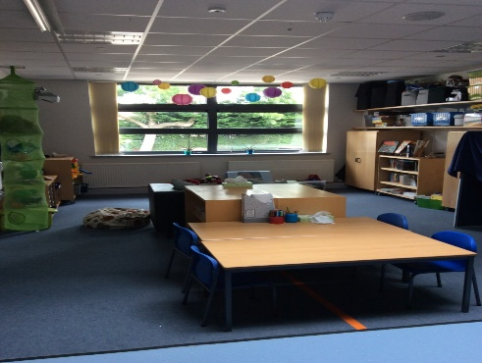

Children are supported and mentored in classes to make positive choices about behaviour and learning whilst building skills with self-regulation, social and emotional wellbeing and learning.

The nurture base also works with other children to build wellbeing skills either individually or in small groups. Some of the groups running this year include Lego therapy, gardening, flourish, and nurture.

Mrs Howe continues to support and upskill our class teachers and PSA’s in social and emotional well-being, nurture and self-regulation as well as leading our whole school wellbeing programme.

Later this session, we will again be offering our very successful ‘Parents Survival’ group for families to work collaboratively with base staff to support their children.

Pupil Support Assistants (PSA’s)

We increase our Fife Council allocation of PSA’s to support children to increase their engagement with the curriculum. These PSA’s support children within mainstream classes and the playground. We currently employ 5 full-time PSA’s and 1 part-time PSA via PEF funding.





