 FAIR ISLE PRIMARY SCHOOL
Christmas Newsletter

Christmas Post 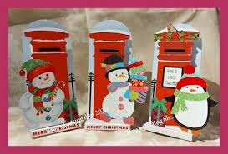
Christmas post will start on Monday 1st December-Friday 12th December. This is when your child can bring in Christmas cards for their friends and post them in the post box and then they will be distributed within the school. Please make sure you write the name of the child and the class they are in on the envelope.

Christmas Parties
Here is list of when the Christmas parties will be this year. Children can bring in party clothes to get changed into or go home for lunch. Lunch is at 12.35pm-1.20pm. The parties will be in the hall in the afternoon on the following dates:
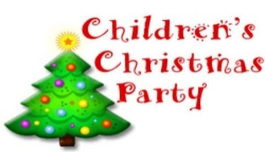
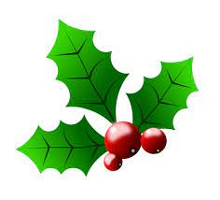 Christmas Parties

Friday 5th December- All P1’S
Monday 8th December- All P2’s
Tuesday 9th December- P3A & P3/4
Friday 12th December- P4A & P4/5 & P5A
Wed 17th December -P5/6, P6A, P7A & P7B

Christmas Fayre 
P7 will be hosting the Christmas fayre which will be on Wednesday 10th December 3.30pm-5.00pm. Parents will be welcome to come along to this event. If you have anything that you would like to donate to the raffle or Bric-a- Brac, please hand these into the school office from Monday 1st Dec. Cake and candy can be handed in on the morning of Wednesday 10th Dec.

School Christmas Lunch
The Christmas Lunch will be on Thursday 11th December 2025. The cost is £2.60,
unless your child is entitled to free school meals. If your child would like lunch that
day, can we ask that you pay & pre-order this in Ipayimpact before 8th December.




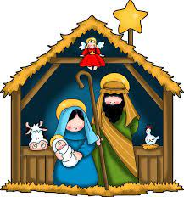

P1 Christmas Performance
P1’s will be having their Christmas Performance on Tuesday 16th December at 9.30am in the hall. Tickets are required which are free of charge and limited to 2 per child. We will email you a link to order your tickets. Afterwards there will be Tea and Coffee available and if you are able to make a small donation, we would appreciate it.

Christmas concert
The P7’s will be attending the Christmas concert at KHS on Tuesday 16th December 1.30pm-2.30pm.They will walk to and from the school accompanied by school staff.

Christmas Assembly
The whole school will be attending Hope church for the Christmas assembly on Friday 19th December at 10.00am.

School Holidays
The school will close on Friday 19th December at 3.00pm and reopen on

Monday 5th January 2026 at 9.00am.

All the staff from Fair Isle Primary would like to wish everyone a Merry Christmas and we look forward to seeing you all in 2026.



