**Fair Isle**

**School Travel Plan**

**2023/24**

Headteacher: Mrs Vicki Bell Junior Road Safety Officers: Kian Bell

Kelsey Craft

School Travel Plan Team: Marta Ramage Kole Dolan

Trudy Brown Jaiden McFarlane

Eva Melia

School address: Fair Isle Road Ella Mulackova

Kirkcaldy

KY2 6EG

Telephone No: 01592 583428

Social Media/Website: [Website](https://blogs.glowscotland.org.uk/fi/fairisleprimaryschool/)



**Contents Page**

**3: 1.0 WHY HAVE A SCHOOL TRAVEL PLAN**

**3.: 2.0 BENEFITS OF HAVING A SCHOOL TRAVEL PLAN**

**4: 3.0 Current Travel Habits**

**3.1 Family Questionnaire Data**

**9: 3.2 Staff Questionnaire Data**

**11: 4.0 ROUTE AUDIT OF KEY ROUTES TO SCHOOL**

**4.1 Access Arrangements**

**12: 5.0 ACTION PLAN**

**14: 6.0 MONITORING AND EVALUATION**

**15: 7.0 DISTRIBUTION OF SCHOOL TRAVEL PLAN**

**16: APPENDIX 1 – ROUTE AUDIT REPORT**

**1.0 Why have a school travel plan**

School-related traffic congestion and the risks congestion poses to the safety of the pupils, teachers, parents, residents, and motorists in and around school locations is a significant problem in communities around Fife.

The most obvious cause of traffic congestion around our schools is vehicles, and the biggest source of those vehicles is parents’ dropping off and picking up their children from school.

Statistics highlight that 1 in 4 cars during the hours of 8:30 to 9:15 and 2:30 to 3:15 is primary school traffic.

Our annual Hands Up Survey highlights that 23%, that’s **5562** primary school children are driven to the school gate each day with a further 17% opting to Park and Stride. That is an additional **4111** pupils being driven in and around the school streets.

Fife Council’s Road and Transportation Service are working with schools in Fife to develop School Travel Plans and support Junior Road Safety Officers to develop campaigns such as Walking Buses, Park n Stride sites, Parking Pledges, available routes to school maps, delivery of Bikeability as well as looking at any engineering works that may be required to make active travel to school your first choice of travel.

**2.0** **BENEFITS OF HAVING A SCHOOL TRAVEL PLAN?**

The benefits of encouraging active travel are clear and a school travel plan can ensure that your school has a long–term vision with aid to support Junior Road Safety Officers with delivering campaigns to;-

* Improve health and well-being by reducing harmful emissions and increasing activity levels.
* Improve safety through engineering measures and increasing road safety education.
* Improve access and opportunity by developing pupils’ skills for safe and independent travel.
* Improve the environment by reducing pollution and CO2 emissions.
* Gain school accreditations such as Fresh Air Frankie STP Awards, Active School Award Eco School Award, Cycle Friendly School Award
* Have access to additional funding and support.

**All work associated with School Travel Planning has been designed to fit into the Curriculum for Excellence.**

**3.0**  **CURRENT TRAVEL HABITS**

Each year all Fife schools undertake the Hands Up Survey which gives a true reflection of how pupils are travelling to school and the latest results show that of pupils are actively travelling to school.

**3.1 Family Questionnaire**

52 families answered the school travel plan online questionnaire, and the results are detailed in the graphs and text below.

**How do you normally travel to and from school?**

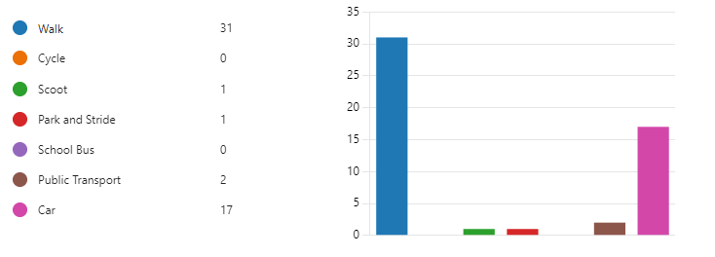

**How far do you live from the school?**

**What is the main reason for choosing this mode of travel?**

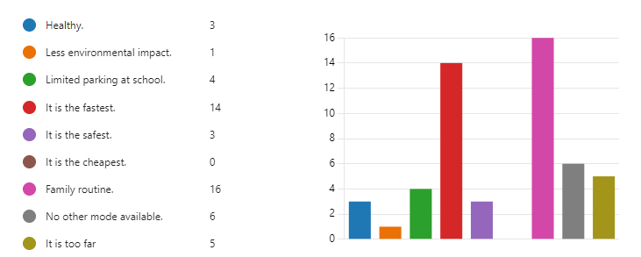

**What factors might affect your decision whether to let your child actively travel to school?**

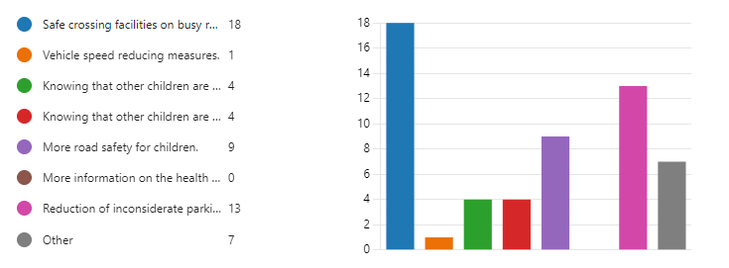

**Parents were then asked if they wanted to add anything else about their journey to school.**

Inconsiderate drivers speeding and inappropriately parking around the school entrances discourages me from allowing my child to make own way to school

Regularly see the same cars parking in Aboyne gardens parking on pavements, on the corner or across drives in the street. Cars driving too fast up & down street at school drop off & pick up times are an issue aswell

Parking in school grounds is horrendous when there is nobody on the gate

* Dallas drive and Appin crescent are extremely busy a one way system whilst school is on would be best cars do not follow the speed limit and no school crossing is available at the back of the school
* I live relatively close to the school my child attends, which is a double edged sword. It is convenient for my child to travel to and from school but the absolutely ridiculous parking by other parents/carers around the school can make it impossible for me to get home from work. This is an inconvenience to me and more so makes me concerned for the safety of ALL of the children outside the school gates. The cars are parked on pavements, grass verges and edges and sometimes just outright abandoned on the road. !! Hazard lights do NOT give you the right to park wherever you like. !
* People parking In the bus stop near the lolly lady. Or parking where she crosses them!
* He arrives at school by car as I need to travel to work from there. Pick up mon- thurs is by family members who live too far away from the school to walk (they park at the bowling green) Friday pick up (and any drop off/pick up when we are off work) is done by parents and is done by walking,
* I stay of the school and the way parents park is so dangerous for the kids trying to see crossing the roads
* It's a good thing for my daughter to have a 15 min walk to school. And it is a safe way. Not good when the rain is pouring.
* The time it takes 4 hours a day. £10 a week I have to pay out of my own pocket doing so. I am unemployed and don't get much money so it is really stretching on the budget
* We enjoy the walk to school but drive in bad weather, parking sensibly. A lot of cars are parked obscuring vision, blocking exits, on the verges, pavements. Seems to be out of laziness/running late as there are plenty of places to park safely nearby.
* I have to take my car so I can head straight to work after
* I would only drive to school if very heavy rain and drop off only then drive away. If I need to drive for any other reason, I always use the bowling green car park as it’s more suitable place to park
* We always park further away from the school, normally in the Fair Isle Bowling Club car park and then walk.
* We love walking to school. Me and my husband work full time and walking down gives us opportunities to talk to my daughter and answer any questions she has about everything around us.
* My main concern is the school car park is always full of parents picking up kids that shouldn't be using the car park making it unsafe.
* My child walks to school but sometimes gets driven. It would be handy having a safe drop off point.

**3.2 Staff Questionnaire**

**How far do you travel for work?**

**What mode of transport do you use to get to work?**

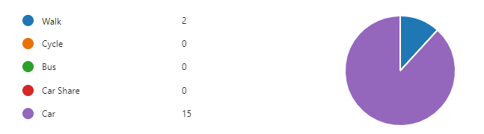

All staff stated that they drive to work each day and park within the school car park.

Staff were also asked if they would like to consider car sharing and 9 said **yes**, they were also asked if they would like to undertake Bikeability training to deliver cycling in school 3 said **yes**.

**When asked what would encourage them to consider an alternative mode of transport to work they replied.**

* If the there was a bus that I could get and it was reliable.
* No public transport available from near home
* I need car at work as regularly have to go out of school to meetings
* Public transport that did not involve changing at certain points, cost and reliability.
* Better bus service
* No alternatives available
* I live 15 miles from the school, another mode of transport isn’t really appropriate I feel. I also need to drop my children off at their childcare and so need to use my car.
* I have to use my car because of family commitments before and after work.

**Finally, when asked are there any improvements you could make to your journey to ensure the routes to school are less congested?**

* No it is not that busy when i am travelling to and from work.
* No, road is not too busy
* Arrive earlier
* Not to my journey but the amount of parents who are using the car park seems to be increasing, especially in wet weather.

**4.0 MAPPING WORK AND ROUTE AUDIT**

A mapping exercise was carried out within the school to identify the routes pupils travelled. These were then analysed and then categorised as active travel routes (green) and vehicular routes (red).

**4.1 Access Arrangements**

The school building houses all classrooms, assembly/dining hall, gym hall and all school administration rooms. A controlled entry system is in operation. The school is surrounded by a large tarmac play area and a grass playing field. There is a staff car park with 40 designated spaces and 2 disabled spaces. There is storage provision for bicycles and scooters. There is a pavement along the front of the school on Fair Isle Road and a bus lay-by for school transport. There is a crossing patrol at the front of the school and at Birnam Road. Yellow lines prohibit parking at both front and back entrances.

**5.0 ACTION PLAN**

|  |  |  |
| --- | --- | --- |
| **Action** | **Solution** | **Action Owner** |
| Promote School Travel Plan | * Upload plan to website and social media pages * Create a JRSO notice board or story board * Create articles for school newsletters, social media, and assemblies, * Keep the school travel plan team updated on all work carried out to include in the Fresh Air Frankie termly newsletter. | School |
| Travel Tracker | * Update the travel tracker every day | School |
| Local and National Campaigns | **Term 1**  Week 1 11th Sept Hands up Survey Active Travel  Week 2 18th Sept Cycling Competition  Week 3 25th Sept Bike Week  Week 4 2nd Oct Interschool Active Travel Challenge  International Walk to School Month  T**erm 2**  Week 16th Nov Launch #dontparkhere Campaign  Week 2 13th Nov Parking Letter to Parents  Week 3 20th Nov Road Safety Week  Week 4 27th Nov Be Bright Be Seen Competition  T**erm 3**  Create an active travel leaflet for the new starts that can be included in the school induction pack.  T**erm 4**  Week 1 8th May Walk to School Week  Week 2 15th May Scoot to School Week  Week 3 22nd May Active Travel Treasure Hunt  Week 4 29th May Bike to School Week | School    School/Travel Plan Team |
| Reduce congestion | Develop the following:-  Parking Pledge  Park N Stride Site  Walking Bus | School/Travel Plan Team |
| Bikeability | Set up cycling staff and deliver Bikeability | School/Bikeability Team |
|  |  |  |
| Awards | Work towards gaining the Fresh Air Frankie School Travel Plan and  Active Schools Award | School/Travel Plan Team |

**6.0 MONITORING & EVALUATION**

The JRSO will continue to meet periodically to monitor progress.

Specific progress will be monitored by participation in the “Hands Up Travel Tally” each year and a repeat of the full travel survey will take place in 2026. The school’s ongoing commitment to travel planning will be publicised in the school handbook, the school newsletters, the Parent’s notice board and through assemblies.

**7.0 DISTRIBUTION OF SCHOOL TRAVEL PLAN**

The following bodies will receive a copy of the School Travel Plan:

• Fife Council Roads and Transportation via the Travel Plan Team

• Fife Council Education Service

• Fife Council School Estates Team

• Parent Partnership

• Active Schools

• Copies will also be made available to the parents from the School Office and via

the school information site.

**Route Audit**

**1. BACKGROUND**

The mapping work enabled the JRSO to pick out a core network of streets used to travel to school. A strategic route audit of walking and cycling routes to the school was then carried out in October 2023. The route audit was attended by:

* 6 pupil members of our JRSO
* Marta Ramage (School Travel Plan Team)
* Trudy Brown (School Travel Plan Team)

The Audit involved walking along the core network of streets leading to the

school and identifying any potential safety hazards or potential improvements.

**2. CURRENT SITUATION**

There are good opportunities for parking and walking a short distance from the school. The roads around the school generally seemed to be quite safe.

The street immediately outside the school (Fair Isle Road) although there is a 20mph speed restriction in place it does seem cars don’t adhere to this.

To pursue the recommendations included in this report they should be incorporated into the School Travel Plan.

Interventions should include Education, Engineering and Enforcement to improve safety around the school and to support a successful School Travel Plan.

Where engineering measures have been identified, these will only be implemented when the School Travel Plan has been approved and signed off.

**3. CORE NETWORK**

The strategic routes chosen for audit are:

Fair Isle Road

Birnam Road

Aboyne Gardens

Kenmore Terrace

Appin Court

Farne Court

St Kilda Crescent

**4. STREET SAFETY AUDIT**

**4.1 Fair Isle Road – main entrance**

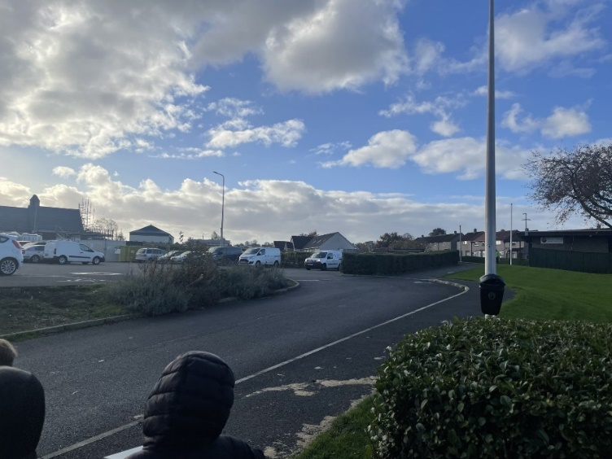It was noted by all of the pupils that there are a lot of vehicles parking, near the gates at the school entrance and nursery at start and finish times. ‘School Keep Clear’ restrictions are rarely observed. The speed cars drive along Fair Isle Road seems to be faster than 20mph, the School Travel Plan team will investigate as to when the last Traffic Survey was completed.

The JRSO’s also thought that the car park at the Bowling Club could be a good option for a Park and Stride site.

**4.2 St Kilda Crescent - footway**

It was agreed that the walking route along St Kilda Crescent is generally good with footways and dropped crossing points along the way. Several areas of damage were noticed.

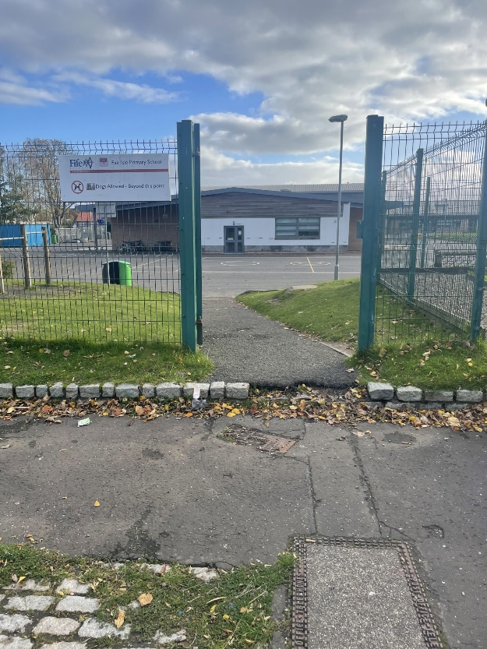**4.3 Aboyne Gardens – drop off**

Pupils pointed out the area close to the school gate off Aboyne Gardens can be busy at peak times. Parents are parking on the cobbled pathway which can obstruct access into the school through the gate.

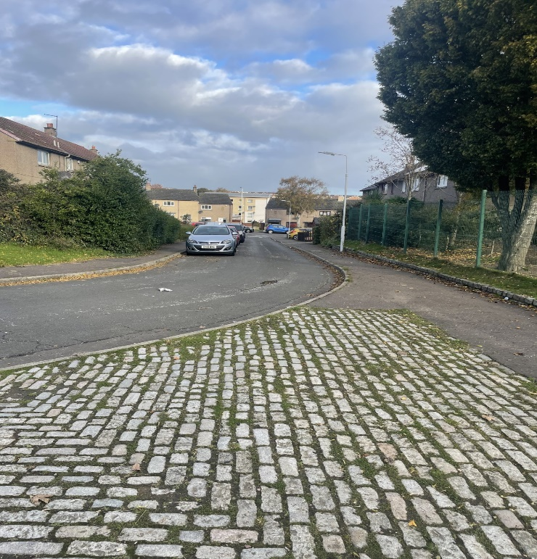

**4.4** **Birnam Road**

The JRSO’s observed that the Zebra crossing and lining needs repainting. The School Travel Plan Team will request this from the Traffic Management Team.

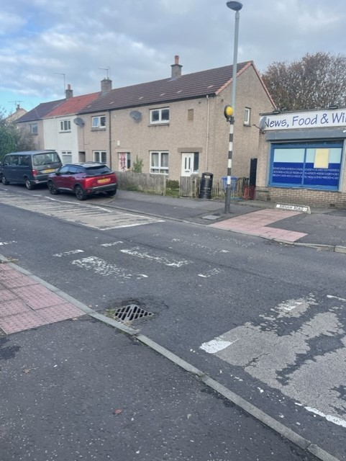

**4.5 Kenmore Terrace and Appin Cresent**

There was a good network of paths for children to travel safely to school being mindful of resident’s driveways and remembering to always check for cars moving out of drives.

**4.6 Farne Court and St Kilda Crescent**

There is a good network of paths for children to travel safely to school.