FAIR ISLE PRIMARY SCHOOL

**December Newsletter**

Here are the upcoming activities in school for December:

**Christmas Post** 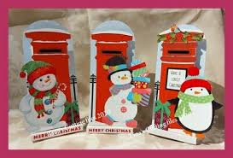

Christmas post will start on **Monday 4th December until Friday 15th December.** This is when your child can bring in Christmas cards for their friends and post them in the post box and then they will be distributed within the school. Please make sure you write the name of the child and the class they are in on the envelope.

**Christmas Parties**

Here is list of when the Christmas parties will be this year. Children can bring in party clothes to get changed into or go home for lunch. Lunch is at 12.35pm-1.20pm. The parties will be in the hall in the afternoon on the following dates:

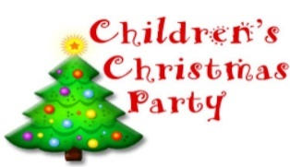

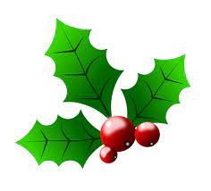 **Christmas Parties **

**Friday 8th December- P1A & P1/2**

**Monday 11th December- P2A & P2/3**

**Tuesday 12th December- P3A & P3/4**

**Thursday 14th December- P4 & P4/5 & P5A**

**Friday 15th December- P5/6 & P6A**

**Monday 18th December- P6/7 & P7A**

**Christmas Fayre**  

P7 will be hosting the Christmas fayre which will be on **Tuesday 5th December 3.30pm-4.30pm** Parents will be welcome to come along to this event. If you have anything that you would like to donate to the raffle or Bric-a- Brac or cake and Candy, please hand these into the school office after **Thursday 30th November.**

**School Christmas Lunch**

The Christmas Lunch will be on **Wednesday 13th December 2023**. The cost is £2.40,

unless your child is entitled to free school meals. If your child would like lunch that

day, can we ask that you pay & pre-order this in Ipayimpact before **8th December.**



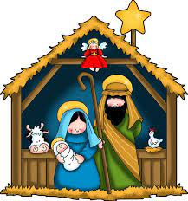

**P1 Christmas Performance**

Both **P1A** and **P1/2** will be having their Christmas Performance on **Thursday 14th** **December at 9.30am** in the hall. Tickets are required which are free of charge and limited to 2 per child. Afterwards there will be Tea and Coffee available and if you are able to make a small donation we would appreciate it. Please return the attached slip if you require tickets. Your child will then be given the tickets.

**Christmas Open Morning**

We are holding an open morning for the P2-P7 classes on **Monday** **18th December 2023** from **9.10am to 10.00am.**This is an opportunity for your child to show you around their classroom and tell you what they have been learning about. This will **not** include **P1A & P1/2** classes as the parents will have already attended the Christmas performance.



**School Holidays**

The school will close on **Wednesday 20th December at 3.00pm** and reopen on

**Thursday 4th January 2023 at 9.00am.**

All the staff from Fair Isle Primary would like to wish everyone a Merry Christmas and we look forward to seeing you all in 2024.

