Fair Isle Primary School

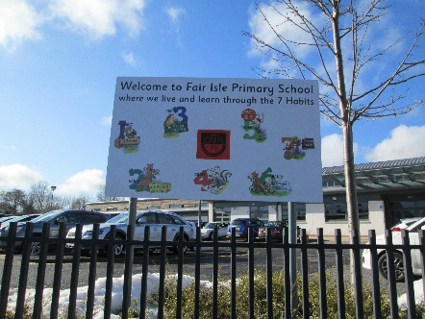

"Opportunities For All"- Developing Leaders One by One

For our current session 2023/24 we received £198,482 through PEF (Pupil Equity Funding). The amount varies from school to school depending on the number of pupils receiving free school meals, giving additional targeted funding for each child in P1-S3 who is eligible, however, the Headteacher has the discretion to make decisions about which children would benefit most from any particular intervention.

We have continued some initiatives from last session and also started new initiatives to raise attainment in literacy, numeracy and health and well-being, in addition, to working to ensure better outcomes for everyone.

We also continue to work towards making sure as many of our initiatives are sustainable should PEF not be available in the future.

**This booklet outlines our initiatives for this session:**

**Nurture/Support Base**

Our base continues to raise attainment for children who have difficulties coping full time in class and to raise attainment in class by decreasing interrupted teaching time resulting from behaviour. Our base supports key children and is led by Mrs Howe (Acting PT) and Pupil Support Assistants.

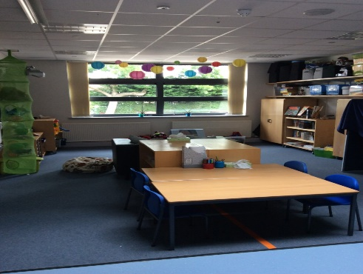

Key children are also mentored by base staff within their own classrooms.

Mrs Howe continues to support and upskill our class teachers and PSA’s in emotional well-being, nurture and self-regulation.

Later this session, we will again be offering our very successful parents’ workshops for families to work collaboratively with base staff and Angela Thomson to support their children.

**Raising attainment P1-P7**  

Mrs Kirkwood, Mr Hooper, Mrs McIntosh and Mrs Lindsey will use their skills and knowledge, as experienced class teachers, to enhance the teaching and learning throughout the school, working with targeted pupils on writing, French or Spanish and mental maths.



**Family Worker**  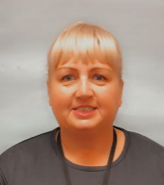

Angela Thomson will be in school Monday to Friday to continue supporting families with issues such as: housing concerns, finance, training opportunities etc. Angela will also be serving at the pupil breakfast club, support adult courses, run pupil and parent groups, homebased support and many other activities. If you would like support from Angela please contact the school to speak with her.

**Breakfast Club**



[This Photo](https://freebie.photography/food/slides/buttered_toast.htm) by Unknown Author is licensed under [CC BY](https://creativecommons.org/licenses/by/3.0/)

We are delighted that we have a daily breakfast club, to give pupils a healthy start to the day, making them ready to learn. This will enable us to keep the daily fee as low as possible. Please contact the school if you are looking for a place. It is open from 8.15am, this costs £2.00 per week.

**Engage Families**

To increase family engagement in school and life skills we aim to empower parents/carers in various opportunities: to develop employability skills, to hold workshops to develop skills, to host adult education classes within our school and to link with agencies to host events such as Woman’s Aid, DAPL, boosting budgets, Our Minds Matter etc. Also continue to empower our parents/carers to lead initiatives such as the school clothing shop/community cupboard.



**Mrs Henderson**

As Acting Principal teacher, she will use her skills and knowledge, as an experienced class teacher, to enhance the teaching and learning throughout the school, working with targeted pupils.

**Place2Be**

The school will have its own dedicated in-house Counsellors to do solution focused 1-1 or small group work. They can also do whole class lessons on topics that arise such as friendships, relationships, family, anxiety etc. They also offer parent and staff training/groups. More details to follow!

**Some previous initiatives which will be continued by class teachers:**

Phonics work 

Reading comprehension



[This Photo](http://myedmondsnews.com/2011/12/edmonds-booktalk-my-nine-favorite-books-of-the-year/) by Unknown Author is licensed under [CC BY](https://creativecommons.org/licenses/by/3.0/)

Lexia 

**First Chances**

We are also delighted to be continuing First Chances, which has been funded for several years through PEF. However, the funding is now coming directly from St Andrews University.



First chances is a project we are doing in partnership with the University of St Andrews, Fife Education and the Robertson Trust. This innovative programme aims to raise the aspirations and attainment of selected pupils from P7 throughout their High School journey, with continued support into higher education. This is led by Mrs Baxter (SfL).

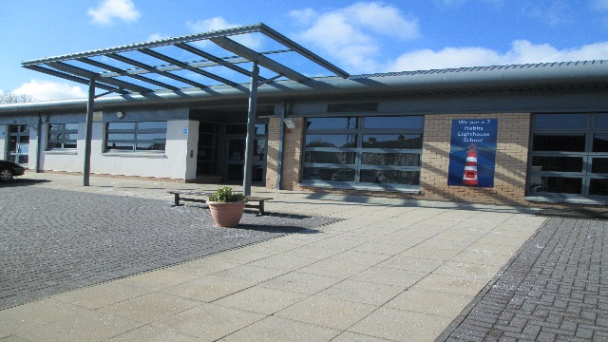

We are a Leader in Me Lighthouse School



We are a Leader in Me Lighthouse School

We are a Leader in Me Lighthouse School

We are a Leader in Me Lighthouse School

