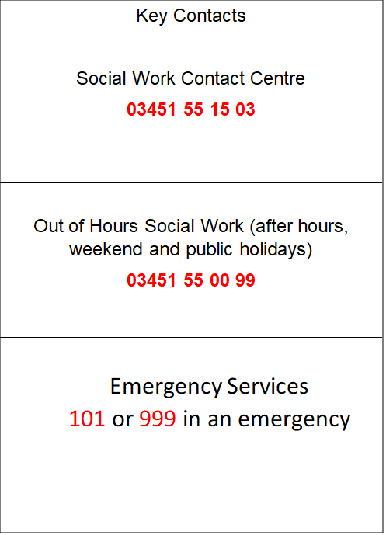

Child Protection & Safeguarding
"Opportunities For All"
Developing Leaders One by One
Information for Parents/Carers

We are a Leader in Me Lighthouse School

“Child Protection is everyone’s job and everyone’s responsibility”

Worried about a child?
If you see behaviour that is of concern, or if a child or young person tells you something worrying, you need to do something about it and speak to someone.

You can speak to a teacher, health visitor, social worker or police officer.

However, if you think a child has been harmed, telephone the Social Work Contact Centre on 03451 55 15 03, from Monday to Friday, 9am to 5pm.
Out-with these hours, please call them on 03451 55 00 99.

You can call the police on telephone number 101, 24/7.

If you consider a child(ren) or young person to be in immediate danger,
do not wait, call the Police on 999

Fair Isle Primary School

Care & Welfare and Child Protection Summary

Child Protection Coordinator is: Vicki Bell - Headteacher
Depute Child Protection Coordinators are: Christy Duncan – DHT and
Steven Hutcheson - DHT

At all times we keep the child’s best interests at the centre of any required actions or planning, and in almost all cases liaise closely with family.

Staff know to alert the Child Protection Coordinator in the school immediately should they have a Child Protection Concern.

When the Child Protection Coordinators are made aware of a concern we do the following in most instances.

- Talk to the child. This is usually our first step. The discussion is conducted sensitively to the child, making it clear that any information they share is confidential unless they or someone they know may be in danger.

We take the child’s views into consideration in planning next steps and include them in any subsequent planning to keep them safe.

If we have to share information with other agencies we will discuss this with the young person wherever possible.

The child is offered a quiet, safe environment if they are upset for as long as needed.
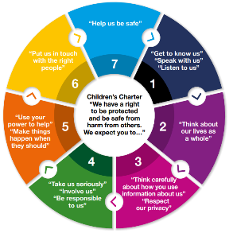
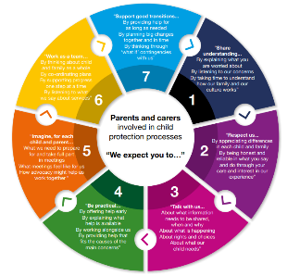

- Contact the child’s family. In almost all situations we include the child’s family early in order to support the child so long as they are not part of the concern. In most instances a family member comes to school to support the child if they are distressed.

- Consider action & update appropriate agencies (Health Team etc). We look at appropriate supports for the young person and their family. This is done in conjunction with the young person and family.

Any safety planning will include the young person’s opinions and is monitored closely.

- Record the concern. We record the concern securely including the action we take and any monitoring required. The record is kept securely with access limited to the Child Protection Coordinator(s), the Head Teacher and the young person’s named person if different.

- Plan and monitor over time. The Child Protection Coordinator will keep in close contact with the child and manage any supports they require over time.

The Child Protection Coordinator will in almost all instances stay in close contact with the child’s family and plan jointly with them to identify supports.

- In the event of a young person being in immediate danger, we contact the Public Protection Unit to liaise with Police and Social Work.

Parents/carers are always contacted unless doing so may put the young person at greater risk.

