Fair Isle Primary School

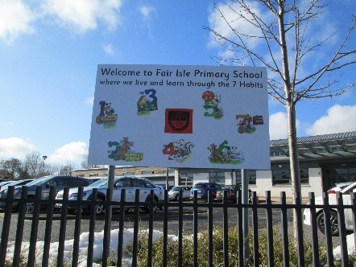

"Opportunities For All"- Developing Leaders One by One

For our current session 2022/23 we received £198,482 through PEF (Pupil Equity Funding). The amount varies from school to school depending on the number of pupils receiving free school meals, giving additional targeted funding for each child in P1-S3 who is eligible, however, the Headteacher has the discretion to make decisions about which children would benefit most from any particular intervention.

We have continued some initiatives from last session and also started new initiatives to raise attainment in literacy, numeracy and health and well-being, in addition, to working to ensure better outcomes for everyone.

We also continue to work towards making sure as many of our initiatives are sustainable should PEF not be available in the future.

**This booklet outlines our initiatives for this session:**

**Nurture/Support Base**

Our base continues to raise attainment for children who have difficulties coping full time in class and to raise attainment in class by decreasing interrupted teaching time resulting from behaviour. Our base supports key children and is led by Mrs Howe and Pupil Support Assistants.

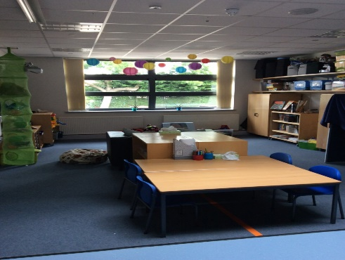

Key children are also mentored by base staff within their own classrooms.

Mrs Howe continues to support and upskill our class teachers and PSA’s in emotional well-being, nurture and self-regulation.

Now restrictions have eased, we hope we will again be offering our very successful parents’ workshops for families to work collaboratively with base staff and Angela Thomson to support their children.

**Lexia**



Our P3 classes, along with some individual pupils from upper school classes, will be participating in a computer-based literacy programme called Lexia to develop their reading skills. Miss Niven (School Support Assistant) will support the children during these sessions, alongside the class teacher. At the end of every level certificates are presented.

**Raising attainment P4-P7**  

Mrs Henderson’s skills and knowledge, as an experienced class teacher, enhances the teaching and learning throughout the upper school, working with targeted pupils in reading and writing, whilst supporting staff by cooperative teaching to raise attainment.



**Raising attainment P1-P3**

Mrs Lyndsay, Mrs Kirkwood and Miss Liddell’s experience and knowledge will also be targeting the teaching and learning of literacy and numeracy at P1, P2 and P3.

**Family Worker**

Angela Thomson will be in school Monday to Friday to continue supporting families with issues such as: housing concerns, finance, training opportunities etc. Angela will also be serving at the pupil breakfast club, support adult courses, run pupil and parent groups, homebased support and many other activities. If you would like support from Angela please contact the school to speak with her.

**First Chances**  

First chances is a project we are doing in partnership with the University of St Andrews, Fife Education and the Robertson Trust. This innovative programme aims to raise the aspirations and attainment of selected pupils from P7 throughout their High School journey, with continued support into higher education.

**Breakfast Club**

We are delighted that we have re-started the breakfast club, to give pupils a healthy start to the day, making them ready to learn. This will enable us to keep the daily fee as low as possible. Please contact the school if you are looking for a place. It is open from 8.15am, this costs £2.00 per week.

**Reading Scheme**

We have purchased a new reading scheme for P4-P7 pupils. This will ensure consistency in reading, continuing Oxford Reading Tree from P1 to P7. We will also be using Oxford Reading Buddy, which is an online reading program, for reading homework. This will give your child/children access to a large number of reading books online.

**Positive destinations P6-P7**



[This Photo](https://rebelem.com/advice-to-the-graduating-resident-victoria-brazil/begin-with-the-end-in-mind/) by Unknown Author is licensed under [CC BY-NC-ND](https://creativecommons.org/licenses/by-nc-nd/3.0/)

Fife data (June 2022) demonstrated that positive destinations primarily lie within social care and education within Kirkcaldy. To best support targeted P6 and P7 pupils, in future positive destinations, links will be made with local care homes to support intergeneration relationships and joined learning.

**Engage Families**

To increase family engagement in school and life skills we aim to empower parents/carers in various opportunities: to develop employability skills, to hold workshops to develop skills, to host adult education classes within our school and to link with agencies to host events such as Woman’s Aid, DAPL, boosting budgets, Our Minds Matter etc. Also continue to empower our parents/carers to lead initiatives such as the school clothing shop/community cupboard.

**Life experiences**

Pupils will benefit from life experiences using the local area and the wider Fife area. We aim to provide a variety of experiences to support learning and well-being.

**7 Habits**

In April 2016 we became the first school in the UK and only 3rd in wider Europe to achieve “Lighthouse Status” through Steven Covey’s “The Leader In Me” the children’s version of his highly acclaimed 7 Habits of Highly Effective People. This encourages leadership at all levels. We continue to teach our new P1’s the 7 habits and use it throughout our daily teaching and practice from P2-P7. This session we are being re-certified for our Lighthouse status.

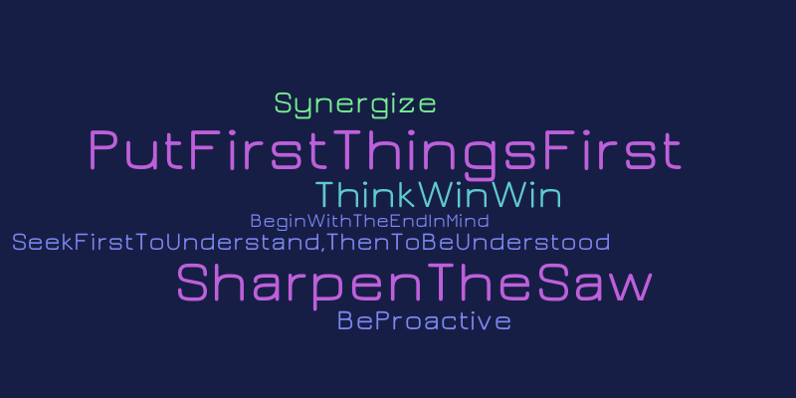

**Some previous initiatives which will be continued by class teachers:**

Phonics work 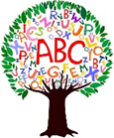

Conceptual numeracy

Reading comprehension



[This Photo](http://myedmondsnews.com/2011/12/edmonds-booktalk-my-nine-favorite-books-of-the-year/) by Unknown Author is licensed under [CC BY](https://creativecommons.org/licenses/by/3.0/)

Spanish



[This Photo](https://bookshelffantasies.com/2016/07/23/vacation-reading-wrap-up/) by Unknown Author is licensed under [CC BY-NC-ND](https://creativecommons.org/licenses/by-nc-nd/3.0/)

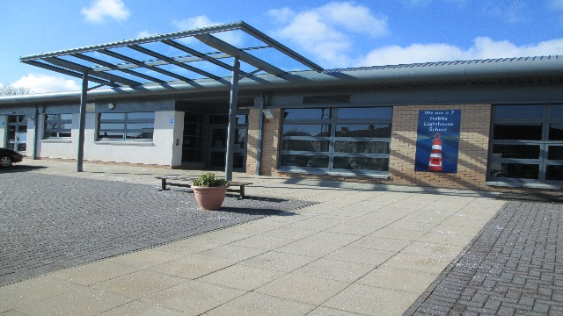

We are a Leader in Me Lighthouse School



We are a Leader in Me Lighthouse School

We are a Leader in Me Lighthouse School

We are a Leader in Me Lighthouse School

