"Opportunities For All"- Developing Leaders One by One



**Fair Isle Primary School**

**Parent/Carer Summary**

**Standards & Quality Report**

**Session 2021 – 2022**

**and**

**School Improvement Plan**

**Session 2022 -2023**



We are a Leader in Me Lighthouse School

**Impact and Outcomes: Session 2021-2022**

**School Improvement Priority 1**: **Whole school improvement of wellbeing**

**Progress and Impact:**

* At the beginning of the year, all classes completed the appropriate level from the resource ‘[improving children and young people's understanding of their wellbeing](https://childreninscotland.org.uk/wp-content/uploads/2019/08/201902_GIRFEC-Toolkit_11.pdf)’.
* The wellbeing indicators were also discussed during stage inputs in the hall and now form part of the school’s values.
* Inputs in the hall for P1-2, P3–5 and P6-7 (led by Lorna Howe) began in September and continued in term 2. P3- 7 started work on the 5 ways to wellbeing and learned about some wellbeing activities, such as guided breathing, through the work on self-regulation. P1-2 began to look at some wellbeing activities such as breathing and mindfulness through self-regulation work. In term 4 all classes covered the 5 ways to wellbeing, kitbag, mindfulness and wellbeing awareness.
* The Branch Out resource, which extends learning with the 5 ways to wellbeing, was used by class teachers for Primary 7 children during term 4.
* Staff training on teaching self-regulation and Emotion Works was completed
* To improve families’ understanding of how to improve their own and their children’s wellbeing we sent out a sway, organised a wellbeing week and organised a school homework competition. The sway gave full information to parents on the Emotion Works programme.
* Throughout the year, individual children were supported across all areas by nurture base.

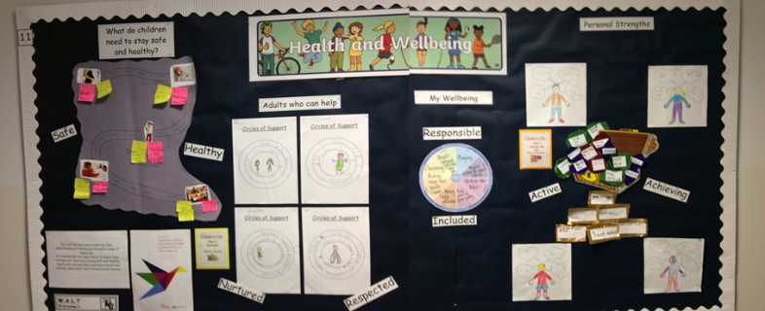

**School Improvement Priority 2: Raise attainment in writing P1-P7 by using models for daily practice**

**Progress and Impact:**

* Professional Learning on the Workshop for Literacy approach was delivered throughout the year to all teaching staff by Miss Duncan.
* Writing was a focus for our Learning Partnership in March: to share the impact of our writing developments, to support validation of writing and to support our processes for ongoing self-evaluation. Our upper classes demonstrated the Fife improvement model, our infant classes demonstrated daily writing opportunities.
* Miss Keith (P7) and Mrs Baxter (SfL) participated in the Fife QI Improving Writing Wave 5 program
* Moderation sessions were had between stage partners to support assessment of extended writing, during terms 1 and 2. During terms 3 and 4, moderation sessions were held across levels to ensure staff are using similar expectations and assessment of a level.
* Acting Principal teacher, Mrs Henderson, devised a new Writing Assessment Criteria for Fair Isle Primary to be implemented in session 2022/2023.
* Throughout the session all teaching staff took part in 4 weekly twilights which covered moderation across stages.
* Headteacher, Mrs Bell, carried out writing validation work in term 2 looking at P2/3/5/6.



[This Photo](https://www.flickr.com/photos/alancleaver/4460976042/) by Unknown Author is licensed under [CC BY](https://creativecommons.org/licenses/by/3.0/)

**Key Priorities for 2022-2023**

**Whole school improvement of writing**

* Using our newly made writing progression, have a consistent approach to support professional judgement amongst all teaching staff.
* Upskilling all teaching staff in using the newly created writing progression and Qi methodology, including tracking.
* Within P1/2/3 increase attainment in writing: Incorporating Qi methodology within these stages.
* Within P4/5/6/7 increase attainment within writing. Using extended writing to show demonstration and transference of skills from daily write.
* Increase attainment figures throughout the school by using literacy workshop approaches.
* Joint working with associated nursery to create opportunities to develop writing experiences in early level, making more accurate declarations N4 to P1.
* A whole school grammar and punctuation progression to be in place to ensure skills are built upon to transfer into next stage of writing.
* Re-visit the approaches for peer and self-assessment across the school and ensure all children are taught these skills to ensure they are supporting improvement when using this approach. This will allow all pupils to lead their own learning.

**Whole school improvement of reading**

* P2 and P3 increase attainment within reading: Incorporating pedagogy from last sessions workshop for literacy training.
* All infant classes to engage with school word wall progressions, for a minimum of twice a week to raise attainment.
* P4, P5, P6 and P7 increase attainment within reading using the newly purchased reading scheme.
* Increase engagement with home reading using whole school digital Oxford Reading buddy through online platforms.
* All classes will have opportunities for reading for enjoyment through weekly quiet reading sessions.
* P1 classes to develop the teaching of phonics through high quality texts. This will provide a depth of understanding and an opportunity to consolidate phonic skil

**Our School Wide Goals (WIGS) for session 2022-2023**

|  |
| --- |
| * P2 and P3 increase attainment within writing. Increase attainment in writing for   children moving from P1 into P2 from 72% to 78%. Increase attainment in  writing for children in P2 moving into P3 from 70% to 74% by May 2023.   * P4, P5, P6 and P7 increase attainment within writing.  For P6 cohort moving   into P7, we aim to increase attainment from 65% to 68%. For P5 cohort  moving into P6, we aim to increase attainment from 70% to 72%. For P4  cohort moving into P5, we aim to increase attainment from 55% to 60%  by May 2023. |



[This Photo](https://www.freeimageslive.co.uk/free_stock_image/education-computer-jpg) by Unknown Author is licensed under [CC BY](https://creativecommons.org/licenses/by/3.0/)



