

**East Wemyss**

**School Travel Plan**



Head Teacher: Mrs Yvette O’Neil

School Address: School Wynd

East Wemyss

KY1 4RN

Telephone Number: 01592 583427

**Summary Page**

The following travel plan is a collaborative plan by parents, children, staff, and stakeholders who have researched and devised the content, agreeing the actions and aims to make the overall journeys to and from East Wemyss PS safer, healthier, and more enjoyable by:

* Reduce congestion around the school by reducing the number of cars used for the

school journey.

* Increase awareness of Active Travel and educating all about road safety.
* Improving Active Travel facilities (bike and scooter storage, helmet storage, etc.).
* Promoting alternatives to car travel (cycling, walking and scooting), increasing the

percentages of active travel.

The key issues and perception relating to journeys to and from school were identified as – inconsiderate parking around the school gate and surrounding streets, which causes problems including: -

Congestion

Blocked vision for walkers and cyclists

Blocked vision for other drivers

Low proportion of children actively travelling to school, especially in bad weather

Concerns about road safety and speed of traffic

Blocking driveways reducing access to our neighbours’ properties

**73%** of those surveyed highlighted that they lived within a 2-mile radius of the school.

Routes identified as safer routes to school are:

1. West Brae
2. East Brae
3. Main Street
4. High Road

**Proposed Behavioural Actions**

Promote Active Travel School

Promote Safer Routes to School

Road Safety Education School/Parents/Fife Council

Reduce Congestion around the school gate School/Parents/Fife Council

Deliver Cycle Training School/Fife Council

This plan is valid for 6 years and will be reviewed during year 3.

**1.0 INTRODUCTION**

**1.1 School background**

East Wemyss Primary School was opened in 1906 as a primary and secondary school. It is now a primary school with a nursery incorporated and is a focal point in the village as well as being a listed building.

It is built on three levels: basement, ground and first floor. The ground and first floor are built around a large central hall.

East Wemyss Primary School is fortunate to have fantastic outdoor learning environments such as the beach, woodland areas and the caves on its doorstep which the children visit regularly throughout the school year. Our school grounds consist of an upper and lower playground and garden. Pupils have been involved in transforming outdoor areas, such as painting the school shelters, and will continue to develop outdoor learning areas with seating and plants to attract wildlife for observation.

The school houses a nursery, 7 classes, a main hall (which is used as the gym hall), support for learning base and a dining room. The children have access to wireless netbooks which can be used anywhere within the school building. A controlled security system is in operation on main entry doors. The school has wheelchair access at all access points.

The aim of our school is to create a welcoming and stimulating environment in which we will support and challenge our pupils to develop the necessary knowledge and skills to enjoy a happy and constructive school life and, furthermore, take their place and play their part in society in their adult life.

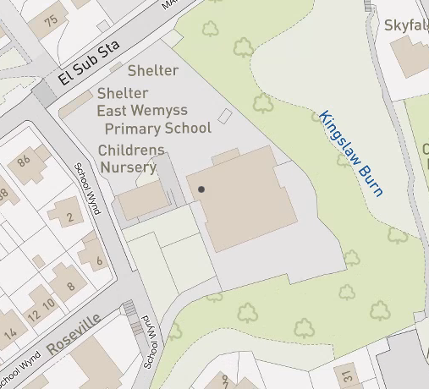There are two entrances into the school grounds.

**2.0** **POLICY AND OBJECTIVES**

**2.1 Formation of Junior Road Safety Officers**

To address the issues raised with congestion around the school gate and to work on future initiatives the school formed its travel action group which consists of Junior Road Safety Officers and members of the school parent council and parent volunteers. These will be appointed during the 2022-2023 session.

**3. CURRENT TRAVEL PATTERNS**

**3.1 Questionnaire Surveys**

During the consultation period **74** families and **??** staff members responded, and the following analysis is based on the data from those surveys.

**3.1.1 Family Survey Data**

**52** families highlighted that active travel was their main mode of travel to school followed by **21** families siting that they drive to school. There was one family who stated they parked at Back Dykes and the walked to school.

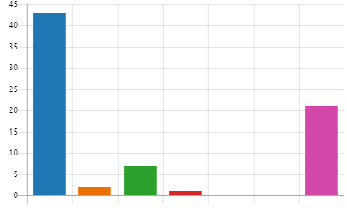Walk 43

Cycle 2

Scoot 7

Park and Stride 1

School Bus 0

Public Transport 0

Car 21

**The main reasons given for travel mode choices are:**

Limited parking around the school

Good for my child’s health

It’s the fastest

Fits in with my family routine

A full list of those who cited other can be found **in Appendix 1.**

When asked “How far do you live from School” only 22 families answered this question. The diagram below highlights this data but does not give a true reflection on the amount of pupils that live within close proximity to the school.

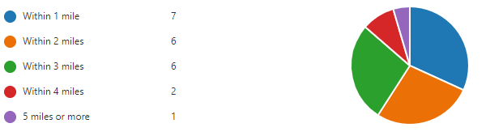

The following diagram showcases the answers from the question “How long does your journey to school take” and the majority of families have indicated that their journey to school takes between 5 and 10 mins.

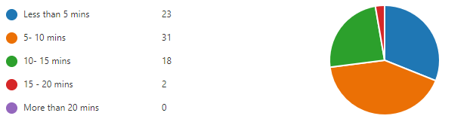

According to the survey **65** families are happy with the way their child/children travel to school with only **9** families stating that they were neither satisfied nor dissatisfied.

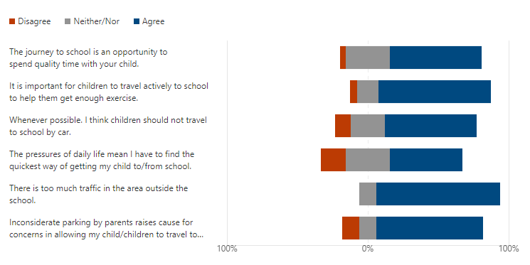Parents were also asked “**to what extent do they agree with the following statements about your child/children journey to school**”.

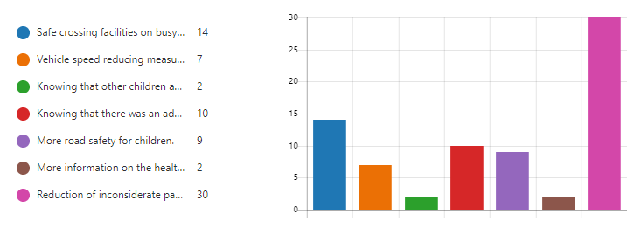When asked “What factors might affect your decision whether or not to let your child/ren travel actively to school, or to the bus stop families indicated that the reduction of inconsiderate parking around the school gate.

All families indicated that they were not aware of any active travel initiatives taking place at school to encourage pupils to be more sustainable.

Finally, when asked if there was anything else that they would like to tell us about the journey to school **40** families answered with the majority citing congestion and the lack of mindfulness when parking around the school gate.

A full list is available if requested.

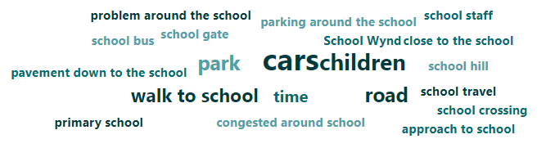

**4.0** **MAPPING WORK**

A mapping exercise was carried out within the school to identify the routes pupils travelled. These were then analysed and the four main routes to school were identified.

**Final Map and identified routes**

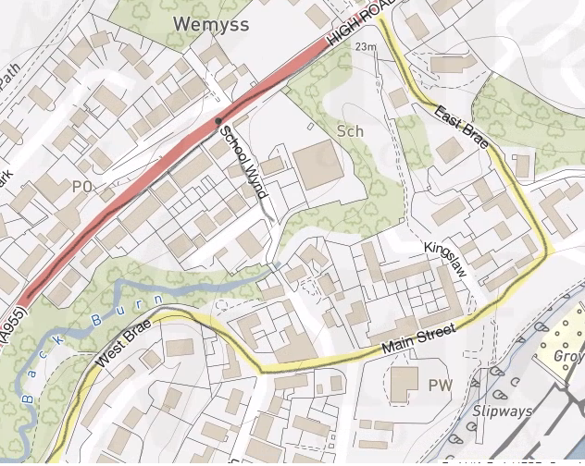

**5.0 ROUTE AUDIT OF KEY ROUTES TO SCHOOL**

A site visit of the above key routes was carried out on the 6th December at 11am The weather conditions were cold but bright and sunny.

Due to the Covid Restrictions the JRSO’s were not in attendance, however, a member of the parent council walked the routes and pointed out areas of concern.

These areas or issues were predominately due to parent/staff behaviour and the lack of a school crossing patrol officer and not those of traffic management or engineering. The full audit report can be found in **Appendix 2** of this document.

**6.0 STAFF DATA**

Members of staff undertook an online survey on how they travel to school and the impact this has on the school run. The following analysis highlights their mode of travel.

**How far do you travel for work?**

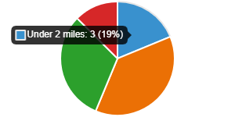

Under 2 miles 3

2 - 5 miles 6

6 - 10 miles 5

11+ miles 2

Majority of staff cited that they drove to school and parked within the school grounds. However, some stated that they parked in the streets around the school. When asked what would encourage them to consider alternative modes of transport majority stated that nothing as they have other commitments outside school. Some stated that they would consider cycling if there was a bike shelter.

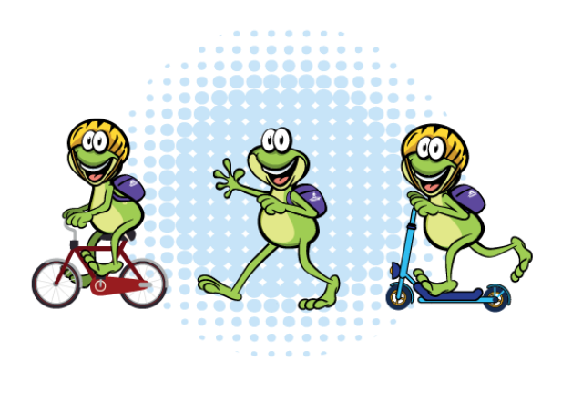

**7.0 BEHAVIOURAL ACTION PLAN**

|  |  |  |  |
| --- | --- | --- | --- |
| **Action** | **Solution** | **Action Owner** | **Target Date (Academic year)** |
| Promote Active Travel | Take part in Active Travel Months      Take part in Bike Week    Take part in the SUSTRANS BIG PEDAL    Walk to school week | School/TAG      School/TAG    School/TAG    School/TAG | Term 2 & Term 4    Term 4    Term 3    Term 2 |
| Promote Safer routes to school | Upload map to website    Put information board up at parents nights    Articles in school newsletters, social media and assemblies | School    School/TAG      School/TAG | Term 1    Term 2  Term 4    Ongoing |
| Road Safety Education | Run poster campaigns    Take part in Road Safety Week. | School/TAG | Ongoing    Term 2 |
| **Reduce congestion around school gate** | Develop the following:     Parking Pledge  Park N Stride Site  Walking Bus | School/TAG | Ongoing |
| Bikeability | Offer cycle training to all P6 and P7 pupils – look at moving cycle parking to front of the building. Apply for cycle parking fund and investigate becoming a Cycle Friendly school. | School | Ongoing |

 8.0 **Physical Measures**

|  |  |  |
| --- | --- | --- |
| **Action** | **Action Owner** | **Target Date** |
|  |  |  |
| Fife Council Traffic Management to investigate traffic restrictions on West Braes and look at a drop off point on Main Street. | Fife Council Traffic Management | ASAP |

**9.0 MONITORING & EVALUATION**

The JRSO’s will continue to meet periodically to monitor progress and will review the Travel Plan on an annual basis.

Specific progress will be monitored by participation in the “Hands Up Travel Tally” each year and a repeat of the full travel survey will take place 6 years after initial launch.

The school’s ongoing commitment to travel planning will be publicised in the school handbook, the school newsletters, the Parent’s notice board and through assemblies.

**10. DISTRIBUTION OF SCHOOL TRAVEL PLAN**

The following bodies will receive a copy of the School Travel Plan:

* Fife Council Assets, Transport and Environment via the Travel Plan Team
* Fife Council Education Service
* Fife Council School Estates Team
* Parent Partnership
* Active Schools
* Copies will also be made available to the parents from the School Office and

via the school information site.

**FIFE COUNCIL**   
**ASSETS, TRANSPORTATION & ENVIRONMENT**

**DULOCH PRIMARY SCHOOL, DUNFERMLINE**

**ROUTE SAFETY AUDIT**

**INTRODUCTION**

This report results from an Audit of key routes undertaken at East Wemyss Primary School at the request of the school to facilitate their School Travel Plan.

The school is situated within a 20-mph zone and has two pedestrian entrances, both accessed from School Wynd.

A site visit of the key routes was carried out on the morning of 25th March, 2022. The weather conditions were warm and sunny. The audit team consisted of:

Marta Ramage – School Travel Plan Coordinator

Yvette O’Neil Head Teacher

The key routes audited were:

High/Main Road

West Brae

East Brae

High Street

**Findings and Recommendations**

**High/Main Road**

Issues

Pupils travelling from the north use the zebra crossing to cross High/Main Road and access the school. This area can become quite congested at times with through traffic.

Proposed Solution

The zebra carriageway markings are quite worn and could do with being refreshed.

Recommendations

MR to request refresh of zebra

**East Brae**

Issues

Cars parking over dropped kerbs right up to the junction with High/Main Road. Road narrows at bend and visibility can sometimes be blocked with the volume of cars.

Recommendations

Traffic Management to review the area.

Action

MR to request investigation by Traffic Management.

**West Braes**

Since the closure of the South playground to vehicles, teachers have been using the limited spaces on School Wynd which has created a congestion issue on West Braes.

Recommendations

Traffic Management to undertake a full review of the area. School to investigate a possible drop off or park and stride site.

Action

MR to request audit by Traffic Management.

**Main Street**

There were no identifiable issues raised within Main Street other than the area can be a bit busy during school drop off and pick up times. The route connects both East and West Brae.

There is an area that could be created as a drop off point that leads direct to Jimmy Shand Court which leads into the school premises.

Action

MR to request Traffic Management to investigate

**SUMMARY**

East Wemyss Primary school is well served by existing crossing points, footways and cycleways.

The challenge at East Wemyss will be encouraging parents to change their behavioural patterns and introduce active travel into their daily routine.

This will help reduce congestion and improve safety around the school gate and improve relations with the school’s neighbours. Promoting safe walking routes and seeking the implementation of the recommendations should make the trip to school more enjoyable and encourage more participation in active travel.