

Strategies and Activities to Support
EAL Learners in the
Secondary School

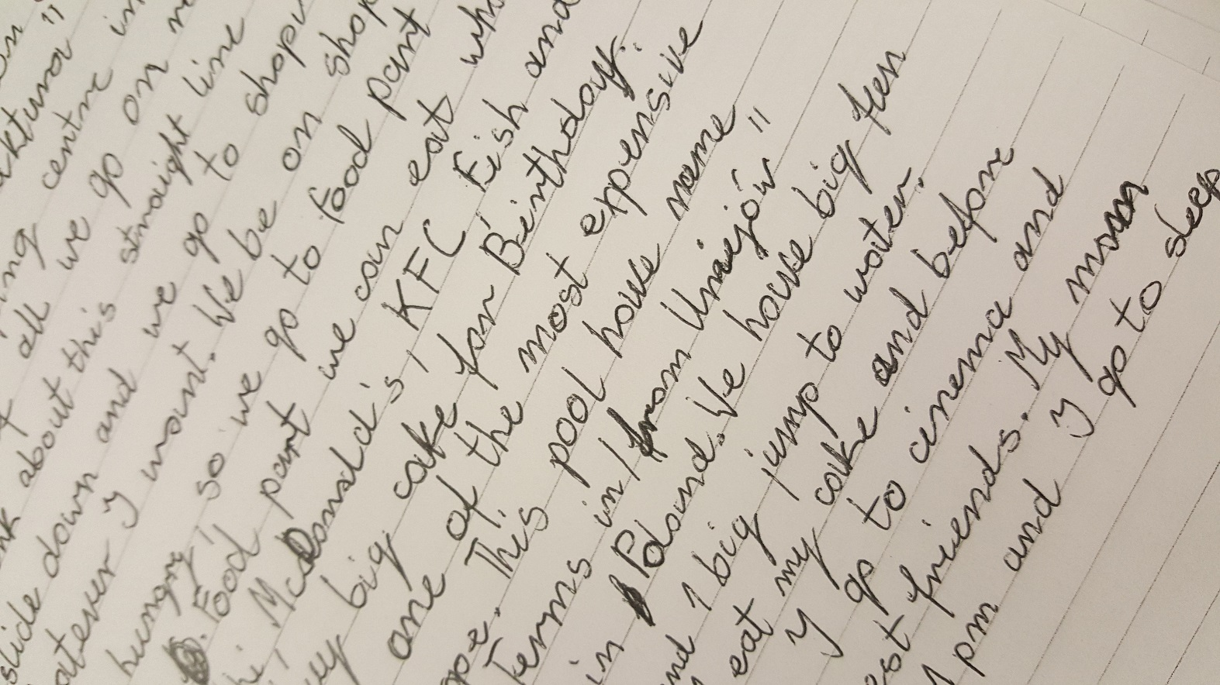

Supporting EAL learners in the Secondary School
This booklet provides practical ideas for teachers to support acquisition of English language and meet the cultural needs of children who are learning English as an Additional Language.
Some EAL learners may need more time to observe their peers and surroundings before they are ready to join in. They may want to participate but due to lack of language they find it difficult. It might also affect their behaviour.
Some children who have been born in the UK may not have developed any English. This will be due to the sole use of first language at home.
EAL Learners have to concentrate much harder than their peers to make sense of their new surroundings. This may make them tired, unresponsive or irritable at first.
Cultural differences may also impact on behaviour.
This booklet is intended to support teachers working with pupils with EAL. Should you require any further information please complete a Request for Assistance form or contact the EAL Support Service on ealsupportenquiries@fife.gov.uk

Strategies to Support Listening and Talking
Stage 1.
Settling in/ ‘silent period’
- Use visuals, gesture and simple language for essential communication
- Don’t force verbal responses/accept gestures
- Give thinking/processing time, await response (wait, repeat, rephrase)

English Language Modelling
- Teach essential words- frequently and consistently
- Teach the names of essential staff and peers
- Assign a buddy/good language role model, use peers to model routines
- Teach social language exchanges - please/thank you/good morning etc.
- Use closed questions, either/or, yes/no, provide choice words (‘juice or milk’?)
- Explain tasks/events – use visual supports
- Encourage set phrases for responses ‘Can I have/Can I go’ etc.
- Extend/expand upon the learner’s verbal attempts
- Use activities with repetitive language
- Paired/small group activities- assign an achievable role
- Refer to visuals/displays/key words/ICT during teaching/instruction
Use Home Language
- Pair the learner with peers with same language/encourage first language use
- Encourage dialogue with parents about school day/learning in their first language
- Organise home/school diary, encourage the learner to talk about their day
- Rehearse responses in their first language

Strategies to Support Listening and Talking
Stage 2.
Teacher/Adult Modelling & Exchanges
- Rephrase/extend sentences and questions
- Model sentence starters/use visual clues
- Repeat the learner’s responses with accurate/extended forms
- Clarify/explain curricular language- give definitions
- Allow time for the learner to mentally rehearse responses
- Vary language functions – instruct, describe, converse etc.
Peer Support
- Group with good English role models
- Use collaborative learning activities, assign roles in group
- Assign paired tasks/feedback/problem solving
Learning Activities to promote language
- Games/activities with repeated set phrases
- Drama/role play
- Reading aloud (if sufficient decoding ability and pupil is comfortable with this).
- Picture dictionary activities
- Cloze language activities/word bank selection
- Story retelling, picture sequencing
- Listening activities/ICT/Videos
- Activities using recordable devices e.g. talking tins etc.
- Use subtitles when available

First Language
- Use the learner’s home language to promote learning
- Encourage discussion of learning in home language
- Allow collaborative activities with peers with same language
Strategies to Support Listening and Talking
Stage 3
Teacher/Adult Modelling & Exchanges
- Model longer verbal exchanges, use a wider range of more advanced vocabulary
- Check understanding through questioning
- Model hypothesising/predicting
- Engage in informal conversation/everyday exchanges
- Use guided/scaffolded questioning
Peer Support
- Use collaborative tasks/problem solving/information seeking tasks
- Allow collaborative presentations/demonstrations/talks etc.
- Partner talk/feedback/think pair share
- Use a wider range of peer groupings
- Use paired reading tasks
Learning Activities to promote Language
- Extended listening and oral tasks/ICT/videos etc.
- Drama/role play activities
- Games with wider language functions e.g. positional/descriptive language
- Dictionary/thesaurus activities
- Activities with different audiences/settings
- Circle time/whole class discussions
- Provide time/opportunities for the learner to initiate talk

Strategies to Support Listening and Talking
Stage 4&5
Teacher/Adult Modelling & Exchanges

- Check understanding prior to tasks through questioning
- Model varied language - explanations, instruction, prediction, hypothesising
- Model frequent everyday conversational exchanges
- Allow time for the learner to initiate conversation
- Allow thinking time for the learner to formulate responses
- Encourage use of academic language where appropriate
- Use formative assessment feedback using curricular/language associated with learning
Peer Support
- Provide peer support younger/new to English pupils
- Provide games encouraging use of more challenging language e.g. positional/descriptive
- Provide collaborative learning tasks - extended language required
- Allow group presentations/demonstrations etc.
- Assign mentoring/ supporting roles in class/school
Learning Activities to promote language content and fluency
- Extended listening activities, longer/challenging language
- Problem solving activities
- Language activities with varied purpose/audience
- Facilitate presentations/ demonstrations individual and group contributions
- Role play/drama activities
- Record/video verbal exchanges/ presentations etc.
Strategies to Support Reading
Stage 1
Pre – reading
- Provide visual cues- props/actions/ posters/video clips/ semantic web/ mind- maps
- Consider the text – font, spacing, size, length
- Provide bilingual dictionaries, word lists, glossaries
- Provide text photocopies with highlighted key words
- Use minimised/summarised/simplified text
- Use text in first language (Novels)
- Provide word meanings/ pre- teach core vocabulary
Structured Reading activities to promote comprehension
- Label diagrams, texts, pictures etc.
- Annotate text with translations of key words and phrases
- Check understanding using true/false, yes/no statements
- Use sequencing activities with/without text
- Model speed, expression whist reading aloud
- Use picture/text matching
- Use gap fill/ cloze with word bank

Strategies to Support Reading
Stage 2
Pre – reading
- Provide the text in first language when available
- Provide character lists/summaries of longer texts
- Encourage predicting the content from titles/images
- Simplify language of the text e.g., meaningful vocabulary, simplified sentence structure, tenses etc.
- Pre- teach contextual vocabulary
Reading
- Model reading – speed, expression, pronunciation
- Rephrase sentences and questions
- Ongoing use of photographic/dual language dictionary
- Highlight words with same roots e.g. muscle/muscular
- Summarise key facts and ideas
- Simplify words not content
Comprehension Activities
- Ask focused questions to check/confirm comprehension
- Ask for a verbal summary of reading
- Provide sentence starters to allow the learner to answer verbally
- Use close activities with key vocabulary
- Encourage transferring information from text into visuals/lists/tables/diagrams/flow charts
- Provide sequencing activities for process/storyline/instruction
- Use match picture/text activities
- Provide collaborative reading tasks e.g. information gap
Strategies to Support Reading
Stage 3
Pre- reading
- Encourage dictionary use
- Photocopy text, highlight key words
- Provide chapter summaries before reading or opportunity to hear text
- Elicit prior knowledge
- Introduce key words/concepts e.g. definitions, semantic webs
- Encourage predicting content from title/picture
- Clarify - idioms e.g. it’s raining cats and dogs
- Collocations Do homework, make bed, feel free
- Phrasal verbs e.g. look at/look for
Reading Activities
- Encourage skimming to gain general ideas,
- Encourage scanning to search for specific information
- Encourage note- taking, provide grid to allow the learner to search for specific information
- Ask to create sub- headings for separate paragraphs
- Use hot- seating, students assume character roles whilst peers question
- Provide sequencing activities – sentences into paragraphs, paragraphs to text
- Encourage answering questions to provide written summaries

Strategies to Support Reading
Stage 4&5

- Discuss complex language- metaphor, colloquialism,
- Encourage use of contextual cues to establish meaning of more complex vocabulary
- Explain hidden and actual meaning of text
- Discuss language of different genres
- Support critical analysis of text e.g. bias, prejudice, stereotype, racism
- Identify different features of types of text
- Be explicit about using specialist vocabulary and model the use of academic language

Strategies to Support Writing
Stage 1.
Useful Resources
- Glossaries/word banks, lists
- ICT
- Bilingual/photographic dictionary
Word Skills/Short copy tasks
- Find/match words, word search
- Label diagrams (with words provided)
- Copy simple texts – avoid lengthy texts (awareness of learners script i.e. Japanese!)
- Group/sort/categorise words
Simple text
- Sequencing, short sentences, word change
- Sentences starters/ match sentence endings/ jumbled sentences
- Gap fill/missing word sentences
- Sentence starters/writing frames
- Story boards/ scaffold writing
- Encourage first language use for research and planning
- Group writing texts
- Allow differentiated presentation e.g. posters, power-points, annotated pictures etc.

Strategies to Support Writing
Stage 2
Useful Resources
  - Glossaries/word banks, lists for pupils to complete
  - ICT
  - Bilingual dictionary
Word Skills
  - Find/match words, word search
  - Label diagram, initial letter provided
  - Group/sort/categorise words
Simple text
  - Sequencing, word change
  - Gap fill/missing word sentences- words not provided
  - Sentence starters/writing frames
  - Scaffold writing
  - Encourage first language use for research and planning
  - Allow differentiated presentation
  - In independent writing focus on meaning over correctness
  - Provide example paragraph (the learners substitute information using the same structure)
  - Draw attention to the difference between spoken and written; formal and informal language

Strategies to Support Writing
Stage 3
Word skills
- crosswords: writing the clues for the words
- build ideas/ wordlists around topic knowledge, practise language before writing through listening, talking and reading activities
Texts
- develop the learner’s awareness of the function (e.g. description, explanation, justification, prediction, analysis) and associated language structures
- deconstruct an example or model text: identify key elements (overall structure, key content, key phrases, key subject-specific vocabulary)
- extended writing: use a scaffolding approach
- encourage independent editing: indicate omission of word, grammatical mistake or spelling mistake and ask pupil to correct

Strategies to Support Writing
Stage 4&5
- build ideas and topic knowledge before writing through listening, talking
and reading activities
- function of writing: develop the learner’s awareness of the function (e.g. description, explanation, justification, prediction, analysis) and associated language structures
- planning: learner’s use a variety of planning techniques before writing, e.g. linear plan, mind map, pupils explain their plan to a partner before writing
- discuss ideas in pairs / small groups
- deconstruct an example or model text: identify key elements (overall
structure, key content, key phrases, subject-specific vocabulary)
- provide alternative vocabulary to extend range;
- provide alternative sentences which clarify meaning or extend ideas; encourage independent editing

