Strategies for supporting EAL Learners in an Early Years setting

This booklet provides relevant information as well as practical ideas for practitioners to support the acquisition of the English language and meet the cultural needs of children who are learning English as an Additional Language.

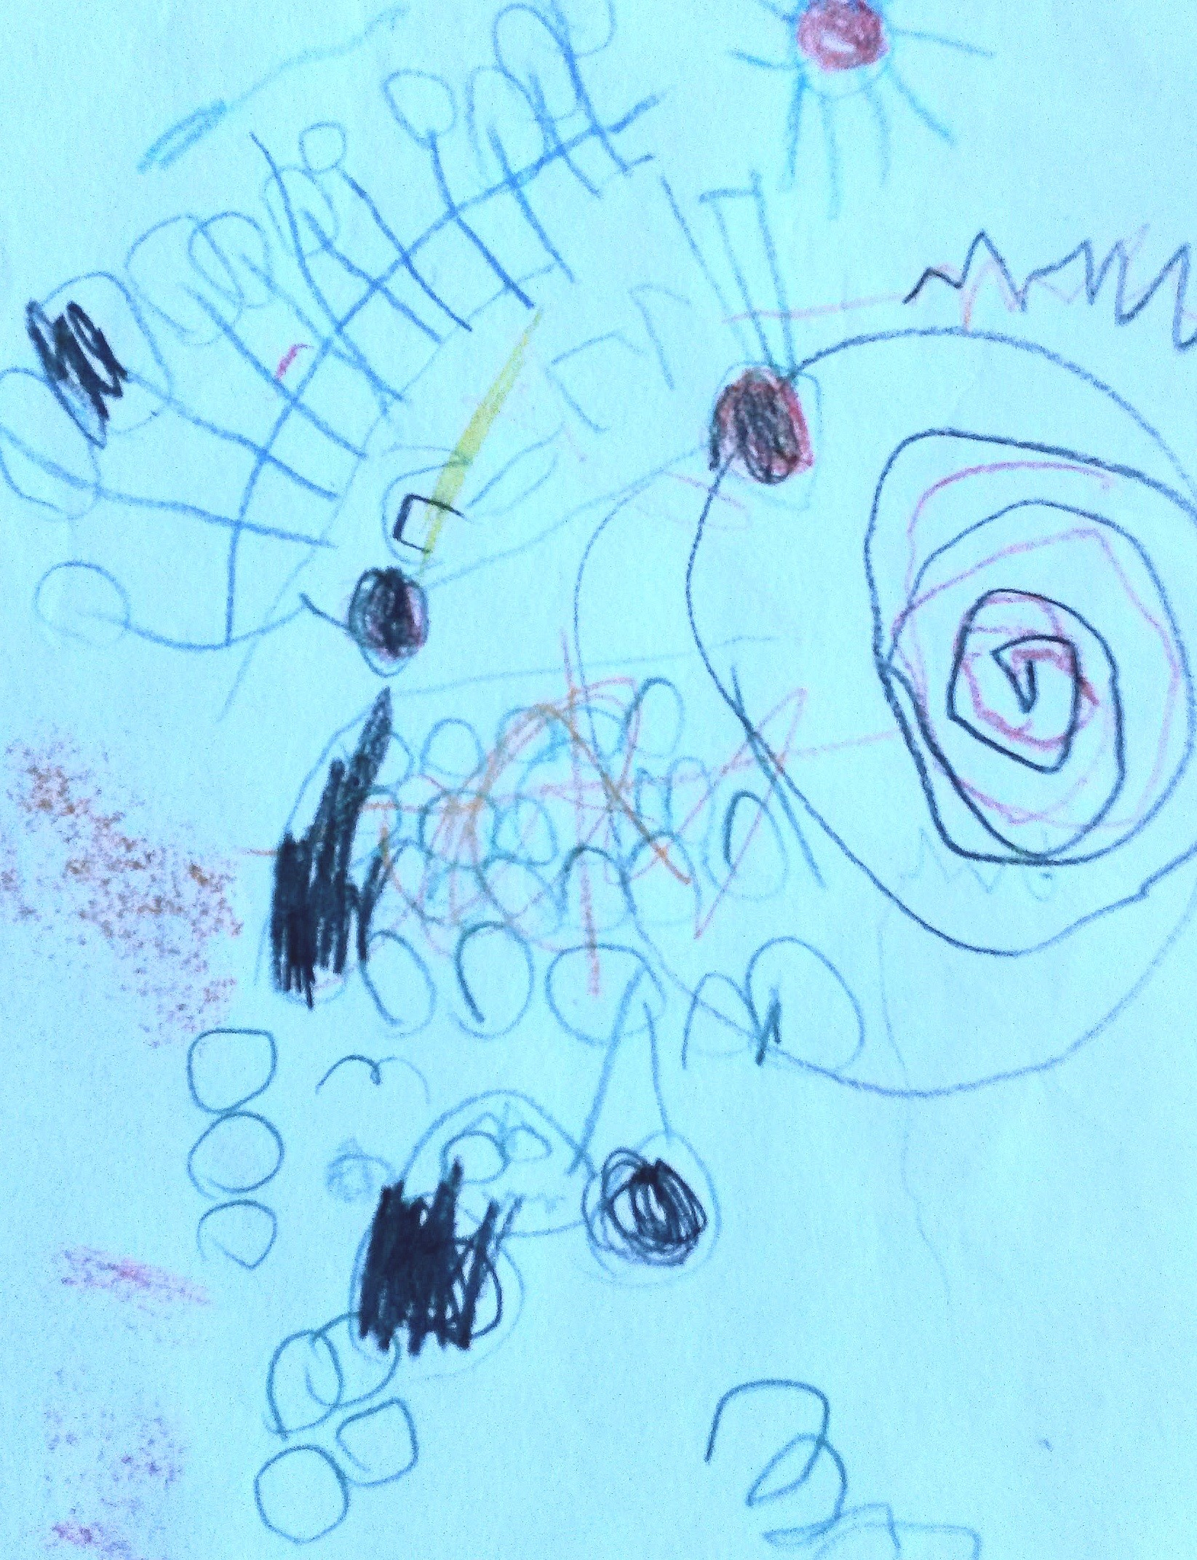

Things to be aware of:
Some learners with EAL may need more time to observe their peers and surroundings before they are ready to join in. They may want to participate but due to limited language skills, they find it difficult. It might also affect their behaviour.
Some children who have been born in the UK may not have developed any English. In some cases, their First Language might be underdeveloped due to other Additional Support Needs.
It may be that their parents may not have built up relationships with local families or other families from their community. These children may not be used to playing with other children.
Some children may become physical if they can’t express their needs or wishes in words e.g., snatching or pushing because they can’t ask.
Learners with EAL may have to concentrate harder than their peers to make sense of their new surroundings. This may make them tired, unresponsive, or irritable at first.
Cultural differences may also impact behaviour.

Should you require any further information please complete a Request for Assistance form or contact the EAL Support Service on
SupportingLearners@fife.gov.uk

Some things to be aware of regarding cultural differences
Learners with EAL may:
- avoid eye contact with adults
- avoid any physical contact
- smile even if reprimanded as it is a gesture of respect
- nod their head to acknowledge rather than demonstrate understanding of what is expected of them
- refuse to eat with other children because of the difference in eating arrangements
- have particular dietary requirements
- not want to have any contact with Nursery pets
- be unfamiliar with the toilet arrangements in the setting (a child might be sent in nappies to avoid difficulties)
- seem physical when playing or may show other behavioural patterns

Note: some cultures may be sensitive about photos, dolls, other images and books showing animals dressed as humans and acting like humans.

Strategies:
Environment
- allow extra time for the child to settle into the new environment
- use culturally sensitive visuals
- value home language and cultural background
- ensure that all practitioners are familiar with the child’s cultural and linguistic background
- make key information accessible- have translations available when possible
- have ‘Welcome’ posters to reflect different cultures
- use dual language books and other resources and share them with parents
- ensure that the displays reflect the different background, cultures and languages of the children
- use visual timetables/ snack menu and make a copy available to parents
- display children’s own named photos to give everyone a sense of belonging
- have examples of writing in different scripts
- include familiar cooking equipment/food items in the role-play area
- include clothes from different cultures for dressing up
- encourage peers to interact with the bilingual child
- provide picture fans for communicating their immediate needs (toilet, hunger, ill)

Learning
- encourage and support peer interaction through play
- allow children to copy others
- value any attempts to communicate/praise
- speak clearly to children as they play providing vocabulary in context
- keep language simple and consistent
- read stories from the child’s culture or stories familiar to them
- allow children to ‘switch off’ at times
- provide opportunities for children to share their own culture, language, and traditions.
- continue talking even when children do not respond
- include in small groups with others
- use varied questioning (eg. Do you want an apple or a pear?)
- pair the learner with a buddy and ask questions of both children
- accept non-verbal responses
- continue to expect that the child will respond
- structure the programme to encourage child- to child interactions
- provide activities which reinforce language practice through role play
- use puppets to support communication
- model the language through talking activities
- use stories and books that have repetition and clear pictures
- support with visuals and gestures
- introduce basic vocabulary in English through play activities
- use picture cards and games to encourage vocabulary development
- support story time with props and flashcards with key visuals
- give pupils time to listen to dual-language stories
- teach repetitive songs and rhymes
- find songs from the child’s culture or songs familiar to them
- use props in a box or make a book of pictures related to the songs and stories

Parents
- arrange for an interpreter to be present at the enrolment and other important meetings
- consider a home visit
- encourage parents to speak in their home language with their child
- discourage parents with little English from teaching children English at home
- ensure that parents with EAL have equal access to information and opportunities provided by the Nursery
- encourage parents to share their culture and involve them in celebrating festivals
- encourage parents to share their child’s learning experiences in their first language (e.g. talking about a book/topic)
- encourage parents to take a new story home and talk to their children before you read it to the group
- be aware that parents may have different expectations of Nursery based on their experiences
- be aware that some parents might appear reluctant to visit the setting because of shyness, or the language barrier
- encourage contact with other parents
- show parents/carers how supported play activities can provide opportunities to model, rehearse, and extend language
- meet with parents regularly to communicate how the child is developing

