Dysart Primary School Anti-Bullying Policy
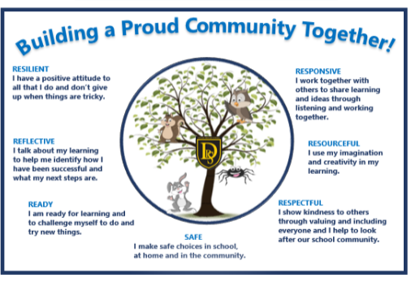

(Consultation with children, parents/carers and wider school community will take place throughout session 2023/24 with redrafted version published by June 2024

All staff at Dysart Primary School are unequivocally opposed to bullying.
What is Bullying?
The Nationally agreed definition of bullying is as follows:
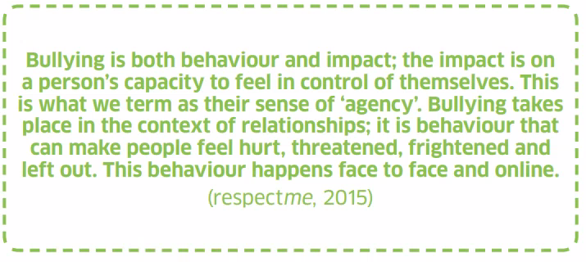
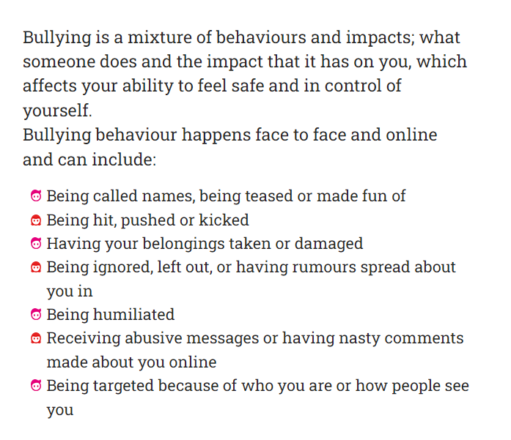
We believe that it is important to make a distinction between conflict and bullying. Children will have conflict and relationship as this can be a natural part of growing up. Describing all relationship difficulties as bullying can devalue the term and obscure the genuine risks associated with children and young people being bullied.

Our Approach at Dysart Primary School

Our approach to anti-bullying sits alongside our Dysart Primary School Positive Relationships and Behaviour strategy. We believe that in supporting children to develop positive relationships and behaviour and supporting the development of essential social skills and knowledge, children are enabled to make the right choices.

We are committed to working in partnership with parents, identifying shared responsibilities in preventing bullying, ensuring the welfare of children who have been bullied, and supporting and challenging those who have bullied.

We aim to ensure that children do not bully others because they understand the harm it causes and choose not to cause such harm. When children are involved in bullying we need to teach them restoratively rather than punitively. As adults we have a responsibility to model empathy, understanding, belonging and respect.

Such an approach may, understandably, be challenged by those who believe that children who bully should experience negative consequences due to their behaviour. Our firm belief is that such an approach is ultimately counterproductive and therefore, all staff, children and parents play an active role in developing and maintaining our school’s anti-bullying policy.

Families have a crucial role in supporting children and young people, and increasingly in managing the bullying behaviour associated with social media used outwith school, as well as supporting schools around mobile phone use within school.

Prejudice-based Bullying
Prejudice-based bullying is when bullying behaviour is motivated by prejudice based on an individual’s actual or perceived identity; it can be based on characteristics unique to a child or young person’s identity or circumstance.” (source: Scottish Government -Respect for All)
The Equality Act (2010) identifies characteristics which are protected by law. This act makes it illegal to discriminate against a person due to the following, which are known as the ‘Protected Characteristics’
- Age
- Disability
- Gender reassignment
- Pregnancy and maternity
- Marriage and civil partnership
- Race
- Sex
- Religion or belief
- Sexual orientation
All children and young people have the right to feel safe regardless of differences or perceived differences. It is never acceptable to use homophobic, racist or offensive language, or make fun of anyone’s disability or their personal circumstances. It is equally unacceptable to suspect someone of having the protected characteristics detailed above and using this as a reason for bullying behaviours.
Preventing Bullying
It is important to all at Dysart Primary School that our children and young people feel safe and that they are valued and supported to be healthy, to achieve, feel nurtured, be active, are respected, demonstrate responsibility and are included through a participative culture. All staff and partners are proactive in promoting positive relationships in the classroom, playground and wider learning community.
Strategies include:
✓ Rights Respecting Charters and Children’s Rights are referred to through learning
✓ Health and wellbeing learning progression within Curriculum for Excellence (RSHP, Cool in School)
✓ Encourage all children to speak up when they see or experience bullying behaviour
✓ Expectations promoted through our vision, values and aims (see Appendix)
✓ Positive behaviour approaches at Dysart Primary School (see separate policy)
✓ Pupil leadership (Peer Mediators, Buddies, Sports Ambassadors, Kitbag Ambassadors)
✓ Planned opportunities for wider successes, both classroom and school level
✓ Restorative conversations and practice
✓ Effective partnership working
✓ Assembly programme
✓ Whole school initiatives including opportunities for family learning
✓ Children are provided with regular playpod opportunities
✓ Pupil supervision during social times and targeted lunch clubs to develop social interactions
✓ Provide opportunities for children to learn how to work together respectfully
We take genuine pride in knowing our children and families. We build trust and relationships to enable us to work together to ensure the very best outcomes for pupils in our care.

Responding to Bullying
- We strongly encourage all children and their families to report instances of bullying
- A member of staff will support the child and meet with them to investigate
- If further action is required this will be recorded as a bullying incident in SEEMIS Wellbeing Module. This is a National recording system. This ensures that bullying information transfers with the child when they change schools.
- Staff will agree support and next steps with child and parent which may include:
- a restorative conversation may be led by a teacher.
- involvement of parents/carers
- use of Respect Me resources to encourage the child being bullied to feel more in control
Staff will check in regularly after an incident of bullying to ensure the bullying behaviour has stopped and children are well supported.
If there are further incidents of bullying behaviour, consideration of more additional strategies will be taken, for example:
- further use of Respect Me resources
- meeting with parents/carers and request for support from home
- change of provision
- involvement of other agencies and involvement of EP.
Resources for Parents/Carers
Respect Me is Scotland’s Anti-bullying Charity
Respect for All - The National Approach to Anti-Bullying for Scotland's Children and Young People | Self-evaluation | National Improvement Hub (education.gov.scot)
Bullying-a-guide-for-parents-and-carers-2016.pdf (respectme.org.uk)
Experiencing bullying behaviour | Social and emotional factors | Specific support needs | Additional support | Parent Zone (education.gov.scot)

