Little Squirrels

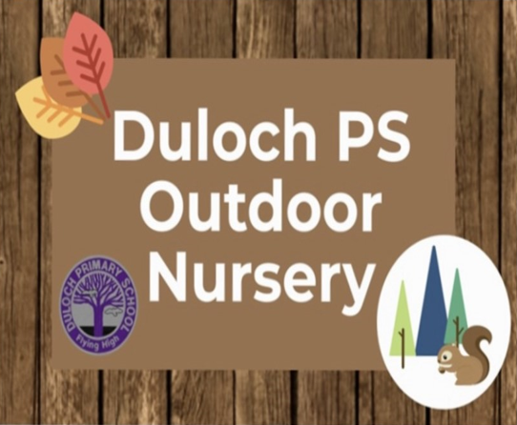

Outdoor Provision – Calais Muir Woods
Outdoor learning is a key part of the early years’ curriculum. Duloch Nursery already use Calais Muir Woods to provide forest kindergarten and to extend this, enabling children to access the forest every day we have established the Little Squirrels Outdoor Nursery Pilot.
The pilot model will run between 9.00 am – 3.00 pm, on either Monday, Tuesday and again on Thursday, Friday during term time. Children will have a blended placement between Duloch Indoor Nursery and Little Squirrels Outdoor Nursery. Parents/Carers will be asked to drop children off at 9 am and collect them by 3.00 pm from the containers which are cited on the edge of the woodlands.
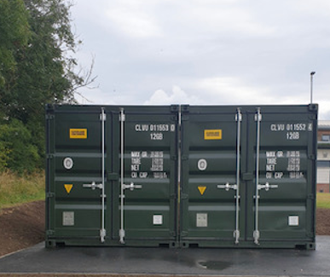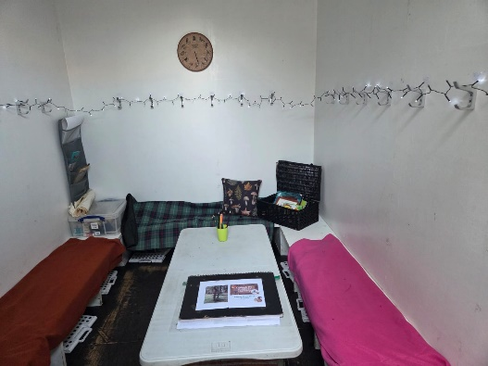

The containers are multi-functional with one providing storage for resources and learning materials and the other as a classroom area where the children gather to prepare for going to site and it is also used as a shelter in inclement weather.
Outdoor Clothing
Children should be dressed appropriately for being outdoors in all weathers. All in one splash suits and wellie boots will be available from the nursery but you may wish to provide your child with their own water-proof clothing.

How do I apply
Application forms are available from Duloch Primary School office and can be returned via email or returned to the office.
(Dulochps.enquiries@fife.gov.uk).
You will be informed of the outcome of your application when processed.


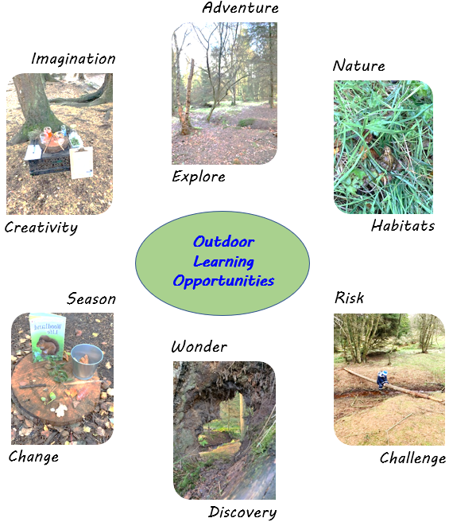

Snack and Lunch
Children will be provided with snack and lunch consisting of cold lunch option and soup which is provided by Direct Catering. This is collected by a member of staff and brought to site daily. You can supply your own packed lunch for your child if you prefer but please be aware that these will be stored in the outdoor next to their bags until lunchtime therefore you should ensure these contain foods that are suitable to remain un-refrigerated for this period of time.
Severe Weather Arrangements
In the case of severe weather i.e. high winds, we will move to the classroom container and have adventure day consisting of walks in the park, visiting library and/or shop. In case of severe weather warning we will use indoor nursery and garden. Parents will be informed of this via group call, email and Seesaw.
Who is eligible?
Initially all 3 and 4-year-old children attending Duloch Nursery in August 2025 will be eligible to apply for the outdoor provision. However, only a maximum of 32 children can be given a place. A ballot will be held if places are oversubscribed. Parents can apply for their child to attend Monday & Tuesday or Thursday & Friday. Those children successful in getting a place will attend their normal nursery provision on the days they are not outdoors at Little Squirrels.
For example:
Child A attends Duloch Nursery Monday-Friday 9.00-3.00pm term time and are offered a place at the outdoor nursery Monday/Tuesday 9.00-3.00 pm term-time therefore they will attend Duloch indoor nursery Wednesday/Thursday/Friday 9,00-3.00 pm term time.
Child B attends Duloch Nursery Monday to Friday 8,00-12.40 for 49 weeks and are offered a place at the outdoor nursery Thursday-Friday 9.00-3.00 pm term-time therefore they will attend Duloch indoor nursery Monday-Wednesday 8.00-12.40 pm for 49 weeks.
For those 3-year-olds starting nursery in August 2025 and who obtain a place at the outdoor nursery you can select to revert back to the original place they were offered for session 2026-27 if you wish.

Little Squirrels
At little squirrels we spend the whole or majority of day outdoors no matter what the weather. The only time we have to come indoors is if there is a severe weather warning which makes it unsafe to be in the woods. The children have the freedom to explore and connect with nature, where they lead their own learning while supported by skilled and experienced staff.
Safety is very important and in collaboration with the children we agree the forest rules, so children know where the boundaries are and how to respond to different situations. Children are encouraged to challenge themselves to develop their awareness of risk and how to keep themselves safe.
Toileting facilities are provided in the toilet tent.
On occasions we go on adventures to explore different parts of the forest.
We have 6 sites which children discovered, named and decide which one they want to go to.
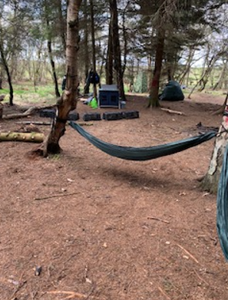  Sky Camp  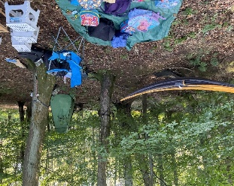 | 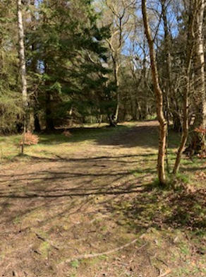  Fairy Camp  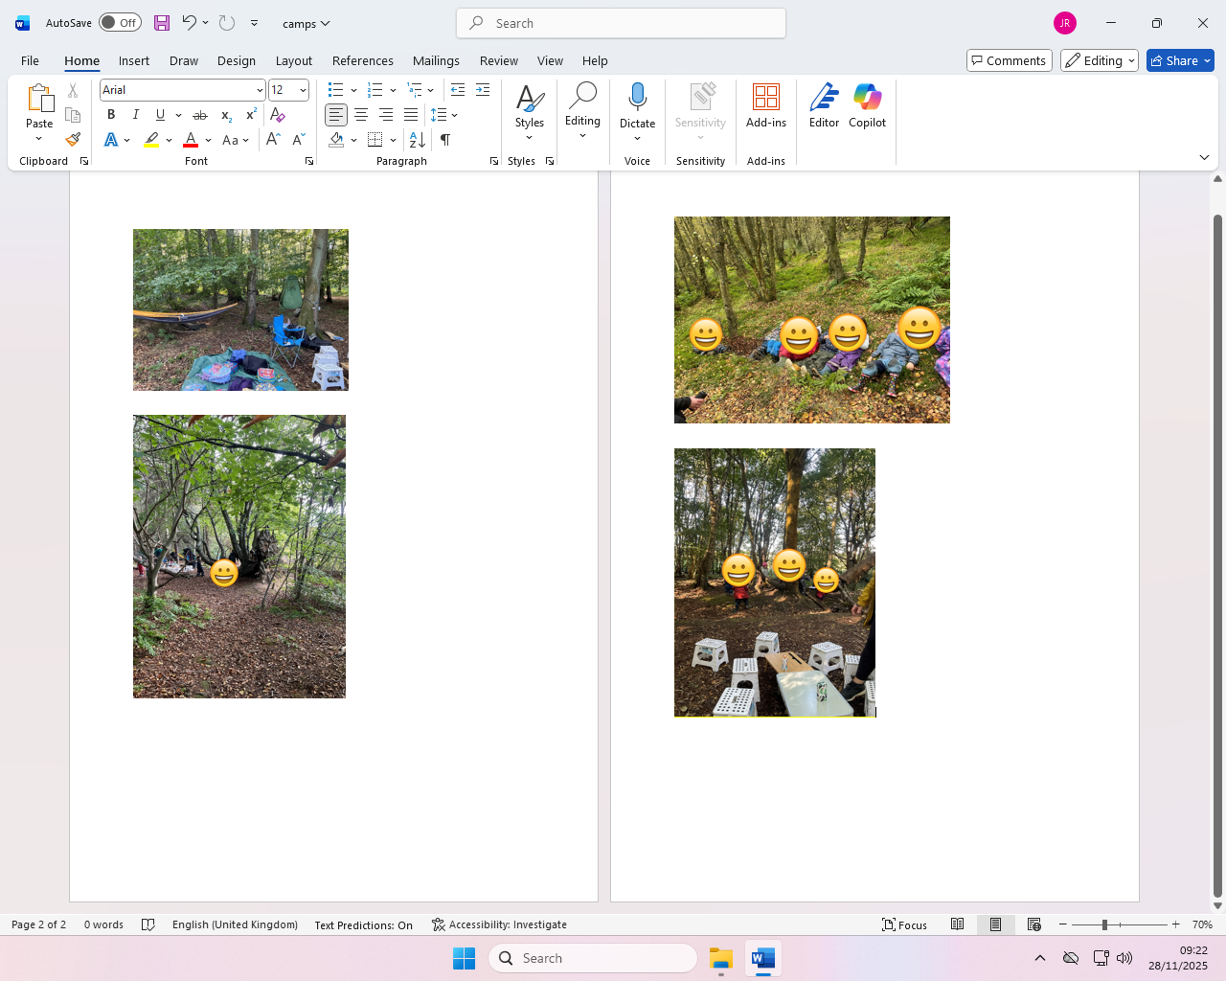
Bear Camp Pirate Ship Camp

Root Camp Cozy Camp

Days are always very busy, and each day provides different learning opportunities…………puddles are a favourite!!

Daily Routine
Children register and choose lunch and with you during drop off at the container or at drop off path, depending on the weather. At the container, we use emotion spoons to check how we feel, share news and look at our floorbook. Then children take their plastic stool that they will be using at the camp, their bags and we head to the camp children voted for day before. At the camp, once children put their bags on the bag tarpaulin and their water bottles on the water table. We then go over safety rules and children place camp boundaries. Children then go to play and explore. They are free to access and choose the activities on offer which are linked to their interests and seasonal topics.
The children are given the opportunity to share their learning through different mediums e.g. our Forest Floor Book, which is very popular and individual jotters that children take home every day to share with you and use them at home too.
We have morning and afternoon snacks along with lunch which are provided from the school kitchen and brought to site, if you prefer you can provide your child with a packed lunch.

After afternoon snack the children help to tidy up and pack away the resources and equipment then we head back to the containers for pick up time, pick up is by 3pm.
If you have to pick up your child early, can you inform a member of staff and you will have to come to site for pick up.
Also, if there is a change of person who is picking up your child can you please phone our official outdoor phone. You will be provided with phone number once your child joins Little squirrels.
For security, we ask you have a family password which we will ask for at pickup to identify this person.
Your child will have an outdoor and indoor key worker who will work together to share learning and contribute to PLJ’s.

If you have any queries regarding the outdoor nursery provision
Please contact the school office.
Email: Dulochps.enquiries@fife.gov.uk
Phone: 01383 602457

